ASSIGNMENT

SUBMITTED BY :ANTO JOSEPH

BATCH :MCA-A

ROLL NO :22

SUBMITTED TO :MERIN MISS

* Table Name:BRANCH

Create Table BRANCH

create table BRANCH(BNAME VARCHAR(20) PRIMARY KEY,CITY VARCHAR(30) NOT NULL);

Insert Values Into The BRANCH

insert into BRANCH values("VRCE","NAGPUR");

insert into BRANCH values("AJNI","NAGPUR");

insert into BRANCH values("KAROLBAGH","DELHI");

insert into BRANCH values("CHANDNI","DELHI");

insert into BRANCH values("DHARAMPETH","NAGPUR");

insert into BRANCH values("MG ROAD","BANGALORE");

insert into BRANCH values("ANDHERI","BOMBAY");

insert into BRANCH values("NEHRU","PALACE DELHI");

insert into BRANCH values("POWAI","BOMBAY");

Screenshot of Table BRANCH

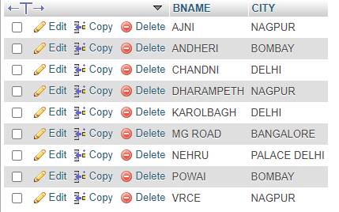

* Table Name:CUSTOMER

Create Table CUSTOMER

create table CUSTOMER(CNAME VARCHAR(15) PRIMARY KEY,CITY VARCHAR(20) NOT NULL);

Insert Values Into The CUSTOMER

insert into CUSTOMER values("ANIL","CALCUTTA");

insert into CUSTOMER values("SUNIL","DELHI");

insert into CUSTOMER values("MEHUL","BARODA");

insert into CUSTOMER values("MANDAR","PATNA");

insert into CUSTOMER values("MADHURI","NAGPUR");

insert into CUSTOMER values("PRAMODV","NAGPUR");

insert into CUSTOMER values("SANDIP","SURAT");

insert into CUSTOMER values("SHIVANI","BOMBAY");

insert into CUSTOMER values("KRANTI","BOMBAY");

insert into CUSTOMER values("NAREN","BOMBAY");

Screenshot of Table CUSTOMER

