STUDENT
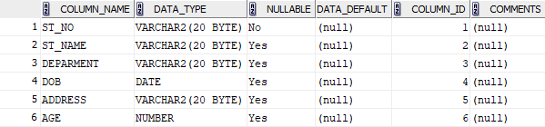

COURSE
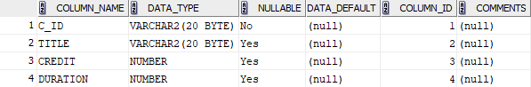

DEPARTMENT
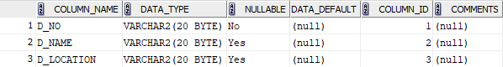

INSTRUCTOR
