Cloud computing final exam

## Q1: Clouds have been proposed (maybe used?) as a way to control drones. Discuss the advantages and disadvantages of this idea. Consider both military and commercial use of drones.

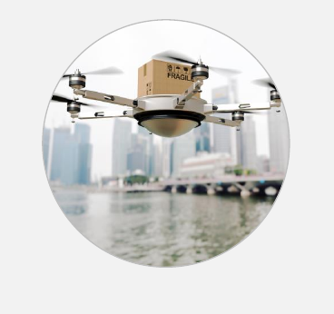  
Illustration 1: Image Source: Open Fog Consortium

Clouds are being used to control drones.[1] However not all drone uses are appropriate for use in the cloud. For purposes of this paper, drones will be classified into two main categories: military and civilian. Until recently drones, or Unmanned Aerial Vehicles (UAV), were primarily under the control of the military. Military drones are used for reconnaissance and communications. Other drones are used for diverse tasks such as:  rescue, search, traffic, surveillance, firefighting and weather monitoring purposes.[2]

Clearly, the primary value of a drone is that data it can gather and safely return to it’s controller. Since it is not practical to send a drone aloft with a server attached, a clear line of communication to a command and control facility is critical. A key problem with drones is the security of the communications channels with the drone.[3] Secure communication requires additional hardware which increases the weight of the drone. This also means that a drone must be able ta communicate directly wih the cloud in nearly real-time. With large numbers of drones and large amounts of data being gathered this may not practical.

A drone that needs direct pilot control should have a secure communications path to the controller and data gathered by the drone can then be uploaded to the cloud. This may be acmplished through use of a Fog which could then upload received data to the cloud through dedicated and more secure communications that are not under the control of the drone. This strategy is proposed by the Open Fog Consortium in their White paper for fleet drone delivery of packages: “Out Of The Fog: Use Case Scenarios – Transportation – High Scale Drone Package Delivery”.[4]

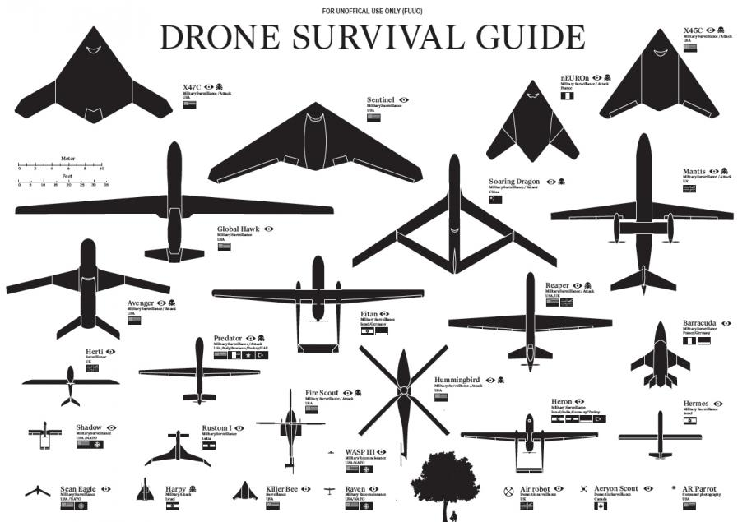  
Illustration 2: Drone Survival Guide (Source: Popuar Science, et. al.)

## Q2: What would be the advantages/disadvantages of controlling the traffic lights of a city using fog computing.

With the growth of Cloud computing and the growth in data collected by devices connected to the internet as part of the growth of the Internet of Things, Fog or Edge computing has been discussed in numerous articles and publications. In GovTech.com numerous articles are related to the question “Can The Internet of Things Transform Public Services”.[5]

Edge services bring the internet closer to the actual devices and users. The advantages of using Fog computing are numerous:

|  |  |  |  |
| --- | --- | --- | --- |
|  | Fog Nodes near IoT device | Fog nodes | Cloud |
| Response Time | Milliseconds, seconds | Seconds | Minutes, |
| Data Storage | Transient | Hour | Permanent |
| Coverage | Block | Numerous Blocks | Global |

When controlling local the traffic lights of a city, Fog computing has numerous advantages. Government Technology magazine notes in an article about Edge Computing that cities like Mesa, Arizona are using Fog/Edge devices to track assets and see actual traffic flow by tracking cellular and satellite devices located in vehicles to produce realtime traffic flows.[6] The same article also notes that Palo Alto, CA uses Smart Meter programs to determine energy usage and identify areas of use. Students at FAU have reported smart sensor programs in place in Orlando that directs drivers to the nearest available parking space and then visibly marks the space as used (lights above the parking area are red/green showing availability).

One disadvantage to using Fog Computing to control and monitor traffic is the amount of data it must process. With the growth of smart devices, the number of IP addresses is increasing and the amount of data gathered will increase. This makes security critical, with more devices the likelihood of an attacker attempting to spoof a legitimate device increases. One concern will be coordination with neighbouring fog controlled areas.

## Q3: Describe a Security SLA using a UML model extending the one we saw for an SLA in Chapter 3. How would you express the degree of security required by the consumer? How would the SLA be enforced? Complement the UML model with explanations to describe the meaning of your classes. Consider the use of patterns.

When establishing a SLA for Security we would need to address three basic areas of agreement between the involved parties. First the agreement would need to define who owns the data and what the responsibilities of the parties are with respect to the data. Second the agreement should outline who has access to the data and how that access is enforced and recorded. Finally an agreement should report to the parties involved, specifics of the data access. Addressing each of these in turn.

A key element of a SLA should involve access rights, logging and reporting access. Patterns already exist to Authorize, Authenticate and provide access to users and their data. Existing patterns to monitor SLA compliance can used to log access and provide awareness through Threat Assessment patterns. A cloud provider can deliver to a user on a periodic basis a record of authorized access and non authorized access when detected. Based upon the work of the Open Web Application Security Project and the FAU Secure Systems Group, I recommend the following outline for SLA Security.

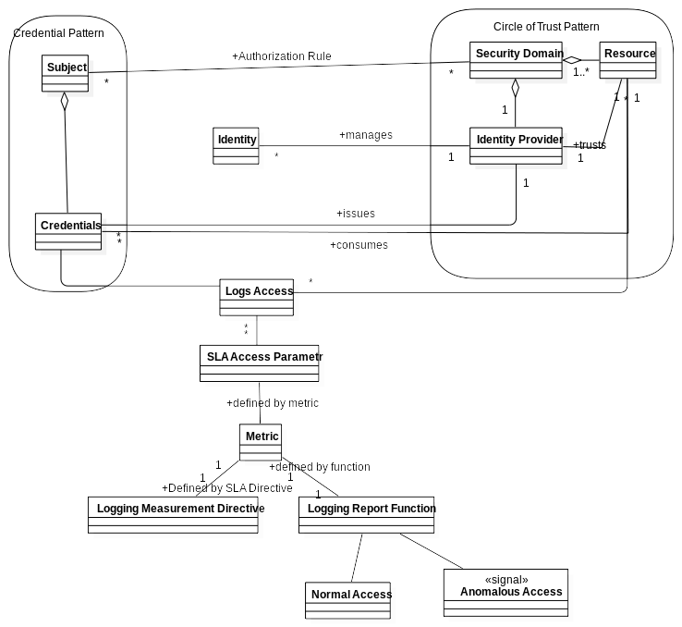

1. “New Software Allows Fleets of Drones to be Controlled By The Cloud”, http://www.forbes.com/sites/gregorymcneal/2014/12/15/new-software-allows-fleets-of-drones-to-be-controlled-by-the-cloud/#35e069265a55
2. “Drones ard Cloud Computing”, http://cloudtweaks.com/2014/09/drones-and-cloud-computing/
3. “WhyIt’s Time to Start iDeveloping a Drone Secu ity Strategy”, http://www.networkworld.com/article/3120288/mobile-wireless/why-its-time-to-start-developing-a-drone-security-strategy.htm
4. “Out of The Fog: Use Case Scenarios”, Open Fog Consortium, https://www.openfogconsortium.org/wp-content/uploads/OpenFog-Transportation-Drone-Delivery-Use-Case.pdf
5. “Can the Internet of Things Transform Public Services”, http://www.govtech.com/fs/perspectives/Can-the-Internet-of-Things-Transform-Public-Services.html
6. “Is Edge Computing The Key to the Internet of Things”, http://www.govtech.com/transportation/Is-Edge-Computing-Key-to-the-Internet-of-Things.html