

Christopher Foley | COT5930 – Cloud Computing | September 25, 2016

Assignment 1

Cloud computing impacts in disaster recovery and use of AWS

# Statement of Problem

Florida is prone to hurricanes. A hurricane can bring disruption and damage, such as floods, cuts of electricity, damage to buildings, accidents and death. There is no centralized system for disaster recovery now. A disaster recovery system must keep information about the disaster and coordinate first responders, firemen, police, medical units and other relevant services.

Propose a cloud-based architecture for such a system for South Florida (Palm Beach, Broward, and Dade counties). Describe the architecture using block or UML diagrams and words.

Consider the data you need to have for fast response and the data that needs to be collected as well as their possible storage. Indicate which type of cloud you need and its deployment.

Be as precise as possible and justify your decisions, itemize your points, do not include descriptions of systems. Give references to papers consulted.

# Review of details

Each county operates its own hurricane proof, self-sufficient “Command Bunker” where elected officials direct efforts to disaster recovery. Compounding the duplication of effort there is a hierarchical structure of disaster preparedness. The goal of the emergency officials is to ensure continued operation of government services and direct recovery efforts. It has been noted that “during disasters, public authorities and their rescue teams play a crucial role in providing warnings and evacuation instructions, and in undertaking rescue operations.” (ITU-T Focus Group on Disaster Relief Systems, Network Resilience and Recovery 2014)

## Access to government electronic services/data

As shown in the figure (Existing Systems), users access data from their workstations via an internal intra-net or a public Internet gateway. The user does not know where their data is being stored nor are they aware of the location of their central server. The users see the data/application front and interact accordingly.

Use of a cloud will be transparent to the users. Access will continue through their current access point, however their data and applications will be removed from their geographic area, potentially.

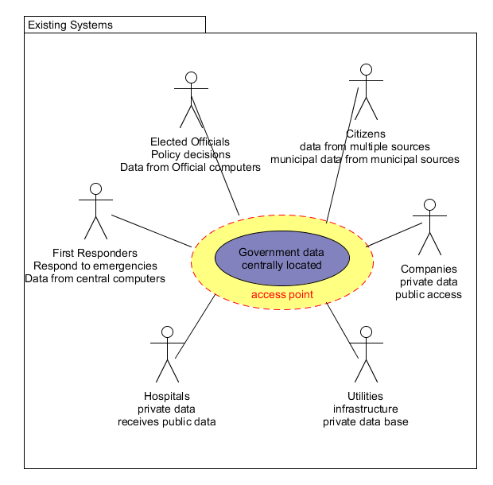

Of consideration is the frequency of storms to affect the area. While it is possible to have a large number of storms affect the tri-county area, the southern tip of Florida is relatively storm free.

## Before The storm(s)

Before the storm there is electrical power and building damage is usually limited to ordinary wear and tear. Government data can be easily accessed from central servers and transmitted locally or globally. Users, typically do not know where their data is physically located and do not care if access is sufficiently rapid.

### Advantages

Switching to a Cloud Computing solution will provide an easily scalable, geographically distributed solution to existing computing needs. Users will not be aware of the actual location of their data. Governments will not be responsible for the cost of purchasing, maintaining and supporting computing servers. After the transition, users will not be aware of the change.

In areas where commercial software is used by government, the cloud providers will be responsible for the maintenance and upgrade of existing systems.

### Disadvantages

Switching to Cloud computing will have a significant up front cost involving creation of a transition plan, façade and data migration plan. Regional data administrators will be required to adopt additional roles during the transition and as the plan moves forward. Computing professionals with needed skills will need to be hired and existing employees will need to be trained on the use of cloud based systems, as appropriate for their level. Significant costs will be involved in retraining government employees.

Certain software systems are specialized for government use and will need to be examined and the cloud computing solution needs to accommodate the appropriate platform designed to house the government systems.

Examination of legal impact of remote data storage and employee retention will be needed.

Transition will require examination of communication systems and buried communications cables.

## During the storm(s)

During the storm, electrical power is intermittent and communication difficult. Emergency responders do not have the ability to respond to emergencies. Above ground communications mediums are interrupted. Electrical lines may be downed. Government and first responder facilities are hardened against damage and have physical power generation systems, but their sizes are limited and as the government needs grows expensive construction will be required. Users on the fringes of storm activity will have power and communication but will not be able to access communications and data stored in the storm center.

### Advantages

Employees and users not located in the storm area will not see any change in their services. Individuals in the storm area who have data connections will have access to electronic services allowing immediate analysis of the storm situation. A specialized disaster recovery plan involving use of the data can be established. Individuals and government officials in the storm area can post updates and communicate with officials outside the affected area.

### Disadvantages

Constant electrical power and contact with computing services outside the area will be required. This will require below ground communications and battery backup, supported by on-site generators that may not be able to operate in the storms.

## After The storm

After the storm users will be attempting to get updates about damage and report problems. Utility crews both local and remote will be responding to problems in their infrastructure. First Responders will be responding to emergencies with damaged infrastructure. Quick access to data is only possible in those areas where there is a direct connection to buried and undamaged data lines. If the power at intermediate stations is interrupted (electrical lines down or local batteries dead communication will be difficult. Communication with the central database will only be possible with a direct connection.

### Advantages

Post storm, the advantages of a cloud based system will be most obvious. Government services for non storm affected areas that still have power and communications will be restored with no delay. Government services in affected areas may be rapidly moved to safe areas as well as temporary areas with minimal delay. Employees working in the affected areas will not require training on additional systems as they will be using the same façade that they are familiar with pre storm. There is no risk to data loss as the data will be geographically isolated from the storm.

During post storm additional electronic resources can be quickly, inexpensively and securely provided to utilities and contractors hired from outside the area to permit them to assess and fix a damaged infrastructure.

### Disadvantages

It may be necessary to invest in portable above ground communication systems to connect to government offices and first responders.

# Recommendations

Primarily due to the low frequency of serious storms to affect the area, I recommend that a secure bunker be built and maintained locally to house a private cloud server that will support the use of local officials and citizens. Investigation is needed to determine the cost of creating a mirror of the local cloud on a geographically distant cloud.

Although a commercial cloud may provide solutions to needs the cost of transition may exceed the benefit. Further study in topics outside the scope of the requirements of this assignment should be required.

### Further Study

Further study in the following areas may be required:

* Legal implications of maintaining legal documents outside the jurisdiction of the local governments.
* Computing software used by government offices. What software services can be transitioned to the cloud provider and which must be maintained by government.
* Since cloud providers provide Platform as a Service (PaaS) it might be more advantageous to maintain existing systems in a local cloud and establish failover platforms in the cloud whose costs will be relatively low until a storm hits and they are used.
* Integration of a full disaster recovery plan with commercial cloud services.
* Possible use of a commercial/private cloud with the private cloud failover to commercial cloud services.

# Annex 1: AWS Data

## EC2 Console showing instance running

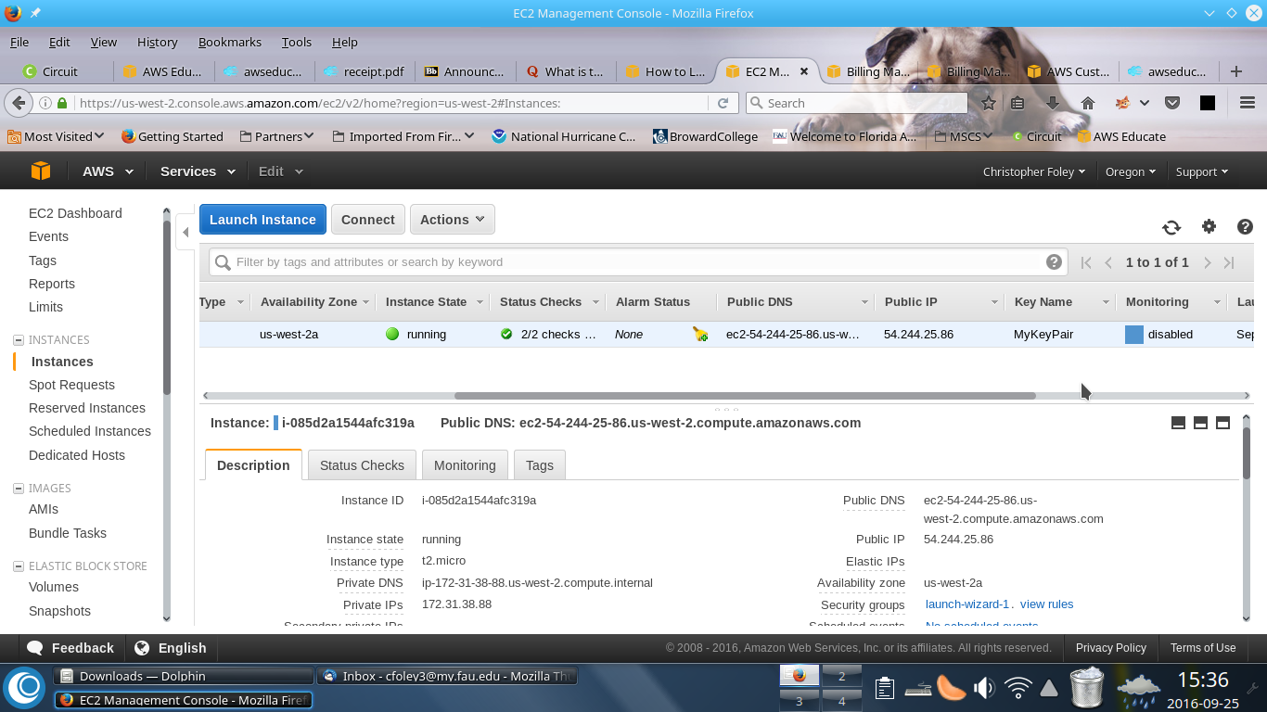

## Screenshot showing command line overlaying window

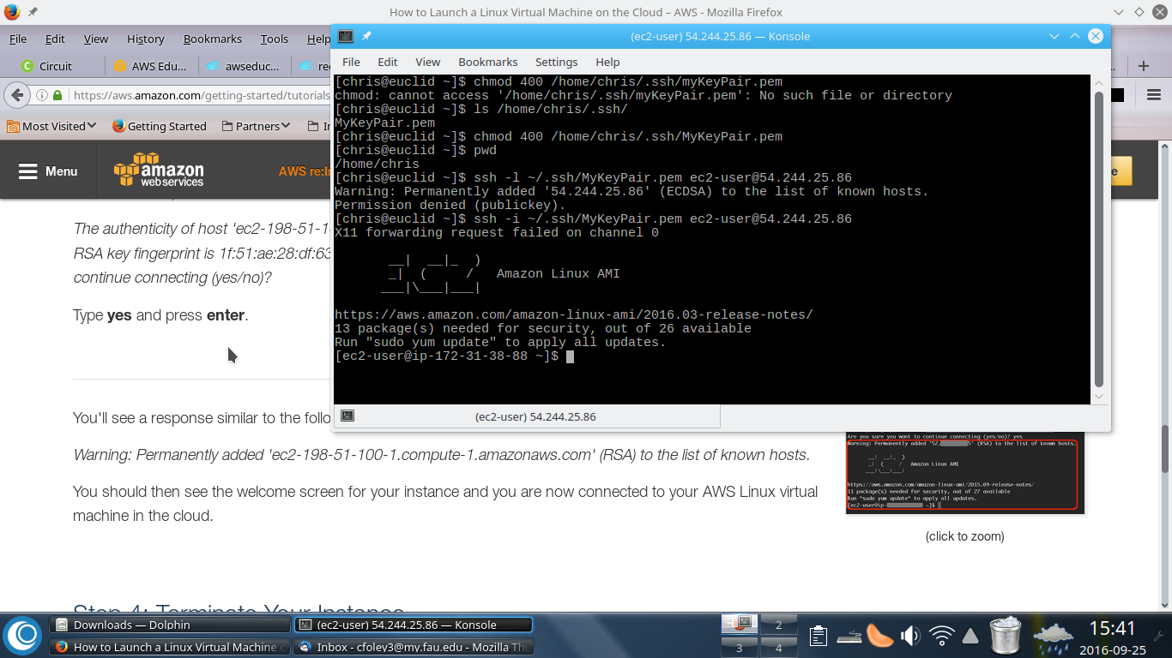

### Command line interface text display showing Connection established

[chris@euclid ~]$ ssh -i ~/.ssh/MyKeyPair.pem ec2-user@54.244.25.86

X11 forwarding request failed on channel 0

__| __|_ )

_| ( / Amazon Linux AMI

___|\___|___|

https://aws.amazon.com/amazon-linux-ami/2016.03-release-notes/

13 package(s) needed for security, out of 26 available

Run "sudo yum update" to apply all updates.

[ec2-user@ip-172-31-38-88 ~]$ pwd

/home/ec2-user

## Command line overlay – ls command

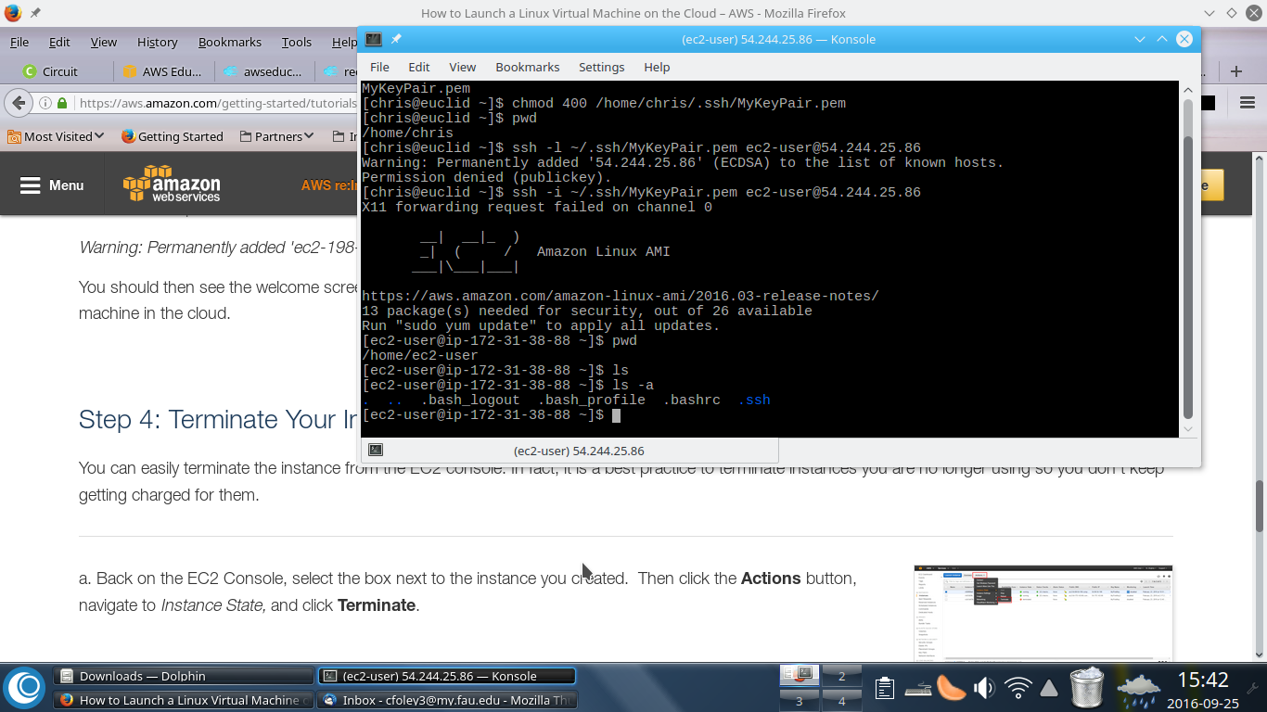

## Command line interface text listing from above

[ec2-user@ip-172-31-38-88 ~]$ ls

[ec2-user@ip-172-31-38-88 ~]$ ls -a

. .. .bash_logout .bash_profile .bashrc .ssh

[ec2-user@ip-172-31-38-88 ~]$

### Amazon Linux shutdown from AWS Console

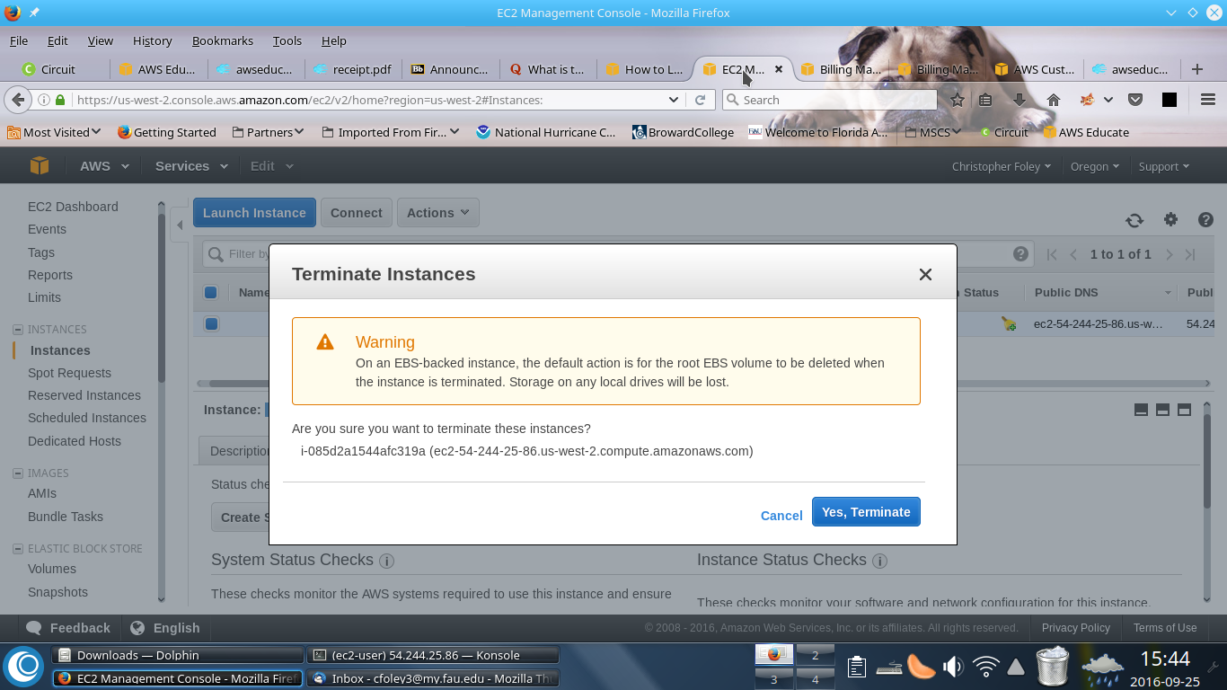

### Command line display at Terminate Instances

Broadcast message from root@ip-172-31-38-88

(unknown) at 19:44 ...

The system is going down for power off NOW!

Connection to 54.244.25.86 closed by remote host.

Connection to 54.244.25.86 closed.

### Connection to Amazon Cloud via Command Line interface

[chris@euclid ~]$ /usr/local/bin/aws --version

aws-cli/1.10.66 Python/3.4.4 Linux/4.7.3-desktop-1omv botocore/1.4.56

[chris@euclid ~]$ /usr/local/bin/aws configure

AWS Access Key ID [None]: <<public access key redacted >>

AWS Secret Access Key [None]: <<secret access key redacted >>

Default region name [None]: us-east-1

Default output format [None]: json

### Create Bucket from Command Line

[chris@euclid ~]$ /usr/local/bin/aws s3 mb s3://my-first-backup-bucket

make_bucket failed: s3://my-first-backup-bucket An error occurred (BucketAlreadyExists) when calling the CreateBucket operation: The requested bucket name is not available. The bucket namespace is shared by all users of the system. Please select a different name and try again.

[chris@euclid ~]$ /usr/local/bin/aws s3 mb s3://cfoley3.fau.edu.my.first.backup.bucket

make_bucket: cfoley3.fau.edu.my.first.backup.bucket

### Copy Files From Local Machine to Bucket

[chris@euclid ~]$ /usr/local/bin/aws s3 cp WebRatio/'Christopher Foley'/Model.wr s3://cfoley3.fau.edu.my.first.backup.bucket

upload: WebRatio/Christopher Foley/Model.wr to s3://cfoley3.fau.edu.my.first.backup.bucket/Model.wr

## Verify that copy worked (of course it did)

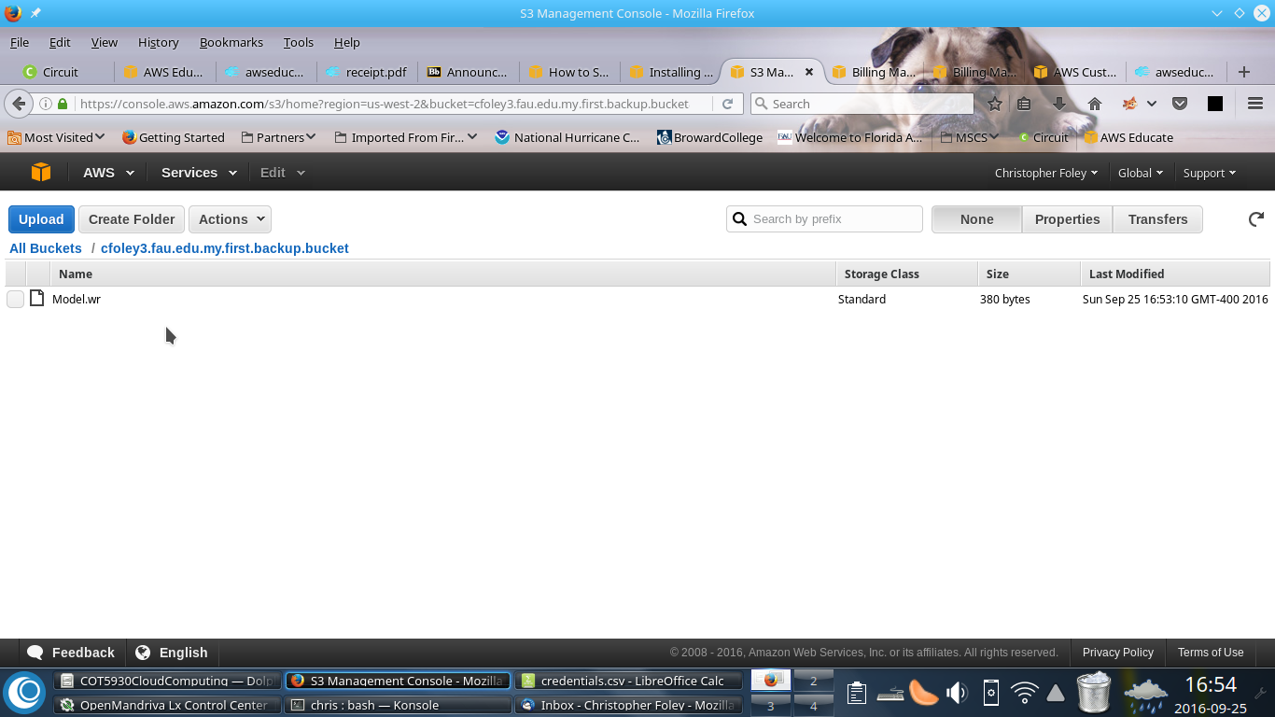

## Upload files via aws console

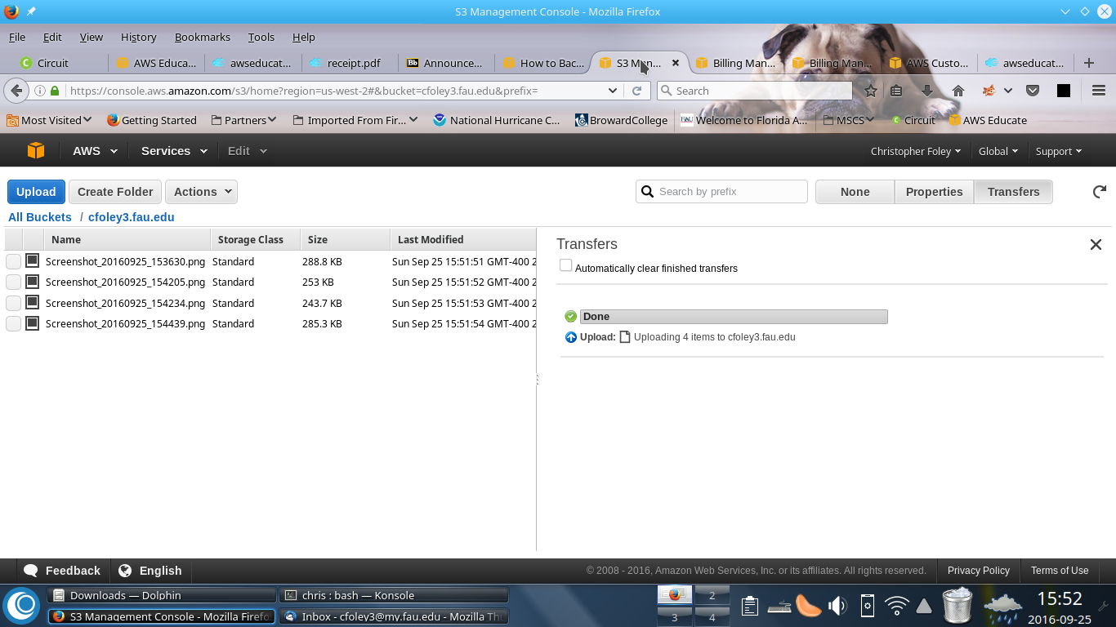

### Directory Listing to see contents of bucket

(note: *.png files were uploaded by graphical interface/console above)

[chris@euclid ~]$ /usr/local/bin/aws s3 ls s3://cfoley3.fau.edu.my.first.backup.bucket2016-09-25 16:53:10 380 Model.wr

[chris@euclid ~]$ /usr/local/bin/aws s3 ls s3://cfoley3.fau.edu

2016-09-25 15:51:51 295816 Screenshot_20160925_153630.png

2016-09-25 15:51:52 259113 Screenshot_20160925_154205.png

2016-09-25 15:51:53 249573 Screenshot_20160925_154234.png

2016-09-25 15:51:54 292242 Screenshot_20160925_154439.png

## Show buckets from command line

[chris@euclid ~]$ /usr/local/bin/aws s3 ls s3://

2016-09-25 15:50:30 cfoley3.fau.edu

2016-09-25 16:49:55 cfoley3.fau.edu.my.first.backup.bucket

## Using amazon’s dynamodb (nosql datbase)

### My Amazon Billing Console (the best place I want to see 0 dollars)

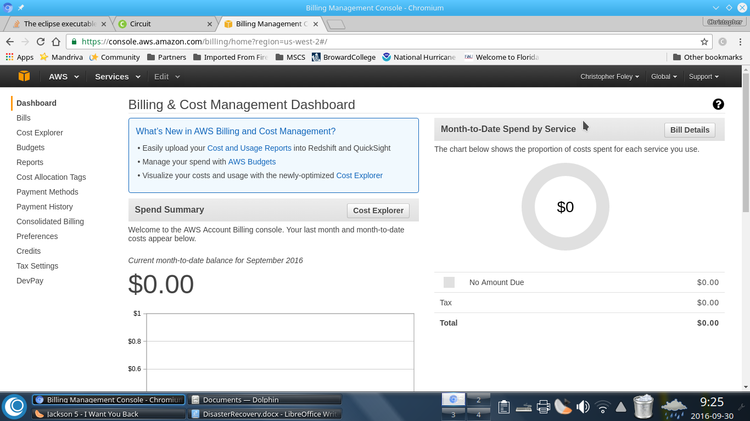

### DynamoDB Tables[1]

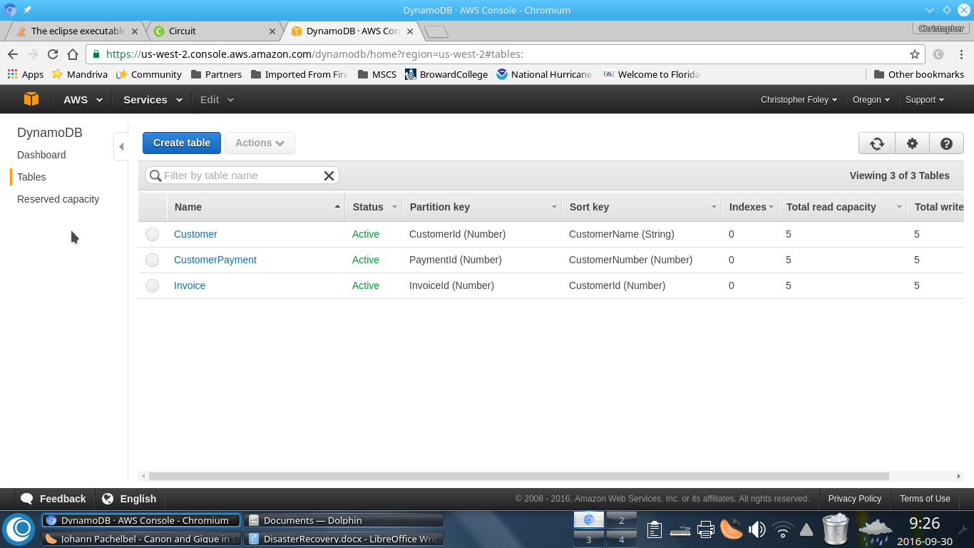

### DynambDB Customers Table

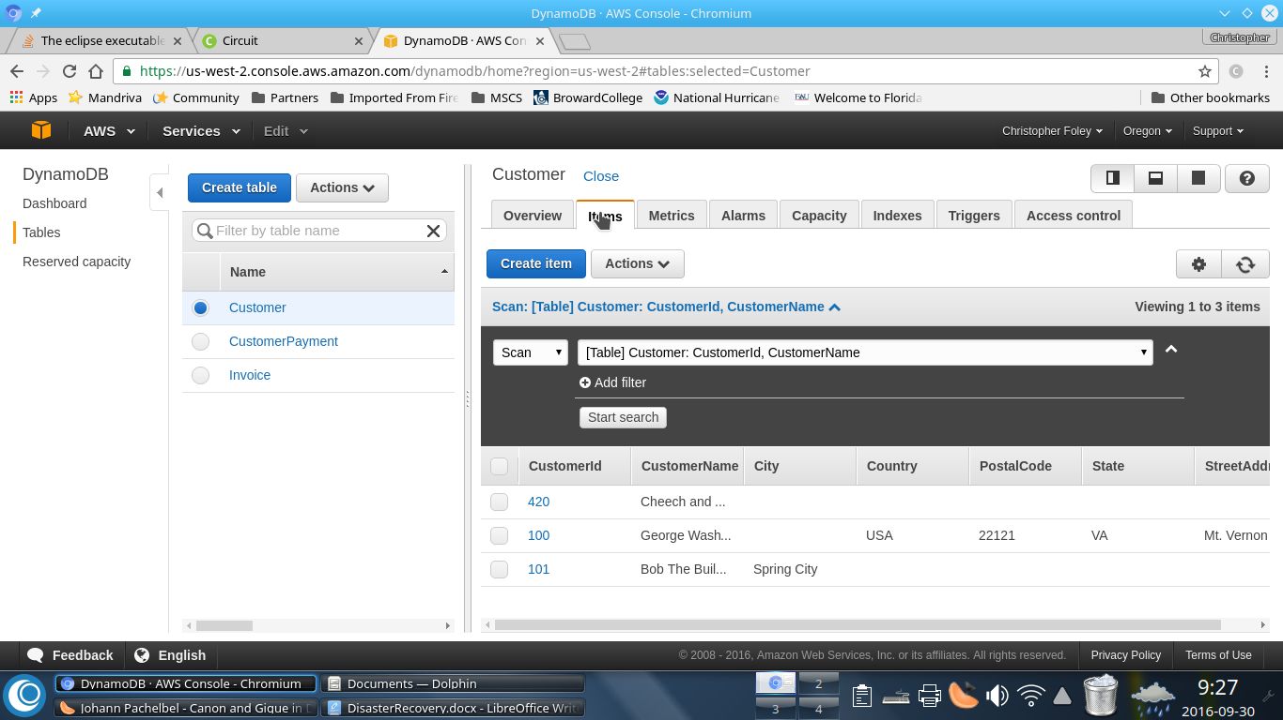

### DynamoDB Invoices Table

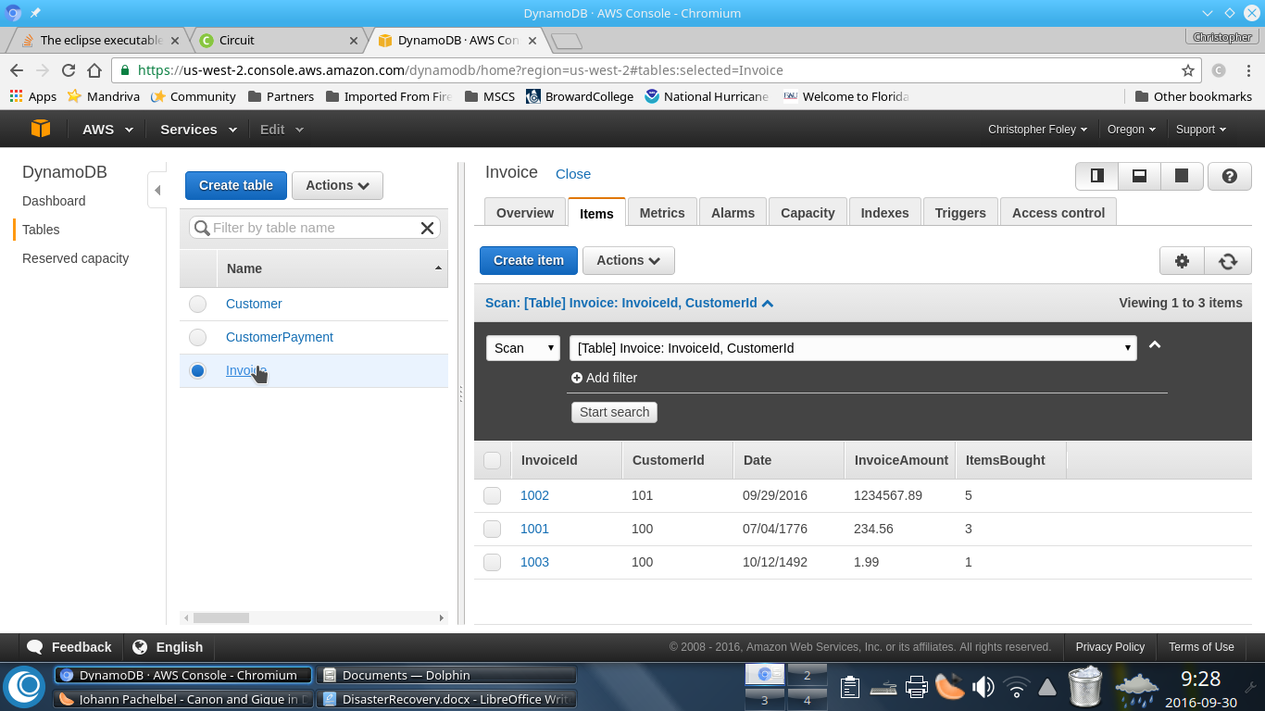

### DynamoDB CustomerPayment Table

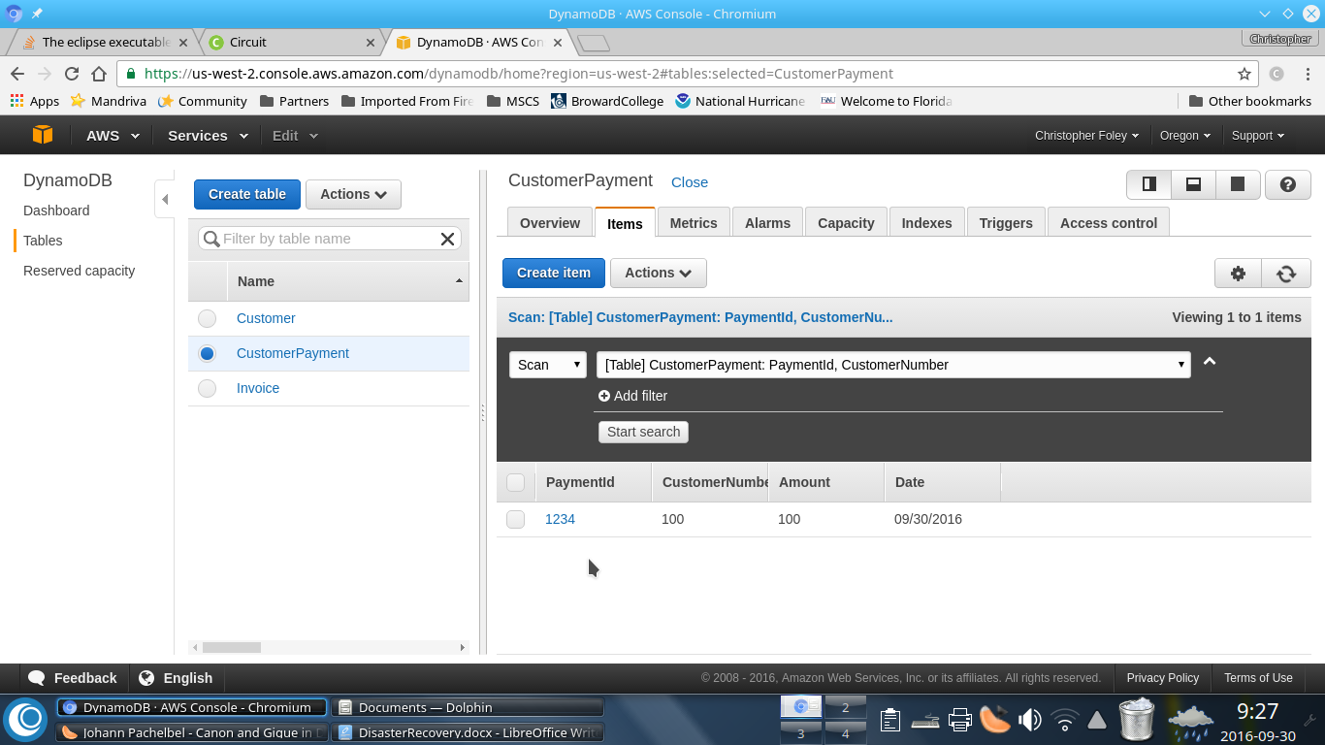

### DynamoDB InvoiceTable (with error)

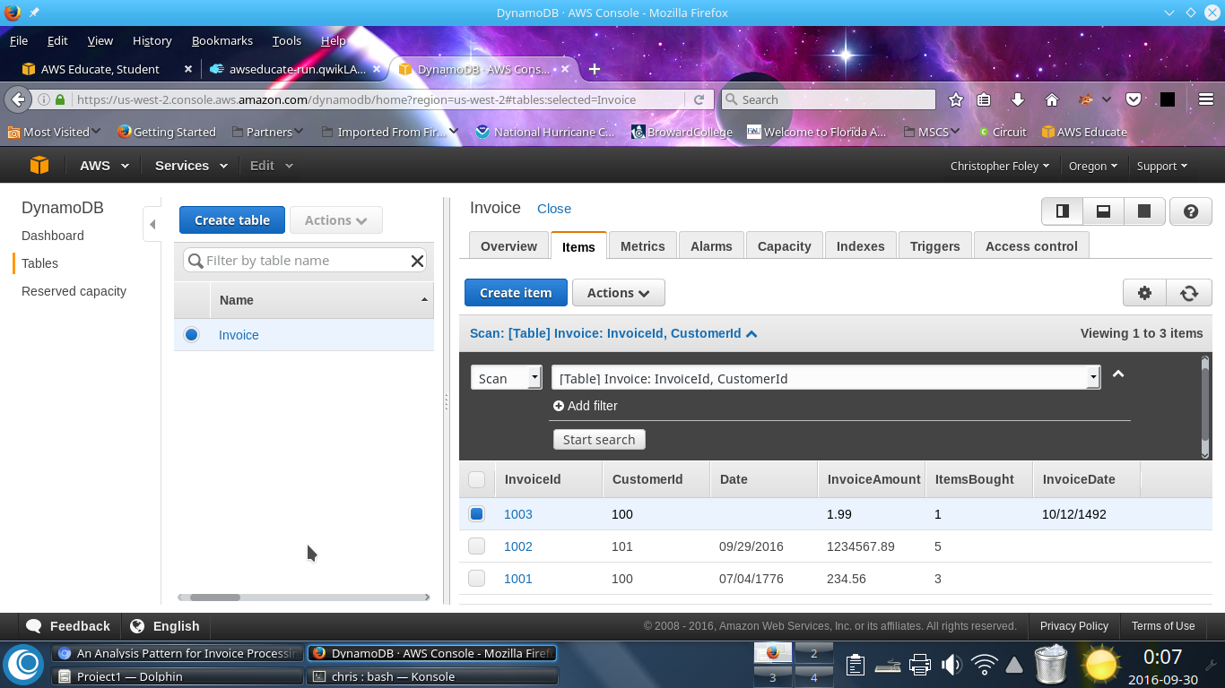

### DynamoDB Invoice change

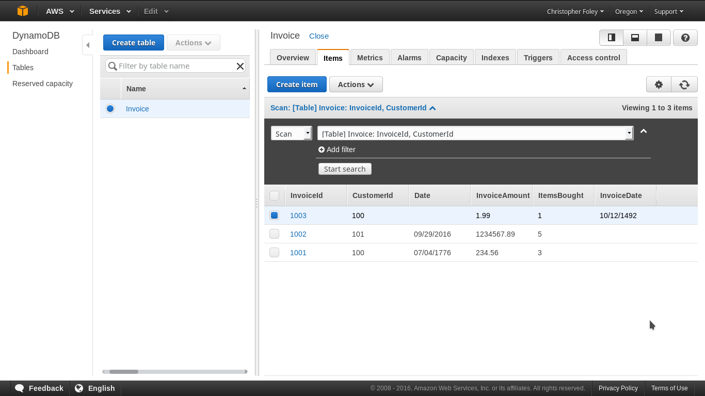

### DynamoDB Invoice table changed

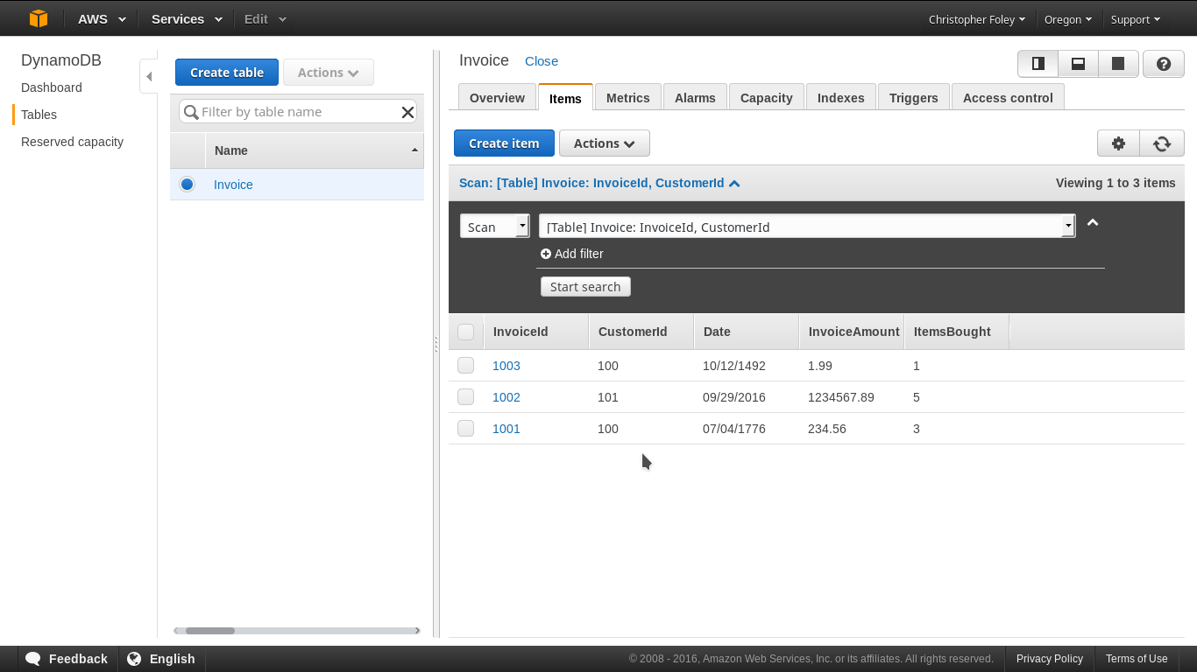

Bibliography

CITATION ITU14 \l 1033: , (ITU-T Focus Group on Disaster Relief Systems, Network Resilience and Recovery 2014),

1. E.B. Fernandez and X. Yuan, “An Analysis Pattern For Invoice Processing”, [http://hillside.net/plop/2009/papers/Process/An%20Analysis%20Pattern%20for%20Invoice%20Processing.pdf](http://hillside.net/plop/2009/papers/Process/An Analysis Pattern for Invoice Processing.pdf)(30-Sep-2016)