Summary of Machine Learning class on 3/15

Deep Learning
Maryam Najafabadi presented an overview of Deep Learning, a course to be offered at FAU in the Fall of 2017. The presentation began with an overview of the relationship between Deep Learning as a subset of Machine learning.

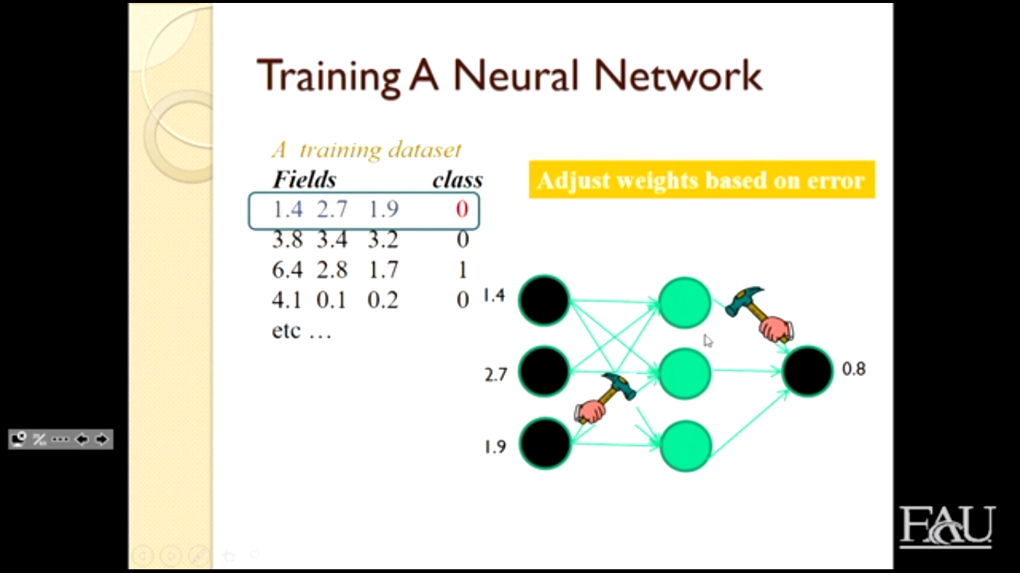
Deep learning is the subset of Machine learning that focuses on Neural networks to learn. A neural networks uses multple layers of analysis to extract features about the data. Deep learning has grown rapidly in the last few years and is supported by many leading companies like Alphabet (parent of Google) and Microsoft.

Examples were given in class of Deep Learning being used to adjust color of images, recognize expressions on faces and answer questions about data presented to it. An example of training a neural network was provided and discussed.

The major breakthroughs in Deep Learning occurred after 2006 when Geoffrey Hinton developed a new algorithm of Deep learning. He also came to the conclusion that to train for deep learning we needed latger data sets.

Part II

In the second segment of the class we learned about Lexis/Nexis’ Relx group and HPCC which is used to analyze data. The Relx group began by creating and selling physical directories and now provides the data electronically in addition to performing analysis on the data. It was noted that each day 45 billion data records are created and the number is growing daily. The objective of the Relx group and HPCC is to disambiguate the data, that is correctly link data to its component parts.

We were reminded about ACID from our data base classes and were given minor examples of the ECL language, created by Lexis/Nexis. ECL is a declarative parameter language designed to be used with data flows.
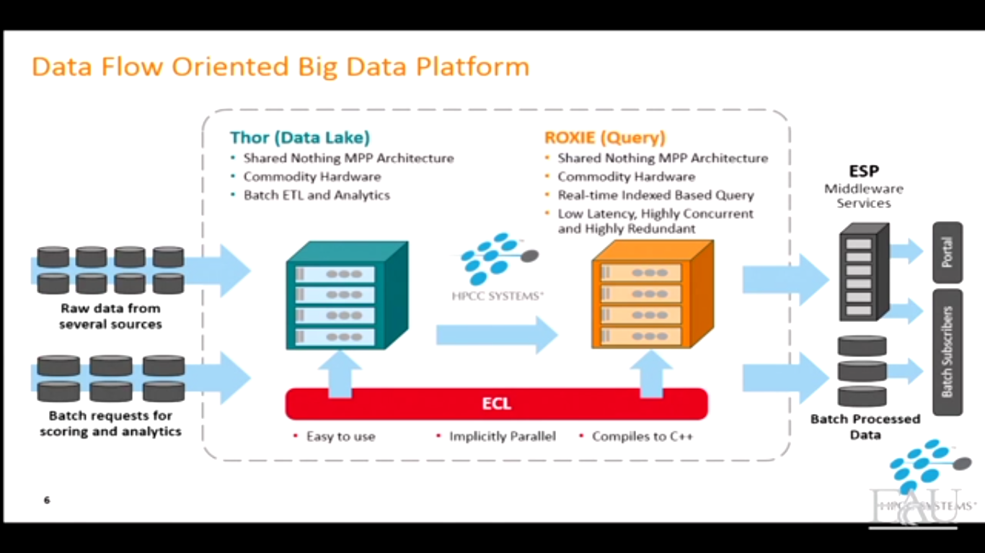
In addition to the discussions about HPCC and ECL we learned about legal implications of patient records as well as the impact of data on the privacy and health of others. Data scientists must balance these requirements with the need to use the data for science.

Near the end of the lecture we also learned about advances in collection, specifically Smart Hats which were hard hats containing sensors which monitored worker conditions. The data is then used to enhance user safety and monitor for dangerous conditions.

