

Florida Atlantic University
CEN5035 RESULT

EDUSnap

Written by:
CEN5035 – RESULT Team
Ashish Arora
Yom Chouloute
Christopher Foley
Divyang Purohit
Venkat Retesh Velapakam

Academic Year: Fall 2016

Table of Contents
1 EDUSnap Team Members 3
2 Project Peer Evaluation 3
3 Purpose 4
3.1 Overview 4
3.2 Product Goals 4
3.3 Targeted Users 5
4 Screen Shots 5
4.1 Screen Shots of Mockup 5
4.2 Screen Shots of Final System 6
5 BPMN 17
6 Scrum Project Space 18
7 Existing Backlog (future Features) 19
8 Reflections on Model Driven Development 20
9 Knowledge gained, lessons learned 20

EDUSnap Team Members

Ashish Arora – Product Developer
Yom Chouloute – Scrum Master
Christopher Foley – Product Owner
Divyang Purohit – Product Developer
Venkat Retesh Velapakam – Product Developer

Project Peer Evaluation

The team after discussion has chosen to allocate our weighting as follows:
Ashish Arora – 20/20
Yom Chouloute – 20/20
Christopher Foley – 20/20
Divyang Purohit – 20/20
Venkat Retesh Velapakam – 20/20

Purpose

Overview
Universities and schools are not small places. Take FAU as an example, this university covers approximately 850 acres. To give you a little perspective, the dimension of a football field, including the end zones covers approximately 1.32 acres. Hypothetically speaking, you can fit 644 football fields inside FAU.

Administrators and facilities employees at these large institutions usually do their best to provide students with a clean, hazard free and a safe environment. They have employees assigned to maintain each region on campus, they use video cameras and the help of the police department to survey all areas.
Although Administrators and maintenance staffs do their best, there is always room for improvement, since it is quasi impossible to monitor every corner on campus.

Introducing “EduSnap” a responsive website created by a group of students at FAU that can make it very easy for anyone on campus report issues that require immediate attention.

We are hoping to add to a link to our responsive site in the University mobile App. Doing so will make it very easy for everyone to access the application.

Product Goals
- Easy to use (Ability to create a ticket in less than 30 seconds)
- Ad Hoc Ticket Submission for faster ticket creation
- User Registration if our users want to track their own tickets
- Different view for each user type
- Email Functionality
- Point system and prize for the person who reports the most completed tickets.

Targeted Users
The following users are targeted as users of the intentional system:

Name | Brief Description
Dispatcher | Responsible for prioritizing and dispatching field technicians to repair observed anomalies.
Technician | Individual who completes the repair
Third Party Vendor Staff | The Third Party Vendor Staff is a third party agent outside FAU Campus which accepts requests from FAU Dispatcher staff if repair is not being provided by FAU repair staff and confirms the request after visiting the site which needs the service. Once the repair is completed Third Party Vendor uploads the picture of task completion on Edu Snap application and notifies the dispatcher.
Manager | Check reports for work done and give away awards to users who have actively reported messages.
Student | Responsible for reporting incidents like repair and damages on campus
Staff | Responsible for reporting incidents like repair and damages on campus
Visitor | Responsible for reporting incidents like repair and damages on campus
FAU Repair Staff | This staff is responsible to fix the issue reported by the users of the EduSnap application

Screen Shots

Screen Shots of Mockup
Due to the time constraints of learning a new tool, see Lessons Learned page Error: Reference source not found, it was decided to rely on traditional methods of interface design which allowed for more rapid implementation as evidenced by the following:
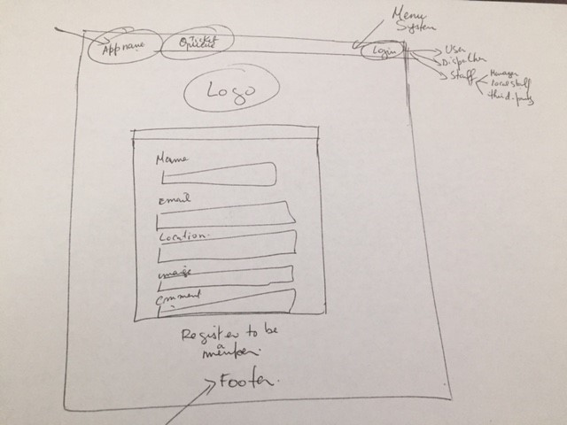

Screen Shots of Final System
The following screen shots were taken for the final presentation:
ﾵ
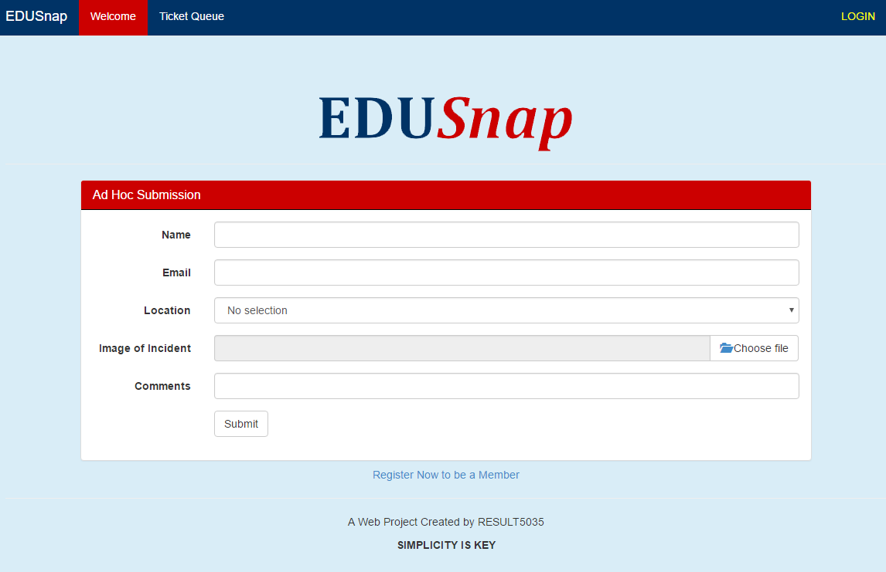
Figure 1- Request Form
Illustration 1: Request Form

ﾵ
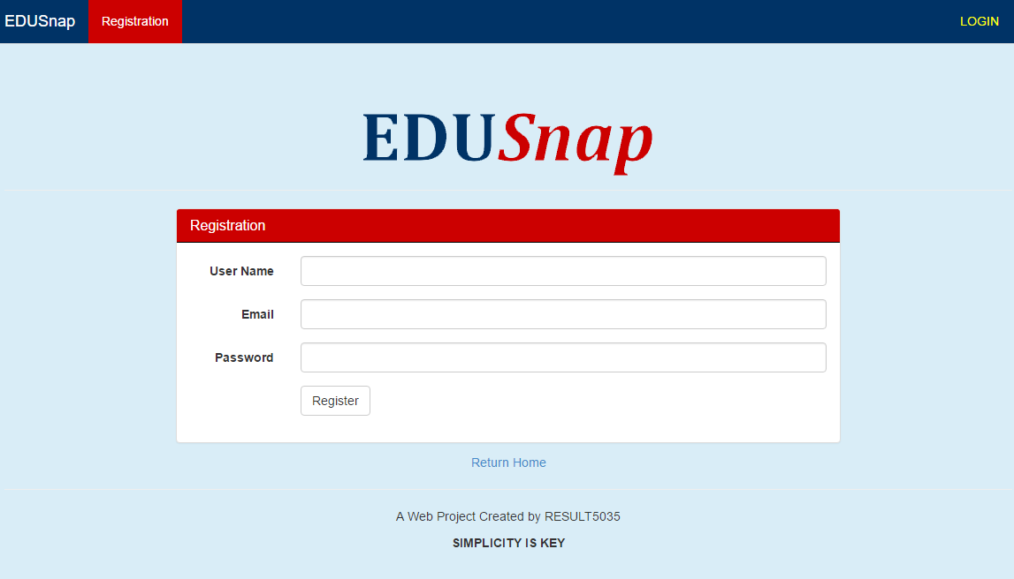
Figure 2- User Registration
Illustration 2: User Registration
ﾵ
ﾵ
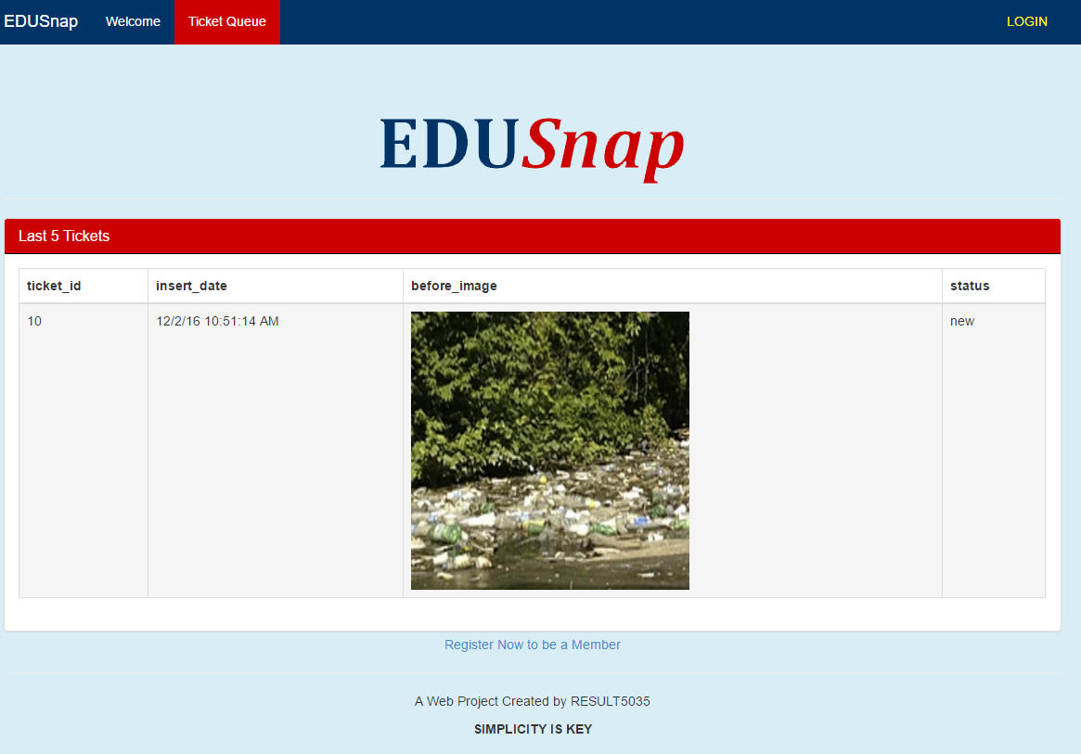
Figure 3- Ticket Queue
Illustration 3: Ticket Queue
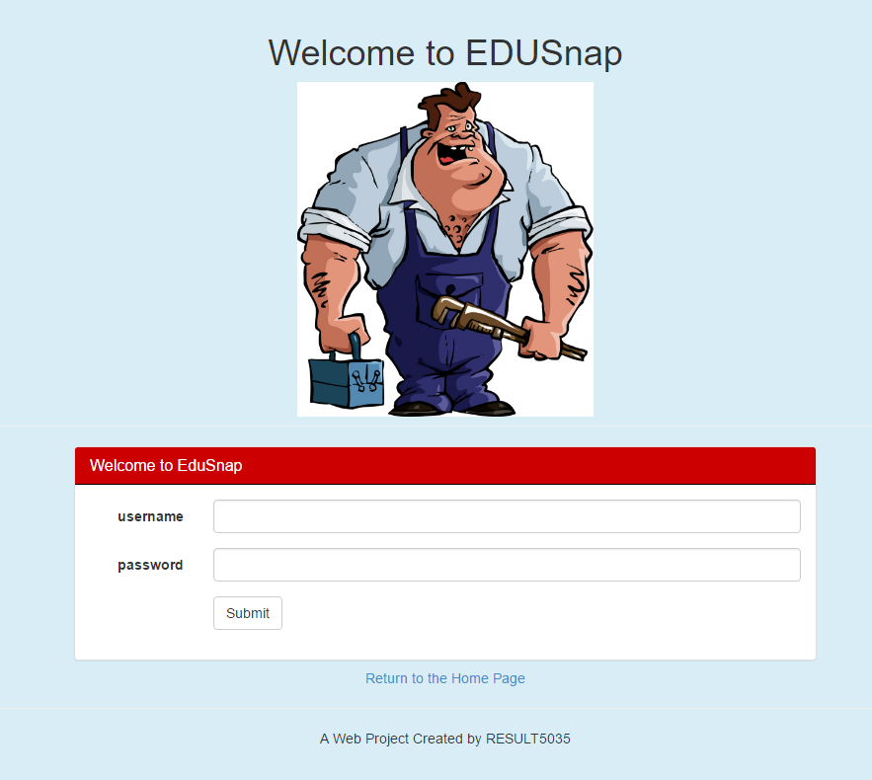
Figure 4- User Login
Illustration 4: User Login
ﾵ
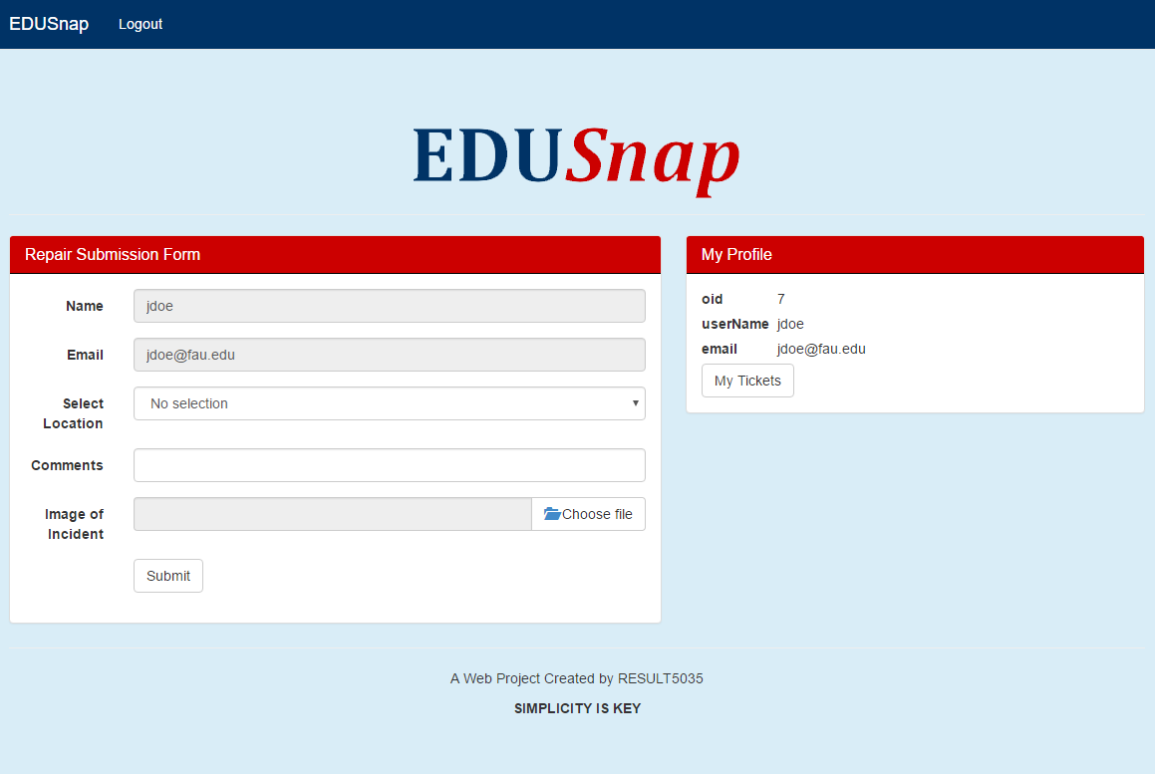
Figure 5- Login: User Vuew
Illustration 5: Login - User View
ﾵ
ﾵ
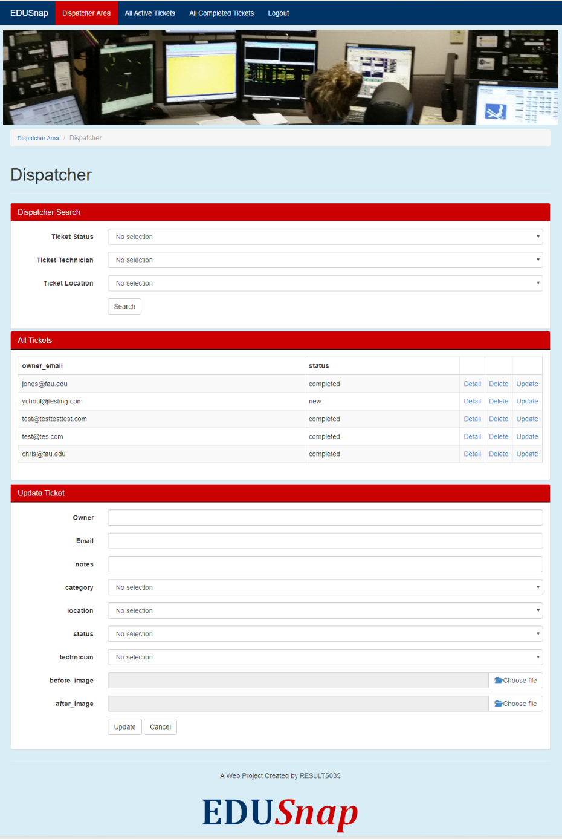
Figure 6- Dispatcher Main Page
Illustration 6: Dispatcher Main Page

Figure 7- Local Technician Page
Illustration 7: Local Technician Page

ﾵ
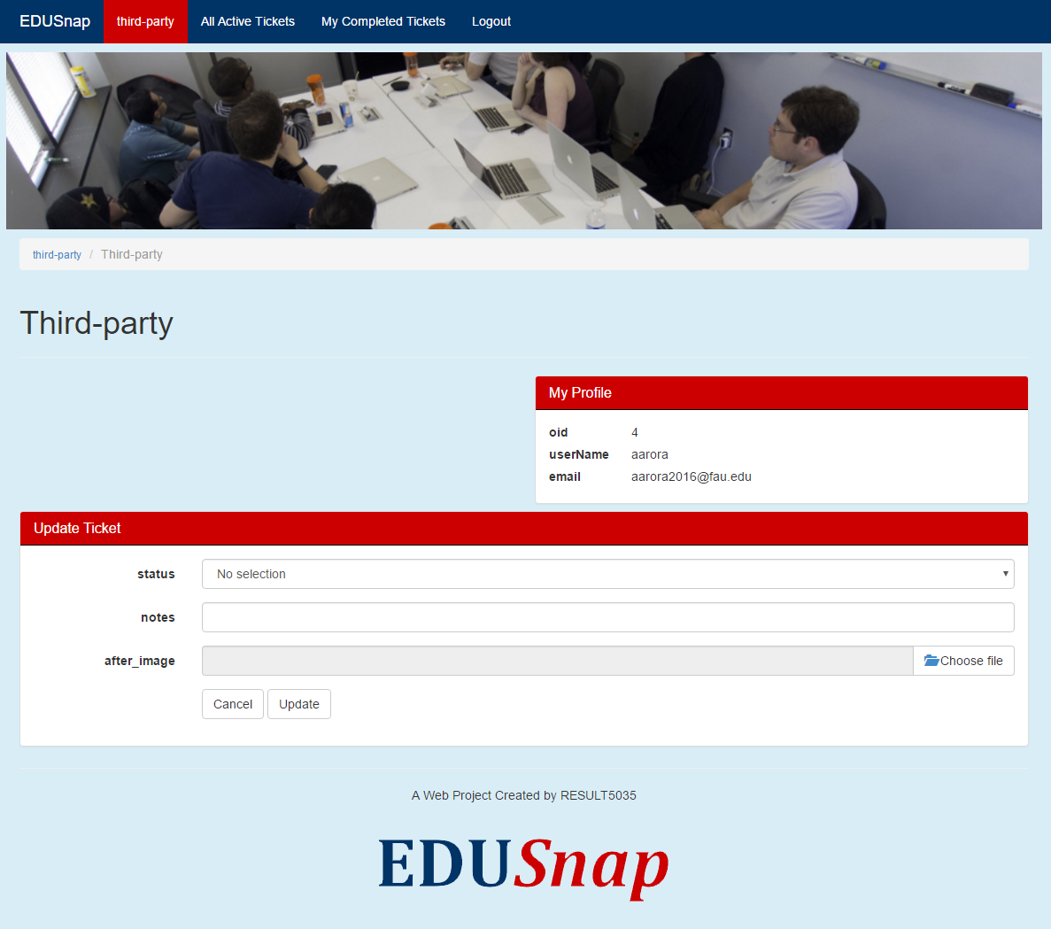
Figure 8: Third Party Vendor Page
Illustration 8: Third Party Vendor Page
ﾵ
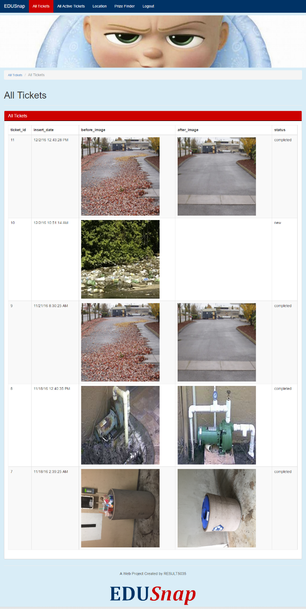
Figure 9- Manager View
Illustration 9: Manager View
ﾵ
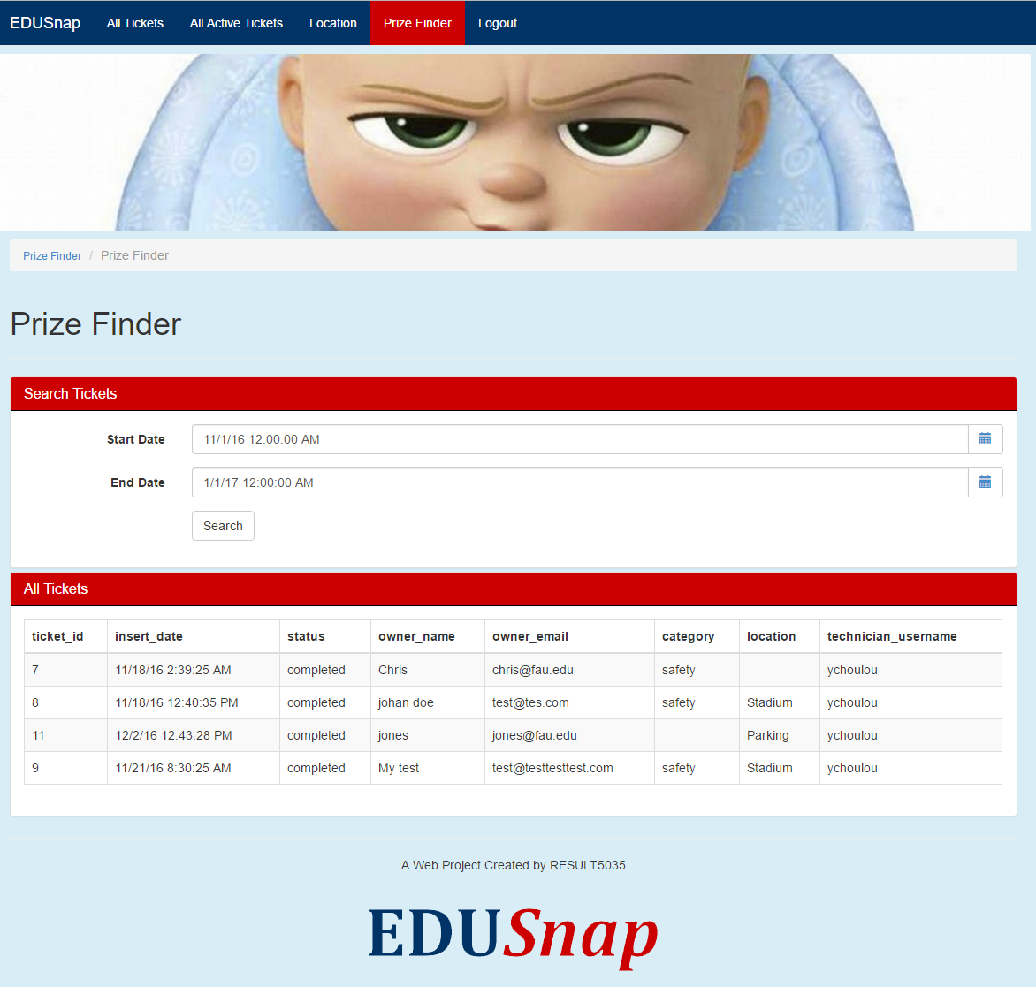
Figure 10- Incentives//Prize page
Illustration 10: Incentive Page
ﾵ
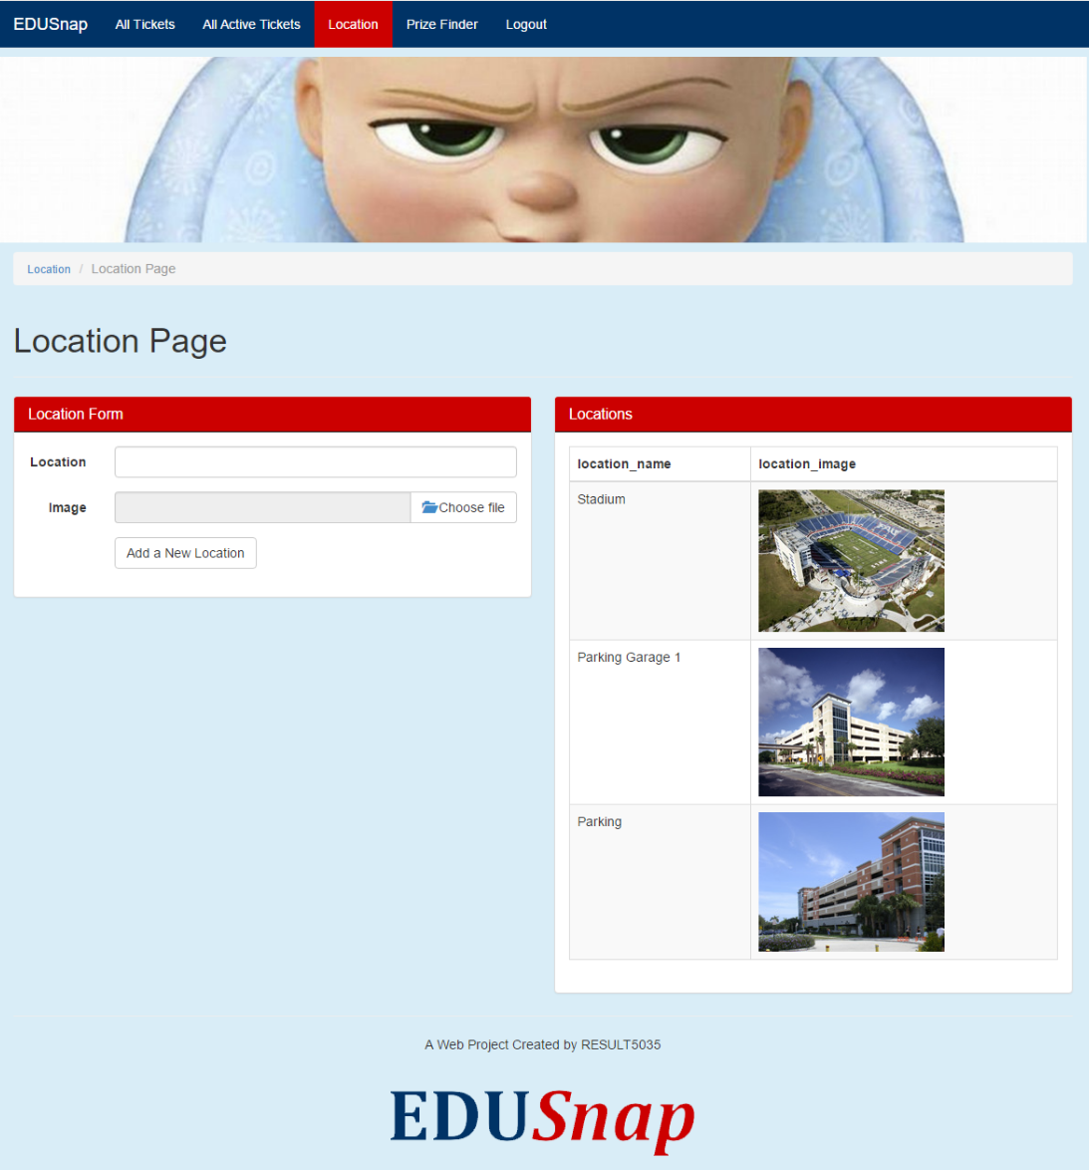
Figure 11- Location Page
Illustration 11: Location Page

BPMN
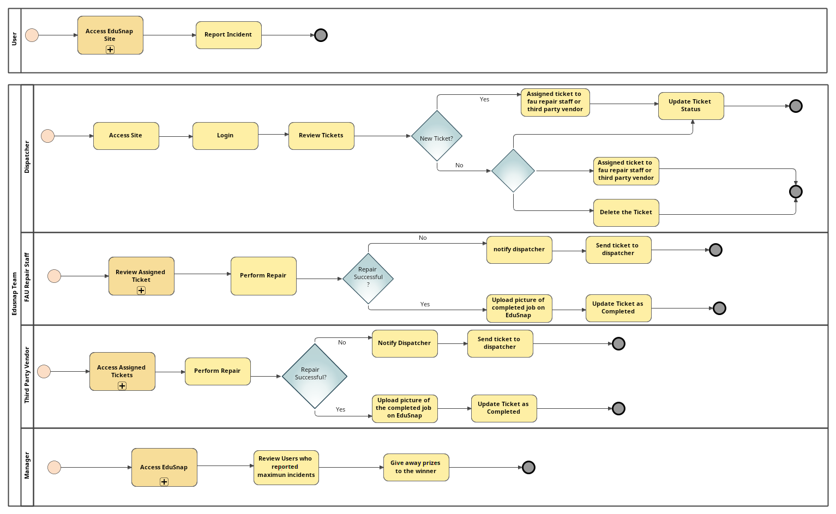

Scrum Project Space
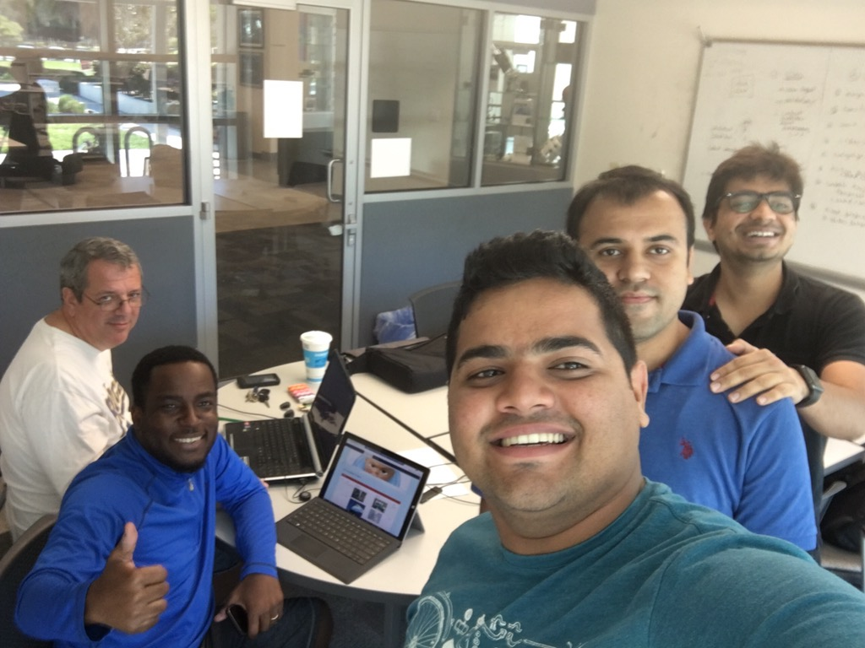
Figure 12: SCRUM Physical Space in the Cube - Engineering East
Illustration 12: Our Scrum physical space was the Cube in Engineering East.

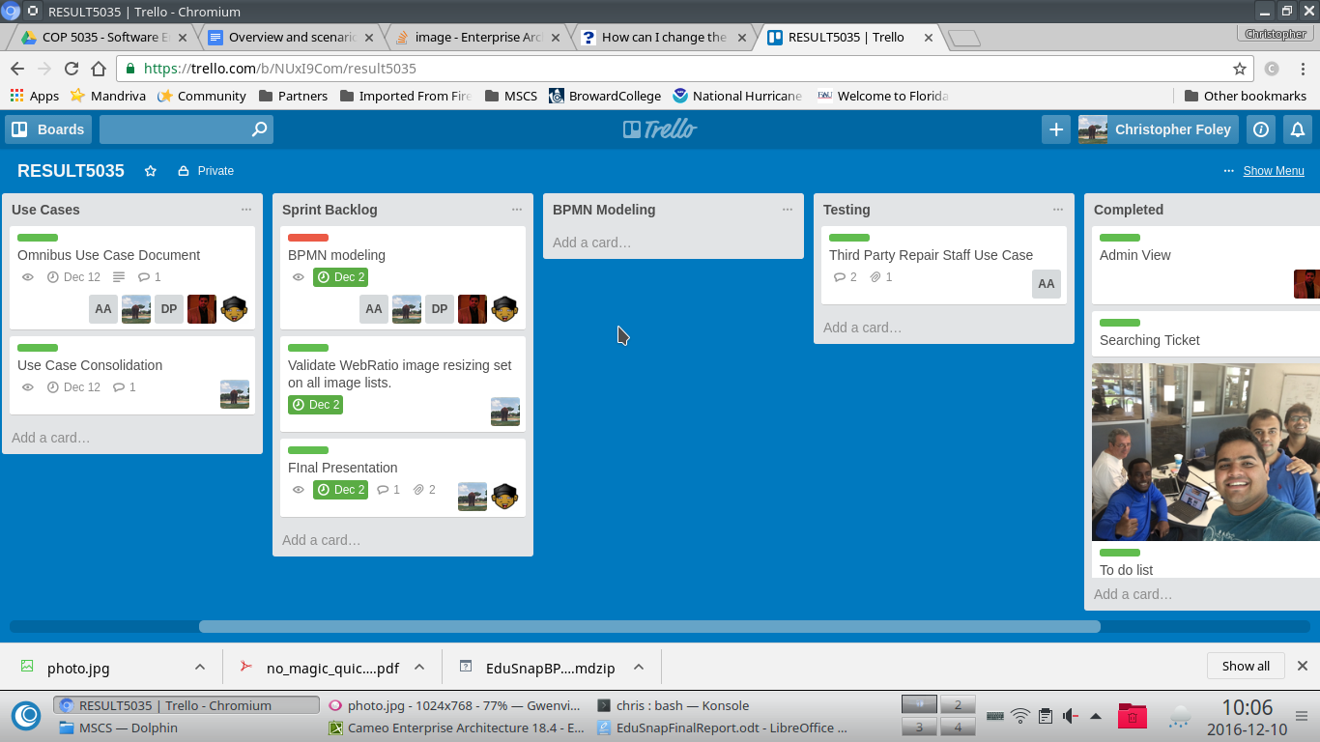
Figure 13: Trello Board
Illustration 13: Our electronic tracking was via Trello.

Existing Backlog (future Features)

- We would like to add GPS functionalities to the system so we can pinpoint the exact location of an issue.
- We would like to package the application and deploy it on its own server.
- We would like to add user management portal, instead of adding users directly to the database
- We would like to promote the application the higher ups.
- We would like to encrypt the sensitive information in the database.

Reflections on Model Driven Development

Model development helps focus the development on users and objects and away from code. By starting our progress with the user flow we were able to develop a user centered application which made development easier. Using models we were able to visually determine flows and exceptions. Integration of new features and quick modifications were made by models. The use of models allowed us to develop products that use features that we may not have been trained to develop.

Knowledge gained, lessons learned
The team gained knowledge of a number of areas including:
- Software modeling
- WebRatio
- MySQL Workbench
- Circuit
- BlackBoard
- Google Drive
- Google Docs
- Cameo Tools
- Scrum (Product owner, scrum master….)

Critical to our added knowledge was the difficulty of adding/changing tools at the beginning of a product cycle. We also developed work arounds for sharing product development in a dispersed environment that permitted all the team to work together from physically different spaces and on hardware running different operating systems.
roductproduct cycle.

