

Florida Atlantic University
CEN5035 RESULT

EDUSnap

Written by:
CEN5035 – RESULT Team
Ashish Arora
Christopher Foley
Divyang Purohit
Venkat Retesh Velapakam
Yom Chouloute

Academic Year: Fall 2016

Table of Contents
Academic Year: Fall 2016 1
1Team Members 1
2Project Peer Evaluation 1
3Purpose 1
4Screen Shots 1
1Screen Shots of Mockup 1
2Screen Shots of Final System 1
5BPMN 1
6Scrum Project Space 1
7Existing Backlog (future Features) 1
8Reflections on Model Driven Development 1
9Knowledge gained, lessons learned 1

EDUSnap Team Members

Ashish Arora – Product Developer
Yom Chouloute – Scrum Master
Christopher Foley – Product Owner
Divyang Purohit – Product Developer
Venkat Retesh Velapakam – Product Developer

Project Peer Evaluation

Ashish Arora – 20/20
Yom Chouloute – 20/20
Christopher Foley – 20/20
Divyang Purohit – 20/20
Venkat Retesh Velapakam – 20/20

Purpose

Overview
Universities and schools are not small places. Take FAU as an example, this university covers approximately 850 acres. To give you a little perspective, the dimension of a football field, including the end zones covers approximately 1.32 acres. Hypothetically speaking, you can fit 644 football fields inside FAU.

Administrators and facilities employees at these large institutions usually do their best to provide students with a clean, hazard free and a safe environment. They have employees assigned to maintain each region on campus, they use video cameras and the help of the police department to survey all areas.
Although Administrators and maintenance staffs do their best, there is always room for improvement, since it is quasi impossible to monitor every corner on campus.

Introducing “EduSnap” a responsive website created by a group of students at FAU that can make it very easy for anyone on campus report issues that require immediate attention.

We are hoping to add to a link to our responsive site in the University mobile App. Doing so will make it very easy for everyone to access the application.

Product Goals
- Easy to use (Ability to create a ticket in less than 30 seconds)
- Ad Hoc Ticket Submission for faster ticket creation
- User Registration if our users want to track their own tickets
- Different view for each user type
- Email Functionality
- Point system and prize for the person who reports the most completed tickets.

Targeted Users
The following users are targeted as users of the intentional system:
Name | Brief Description
Dispatcher | Responsible for prioritizing and dispatching field technicians to repair observed anomalies.
Technician | Individual who completes the repair
Third Party Vendor Staff | The Third Party Vendor Staff is a third party agent outside FAU Campus which accepts requests from FAU Dispatcher staff if repair is not being provided by FAU repair staff and confirms the request after visiting the site which needs the service. Once the repair is completed Third Party Vendor uploads the picture of task completion on Edu Snap application and notifies the dispatcher.
Manager | Check reports for work done and give away awards to users who have actively reported messages.
Student | Responsible for reporting incidents like repair and damages on campus
Staff | Responsible for reporting incidents like repair and damages on campus
Visitor | Responsible for reporting incidents like repair and damages on campus
FAU Repair Staff | This staff is responsible to fix the issue reported by the users of the EduSnap application

Screen Shots

Screen Shots of Mockup
Due to the time constraints of learning a new tool, see Lessons Learned page 18, it was decided to rely on traditional methods of interface design which allowed for more rapid implementation as evidenced by the following:
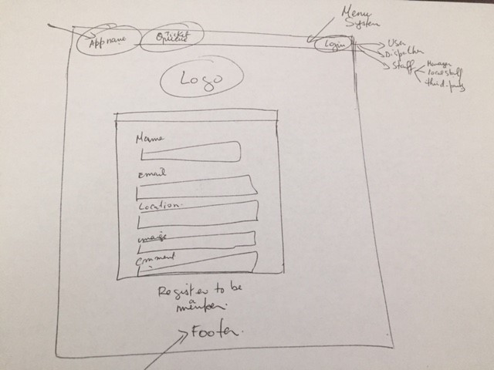

Screen Shots of Final System
The following screen shots were taken for the final presentation:
Here are a few snapshot taken from the system, just in case the WebRatio server is out of service:

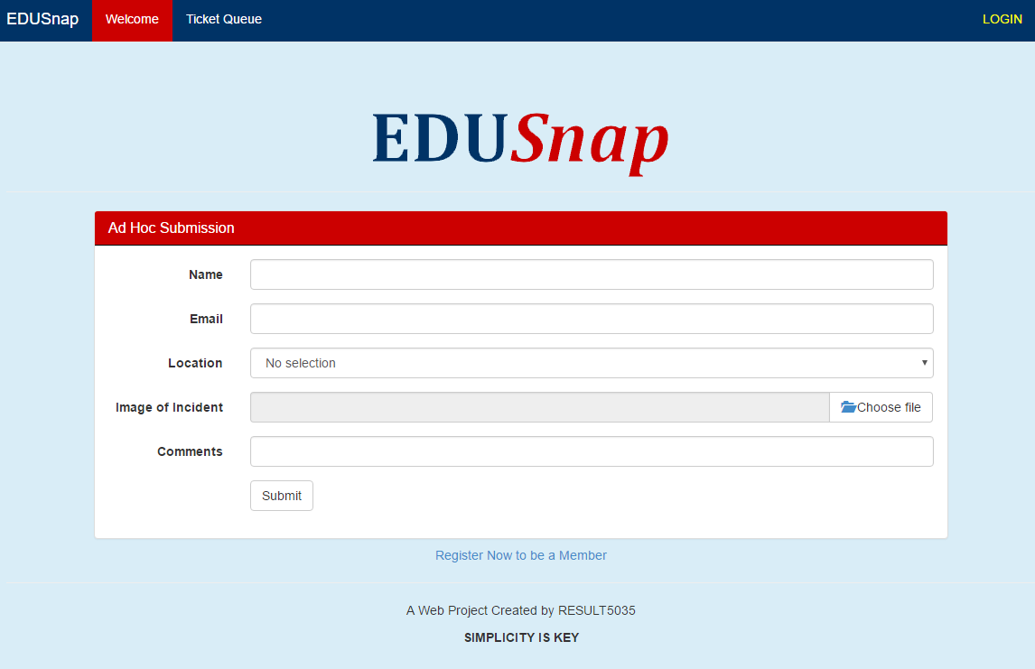
Illustration 1: Request Form

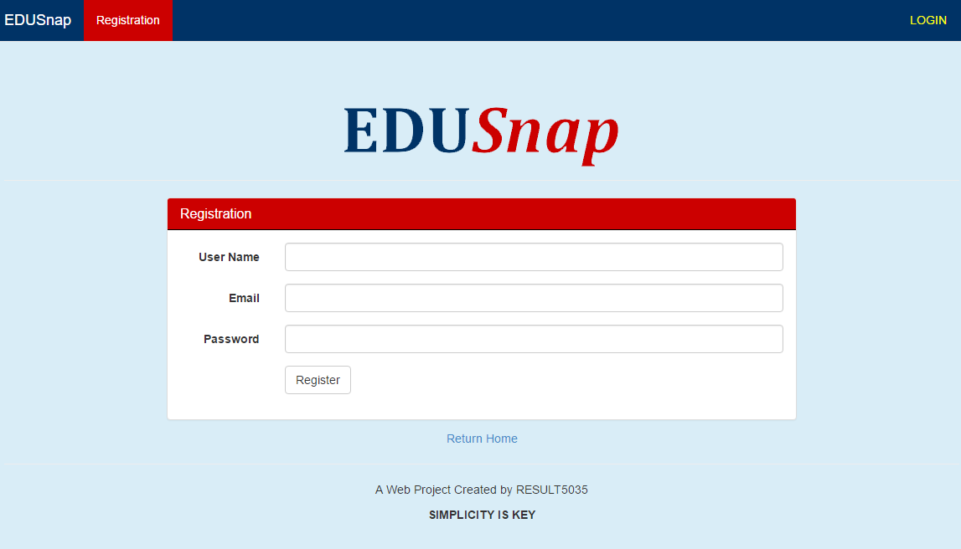
Illustration 2: User Registration
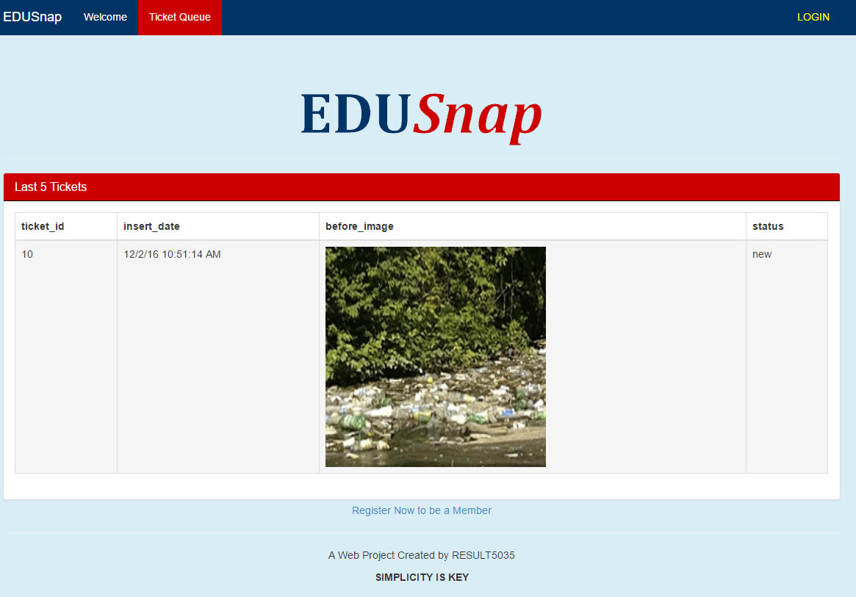
Illustration 3: Ticket Queue
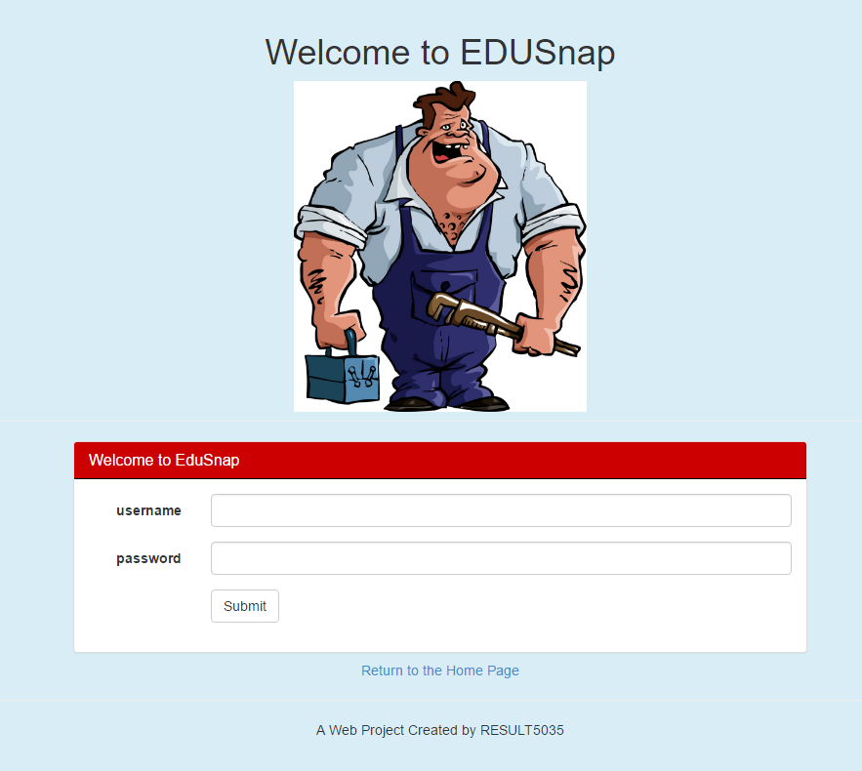
Illustration 4: User Login
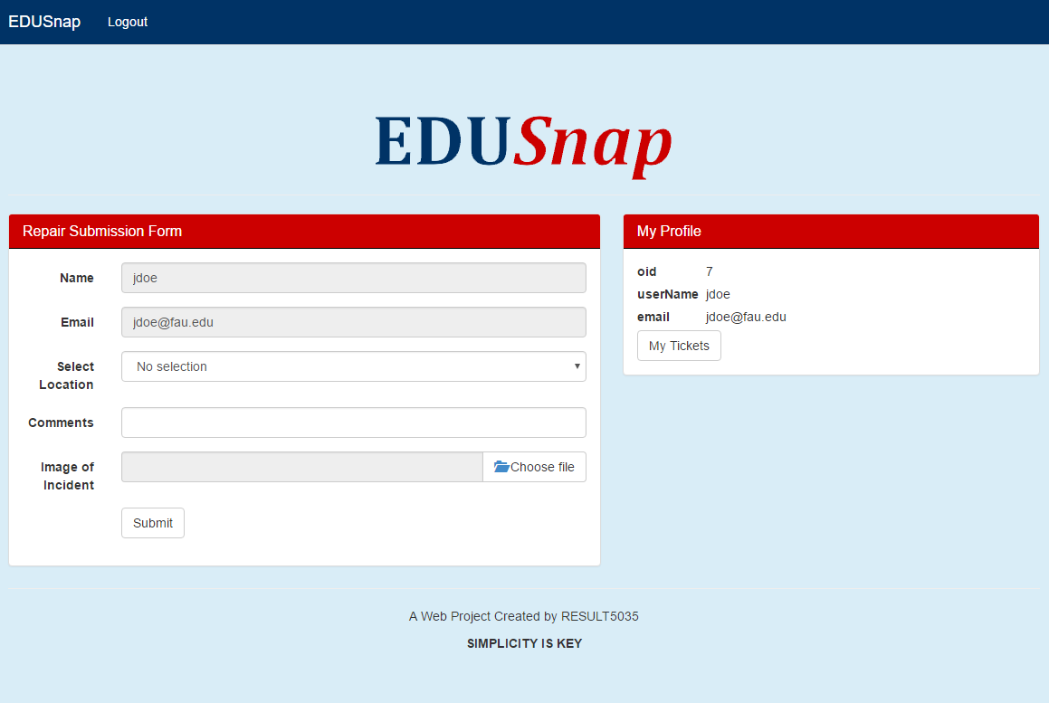
Illustration 5: Login - User View
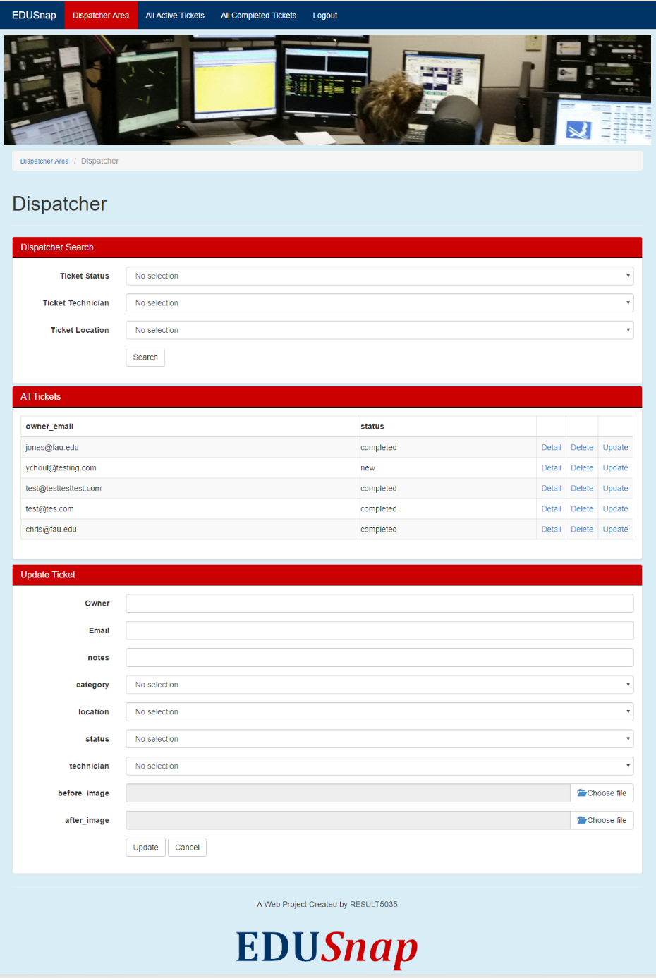
Illustration 6: Dispatcher Main Page

Illustration 7: Local Technician Page

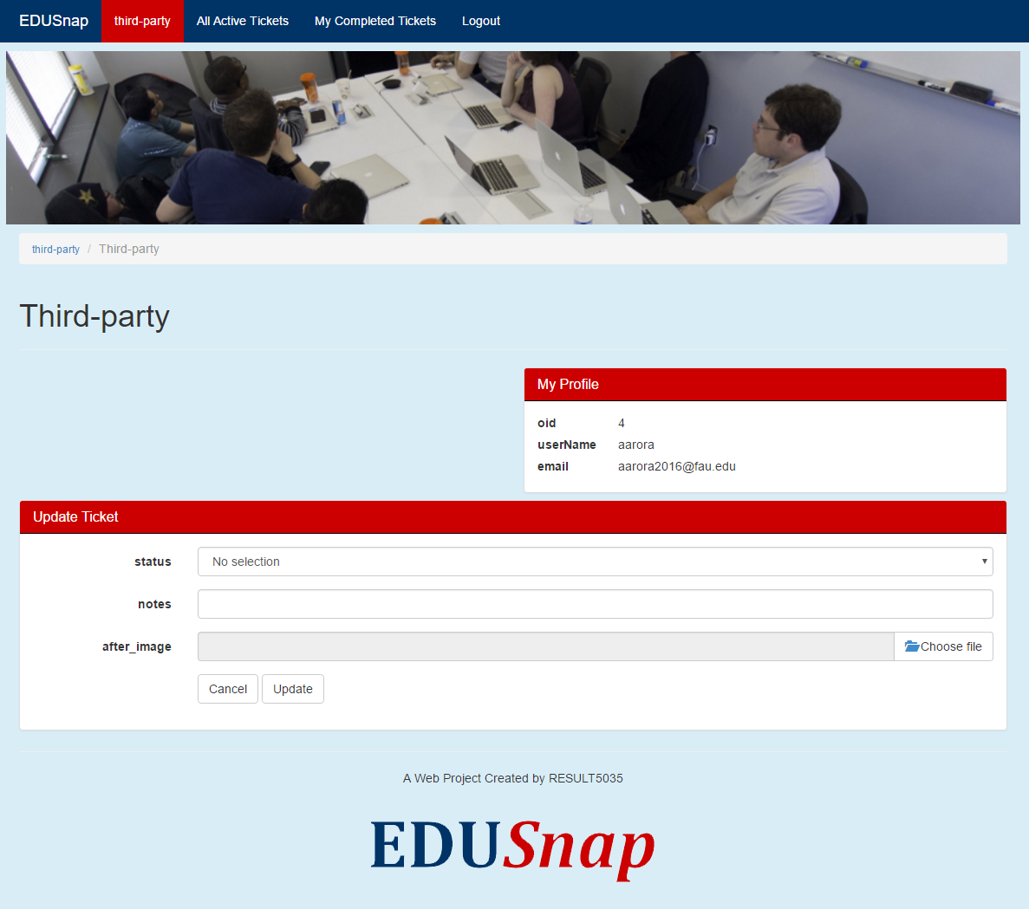
Illustration 8: Third Party Vendor Page
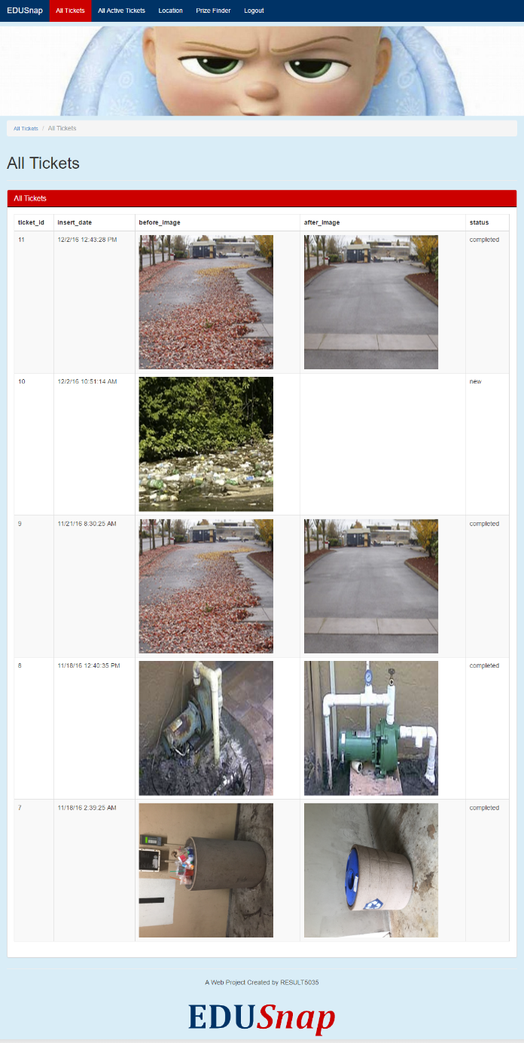
Illustration 9: Manager View
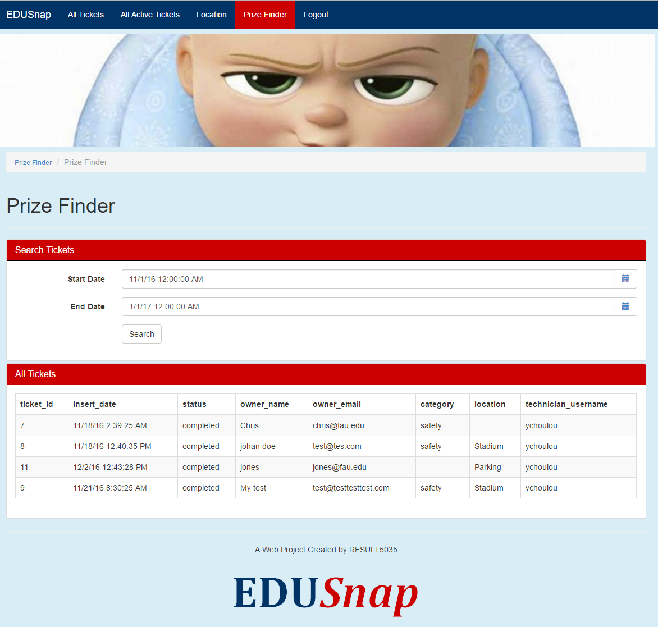
Illustration 10: Incentive Page

Illustration 11: Location Page

BPMN
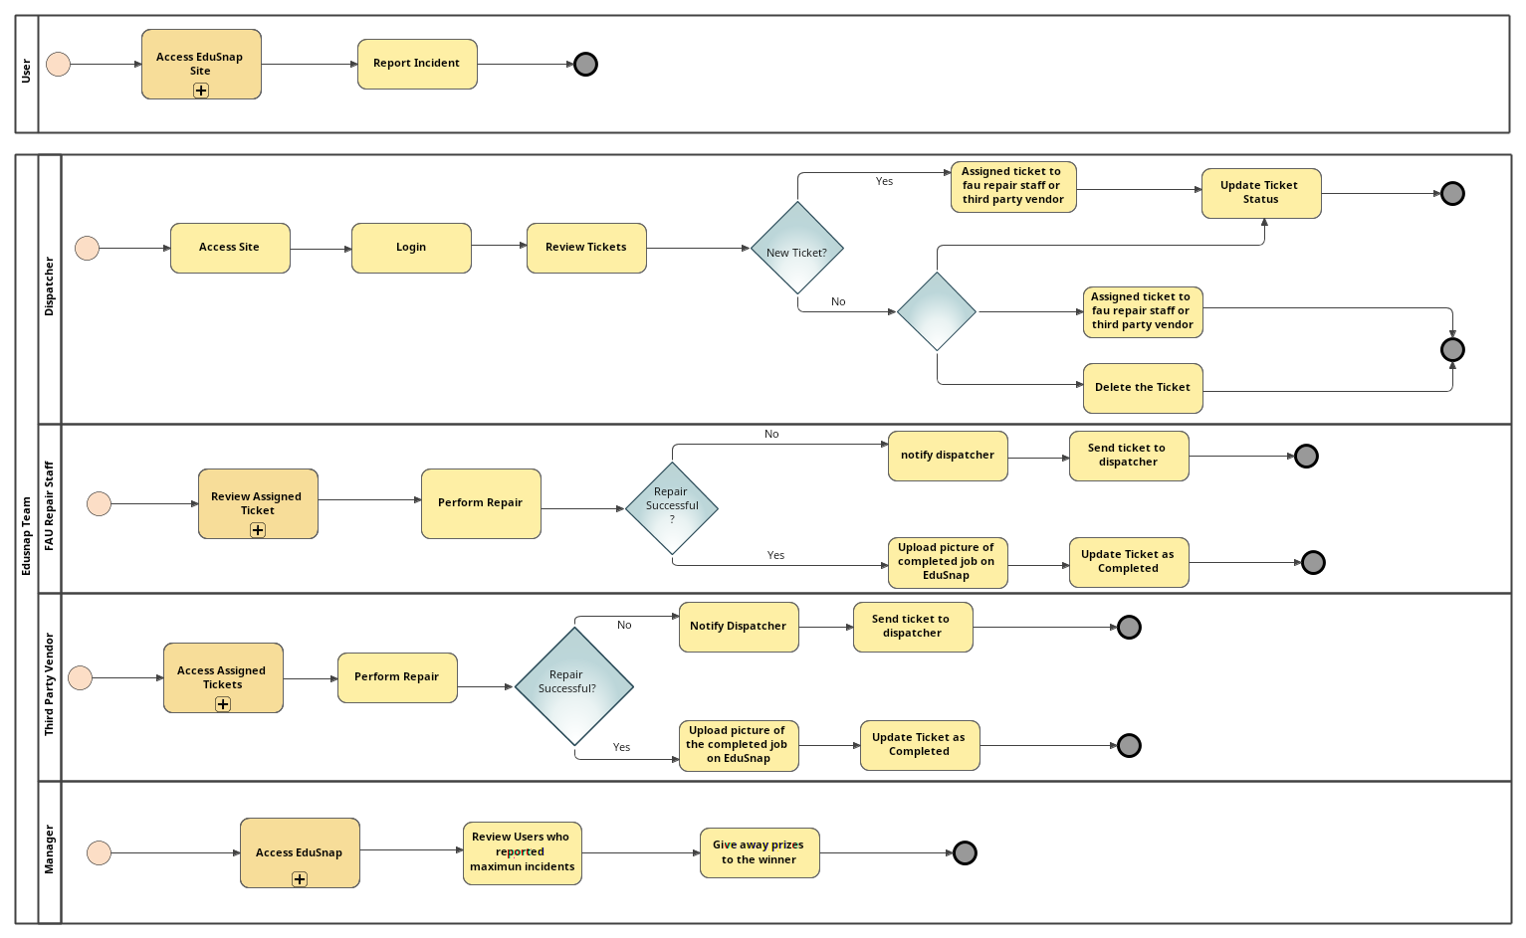

Scrum Project Space

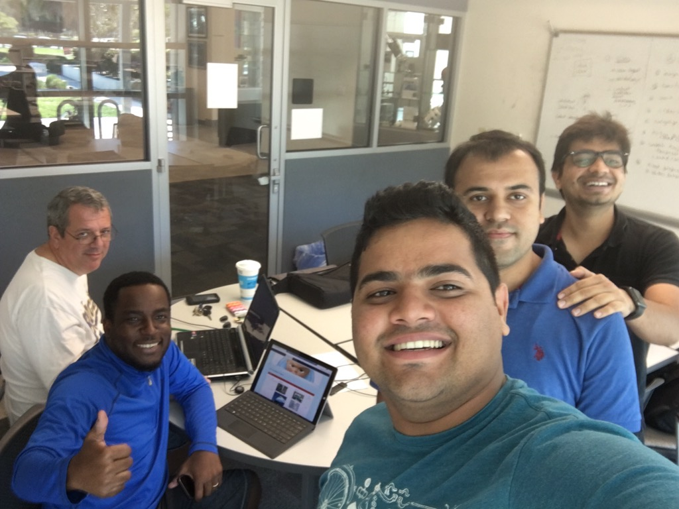
Illustration 12: Our Scrum physical space was the Cube in Engineering East.

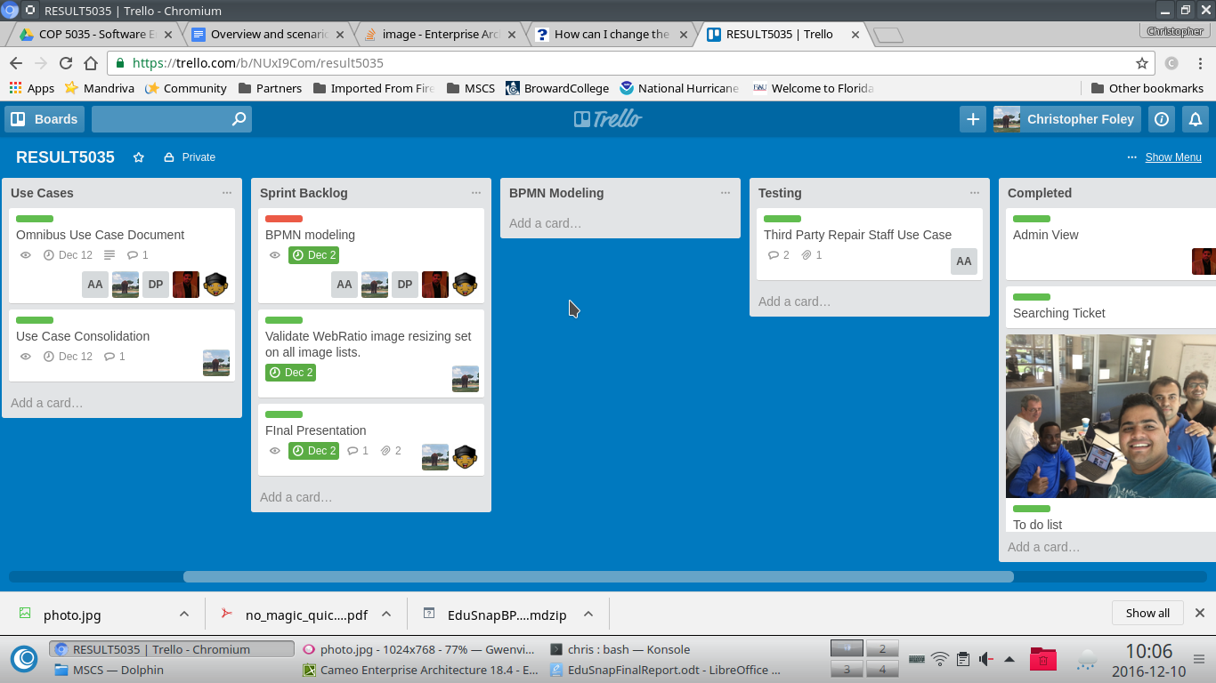
Illustration 13: Our electronic tracking was via Trello.

Existing Backlog (future Features)

- We would like to add GPS functionalities to the system so we can pinpoint the exact location of an issue.
- We would like to package the application and deploy it on its own server.
- We would like to add user management portal, instead of adding users directly to the database
- We would like to promote the application the higher ups.
- We would like to encrypt the sensitive information in the database.

Reflections on Model Driven Development

Model development helps focus the development on users and objects and away from code. By starting our progress with the user flow we were able to develop a user centered application which made development easier. Using models we were able to visually determine flows and exceptions. Integration of new features and quick modifications were made by models. The use of models allowed us to develop products that use features that we may not have been trained to develop.

Knowledge gained, lessons learned
The team gained knowledge of a number of areas including:
- Software modeling
- Webratio
- Cameo Tools
- Scrum (Product owner, scrum master….)

Critical to our added knowledge was the difficulty of adding/changing tools at the beginning of a product cycle.

