COP5339 - OOP

COP5339 - Object Oriented Programming

Written by:
Christopher Foley
Z15092976

Academic Year: 2016-2017

Table of Contents
Academic Year: 2016-2017 1
1. Assignment 3
2. Problems/Explanations 4
2.1. Problems 8
3. Source Generated 10
3.1. Container.java 10
3.2. CraneView.java 11
3.3. Port.java 12
3.4. ShipStay.java 13
3.5. CraneController.java 14
3.6. Location.java 15
3.7. Section.java 16
3.8. Subsection.java 16
3.9. Crane.java 17
3.10. Operator.java 18
3.11. Ship.java 19
3.12. Warehouse.java 20

Assignment

- Continue with the class model of Assignment 2 (without the patterns).
- We need to add security constraints such that crane operators must be authenticated and can only operate the cranes for which they are authorized. Write the constraints in OCL and show in the UML model how to enforce these constraints using views.
- Add safety constraints in OCL such that cranes cannot carry containers that weigh more than their limits and cannot accelerate beyond their limits.
- Write a Java or C++ program to load a container in a ship. Use the attached sequence diagram as a guide.
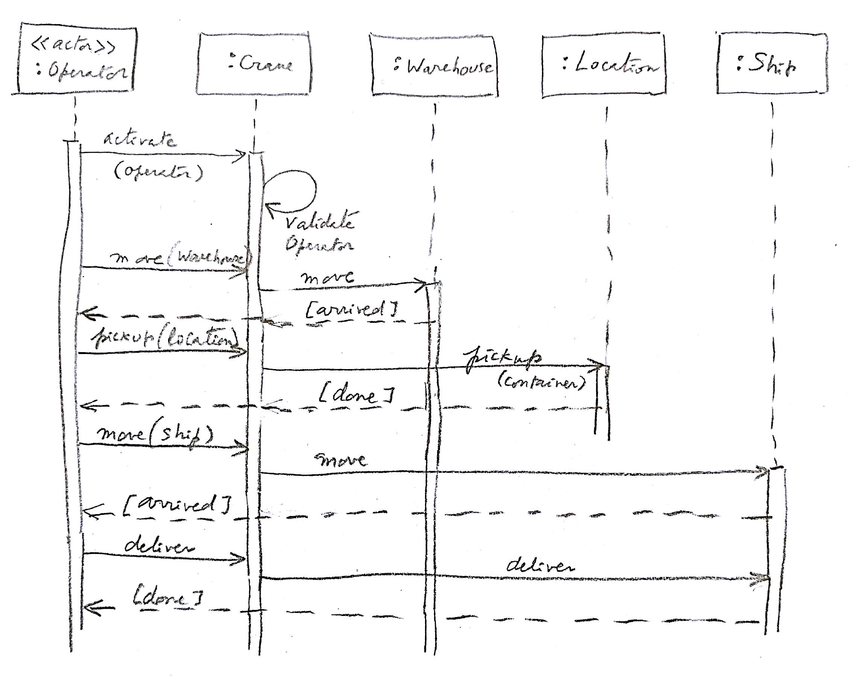

Problems/Explanations

Development was done with ARGO UML. The following Class and Sequence diagrams were created with ARGO.
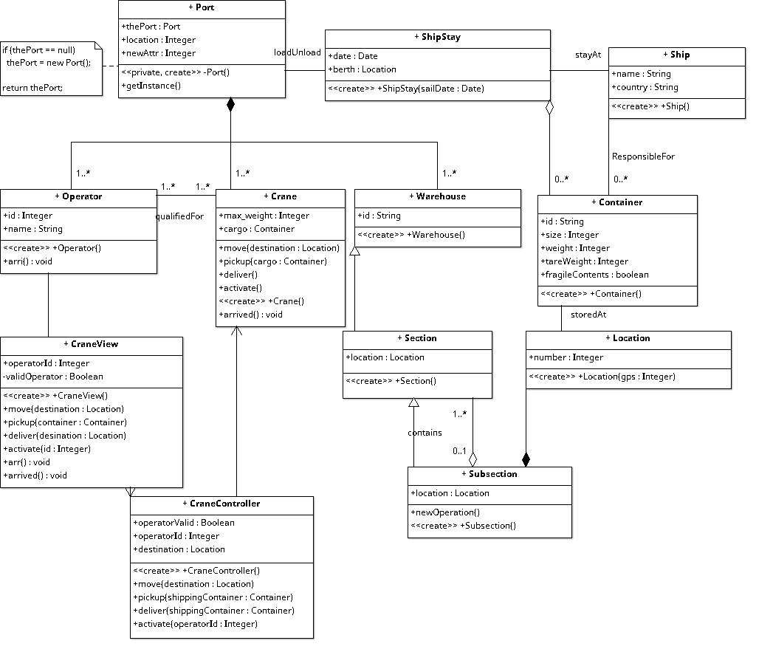
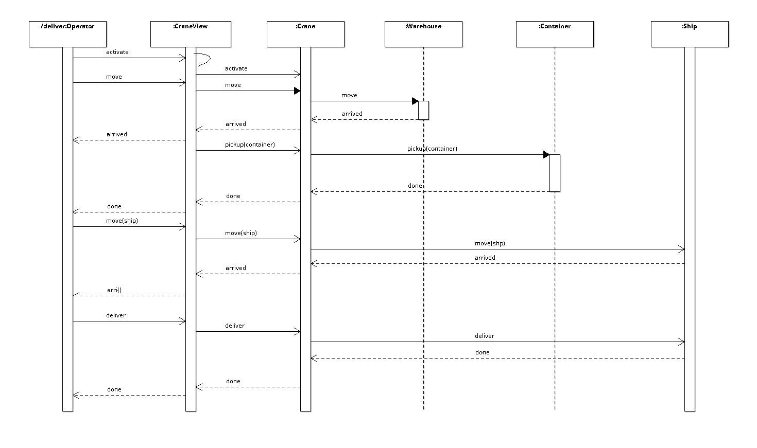
Input of OCL was via an OCL Editor
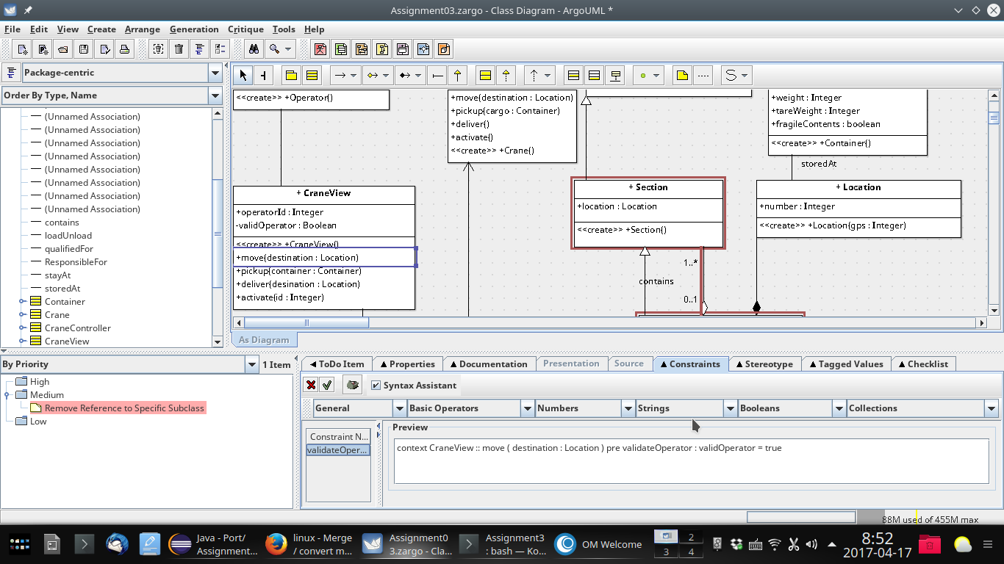
Of note is that the syntax follows OCL conventions:
context CraneView :: move ( destination : Location ) pre validateOperator : validOperator = true
This is then implemented in the code as (blank lines deleted and highlight added for emphasis):
import java.util.Vector;
public class CraneView {
public Integer operatorId;
private Boolean validOperator;
public Vector myOperator;
public Vector myCraneController;
public CraneView() {
}
/**
*
* @precondition validateOperator: validOperator = true
*/
public void move(Location destination) {
}
public void pickup(Container container) {
}

Problems

During development, during the final check on April 16, a NULL Pointer exception was encountered which corrupted the profile for the project and its automatic backup, with no graphic notice to the user. The error appeared on the Console but Argo gracefully recovered with no appreciable problem until the saved files were reopened. This was evidenced by the following:
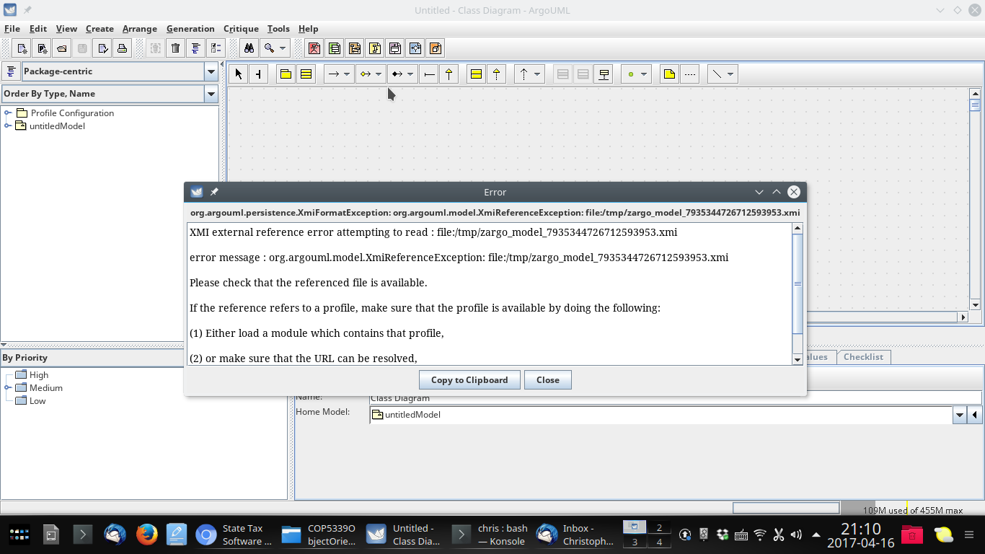
Prior to the first faiilure constraints had been created in classes as evidenced by the following grep output (after the error the previously generated source was copied to a saved location):
[chris@euclid Assignment3Save]$ ls
Container.java CraneView.java Operator.java Ship.java Warehouse.java
CraneController.java gzipOfAssignment3 Port.java ShipStay.java
Crane.java Location.java Section.java Subsection.java
[chris@euclid Assignment3Save]$ grep pre *.java
CraneView.java: * @precondition validOperator: validOperator = true
CraneView.java: * @precondition validOperator: validOperator = true
CraneView.java: * @precondition weightLimit: crane . max_weight >= container . weight
CraneView.java: * @precondition cargoPresent: crane . cargoForTransport <> 0
CraneView.java: * @precondition validOperator: validOperator = true

It can be seen that the only missing was the speed scaling when a fragile container was loaded. The operator validation was at the CraneView module and the speed was to be added at the CraneController. The CargoPresent and weightLimit were to be added to both CraneView and CraneController.

I have not decompiled or run the resulting code to determine the java compiler’s implementation of the @precondition directive.

Source Generated
The following files were generated, no blank lines removed.

Container.java
import java.util.Vector;

public class Container {

public String id;

public Integer size;

public Integer weight;

public Integer tareWeight;

public boolean fragileContents;

public Ship ResponsibleFor;
public Vector myShipStay;
public Location storedAt;

public Container() {
}

}

CraneView.java
import java.util.Vector;

public class CraneView {

public Integer operatorId;

private Boolean validOperator;

public Vector myOperator;
public Vector myCraneController;

public CraneView() {
}

/**
*
* @precondition validateOperator: validOperator = true
*/
public void move(Location destination) {
}

public void pickup(Container container) {
}

public void deliver(Location desination) {
}

public void activate(Integer id) {
}

public void arrived() {
}

}

Port.java
import java.util.Vector;

/*
* getInstance()
*/
public class Port {

public Port thePort;

public Integer location;

public Integer newAttr;

public Vector loadUnload;
/**
*
* @element-type Operator
*/
public Vector myOperator;
/**
*
* @element-type Crane
*/
public Vector myCrane;
/**
*
* @element-type Warehouse
*/
public Vector myWarehouse;

private Port() {
}

public void getInstance() {
}

}

ShipStay.java
import java.util.Vector;
import java.util.Date;

public class ShipStay {

public Date date;

public Location berth;

public Vector loadUnload;
public Vector stayAt;
/**
*
* @element-type Container
*/
public Vector myContainer;

public ShipStay(Date sailDate) {
}

}

CraneController.java
import java.util.Vector;

public class CraneController {

public Boolean operatorValid;

public Integer operatorId;

public Location destination;

public Vector myCrane;

public CraneController() {
}

public void move(Location destination) {
}

public void pickup(Container shippingContainer) {
}

public void deliver(Container shippingContainer) {
}

public void activate(Integer operatorId) {
}

}

Location.java
import java.util.Vector;

public class Location extends Warehouse {

public Integer number;

public Container storedAt;
public Vector mySubsection;

public Location(Integer gps) {
}

}

Section.java
public class Section extends Warehouse {

public Location location;

public Subsection contains;

public Section() {
}

}

Subsection.java
import java.util.Vector;

public class Subsection extends Section {

public Location location;

public Location myLocation;
/**
*
* @element-type Section
*/
public Vector contains;

public void newOperation() {
}

public Subsection() {
}

}

Crane.java
import java.util.Vector;

public class Crane {

public Integer max_weight;

public Container cargo;

/**
*
* @element-type Operator
*/
public Vector qualifiedFor;
public Vector myPort;

public void move(Location destination) {
}

public void pickup(Container cargo) {
}

public void deliver() {
}

public void activate() {
}

public Crane() {
}

public void arrived() {
}

}

Operator.java
import java.util.Vector;

public class Operator {

public Integer id;

public String name;

/**
*
* @element-type Crane
*/
public Vector qualifiedFor;
public Vector myPort;
public Vector myCraneView;

public Operator() {
}

public void arri() {
}

}

Ship.java
import java.util.Vector;

public class Ship {

public String name;

public String country;

public Vector stayAt;
/**
*
* @element-type Container
*/
public Vector ResponsibleFor;

public Ship() {
}

}

Warehouse.java

import java.util.Vector;

public class Warehouse {

public String id;

public Vector myPort;

public Warehouse() {
}

}

