Assignment 2 – Cloud Computing

Question 1: (based on Dodani’s paper): Slide 124 of this chapter shows the IBM Tivoli reference architecture (RA). Relate each unit in that diagram and slide 121 to the units in the RAs for Iaas and PaaS seen earlier. Draw a UML model to show this mapping and justify your mapping.

Using the following Reference Architecture:

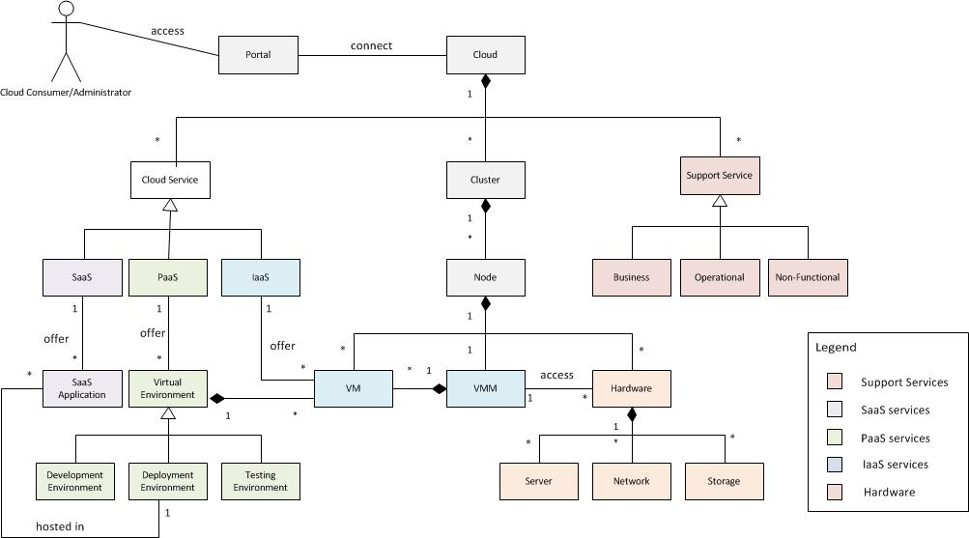
I would map as follows:

All of “Figure 5: The Managed Environment” is specific hardware and therefore is mapped to the hardware environment.

“Figure 6: Geographical Cloud Environment” describes virtual machines, Virtual Service Management, Usage Reporting tools, and user access. They are mapped to user access at the Portal level, VMM, and The virtual environment. The Usage Reporting tools are mapped to the Support Services.

The Geographical Cloud is repeated in “Figure 7:Central Monitoring and Management Implementation” which also shows the management functions and Tivoli test cloud support functions.

Removing used portions from the RA above, I propose the following mapping:

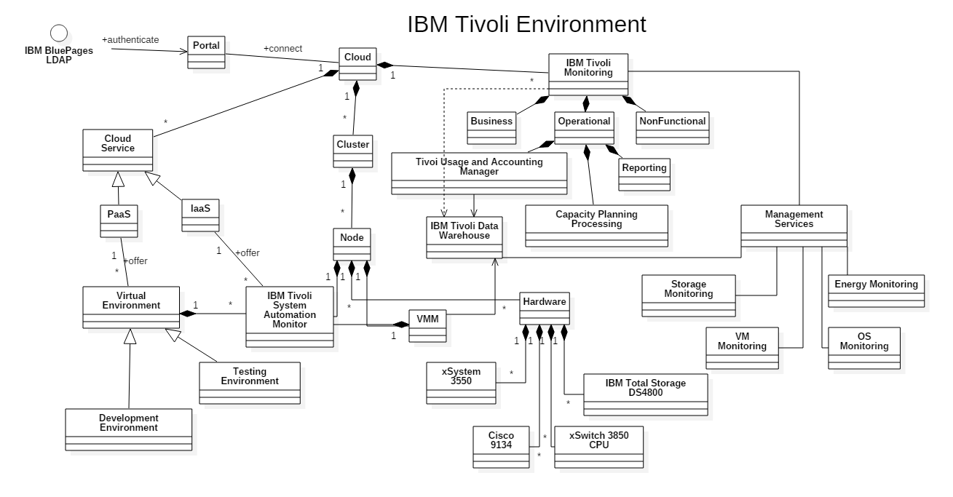

Question 2: Compare two foreign clouds with Amazon’s EC2. Put in a table corresponding features side by side with some explanation, e.g. Cloud A : Several databases: relational, noSQL,… Cloud B: only relational. EC2: Relational,…..

Selecting cloud offerings to compare to Amazon EC2 is a difficult process. A cursory list of foreign Cloud providers involved such companies as Rackspace, Ericsson/Intel’s Hyperscale Datacenter System 8000, Siemens’ Mindsphere, Alibaba’s Cloud Solution, Telstra (Australia) and Croc’s (Russia) Cloud Solution. Russian companies offering cloud services appear to be focused on the creation of Private clouds, possibly reflecting concern for the stability of the area. To determine if a Cloud provider is truly foreign either the location of their main corporate office or contract jurisdiction was used (when available).

Many cloud providers have come and gone. NineCloud’s web site now refers visitors to their parent company Macquarie Telecom LAUNCH product page, where after some indirection we learn that they have hybrid and private cloud solutions, but require contact information to get data.
After much thought and discussion with classmates, who suggested I stick with Ericsson and The final two foreign networks were Alibaba’s (China) Cloud Solution and Cloud Central (Australia). In the table below, blank spaces indicate that no data was publicly available for comparison.

 | Amazon EC2 | Alibaba Cloud | Cloud Central
Location | United States | China | Australia
Maximum VM | 12
Maximum Memory per VM  Storage | 244GB | 128GB (16 cpu core) | 68GB (linux), `128GB (Windows)
Elastic Storage | Yes | Yes | Yes
Databases (SQL) | MySQL, Oracle, MariaDB, PostgreSQL | MySQL, PostgreSQL, SQL Server | MySQL
Databases (noSQL) | DynamoDB | ApsaraDB | MongoDB
Operating Systems | Linux, Windows | Linux, Windows | Linux*, Windows, Others**
Data Center Locations | Worldwide | China, Singapore, US, Dubai***, India*** | Sydney, Melbourne, Canberra
Data locations | User specified | User specified | Australia
Connection | Direct Connect, Configurable DNS | Direct Connect, Configurable DNS | Direct Connect, Confgurable DNS

Table Notes:
* - various Linux offerings available (Centos 6, Debian 7, Oracle, Ubuntu, VyOS)
** - user defined OS permitted, if compatible
*** - announced but locations not specified.

Conclusions: When researching all providers compared their offerings to AWS but stated they had a lower cost. It was not possible to review many due to language or financial limitations. Alibaba the “Amazon” equivalent in China has announced plans to expand. Many companies are consolidating or offering hybrid cloud services.

There are numerous legal concerns. A review in InfoWorld reports that the agreement for some non-US based Cloud Providers stated that some Microsoft data may be stored in servers on the US Mainland. It was observed by someone analyzing data paths locally that when transferring data from SE Asia to Australia it was not uncommon for the data to be routed through servers in California.

Aibaba Cloud is making a major effort to expand worldwide and compete directly with AWS. Many other non-US cloud offerings are hoping to compete but have not expressed their objective of directly competing with Amazon.

References:

Eduardo Fernandez, “Cloud Computing”, Lecture Notes, Florida Atlantic University, Fall 2016.

Mahesh Dodani: “On “Cloud Nine” through Architecture”, Journal of Object Technology, Vol 9, no. 3, May-June 2010

InfoWorld.com, Deep Dive Series, “The Public Cloud Meaguide”, downloaded October 2016.

“Elastic Compute Services”, International Edition, Alibaba Cloud, downloaded 10-11-16.

Alibaba Cloud Procuct Introduction Documents:
Elastic Compute Services (ECS) – Product Introduction, last modified 10-24-16
ApsaraDB for RDS – Product Introduction, last modified 10-12-16
ApsaraDB for Memcache – Product Introduction, last modified 8-23-16

Zdnet.com – Australian Clouds Compared, November 17, 2011, http://www.zdnet.com/article/australian-clouds-compared/ , accessed throughout October, 2016, last accessed 10-29-16

Multiple Product Information Bulletins – Cloud Central (https://www.cloudcentral.com.au/) and Cumulogic.com (http://www.cumulogic.com/wp-content/uploads/2013/05/CloudCentral-CumuLogic-datasheet.pdf)

