Security Defenses of IaaS Providers

When reviewing security defenses of IaaS providers it is helpful to recall a the basic attributes of a cloud:
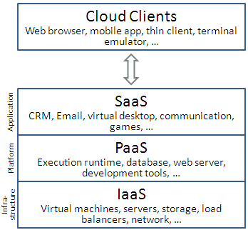
Illustration 1: Cloud Computing Layers
- Multitenancy (Shared Resources)Elasticity
- Pay for use.
- Scalability
- Self provisioning of resources

These attributes lead to an abstract definition of a cloud which provides a wide variety of ways for a cloud provider to implement services. In this paper I intend to look at cloud security in the IaaS layer. According to Wikipedia the IaaS layer “refers to online services that abstract the user from the details of infrastructure like physical computing resources, location, data partitioning, scaling, security, backup etc.” Typically in the IaaS layer services are provided by a virtual machine, hypervisor, which allows access by the platform to the physical layer. It is possible for multiple hypervsiors to run in the same physical space sharing access to multiple resources.
Referring to a class diagram and pattern found in “A Security Reference Architecture for Cloud Systems”, it can be seen that the areas that can be exploited include the user, hardware and virtual machine.
Before comparing in a table the attributes of each provider will be discussed. It should be noted that not all providers give the same degree or quantity of information. For example, one worldwide provider is not discussed because all their product information states is that they are secure. One who is discussed, emphasizes physical security and background checks of their employees and states that they use encryption but provides little other valuable data.

Amazon – EC2
Amazon’s Elastic Compute Services (EC2) provides security at multiple layers which build on previous layers. Control of the physical layer and resources is not by the guest OS but the Hypervisor which runs in a privileged state. The Guest OS and other features run at priority levels which do not override the Hypervisor. Access to physical media is virtual and all memory used is initialized to zero after the virtual interfaces and customer have used it but before it is reallocated by the hypervisor.

Access is via a firewall which is initially configured to deny all access, command access to start and stop instances of the EC2 OS are via signed, logged API’s which will deny access if proper credentials are not provided. AES-256 encryption is provided and encouraged. Users may also clear their memory and resources via specific methods.
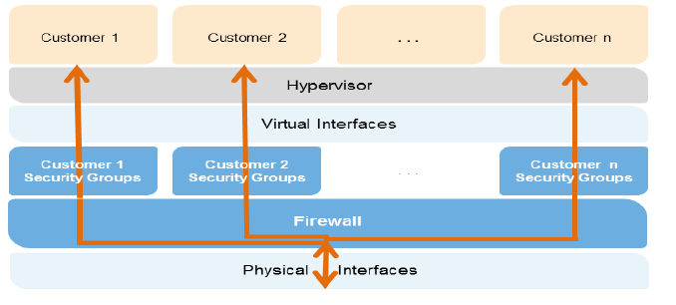
Illustration 2: Amazon EC2 Multipe Layers of Security
Amazon does note that the user must also provide some level of security and take precautions.

IBM Bluemix -
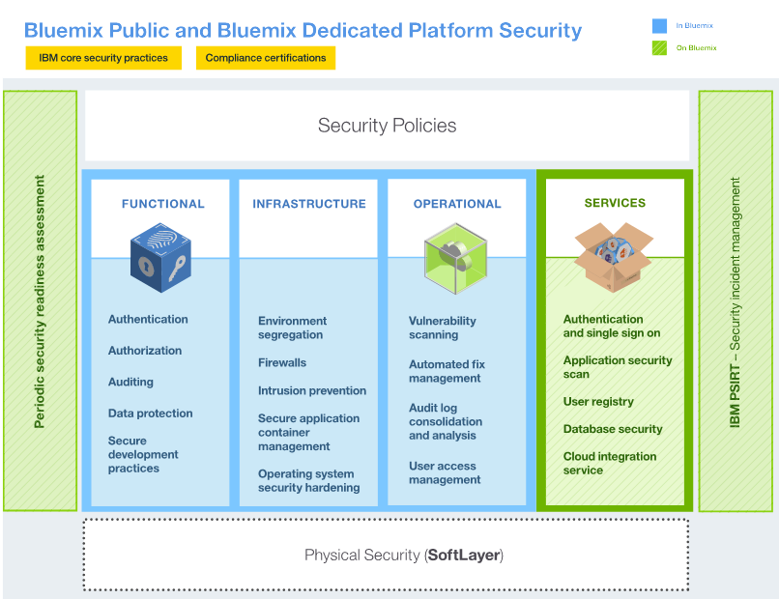
Illustration 3: Bluemix Hardward Security diagram
https://console.ng.bluemix.net/docs/api/content/security/images/sec_deployment.svgThe IBM Bluemix Cloud is a new entrant to the world of Cloud provicers and as such is focused on providing tools to encourage cloud developers to use their systems. The bulk of their security seems to be based on HSM product which creates a network within a network. Other references indicate that the hypervisor is an IBM 3550 Vmware virtual center. The documents do not give specifics of logging but indicate that they developed using Open Source Software which many feel is more secure than proprietary systems.

IBM States that “With Bluemix, securing your data against unauthorized access is a joint effort between Bluemix and you.”

Microsoft Azure -
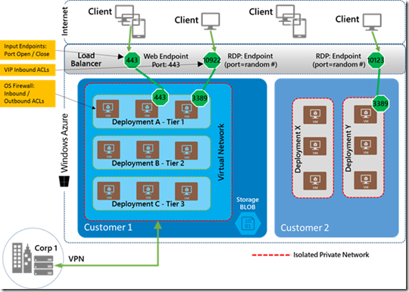
The Microsoft Azure product is designed to let users run their software. To secure the user data multiple keys are required and encryption is provided. Microsoft recognizes that users have some responsibility for data security and have guidelines to that extent which users may implement through the Azure Security Center.

As data enters the Microsoft Cloud microsoft relies on a series of controls to protect the data. First there are data access controls which provide user administrators the ability to restrict access. A Rights Management Service can protect data through policies. Microsoft also provides a Data Loss Prevention tool which permits users to scan outgoing data to determine what is needed.

Physical access is through a virtual network in which all ports are disabled and then enabled ad mapped to the user application one at a time.

It should be noted that the Azure Document “Protecting Data and Privacy in The Cloud” Microsoft also describes the standards it takes to physically protect customer data from external physical sources and describes the limits its employees have in accessing customer data.

Google Cloud -

Access to the Google Cloud is through the Google API. All access must be authorized. Access may be via a user as noted in Illustration 4 or an application may contain the credentials (Illustration 5).
Illustration 4: Google Cloud User Centric Authorization

Illustration 5: Google Cloud Server-Centric Authorization

Google uses an entity known as a project to determine ownership. All resources are owned by projects and projects may be shared by multiple users. Google's security document “Google Cloud Platform Security” goes into great detail about the physical protection of data. Within the Google document a link to the “Google Security Whitepaper” talks about Google's physical security and employee background checks. A key element of the Google Security is that the Google Cloud runs on custom built machines designed around a custom designed Operating System (Linux like) that google continually updates. Google emphasizes it long experience in browsing and monitoring to find errors and problems. A key element of google's cloud offering is that all access is via a secured Global API gateway infrastructure where validation and checking occurs.
Google states that they offer services similar to AWS and provide tables for those transitioning and it compares both services. What is important to note is that Google offers similar services, allows users to use their own images after uploading and conversion to the Google Image. A base image is used to create the Google Compute Image.

Recommendation:
All providers use containers and some degree of validation of access. Most allow user defined operation systems but I was unable to clearly find information on how they restrict access. I had originally wanted to review the security of the Alibaba network, but the documentation was minimal and I doubted that the network was secure from Government snooping.
Google and Amazon appear to be the most similar. Microsoft Azure appears to be created to fill a gap in the Microsoft product line. Microsoft Azure has the advantage of ease of install to create a local private cloud. IBM Bluemix has numerous preloaded applications, but is confusing to the newcomer to the Cloud scene. My experience with IBM was not pleasant and I felt much of my time was wasted.
If I were to recommend a cloud provider I would recommend Amazon. Their industry leadership and constant evolution allows them to continually improve and offer new features. The AWS Cloud is world wide and is used by many. The cloud offering allows users of all levels to leverage their services. The security features are clearly deliniate and it they have clearly taken steps to protect their customers data from loss from within and outside the network.

Part 2: Create a relational database on Bluemix and replicate the effort of Assignment 1
When using Bluemix numerous options are available for relational databases. However only Elephant and clearDB are available on the free plan. ElephantDB is postgreSQL and clearDB is SQL. Since I have never worked with postgreSQL I am forced to use clearDB which is provided by a third party. The database was based upon “An Analysis Pattern for Invoice Processing.” Access is spotty and after numerous attempts to connect the following was produced:
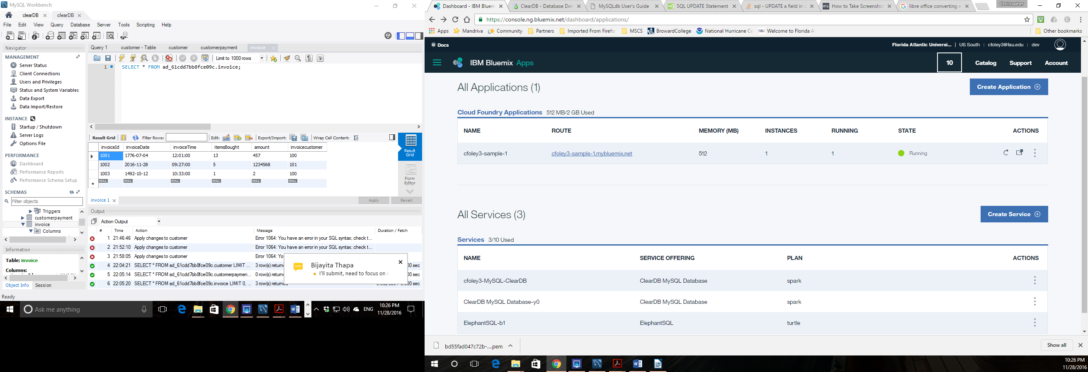Illustration 6: IBM Bluemix console showing one container and three relational database instances
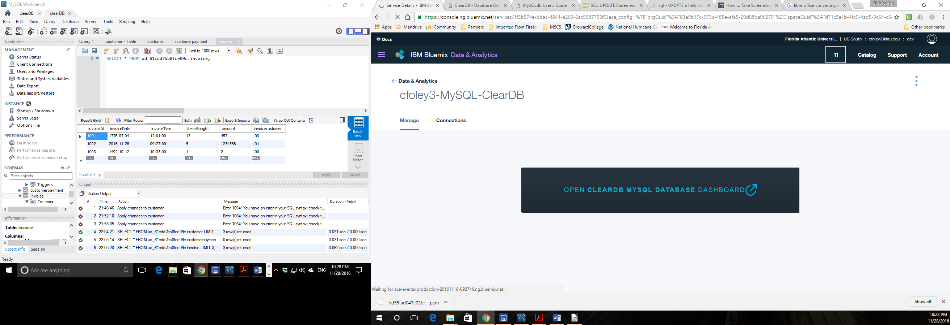Illustration 7: Bluemix to clearDB management console
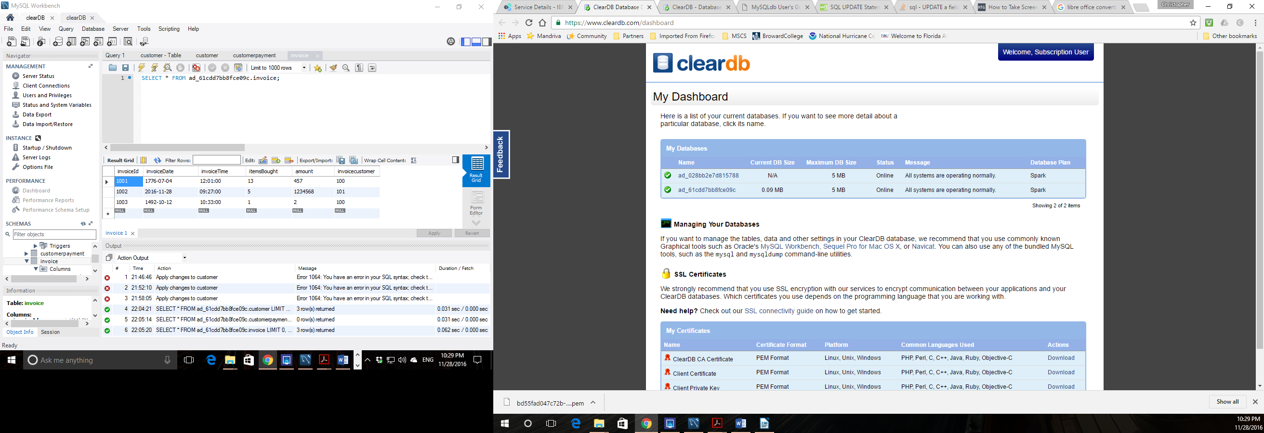Illustration 8: clearDB console (2 DB created 2nd has data)
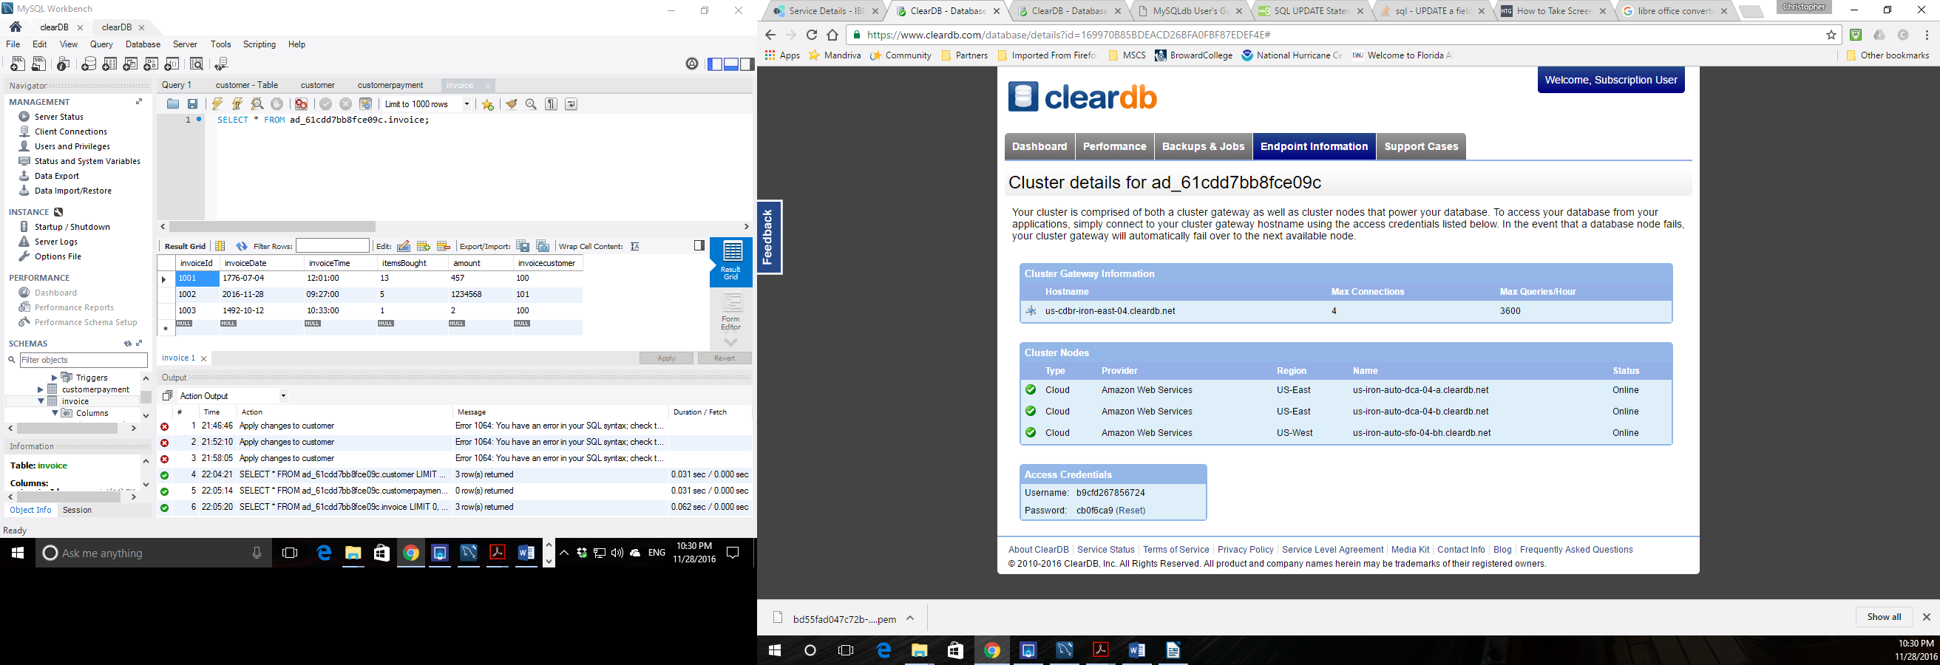Illustration 9: clearDB endpoint showing db is AWS relational DB
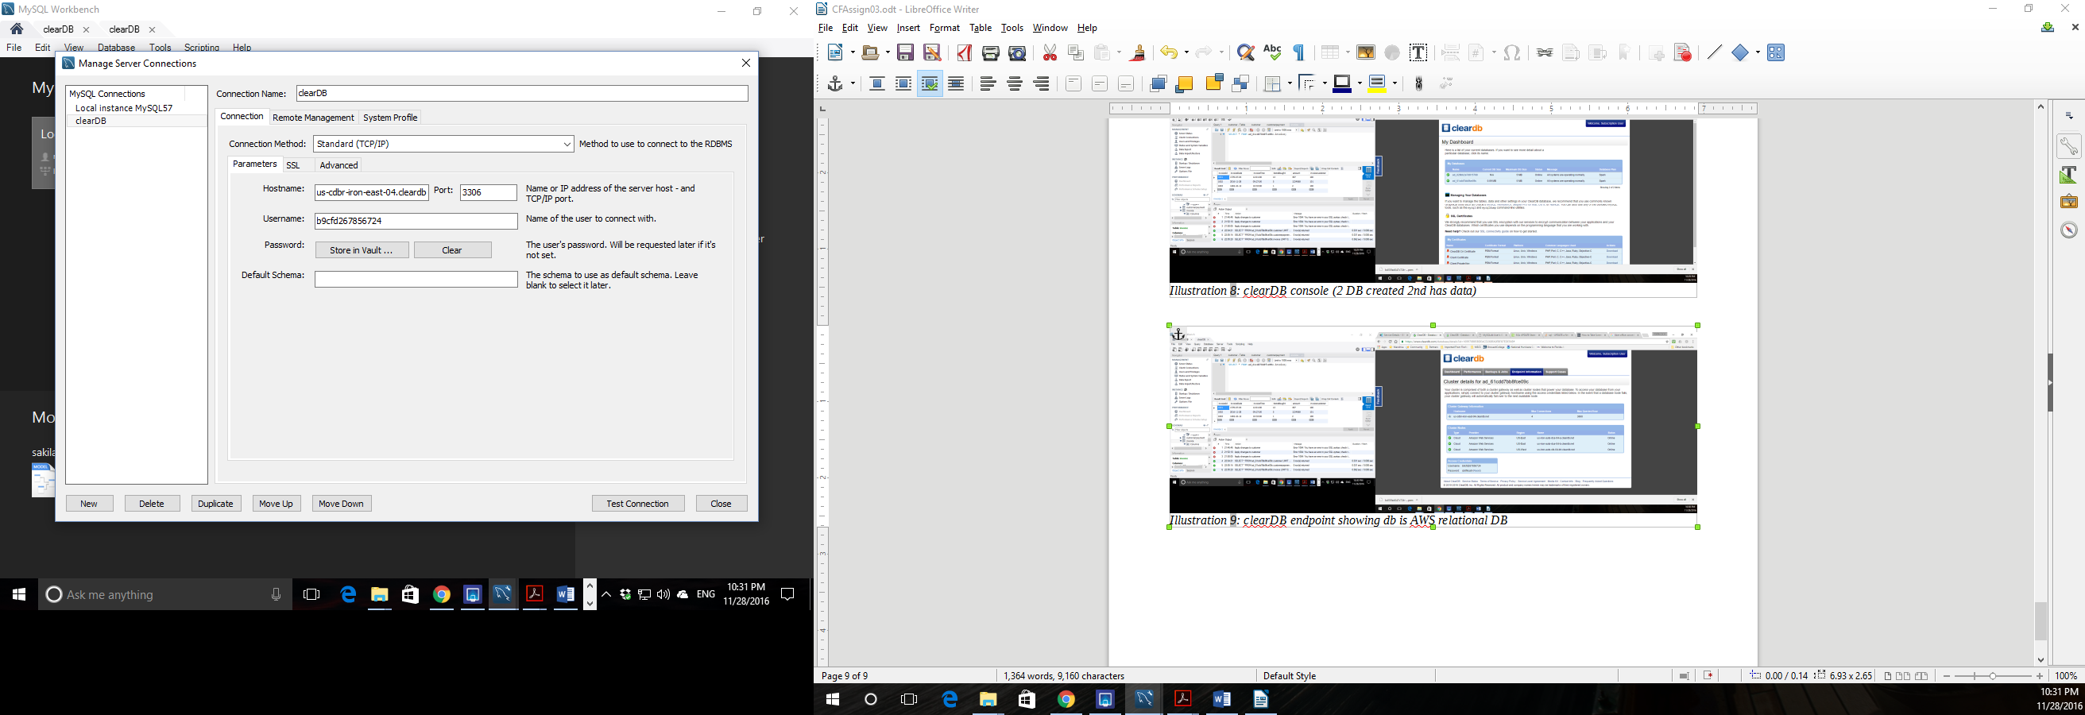Illustration 10: mySQL Workbench showing clearDB connection data

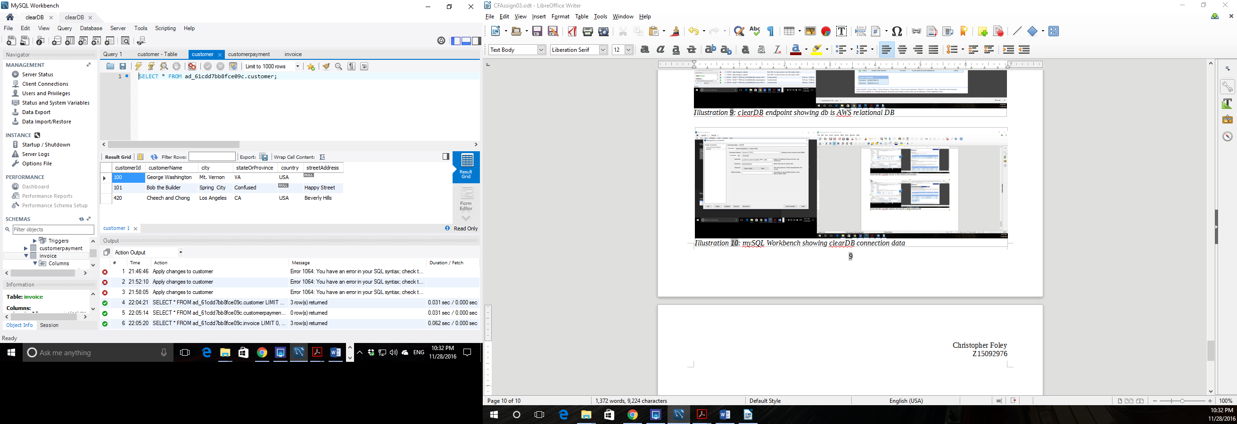Illustration 11: Customer data table
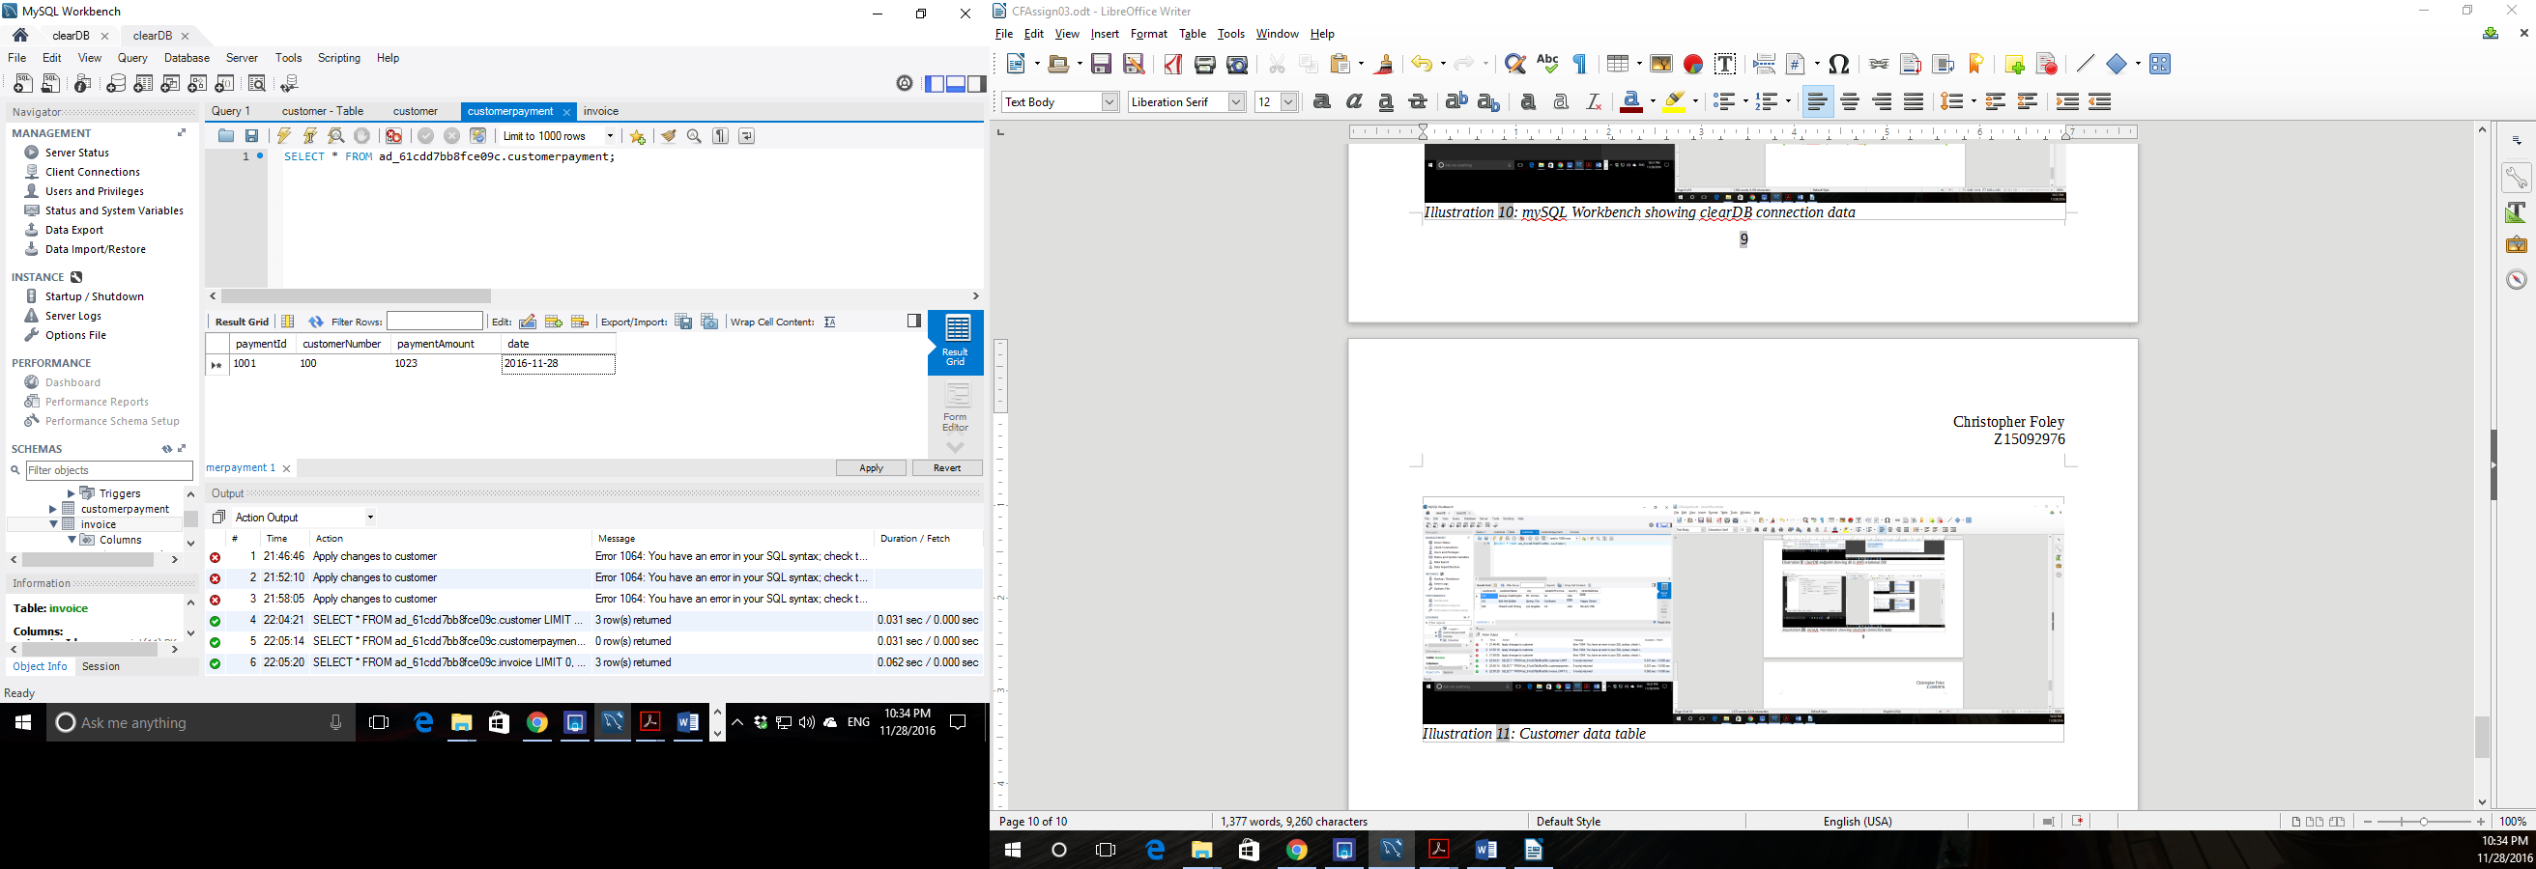Illustration 12: Customer payment
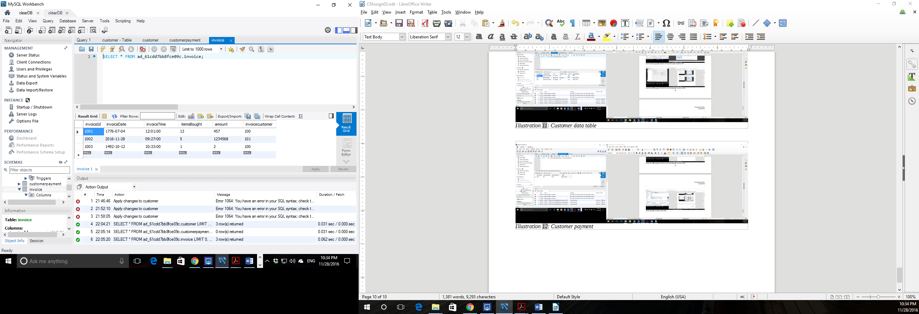Illustration 13: customer invoices
Due to SQL problems and time I was unable to automatically update the customer balance due from automatic summation of invoices and payments. An application was available but required additional skills that I would not be able to gain in the time alloted for this assignment.

Balint, Molnar, “Security and Privacy In Cloud Computing”, http://www.hit.bme.hu/~buttyan/courses/BMEVIHIM219/2013/hw-CloudSec.pdf, last downloaded (11/25/2016)
“Cloud Computing”, https://en.wikipedia.org/wiki/Cloud_computing#Infrastructure_as_a_service_.28IaaS.29, last retrieved (11/26/2016)
Fernandez, Eduardo B., “A Security Reference Architecture for Cloud Systems”, https://www.owasp.org/images/9/9f/SecResearchOWASP7-2013.pdf, last downloaded (11/26/2016).
“Overview of AWS Security Compute Services”, https://d0.awsstatic.com/whitepapers/Security/Security_Compute_Services_Whitepaper.pdf last downloaded (11/26/2016).
IBM Bluemix documents, “Bluemix Secuity” , https://console.ng.bluemix.net/docs/security/index.html#data-security, last updated 10/19/2016
Google Cloud Platform, “Gllgle Cloud Platform Security”, https://cloud.google.com/security/, last verified (11/26/2016)
https://cloud.google.com/security/whitepaper
Google, “Google Cloud Platform for AWS Professionals”, https://cloud.google.com/docs/compare/aws/compute
E.B. Fernandez and X. Yuan, “An Analysis Pattern For Invoice Processing”, http://hillside.net/plop/2009/papers/Process/An%20Analysis%20Pattern%20for%20Invoice%20Processing.pdf (30-Sep-2016)

