

.

Name : **Amal Mohammed El belbisi**

ID: **220170957**

|  |  |  |  |  |  |  |  |  |  |  |  |  |
| --- | --- | --- | --- | --- | --- | --- | --- | --- | --- | --- | --- | --- |
| Ephoc | P1 | P2 | q | dt | w1 | w2 | ∑(p*w) | ta | e | w1(new) | w2(new) | q(new) |
| E1 | 2 | 2 | 0 | 0 | 0 | 0 | 0 | 1 | -1 | -0.2 | -0.2 | 0.1 |
| 1 | -2 | 0.1 | 1 | -0.2 | -0.2 | 0.1 | 1 | 0 | -0.2 | -0.2 | 0.1 |
| -2 | 2 | 0.1 | 0 | -0.2 | -0.2 | -0.1 | 0 | 0 | -0.2 | -0.2 | 0.1 |
| -1 | 1 | 0.1 | 1 | -0.2 | -0.2 | -0.1 | 0 | 1 | -0.3 | -0.1 | 0 |
| E2 | 2 | 2 | 0 | 0 | -0.3 | -0.1 | -0.8 | 0 | 0 | -0.3 | -0.1 | 0 |
| 1 | -2 | 0 | 1 | -0.3 | -0.1 | -0.1 | 0 | 1 | -0.2 | -0.3 | -0.1 |
| -2 | 2 | -0.1 | 0 | -0.2 | -0.3 | -0.1 | 0 | 0 | -0.2 | -0.3 | -0.1 |
| -1 | 1 | -0.1 | 1 | -0.2 | -0.3 | 0 | 1 | 0 | -0.2 | -0.3 | -0.1 |
| E3 | 2 | 2 | -0.1 | 0 | -0.2 | -0.3 | -0.9 | 0 | 0 | -0.2 | -0.3 | -0.1 |
| 1 | -2 | -0.1 | 1 | -0.2 | -0.3 | 0.5 | 1 | 0 | -0.2 | -0.3 | -0.1 |
| -2 | 2 | -0.1 | 0 | -0.2 | -0.3 | -0.1 | 0 | 0 | -0.2 | -0.3 | -0.1 |
| -1 | 1 | -0.1 | 1 | -0.2 | -0.3 | 0 | 1 | 0 | -0.2 | -0.3 | -0.1 |

Q1/

w(new)=w(old)+(α*e*input)

α=.1, w1=0, w2=0, q=0

***Q2/***

**i.**

**No, they are not linearly separable. We need 2 hyperplan to distinguish these categories.**

**ii/**

**To design such network, let see how can represent input data.**

**Assume each square represents an input for the network, 1 represents blue square and 0 represents white square.(Class I =>1 , Class II =>0)**

|  |  |  |  |  |
| --- | --- | --- | --- | --- |
| p1 | p2 | p3 | p4 | output |
| 1 | 0 | 1 | 0 | 1 |
| 0 | 1 | 0 | 1 | 1 |
| 1 | 1 | 0 | 0 | 0 |
| 0 | 0 | 1 | 1 | 0 |

In the table, (p1 and p2) or (p3 and p4) can be used to determine the class type and it is represent XOR logic function.

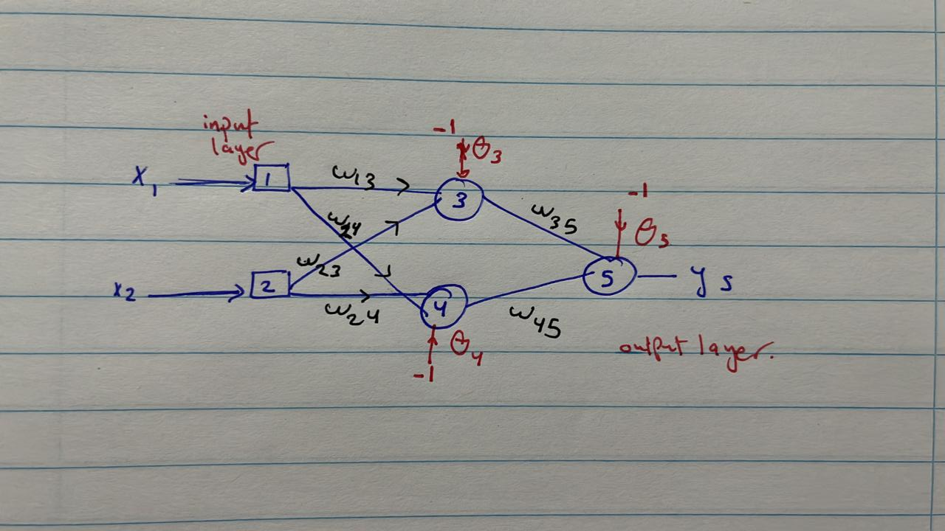

Q3/

We have two variables for this problem each of them with 8 binary bits. So, each chromosome contains 16 genes, 6 of them for x1 and the other 6 genes for x2. Firstly, I used binary encoding to create initial population with random binary bit using MATLAB online. population size is determined to be 20 chromosomes for each generation

Then I mapped each chromosome decimal value to be inside close interval [-2,2] as follow [(2-(-2))/255]=.01568627

X1= 0.0156827*(decimal_x1)-2

X2=0.0156827*( decimal_x2)-2

The values will be used to determine fitness function

Generation is putted to 600

generation Crossover probability=0.7

Mutation probability=0.01

Mutation process is obtained by complement one bit in chromosome

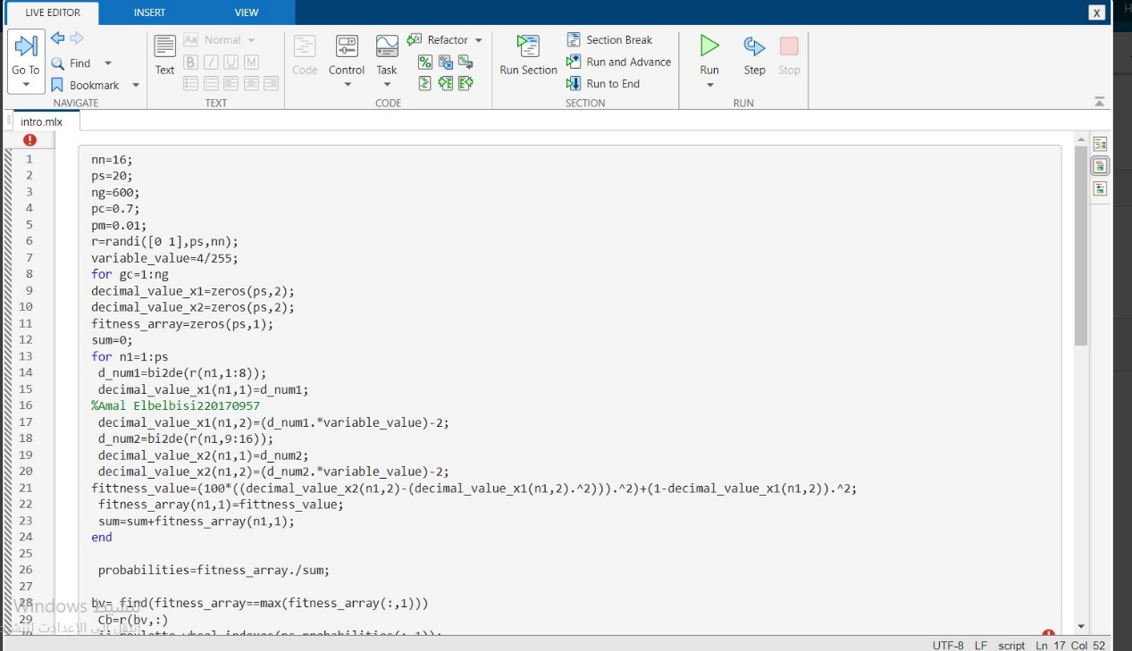

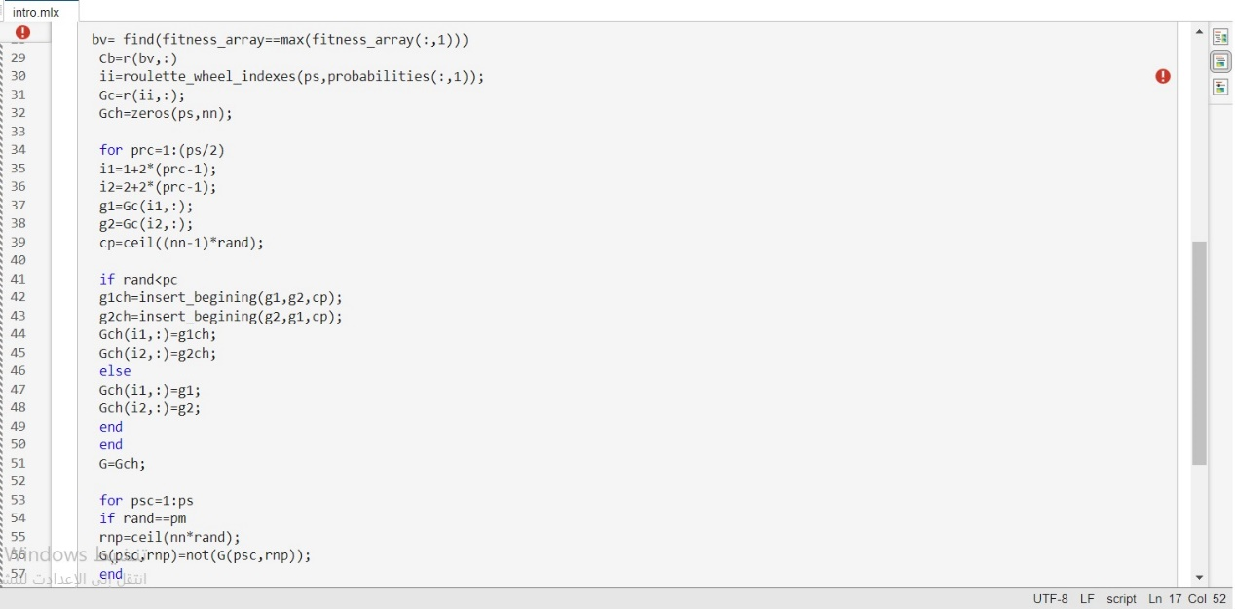

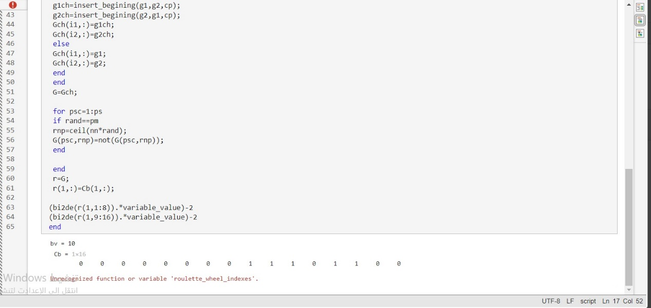

## Roulette_wheel code

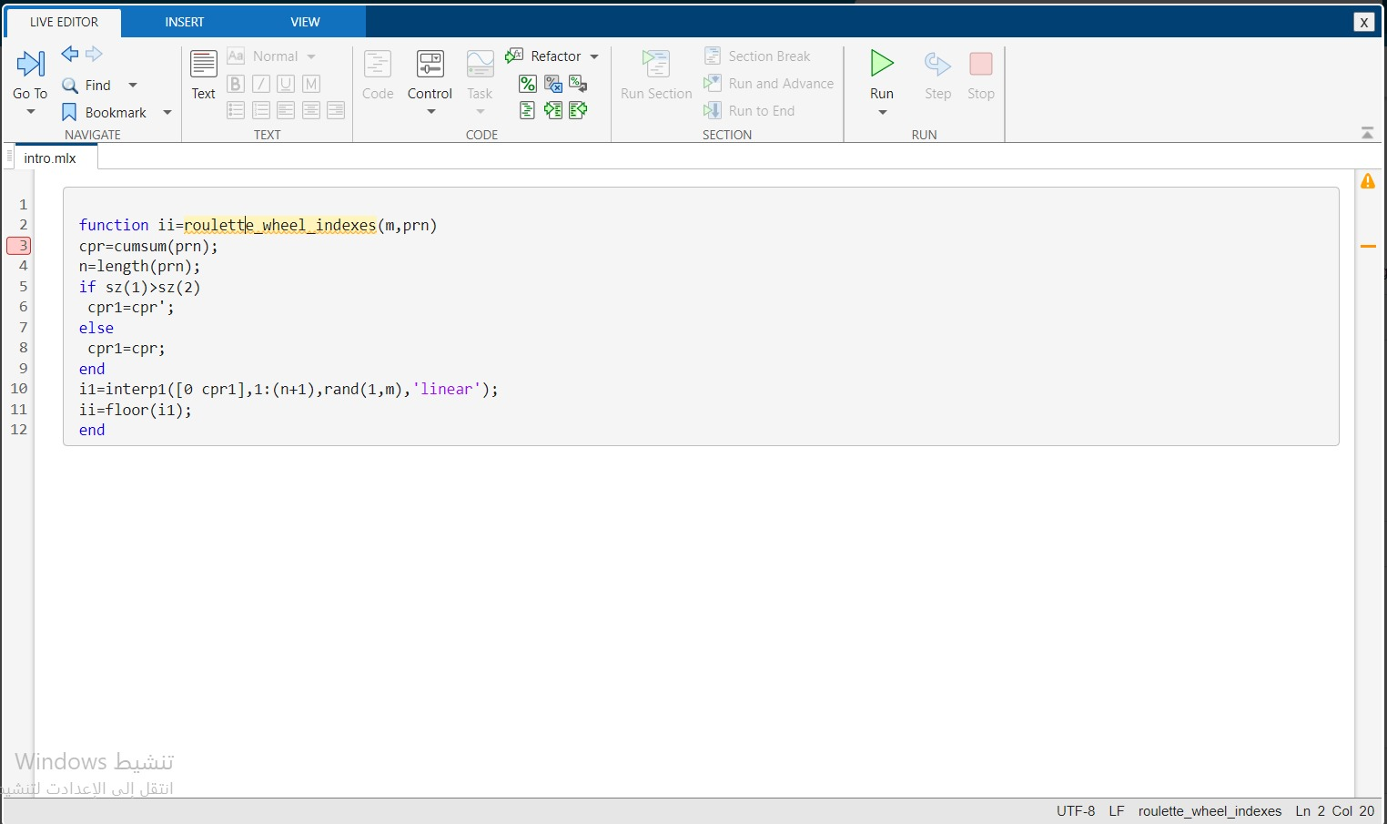

Crossover code

