LAB-3

PARTICLE SWARM OPTIMIZATION

Code:

import numpy as np

class Particle:

def __init__(self, dim, bounds):

self.position = np.random.uniform(bounds[0], bounds[1], dim)

self.velocity = np.random.uniform(-1, 1, dim)

self.best_position = self.position.copy()

self.best_value = float('inf')

def update_velocity(self, global_best, w=0.5, c1=1.5, c2=1.5):

r1 = np.random.rand(len(self.position))

r2 = np.random.rand(len(self.position))

cognitive = c1 * r1 * (self.best_position - self.position)

social = c2 * r2 * (global_best - self.position)

self.velocity = w * self.velocity + cognitive + social

def update_position(self, bounds):

self.position += self.velocity

# Keep within bounds

self.position = np.clip(self.position, bounds[0], bounds[1])

def objective_function(x):

# Example: Sphere function (minimize sum of squares)

return np.sum(x**2)

def particle_swarm_optimization(dim, bounds, num_particles=30, max_iter=100):

swarm = [Particle(dim, bounds) for _ in range(num_particles)]

global_best_position = np.random.uniform(bounds[0], bounds[1], dim)

global_best_value = float('inf')

for iteration in range(max_iter):

for particle in swarm:

fitness = objective_function(particle.position)

# Update personal best

if fitness < particle.best_value:

particle.best_value = fitness

particle.best_position = particle.position.copy()

# Update global best

if fitness < global_best_value:

global_best_value = fitness

global_best_position = particle.position.copy()

for particle in swarm:

particle.update_velocity(global_best_position)

particle.update_position(bounds)

print(f"Iteration {iteration+1}/{max_iter}, Global Best Value: {global_best_value}")

return global_best_position, global_best_value

if __name__ == "__main__":

dim = 2

bounds = (-10, 10)

best_pos, best_val = particle_swarm_optimization(dim, bounds)

print(f"Best Position: {best_pos}")

print(f"Best Value: {best_val}")

Output:

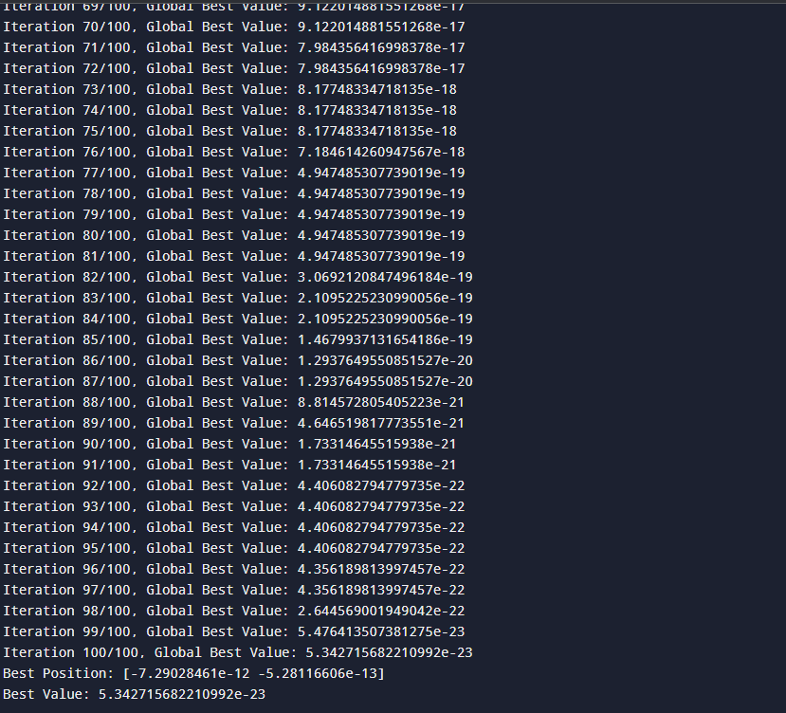

ANT COLONY OPTIMIZATION

Code:

import numpy as np

import random

class AntColony:

def __init__(self, distances, n_ants, n_best, n_iterations, decay, alpha=1, beta=1):

self.distances = distances

self.pheromone = np.ones(self.distances.shape) / len(distances)

self.all_inds = range(len(distances))

self.n_ants = n_ants

self.n_best = n_best

self.n_iterations = n_iterations

self.decay = decay

self.alpha = alpha

self.beta = beta

def run(self):

shortest_path = None

all_time_shortest_path = ("placeholder", float('inf'))

for i in range(self.n_iterations):

all_paths = self.construct_all_paths()

self.spread_pheromone(all_paths, self.n_best, shortest_path=shortest_path)

shortest_path = min(all_paths, key=lambda x: x[1])

if shortest_path[1] < all_time_shortest_path[1]:

all_time_shortest_path = shortest_path

self.pheromone *= self.decay

print(f"Iteration {i+1}/{self.n_iterations}, Best Path: {all_time_shortest_path[1]}")

return all_time_shortest_path

def construct_all_paths(self):

all_paths = []

for _ in range(self.n_ants):

path = self.construct_path(0) # start at node 0

all_paths.append((path, self.path_distance(path)))

return all_paths

def construct_path(self, start):

path = []

visited = set()

visited.add(start)

path.append(start)

prev = start

for _ in range(len(self.distances) - 1):

move = self.pick_move(self.pheromone[prev], self.distances[prev], visited)

path.append(move)

visited.add(move)

prev = move

return path

def pick_move(self, pheromone, dist, visited):

pheromone = np.copy(pheromone)

pheromone[list(visited)] = 0

row = pheromone ** self.alpha * ((1.0 / dist) ** self.beta)

norm_row = row / row.sum()

move = np.random.choice(self.all_inds, 1, p=norm_row)[0]

return move

def path_distance(self, path):

total = 0

for i in range(len(path)):

total += self.distances[path[i % len(path)]][path[(i + 1) % len(path)]]

return total

def spread_pheromone(self, all_paths, n_best, shortest_path):

sorted_paths = sorted(all_paths, key=lambda x: x[1])

for path, dist in sorted_paths[:n_best]:

for move in range(len(path)):

from_city = path[move % len(path)]

to_city = path[(move + 1) % len(path)]

self.pheromone[from_city][to_city] += 1.0 / self.distances[from_city][to_city]

self.pheromone[to_city][from_city] += 1.0 / self.distances[to_city][from_city]

if __name__ == "__main__":

distances = np.array([

[np.inf, 2, 2, 5, 7],

[2, np.inf, 4, 8, 2],

[2, 4, np.inf, 1, 3],

[5, 8, 1, np.inf, 2],

[7, 2, 3, 2, np.inf]

])

ant_colony = AntColony(distances, n_ants=10, n_best=3, n_iterations=100, decay=0.95, alpha=1, beta=2)

shortest_path, distance = ant_colony.run()

print("Best path found:", shortest_path)

print("Path distance:", distance)

Output:

