AAMAL MAGDUM – 1BM23CS002

**Lab program-3**

import java.util.Scanner;

class Book {

String name;

String author;

int price;

int numPages;

Book(String name, String author, int price, int numPages) {

this.name = name;

this.author = author;

this.price = price;

this.numPages = numPages;

}

@Override

public String toString() {

String bookDetails = "Book name: " + this.name + "\n" +

"Author name: " + this.author + "\n" +

"Price: " + this.price + "\n" +

"Number of pages: " + this.numPages + "\n";

return bookDetails;

}

}

public class Main {

public static void main(String[] args) {

Scanner s = new Scanner(System.in);

System.out.print("Enter the number of books: ");

int n = s.nextInt();

Book[] books = new Book[n];

for (int i = 0; i < n; i++) {

System.out.print("Enter name of book " + (i + 1) + ": ");

String name = s.next();

System.out.print("Enter author of book " + (i + 1) + ": ");

String author = s.next();

System.out.print("Enter price of book " + (i + 1) + ": ");

int price = s.nextInt();

System.out.print("Enter number of pages in book " + (i + 1) + ": ");

int numPages = s.nextInt();

books[i] = new Book(name, author, price, numPages);

}

System.out.println("\nBook Details:");

for (Book book : books) {

System.out.println(book);

}

s.close();

}

}

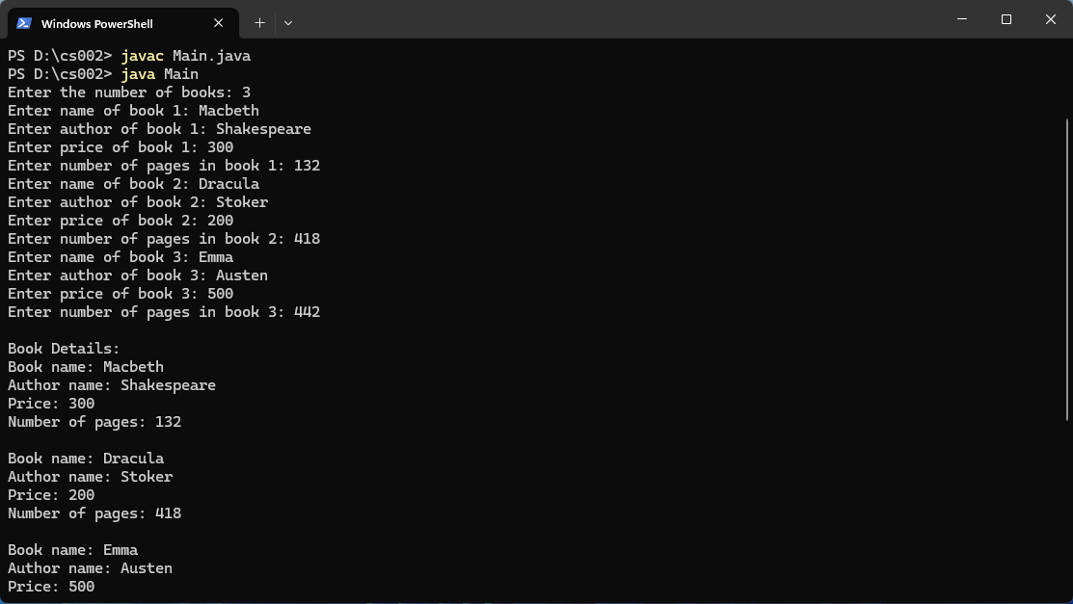

**Lab program-4**

import java.util.Scanner;

abstract class Shape {

int dim1;

int dim2;

public Shape() {

this.dim1 = 0;

this.dim2 = 0;

}

public Shape(int dim1, int dim2) {

this.dim1 = dim1;

this.dim2 = dim2;

}

public abstract void printArea();

}

class Rectangle extends Shape {

public Rectangle(int length, int width) {

dim1 = length;

dim2 = width;

}

public void printArea() {

int area = dim1 * dim2;

System.out.println("Area of Rectangle: " + area);

}

}

class Triangle extends Shape {

public Triangle(int base, int height) {

dim1 = base;

dim2 = height;

}

public void printArea() {

double area = 0.5 * dim1 * dim2;

System.out.println("Area of Triangle: " + area);

}

}

class Circle extends Shape {

public Circle(int radius) {

dim1 = radius;

dim2 = 0;

}

public void printArea() {

double area = Math.PI * dim1 * dim1;

System.out.println("Area of Circle: " + area);

}

}

public class shapes {

public static void main(String[] args) {

Scanner in = new Scanner(System.in);

System.out.println("Enter length and width for Rectangle:");

int length = in.nextInt();

int width = in.nextInt();

Shape rectangle = new Rectangle(length, width);

rectangle.printArea();

System.out.println("Enter base and height for Triangle:");

int base = in.nextInt();

int height = in.nextInt();

Shape triangle = new Triangle(base, height);

triangle.printArea();

System.out.println("Enter radius for Circle:");

int radius = in.nextInt();

Shape circle = new Circle(radius);

circle.printArea();

in.close();

}

}

