Department of Aerospace Engineering
AE681 Composite Materials

Manufacturing of Composites

Spray Lay-Up
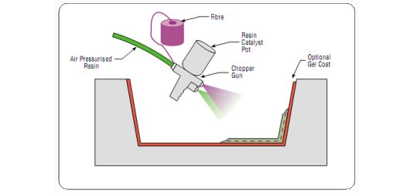

Description:

Fibre is chopped in a hand-held gun and fed into a spray of catalyzed resin directed at the mould. The deposited materials are left to cure under standard atmospheric conditions.

Material Options:

- Resins: Primarily polyester
- Fibres: Glass roving only
- Cores: None. These have to be incorporated separately

Typical Applications:

Simple enclosures, lightly loaded structural panels, e.g. caravan bodies, truck fairings, bathtubs, shower trays, some small dinghies.

Main Advantages:
- Widely used for many years.
- Low cost way of quickly depositing fibre and resin.
- Low cost tooling.

Main Disadvantages:
- Laminates tend to be very resin-rich and therefore excessively heavy.
- Only short fibres are incorporated which severely limits the mechanical properties of the laminate.
- Resins need to be low in viscosity to be sprayable. This generally compromises their mechanical/thermal properties.
- The high styrene contents of spray lay-up resins generally mean that they have the potential to be more harmful and their lower viscosity means that they have an increased tendency to penetrate clothing.
- Limiting airborne styrene concentrations to legislated levels is becoming increasingly difficult.
Wet/Hand Lay-up

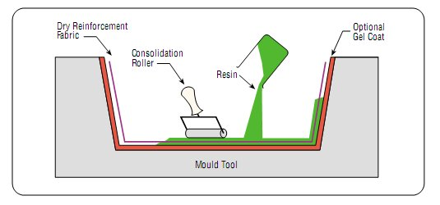
Description:

Resins are impregnated by hand into fibres which are in the form of woven, knitted, stitched or bonded fabrics. This is usually accomplished by rollers or brushes, with an increasing use of nip-roller type impregnators for forcing resin into the fabrics by means of rotating rollers and a bath of resin. Laminates are left to cure under standard atmospheric conditions.

Materials Options:

- Resins: Any, e.g. epoxy, polyester, vinylester, phenolic
- Fibres: Any, although heavy aramid fabrics can be hard to wet-out by hand.
- Cores: Any.

Typical Applications:

Standard wind-turbine blades, production boats, architectural mouldings.

Main Advantages:
- Widely used for many years.
- Simple principles to teach.
- Low cost tooling, if room-temperature cure resins are used.
- Wide choice of suppliers and material types.
- Higher fibre contents and longer fibres than with spray lay-up.

Main Disadvantages:
- Resin mixing, laminate resin contents, and laminate quality are very dependent on the skills of laminators. Low resin content laminates cannot usually be achieved without the incorporation of excessive quantities of voids.
- Health and safety considerations of resins. The lower molecular weights of hand lay-up resins generally mean that they have the potential to be more harmful than higher molecular weight products. The lower viscosity of the resins also means that they have an increased tendency to penetrate clothing.
- Limiting airborne styrene concentrations to legislated levels from polyesters and vinylesters is becoming increasingly hard without expensive extraction systems.
- Resins need to be low in viscosity to be workable by hand. This generally compromises their mechanical/thermal properties due to the need for high diluent/styrene levels.

Vacuum Bagging
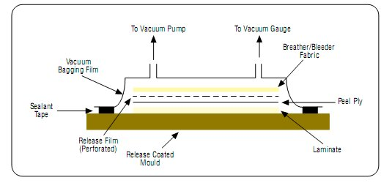

Description:

This is basically an extension of the wet lay-up process described above where pressure is applied to the laminate once laid-up in order to improve its consolidation. This is achieved by sealing a plastic film over the wet laid-up laminate and onto the tool. The air under the bag is extracted by a vacuum pump and thus up to one atmosphere of pressure can be applied to the laminate to consolidate it.

Materials Options:

- Resins: Primarily epoxy and phenolic. Polyesters and vinylesters may have problems due to excessive extraction of styrene from the resin by the vacuum pump.
- Fibres: The consolidation pressures mean that a variety of heavy fabrics can be wet-out.
- Cores: Any.

Typical Applications:

Large, one-off cruising boats, racecar components, core-bonding in production boats.

Main Advantages:
- Higher fibre content laminates can usually be achieved than with standard wet lay-up techniques.
- Lower void contents are achieved than with wet lay-up.
- Better fibre wet-out due to pressure and resin flow throughout structural fibres, with excess into bagging materials.
- Health and safety: The vacuum bag reduces the amount of volatiles emitted during cure.

Main Disadvantages:
- The extra process adds cost both in labour and in disposable bagging materials.
- A higher level of skill is required by the operators.
- Mixing and control of resin content still largely determined by operator skill.

Filament Winding:
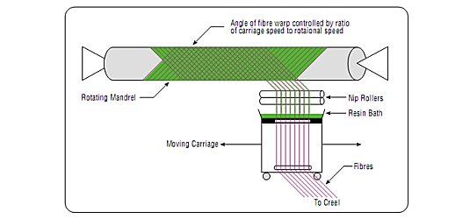

Description:

This process is primarily used for hollow, generally circular or oval sectioned components, such as pipes and tanks. Fibre tows are passed through a resin bath before being wound onto a mandrel in a variety of orientations, controlled by the fibre feeding mechanism, and rate of rotation of the mandrel.

Materials Options:

- Resins: Any, e.g. epoxy, polyester, vinylester, phenolic
- Fibres: Any. The fibres are used straight from a creel and not woven or stitched into a fabric form
- Cores: Any, although components are usually single skin

Typical Applications:

Chemical storage tanks and pipelines, gas cylinders, fire-fighters breathing tanks

Main Advantages:
- This can be a very fast and therefore economic method of laying material down.
- Resin content can be controlled by metering the resin onto each fibre tow through nips or dies.
- Fibre cost is minimised since there is no secondary process to convert fibre into fabric prior to use.
- Structural properties of laminates can be very good since straight fibres can be laid in a complex pattern to match the applied loads.

Main Disadvantages:
- The process is limited to convex shaped components.
- Fibre cannot easily be laid exactly along the length of a component.
- Mandrel costs for large components can be high.
- The external surface of the component is unmoulded, and therefore cosmetically unattractive.
- Low viscosity resins usually need to be used with their attendant lower mechanical and health and safety properties.

Pultrusion
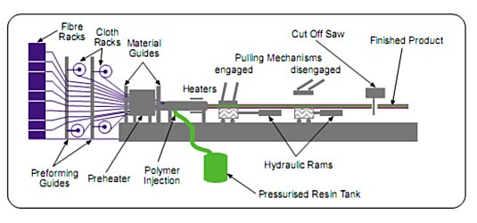
Description:

Fibres are pulled from a creel through a resin bath and then on through a heated die. The die completes the impregnation of the fibre, controls the resin content and cures the material into its final shape as it passes through the die. This cured profile is then automatically cut to length. Fabrics may also be introduced into the die to provide fibre direction other than at 0°. Although pultrusion is a continuous process, producing a profile of constant cross-section, a variant known as 'pulforming' allows for some variation to be introduced into the cross-section. The process pulls the materials through the die for impregnation, and then clamps them in a mould for curing. This makes the process non-continuous, but accommodating of small changes in cross-section.

Material Options:

- Resins: Generally epoxy, polyester, vinylester and phenolic
- Fibres: Any
- Cores: Not generally used

Typical Applications:

Beams and girders used in roof structures, bridges, ladders, frameworks

Main Advantages:
- This can be a very fast, and therefore economic, way of impregnating and curing materials.
- Resin content can be accurately controlled.
- Fibre cost is minimised since the majority is taken from a creel.
- Structural properties of laminates can be very good since the profiles have very straight fibres and high fibre volume fractions can be obtained.
- Resin impregnation area can be enclosed thus limiting volatile emissions.

Main Disadvantages:
- Limited to constant or near constant cross-section components.
- Heated die costs can be high.

Resin Transfer Moulding (RTM)
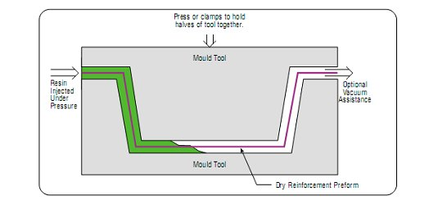

Description:

Fabrics are laid up as a dry stack of materials. These fabrics are sometimes pre-pressed to the mould shape, and held together by a binder. These 'preforms' are then more easily laid into the mould tool. A second mould tool is then clamped over the first, and resin is injected into the cavity. Vacuum can also be applied to the mould cavity to assist resin in being drawn into the fabrics. This is known as Vacuum Assisted Resin Injection (VARI). Once all the fabric is wet out, the resin inlets are closed, and the laminate is allowed to cure. Both injection and cure can take place at either ambient or elevated temperature.

Material Options:

Resins: Generally epoxy, polyester, vinylester and phenolic, although high temperature resins such as bismaleimides can be used at elevated process temperatures.

Fibres: Any. Stitched materials work well in this process since the gaps allow rapid resin transport. Some specially developed fabrics can assist with resin flow

Cores: Not honeycombs, since cells would fill with resin, and pressures involved can crush some foams
Typical Applications:

Small complex aircraft and automotive components, train seats.

Main Advantages:
- High fibre volume laminates can be obtained with very low void contents.
- Good health and safety, and environmental control due to enclosure of resin.
- Possible labour reductions.
- Both sides of the component have a moulded surface.

Main Disadvantages:
- Matched tooling is expensive and heavy in order to withstand pressures.
- Generally limited to smaller components.
- Unimpregnated areas can occur resulting in very expensive scrap parts.

Other Infusion Processes
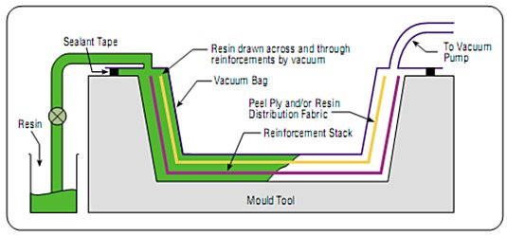

Description:

Fabrics are laid up as a dry stack of materials as in RTM. The fibre stack is then covered with peel ply and a knitted type of non-structural fabric. The whole dry stack is then vacuum bagged, and once bag leaks have been eliminated, resin is allowed to flow into the laminate. The resin distribution over the whole laminate is aided by resin flowing easily through the non-structural fabric, and wetting the fabric out from above.

Materials Options:

- Resins: Generally epoxy, polyester and vinylester.
- Fibres: Any conventional fabrics. Stitched materials work well in this process since the gaps allow rapid resin transport.
- Cores: Any except honeycombs.

Typical Applications:

Semi-production small yachts, train and truck body panels

Main Advantages:
- As RTM above, except only one side of the component has a moulded finish.
- Much lower tooling cost due to one half of the tool being a vacuum bag, and less strength being required in the main tool.
- Large components can be fabricated.
- Standard wet lay-up tools may be able to be modified for this process.
- Cored structures can be produced in one operation.

Main Disadvantages:
- Relatively complex process to perform well.
- Resins must be very low in viscosity, thus comprising mechanical properties.
- Unimpregnated areas can occur resulting in very expensive scrap parts.

Prepregs
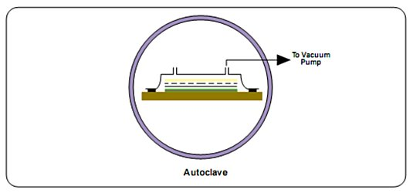
Description:
Fabrics and fibres are pre-impregnated by the materials manufacturer, under heat and pressure or with solvent, with a pre-catalyzed resin. The catalyst is largely latent at ambient temperatures giving the materials several weeks, or sometimes months, of useful life when defrosted. However to prolong storage life the materials are stored frozen. The resin is usually a near-solid at ambient temperatures, and so the pre-impregnated materials (prepregs) have a light sticky feel to them, such as that of adhesive tape. Unidirectional materials take fibre direct from a creel, and are held together by the resin alone. The prepregs are laid up by hand or machine onto a mould surface, vacuum bagged and then heated to typically 120-180°C. This allows the resin to initially reflow and eventually to cure. Additional pressure for the moulding is usually provided by an autoclave (effectively a pressurized oven) which can apply up to 5 atmospheres to the laminate.
Materials Options:
- Resins: Generally epoxy, polyester, phenolic and high temperature resins such as polyimides, cyanate esters and bismaleimides.
- Fibres: Any. Used either direct from a creel or as any type of fabric.
- Cores: Any, although special types of foam need to be used due to the elevated temperatures involved in the process.

Typical Applications:

Aircraft structural components (e.g. wings and tail sections), F1 racing cars, sporting goods such as tennis racquets and skis.

Main Advantages:
- Resin/catalyst levels and the resin content in the fibre are accurately set by the materials manufacturer. High fibre contents can be safely achieved.
- The materials have excellent health and safety characteristics and are clean to work with.
- Fibre cost is minimized in unidirectional tapes since there is no secondary process to convert fibre into fabric prior to use.
- Resin chemistry can be optimized for mechanical and thermal performance, with the high viscosity resins being impregnable due to the manufacturing process.
- The extended working times (of up to several months at room temperatures) means that structurally optimized, complex lay-ups can be readily achieved.
- Potential for automation and labour saving.

Main Disadvantages:
- Materials cost is higher for preimpregnated fabrics.
- Autoclaves are usually required to cure the component. These are expensive, slow to operate and limited in size.
- Tooling needs to be able to withstand the process temperatures involved.
- Core materials need to be able to withstand the process temperatures and pressures.

Resin Film Infusion (RFI)
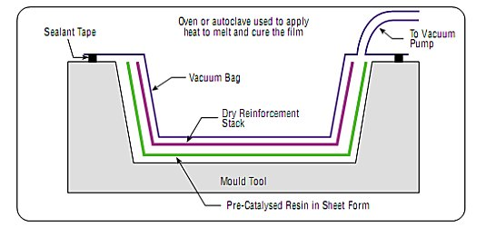

Description:

Dry fabrics are laid up interleaved with layers of semi-solid resin film supplied on a release paper. The lay-up is vacuum bagged to remove air through the dry fabrics, and then heated to allow the resin to first melt and flow into the air-free fabrics, and then after a certain time, to cure.

Materials Options:

Resins: Generally epoxy only.

Fibres: Any

Cores: Most, although PVC foam needs special procedures due to the elevated temperatures involved in the process

Typical Applications:

Aircraft radomes and submarine sonar domes.

Main Advantages:
- High fibre volumes can be accurately achieved with low void contents.
- Good health and safety and a clean lay-up, like prepreg.
- High resin mechanical properties due to solid state of initial polymer material and elevated temperature cure.
- Potentially lower cost than prepreg, with most of the advantages.
- Less likelihood of dry areas than SCRIMP process due to resin traveling through fabric thickness only.

Main Disadvantages:
- Not widely proven outside the aerospace industry.
- An oven and vacuum bagging system is required to cure the component as for prepreg, although the autoclave systems used by the aerospace industry are not always required.
- Tooling needs to be able to withstand the process temperatures of the resin film (which if using similar resin to those in low-temperature curing prepregs, is typically 60-100°C).
- Core materials need to be able to withstand the process temperatures and pressures.

