Program 1

Write a program that prompts the user to enter his first name and last name and then
displays a message “Greetings!!! First name Last name”

fname=input("Enter your first name")
lname = input("Enter your last name")
print("Greetings!!!",fname,lname)

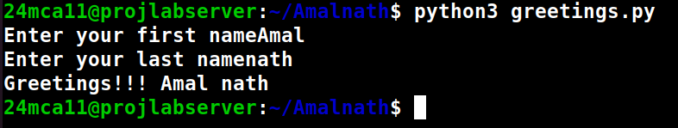
Program 2

Write a program to demonstrate different number data types in python?

x,y,z,= 2,3.3,3+2;
print("Type of x = ", type(x))
print("Type of y = ", type(y))
print("Type of z = ", type(z))

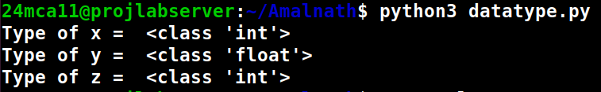

Program 3

Write a program to calculate the area of a circle by reading inputs from the user

r=float(input("Enter the radius of the circle:" ))
area = 3.14*r*r
print("Area of the circle=", area)

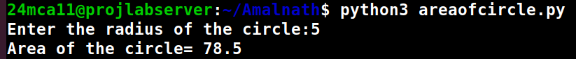

Program 4

Write a program to calculate the salary of an employee given his basic pay (to be entered by
the user) . HRA = 10 percent of the basic pay, TA = 5 percent of the basic pay.

bp=float(input("Enter the basic pay of the employee: "))
hra= 0.10*bp
ta=0.5*bp
salary = bp+hra+ta
print("Salary of the employee is ", salary)
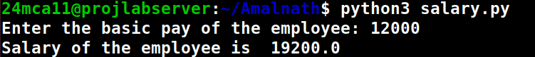

Program 5

Write a Python program to perform arithmetic operations on two integer numbers.

x=int(input("Enter the first number"))
y=int(input("Enter the second number"))
print("sum: ", x,"+",y,"=", x+y)
print("Difference : ",x,"-",y,"=",x-y)
print("Multiplication", x,"*",y,"=",x*y)
print("Division: ",x,"/",y,"=",x/y)
print("Reminder: ",x,"%",y,"=",x%y)

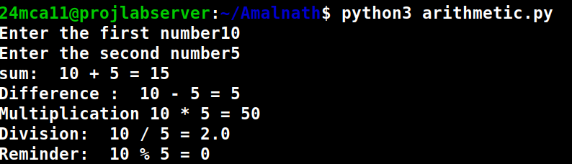

Program 6

Write a Python program to get a string which is n (non-negative integer) copies of a given
string.

str=input("Enter the string")
n=int(input("Enter the number of repitations"))
print(str * n)

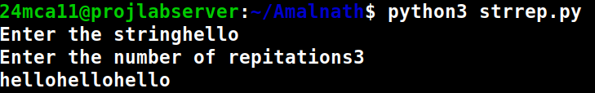

Program 7

Program to accept an integer n and compute n+nn+nnn.
[Hint : n = 5, then compute 5 + 55 + 555]

n=( input("Enter the number"))
print(n,"+",n*2,"+",n*3)
sum=int(n)+int(n*2)+int(n*3)
print(sum)

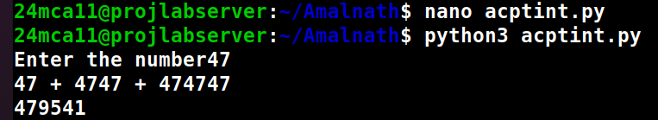

Program 8

Find biggest of 3 numbers entered.

n1 = int(input("Enter the first num: "))
n2 = int(input("Enter the second num: "))
n2 = int(input("Enter the third num: "))
big = n1
if n2>big:
big=n2
elif n3>big:
big=n3
print("The biggest number is ", big)

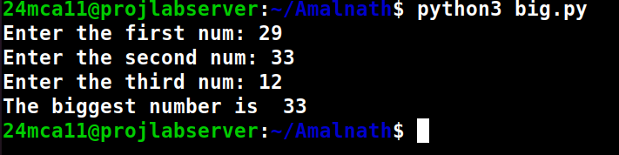

Program 9

Program to determine whether a year is a leap year or not.

year = int(input("Enter a year: "))
if(year % 400 == 0)and(year % 100 == 0):
print("{0} is a leap year", format(year))
elif(year % 4 == 0)and(year % 100!=0):
print("{0} is a leap year", format(year))
else:
print("{0} is not a leap year", format(year))
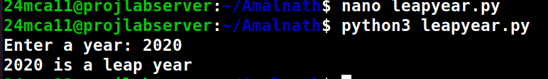

Program 10

Write a Python program to determine the rate of entry-ticket in a trade fair based on age as
follows:

Age
<10
>=10 and <60
>= 60
Rate
7
10
5

age=int(input("Enter the age: "))
if(age<10):
print("The tiket rate is 7")
elif (age>=10)and(age<60):
print("The ticket rate is 10")
elif (age>=60):
print("The ticket rate is 5")
else:
print("invalid entry")

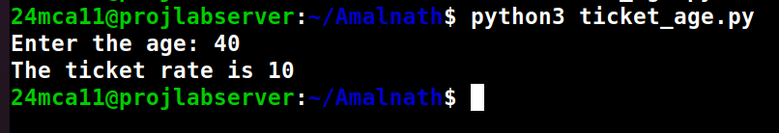

Program 11

Write a Python program to solve a quadratic equation.

import cmath
a=int(input("Enter the first number "))
b= int(input("Enter the second number "))
c= int(input("Enter the third number "))
d=(b**2)-(4*a*c)
if d>=0:
ans1=(-b-(cmath.sqrt(d))/2*a)
ans2=(-b+(cmath.sqrt(d))/2*a)
print(f"The solution are {ans1} and {ans2}")
else:
print("No real solution exist")

