Predicting Land Prices in the Colombo District
  - IT5514 Applied Machine Learning - Assignment 02

Predicting Land Prices in the Colombo District
Module: IT5514 Applied Machine Learning | Assignment 02 | Individual Assignment
Name: _______________________ Index Number: _______________________

1. Introduction
Land is the largest purchase most Sri Lankan families ever make, yet there is no public, plot-level price index for the Colombo district. Buyers and sellers mostly judge prices from a handful of advertisements in the same area, and asking prices for similar land can differ several times over. The aim of this assignment was to build a model that estimates a fair asking price per perch for a plot of land in the Colombo district, from its area, size, land type and the facilities around it.
The work follows the assignment guideline given in class:
- A local (Sri Lankan) dataset was used.
- The data was analysed and preprocessed.
- Random Forest and XGBoost were applied, with hyperparameters designed and tuned rather than left at their defaults, and other models suited to the problem were added (LightGBM, CatBoost and a stacked ensemble).
- Performance was evaluated and compared, and the results were interpreted, including model explainability with SHAP and LIME.
- Inference was demonstrated on a listing kept aside from all training and testing, through a small front-end application that loads the saved (pickled) model.
The main task is regression (predicting the price). As an extension, the same problem was also framed as classification into Low, Medium and High price bands.
All the work was done in Python with Pandas, scikit-learn, XGBoost, LightGBM and CatBoost. The accompanying files are:
File | Contents
01_data_preparation.ipynb | Cleaning and preprocessing (Section 3)
02_modelling.ipynb | Models, tuning, comparison, interpretation, classification, inference (Sections 4-7)
03_unseen_areas.ipynb | Check of how well the models work for areas they have never seen (Section 6.3)
04_explainability.ipynb | SHAP and LIME explanations of the final model (Section 6.4)
app.py, catboost_wrapper.py | Front-end application (Section 7)
land_price_model.pkl | Saved final models

2. Dataset
Source. Land prices of Colombo district, published on Kaggle by user ruchiraayeshmantha (https://www.kaggle.com/datasets/ruchiraayeshmantha/land-prices-of-colombo-district). The dataset contains land sale advertisements from the Colombo district, posted between 31 July and 21 September 2021. Each advertisement was enriched with location information: the distance to Colombo Fort, and the distance to and number of nearby schools, universities, hospitals, banks, finance companies, supermarkets, fuel stations, railway stations and expressway entrances.
The file has 4,494 rows and 35 columns with no missing values:
Group | Columns
Listing | Address (area name, 160 areas), Land_size(Perches), Land_type, Posted_Date_new
Price | Mentioned Price(Rs), Price_Scale, Price per Perch
Location | 27 distance and count features (e.g. Distance from fort, min_dist_nearest_railway, count_banks_within_2km)
Other | Address_ID (row identifier)
The busiest areas are Ranala (350 listings), Makandana (270), Kaduwela (250), Kesbewa (206) and Piliyandala (204). These are suburban areas where large blocks of land are divided and sold plot by plot.

3. Data Preparation

3.1 Choice of target
Two columns describe the price: Mentioned Price(Rs) (the number written in the advertisement) and Price per Perch. Price per perch was chosen as the target, because it makes plots of different sizes comparable. A 6-perch plot in Nugegoda and a 40-perch plot in Kaduwela can’t be compared on total price, but they can be compared per perch, and this is also how land is normally advertised and discussed in Sri Lanka.
Mentioned Price(Rs) was then removed from the features. For most rows it is either identical to the target or equal to the target multiplied by the land size, so leaving it in would hand the model the answer (data leakage). Address_ID was also removed, since it is just a row number.

3.2 Price scale
Advertisers quote prices in different ways, recorded in Price_Scale: per perch (3,568 rows), as a total price (923 rows), or per acre (3 rows). Checking Price per Perch against the mentioned price for each scale showed that:
- per perch: Price per Perch equals the mentioned price, which is correct
- total price: Price per Perch equals the mentioned price ÷ land size, so these were already converted correctly
- per acre: Price per Perch still held the per-acre price, which is wrong
The three per-acre rows were corrected by dividing by 160 (1 acre = 160 perches). After that, Price_Scale only describes how the advertisement was written, not the land, so it was dropped.

3.3 Duplicates
After removing the ID and the mentioned price, 198 rows were exact duplicates and were removed (4,296 rows remained). This is more than the 177 duplicates in the raw file. The difference is listings that were posted twice, once as a per-perch price and once as a total price: they become identical once the price is expressed per perch. Duplicates were removed before splitting the data, so the same listing could not end up in both the training and the test set.

3.4 Skewed target and outliers
The price per perch ranges from about Rs 4,600 to Rs 85 million, with a median of about Rs 900,000. The distribution is extremely right-skewed (skewness 7.19), as Figure 1 shows.
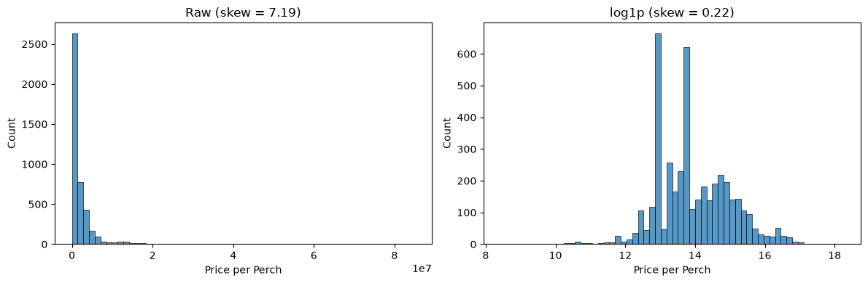
Figure 1: Price per perch before and after the log transform
Applying the IQR rule from the module’s feature-engineering lab directly to this target would flag 297 listings as outliers. Most of them are genuine, expensive land close to the city centre, so removing them would remove exactly the information the model needs about central Colombo. Instead:
- The target was log-transformed with log1p, which reduces the skewness to 0.22.
- The IQR rule was applied on the log scale, which flags only 21 listings. These are extreme values such as a few thousand rupees per perch (almost certainly typos or a misread price scale), and they were removed. 4,275 rows remained.
- All models predict the log price. Predictions are converted back to rupees with expm1.
Outliers in the features (distances and counts) were left alone, because tree-based models split on thresholds and are not distorted by extreme feature values the way linear models are.
The two tall peaks in the log histogram come from popular round asking prices (for example Rs 400,000, 430,000 and 450,000 per perch). They are mostly in suburban areas such as Kaduwela, Homagama and Bomiriya, where developers sell many plots from the same block at the same price.

3.5 Land type
Land_type combines several types in one value, for example “Commercial, Residential, Other”, giving 14 different combinations, some with only 1-3 listings. Since a plot can legitimately be several types at once, it was split into four yes/no columns: is_Residential, is_Commercial, is_Agricultural and is_Other. This way a “Commercial, Residential” plot shares information with all other commercial plots and all other residential plots, instead of being a rare category of its own.

3.6 Posting date and area
- Posting date was dropped. All listings were posted within about eight weeks, which is too short for land prices to change meaningfully, so the date would mostly add noise.
- Area (Address) has 160 values. One-hot encoding would add 160 sparse columns, so it was target encoded instead: each area is replaced by its average log price, using scikit-learn’s TargetEncoder. The encoder uses internal cross-fitting, so a listing’s own price is never used to encode it. CatBoost handles the area natively (Section 4.3).
- Scaling was applied only for the linear baseline (Ridge regression), whose penalty treats all coefficients equally and therefore needs features on comparable scales. Tree-based models don’t need scaling, because a split on “distance < 5 km” works the same whatever the units.

3.7 Location features are recorded per area, not per plot
While interpreting the results, an important property of the data came to light: all 27 location features have exactly one value per area. The distances and counts were calculated from the area name, not from each plot’s position, so every listing in, say, Kaduwela has the same distance to Fort, the same number of nearby banks, and so on. The whole dataset contains only 160 distinct location “points”, one for each area.
So, within an area, the only things that differ between listings are the land size, the land type and the price itself. This has three consequences, discussed in Sections 6.1, 6.3 and 7: the feature importances must be read carefully, a separate test on unseen areas is needed, and the application should not let users edit the location values.

3.8 Exploratory analysis of the cleaned data
Two questions were explored before modelling: how much price depends on the area, and which features move with price and with each other.
Price by area. The 160 areas are very unevenly represented. The median area has only 8 listings, and 88 areas have fewer than 10. Among the 58 areas with at least 15 listings, the median price per perch ranges from about Rs 215,000 in Kosgama to Rs 18 million in Kurunduwatta, an 84-fold difference (Figure 2). The most expensive areas are all in central Colombo (Kurunduwatta, Kollupitiya, Bambalapitiya, Havelock Town, Wellawatta). The cheapest are on the outer eastern and south-eastern edge of the district (Kosgama, Bope, Padukka, Meegoda, Dampe).
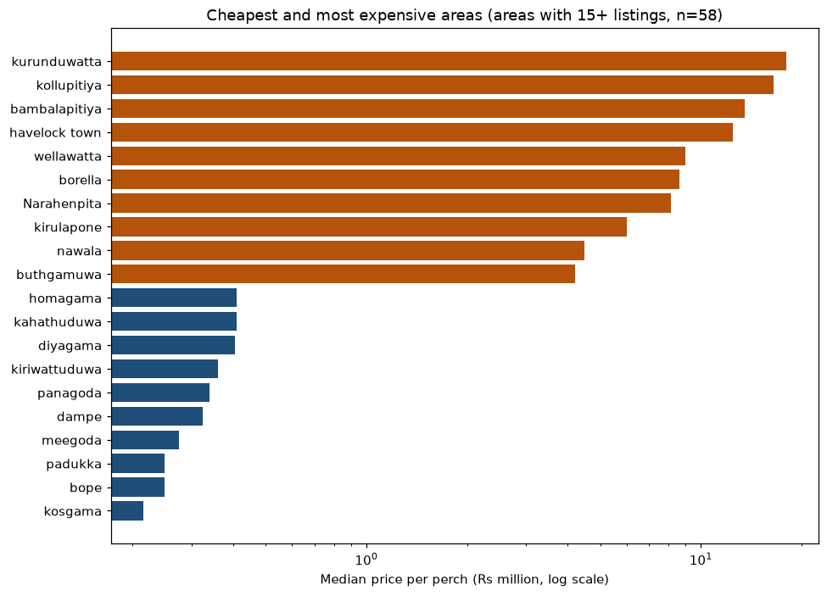
Figure 2: Median price per perch in the 10 cheapest and 10 most expensive areas (log scale)
Two modelling decisions follow from this. First, the area is likely to be the single most informative piece of information. Second, with so many rare areas, one-hot encoding would create many columns that each describe only a handful of listings. Cross-fitted target encoding and CatBoost’s native handling cope much better with rare categories (Section 3.6).
Correlations. Spearman correlation was used instead of Pearson, because prices are heavily skewed and the relationships only need to be consistently increasing or decreasing, not straight lines (Figure 3, left).
- Distance from Fort has the strongest relationship with price (ρ = −0.81), followed by distance to the nearest grade-A government school (−0.78).
- The number of supermarkets (+0.76) and banks (+0.75) within 2 km are the strongest positive relationships. They act as measures of how built-up and commercial an area is.
- Land size is positively related to price per perch (ρ = +0.40), which is unexpected; Section 6.1 discusses why.
- The land type columns have weak relationships with price on their own (|ρ| < 0.15).
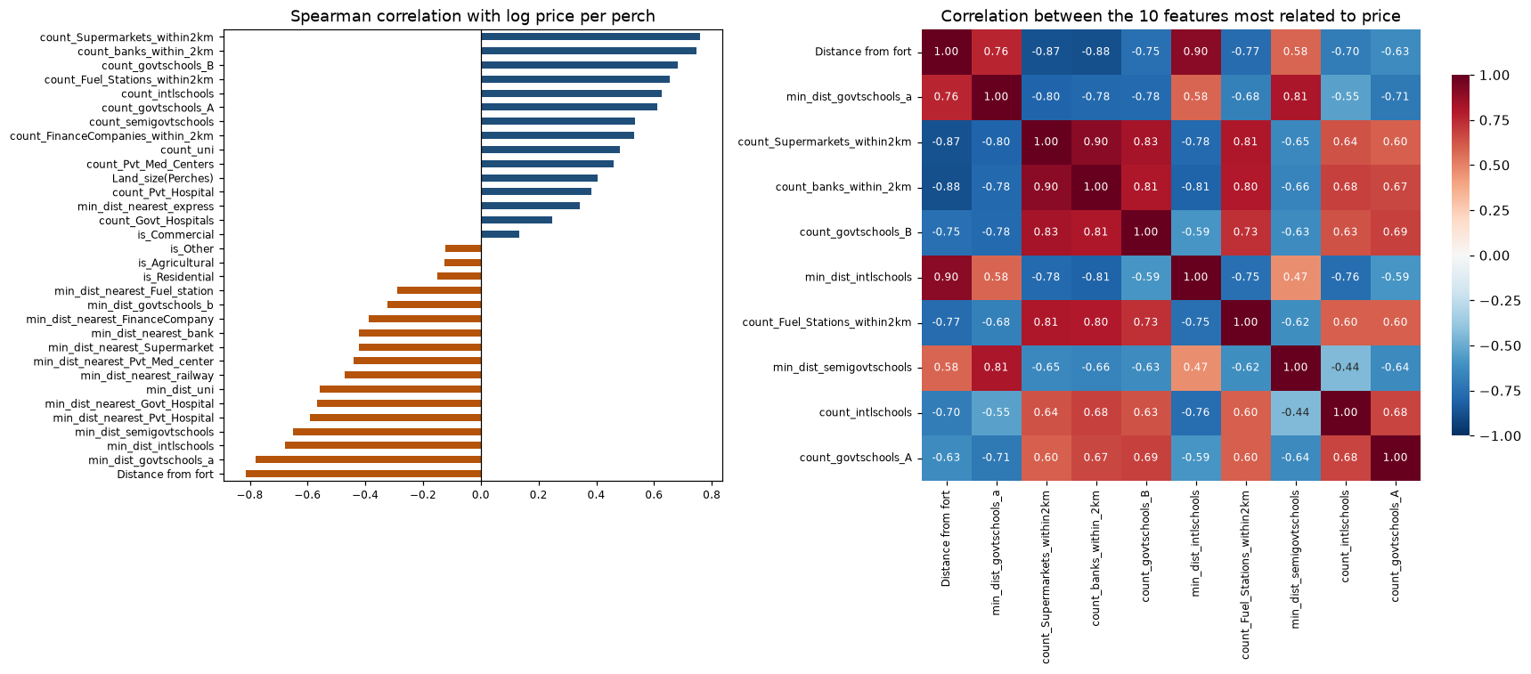
Figure 3: Spearman correlation of each feature with log price (left) and between the ten features most related to price (right)
The right-hand side of Figure 3 shows that the location features are strongly correlated with each other. Among the ten features most related to price, 22 of the 45 pairs have |ρ| above 0.7; for example, distance from Fort and the number of banks within 2 km have ρ = −0.88. These features mostly describe the same thing: how central and built-up an area is. This multicollinearity is why Random Forest was allowed to consider only a subset of features at each split (Section 4.3), and why feature importances must be read for location as a whole rather than feature by feature (Sections 6.1 and 6.4). It was also the first sign of the finding in Section 3.7, that the location features are recorded per area.
The final modelling table has 4,275 rows, 33 features and the log target.

4. Methodology

4.1 Data split and validation
- One listing was set aside for the inference demonstration (a 9.7-perch plot in Dampe) before anything else. It was not used in training, tuning or testing.
- The remaining 4,274 rows were split 80/20 into training (3,419) and test (855) sets. The split was stratified by price thirds, so cheap and expensive land are equally represented in both sets.
- All tuning and model selection used 5-fold cross-validation on the training set only. Each model was evaluated on the test set once, so the choice of final model is not biased towards whatever happened to suit the test split.
Metrics. The main metric is the RMSE of the log price. Because the target is in logs, an RMSE of 0.37 means predictions are typically within a factor of about e^0.37 ≈ 1.45 of the true price. R² on the log scale is also reported. Converted back to rupees, the MAE, the mean absolute percentage error (MAPE) and the median absolute percentage error are reported. The median percentage error is the most useful single number for a buyer, since it isn’t dominated by a few very cheap plots where a small rupee error is a large percentage.

4.2 Models
Model | Why it was included
Ridge regression | Baseline. If tree models can’t beat a linear model clearly, their extra complexity isn’t justified
Random Forest | Required. Averages many deep, de-correlated trees; robust to noise and needs little preprocessing
XGBoost | Required. Gradient boosting: trees built one after another, each correcting the errors of the previous ones
LightGBM | Another gradient boosting library that grows trees leaf-wise; a check that XGBoost’s result isn’t implementation-specific
CatBoost | Built for categorical features. The most informative feature, Address, has 160 categories, and CatBoost encodes them with ordered target statistics
Stacking | Combines the tuned RF, XGBoost and CatBoost with a Ridge meta-model; helps when the base models make different mistakes
Deep learning was not used, following the module guideline, and with 4,000 tabular rows it would not be expected to beat gradient boosting anyway.

4.3 Hyperparameter design
Every model was first trained with library defaults, then tuned with RandomizedSearchCV (5-fold CV, minimising log RMSE). The search ranges were chosen for this dataset of about 3,400 training rows and 33 features, whose prices are noisy because they are asking prices, not sale prices.
Random Forest (25 candidates)
Parameter | Search range | Selected | Reasoning
n_estimators | 200-800 | 271 | More trees reduce variance, but the gain flattens after a few hundred
max_depth | 10, 15, 20, 30, unlimited | 20 | Unlimited trees can memorise individual listings
min_samples_leaf | 1, 2, 3, 5, 8 | 3 | Leaves of a single listing would fit noise in the asking prices
max_features | 0.3-1.0 | 0.3 | Many features are highly correlated (Section 3.7); considering fewer at each split makes the trees more different from each other
max_samples | 70%, 85%, 100% | 100% | Bootstrap sample size
XGBoost (40 candidates)
Parameter | Search range | Selected | Reasoning
learning_rate | 0.01-0.2 (log scale) | 0.0127 | Small steps generalise better but need more trees
n_estimators | 300-1500 | 1066 | Paired with the small learning rate
max_depth | 3-8 | 5 | Boosted trees should be shallow; each corrects only part of the error
min_child_weight | 1-10 | 1 | Minimum data needed in a leaf
subsample / colsample_bytree | 0.6-1.0 / 0.5-1.0 | 0.79 / 0.78 | Random row and column sampling to reduce overfitting
reg_lambda / gamma | 0.1-10 / 0-0.3 | 4.04 / 0.18 | L2 penalty on leaf values, and minimum gain required to split
LightGBM (30 candidates) selected num_leaves 15, learning_rate 0.0125, n_estimators 820, min_child_samples 11, subsample 0.60, colsample_bytree 0.90 and reg_lambda 0.25.
CatBoost (12 candidates from a grid of depth 4/6/8, learning rate 0.03/0.06/0.1, l2_leaf_reg 1/3/5/10 and 800/1200 iterations) selected depth 8, learning rate 0.03, l2_leaf_reg 5 and 800 iterations.
A pattern runs through all of these choices: every model chose strong regularisation. Random Forest considers only 30% of features per split and needs 3 listings per leaf. XGBoost and LightGBM chose very small learning rates, sub-sampling and small trees (LightGBM’s 15 leaves is near the bottom of its range). This is consistent with what Section 3.7 found: within an area there is little real signal beyond size and type, so the best models are the ones that avoid chasing noise.

5. Results

5.1 Model comparison
Model | CV RMSE (log) | Test RMSE (log) | Test R² (log) | Test MAE (Rs/perch) | Test MAPE | Test median APE
Stacking (RF + XGB + Cat) | 0.4265 | 0.3677 | 0.866 | 554,620 | 23.2% | 11.8%
LightGBM (tuned) | 0.4274 | 0.3726 | 0.862 | 567,464 | 24.5% | 13.5%
XGBoost (tuned) | 0.4282 | 0.3729 | 0.862 | 561,203 | 24.2% | 12.2%
Random Forest (tuned) | 0.4289 | 0.3742 | 0.861 | 552,220 | 23.1% | 11.5%
CatBoost (tuned) | 0.4311 | 0.3677 | 0.866 | 565,099 | 24.0% | 12.3%
Random Forest (default) | 0.4450 | 0.4092 | 0.834 | 537,807 | 24.3% | 10.3%
XGBoost (default) | 0.4490 | 0.4138 | 0.830 | 594,944 | 25.6% | 11.0%
Ridge (baseline) | 0.4509 | 0.4063 | 0.836 | 594,270 | 28.8% | 16.5%
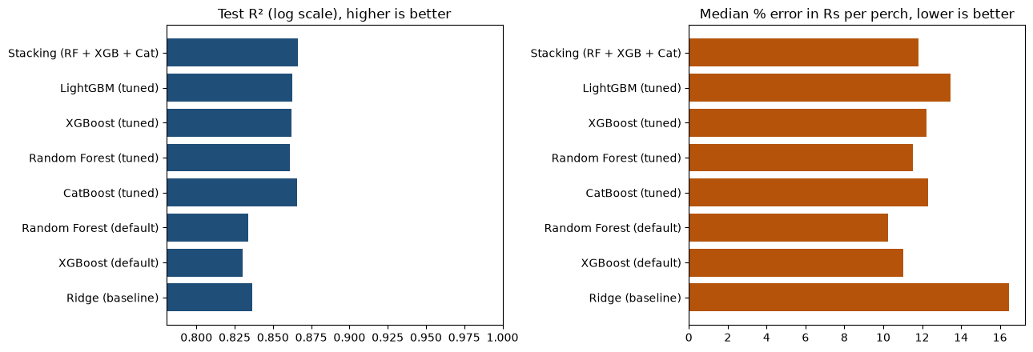
Figure 4: Test R² and median percentage error for each model
The main observations are:
- Tuning clearly helped. Tuning reduced the cross-validated RMSE of Random Forest from 0.445 to 0.429 and of XGBoost from 0.449 to 0.428. Test R² rose from about 0.83 to 0.86 for both. The defaults (unlimited tree depth for Random Forest, a fast learning rate for XGBoost) overfit this noisy data.
- The tuned tree models are very close to each other. All five tuned models fall within 0.005 RMSE in cross-validation, which is smaller than the variation between folds. No single algorithm is clearly better here; the dataset, not the algorithm, limits the accuracy.
- The linear baseline is already strong (R² 0.836). The tree models improve on it by about 3 points of R² and cut its median error from 16.5% to about 12%. That improvement is real and useful, but modest. Section 6.3 explains why: most of the price is explained by the area, which even a linear model captures through the target-encoded area feature.
- The default Random Forest has the lowest median error (10.3%) despite having a worse RMSE. RMSE penalises large errors heavily, so tuning for RMSE made the models more careful about the expensive outliers, at a small cost on typical listings. Which one is “better” depends on whether large errors or typical errors matter more. For a pricing tool, avoiding large mistakes is the better priority, so the RMSE-based selection was kept.

5.2 Final model
The stacked ensemble had the lowest cross-validated RMSE (0.4265) and was selected as the final model. On the test set it also shares the best R² (0.866) with CatBoost. The Ridge meta-model gave weights of 0.47 to Random Forest, 0.30 to CatBoost and 0.22 to XGBoost. The ensemble leans most on Random Forest, whose averaging approach makes different errors from the two boosting models.
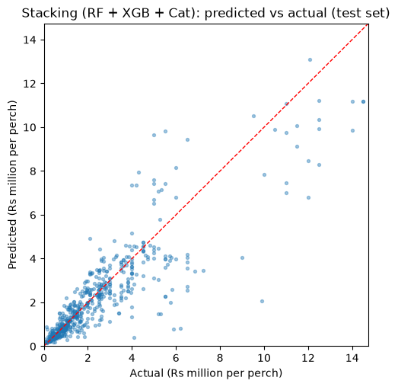
Figure 5: Predicted vs. actual price per perch on the test set (final model)
Figure 5 shows the predictions follow the actual prices well across the range. Two patterns are visible: the spread grows with price (expected, since errors are roughly proportional), and the very highest prices are under-predicted. Rare, very expensive plots in central Colombo are pulled towards the average of their area.

6. Interpretation

6.1 Which features matter
Permutation importance was used: each feature is shuffled in the test set, and the importance is how much the RMSE increases. Unlike the built-in importances, this works the same way for every model, including the stacked ensemble.
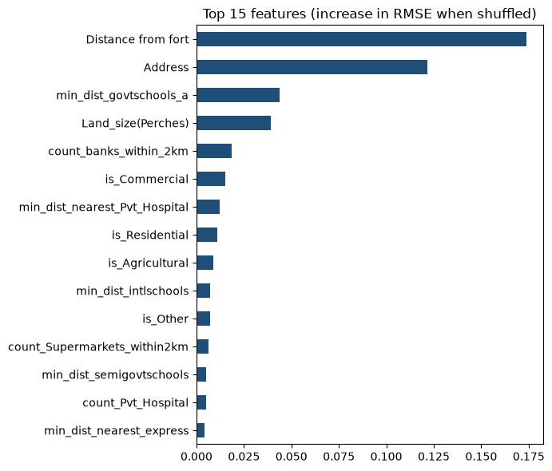
Figure 6: Permutation importance of the final model
The two strongest features are distance from Colombo Fort and area. Because all location features are constant within an area (Section 3.7), these two carry largely the same information, and the importance is divided between them somewhat arbitrarily. The fair reading is that location as a whole dominates. Among the remaining features, land size and the land type columns (commercial, residential, agricultural) matter most, since they are the only features that vary between plots in the same area.
The direction of the main effects, measured directly from the data (median price per perch by quartile):
Feature | Lowest quartile | Highest quartile | Direction
Distance from Fort | Rs 3.75 M (3-13 km) | Rs 0.44 M (22-43 km) | About 8.5× cheaper furthest from the city
Distance to railway | Rs 2.60 M (< 1 km) | Rs 0.44 M (> 6.7 km) | Closer to rail = more expensive
Banks within 2 km | Rs 0.59 M (0-2 banks) | Rs 3.70 M (15+ banks) | Proxy for how commercial/urban the area is
Land size | Rs 0.65 M (≤ 7 perches) | Rs 2.35 M (> 16 perches) | Larger plots cost more per perch
The last row is counter-intuitive, since bulk land is usually cheaper per unit. It is most likely explained by where the plots are, not by their size. Small plots of 6-10 perches are typical of suburban housing developments sold off a larger block, while large plots in the dataset are more often commercial land in built-up areas. This is a reminder that these figures show associations, not causes.

6.2 Price-band classification
For the classification extension, the training prices were split into thirds: Low (below Rs 672,486 per perch), Medium (up to Rs 1,800,000) and High (above). The band edges were calculated from the training data only.
Model | Accuracy | Macro F1
Random Forest classifier (tuned) | 0.905 | 0.905
XGBoost classifier (tuned) | 0.897 | 0.896
Final regression model, prediction converted to a band | 0.892 | 0.892
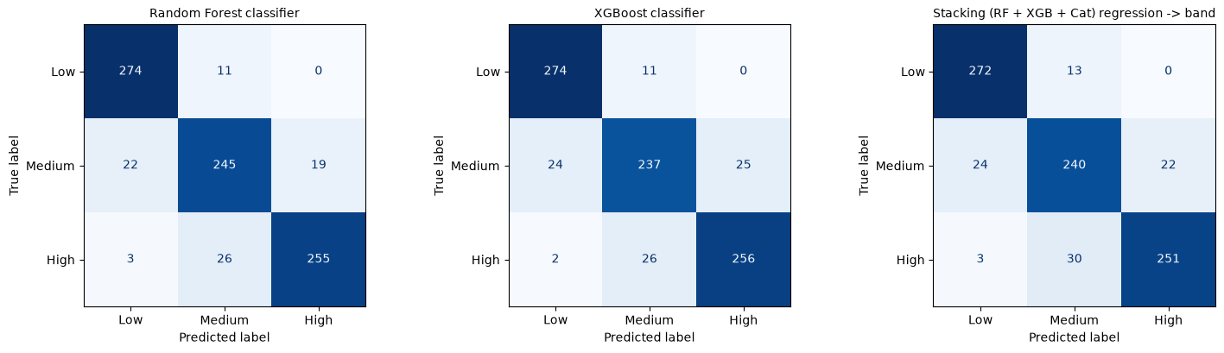
Figure 7: Confusion matrices for the three approaches
All three approaches reach about 90% accuracy, and almost every mistake is between neighbouring bands. A Low plot is almost never classified as High or the other way round (Figure 7). Medium is the hardest class (F1 0.86, against 0.94 for Low and 0.91 for High), as expected: plots near either edge of the Medium band can fall on either side through small price differences. Training a dedicated classifier gave only slightly better results than converting the regression output to a band. This shows the two framings capture the same underlying information.

6.3 Seen areas vs. unseen areas
Because the location features are fixed per area (Section 3.7), the price variation can be split into two parts. 81% of the variance in log price is between areas and only 19% is within areas. Most of what the models learn is therefore “what does land cost in this area”, and the remaining 19% has to be explained by land size, land type and noise.
The random split used in Section 5 tests seen areas: almost every area in the test set also appears in the training set. That is the right test for the application, which only offers areas from the dataset. It doesn’t show whether the models have learnt anything general about location. To check that, the models were also evaluated with grouped cross-validation (GroupKFold, grouped by area). Each fold’s test areas are completely absent from its training data, so the model can’t use the area name and has to rely on the 27 location features (03_unseen_areas.ipynb).
Model | CV RMSE, seen areas | CV R², seen areas | CV RMSE, unseen areas | CV R², unseen areas
Ridge (baseline) | 0.451 | 0.808 | 0.672 | 0.541
Random Forest (tuned) | 0.429 | 0.827 | 0.557 | 0.688
XGBoost (tuned) | 0.428 | 0.827 | 0.576 | 0.665
CatBoost (tuned) | 0.431 | 0.825 | 0.542 | 0.703
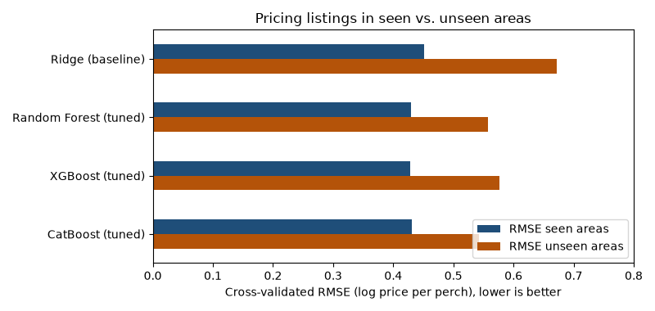
Figure 8: Cross-validated error for seen vs. unseen areas
(These are cross-validation figures on the training set, which is why the seen-area R² of about 0.83 is a little lower than the 0.86 measured on the test set in Section 5.)
Three conclusions follow:
- Unseen areas are much harder. The error rises from about 0.43 to 0.54-0.58 for the tree models. In practical terms, a typical prediction moves from within a factor of about 1.5 of the true price to within a factor of about 1.7. The models are noticeably less reliable for an area outside the dataset, which is why the application only offers known areas.
- This is where the tree models really earn their place. With seen areas, the tree models beat Ridge by only about 0.02 in RMSE. With unseen areas the gap grows to over 0.1: R² 0.69-0.70 against 0.54. Once the area name isn’t available, price has to be inferred from the distances and counts, and those relationships are non-linear (the effect of distance to Fort flattens out beyond about 20 km, for example). Trees capture that; a linear model can’t.
- The location features do carry real, general information. An R² of 0.70 for areas the model has never seen means that distance to the city, transport and the density of banks, schools and hospitals explain most of the difference in price between areas. Within an area, as noted, they can’t help, because they don’t vary.
CatBoost generalises best to new areas. Its ordered target statistics treat an unknown area cleanly as “no information”, while the stacked ensemble’s target encoder falls back to the overall average. For a future version of the application that allowed new areas, CatBoost on its own would be the better choice. For the current application, restricted to known areas, the stacked ensemble remains the best model.

6.4 Explainability with SHAP and LIME
Permutation importance (Section 6.1) shows which features matter overall. It doesn’t show in which direction they push the price, or why the model priced one particular plot as it did. Two explainability methods were applied to the final stacked model for this (04_explainability.ipynb):
- SHAP splits every prediction into a contribution from each feature, so that the baseline plus the sum of the contributions equals the prediction. Because a stacked ensemble can’t be opened up by tree-specific methods, the model-agnostic PermutationExplainer was used, with 50 training listings as the background, to explain 120 test listings.
- LIME explains a single prediction. It creates 5,000 perturbed copies of the listing, asks the model to price each one, and fits a simple weighted linear model to the answers.
Both methods work on numbers, so each area name was given an integer code, and a small wrapper converts the codes back to names before calling the model. A check confirmed that the wrapper gives exactly the same predictions as the model. All explanations are on the log scale, where a contribution of −0.10 means roughly 10% lower in price.
Global explanation (SHAP).
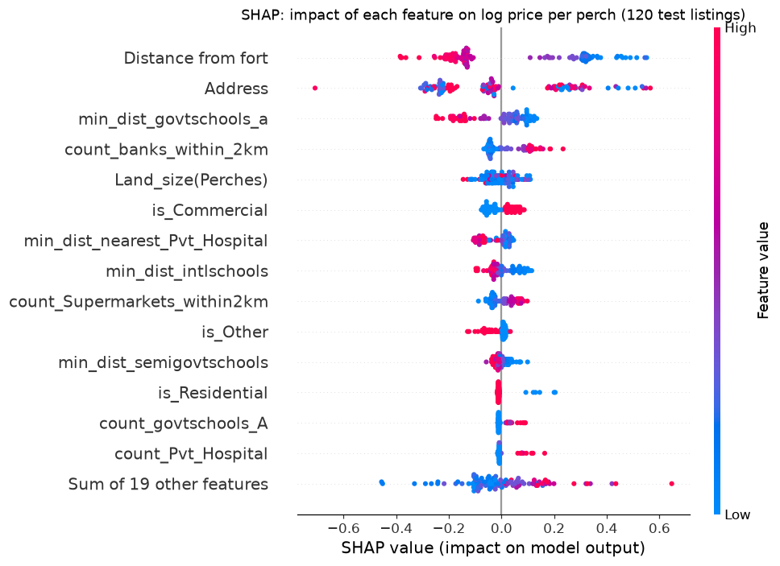
Figure 9: SHAP summary of 120 test listings (red = high feature value, blue = low)
Figure 9 confirms the direction of the main effects found in Section 6.1, now for the model itself rather than the raw data:
- Distance from Fort: a long distance (red) pushes the price down by up to about 0.4 (around 33% lower). Short distances (blue) push it up by as much as 0.5.
- Banks within 2 km and supermarkets within 2 km: more of them (red) raise the price, a sign of a built-up, commercial area.
- Distance to grade-A government schools and private hospitals: being far from them lowers the price.
- Land type: commercial land (is_Commercial = 1) is priced higher, and land listed as “Other” lower.
- Land size has small effects in both directions, which matches its low importance.
Grouped view. Section 3.7 showed that the location features are constant within an area, so SHAP splits the credit between them somewhat arbitrarily. Adding the contributions together gives a fairer summary:
Feature group | Share of total SHAP impact
Location (area + 27 distance and count features) | 87.1%
Land type (4 columns) | 8.6%
Land size | 4.3%
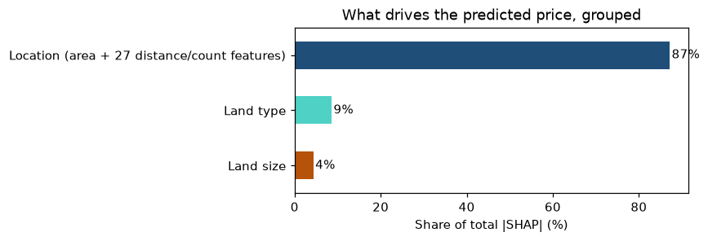
Figure 10: SHAP impact grouped into location, land type and land size
This matches the finding in Section 6.3 that 81% of price variation lies between areas, reached in a completely different way. Where the land is explains almost all of the model’s decisions.
Local explanation of the held-out listing (SHAP). The Dampe listing kept aside for inference (Section 7.1) had an actual price of Rs 300,000 per perch and a predicted price of Rs 332,620.
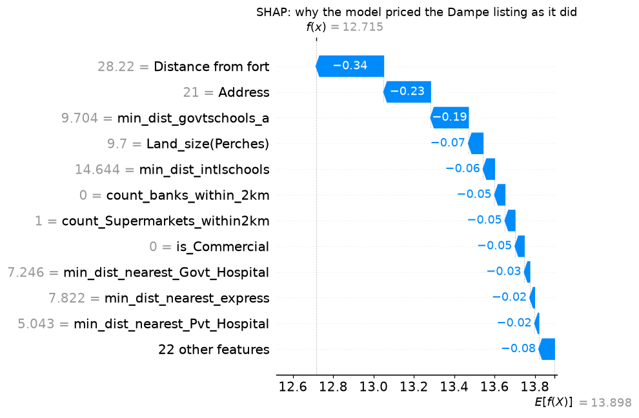
Figure 11: SHAP waterfall for the held-out Dampe listing (Address is shown as its area code; 21 = Dampe)
The model starts from the average prediction (13.898 on the log scale, about Rs 1.09 million per perch). Every major feature then pulls the price down. The plot is 28 km from Fort (−0.34), Dampe is a low-priced area (−0.23), the nearest grade-A school is almost 10 km away (−0.19), and there are no banks and only one supermarket within 2 km. The contributions add up to −1.183, which gives 12.715 on the log scale: exactly the model’s prediction of Rs 332,620. In plain terms, the model sees an outer-suburban, non-commercial plot far from city amenities and prices it at about a third of the average.
Local explanation of the same listing (LIME).
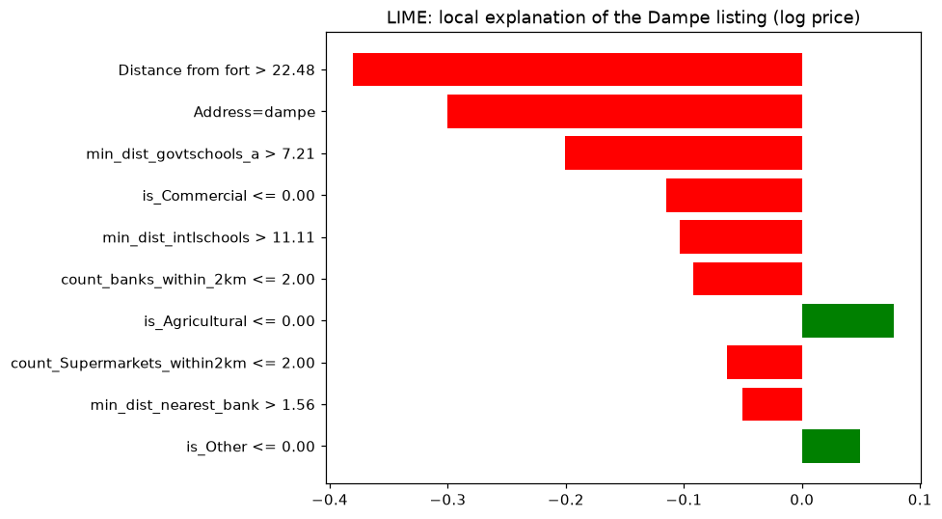
Figure 12: LIME explanation for the held-out Dampe listing (red = lowers the price, green = raises it)
Comparison of the two methods for the Dampe listing:
Feature | SHAP contribution | LIME weight | Same direction?
Distance from Fort | −0.336 | −0.380 | Yes
Address (Dampe) | −0.233 | −0.300 | Yes
Distance to grade-A govt. school | −0.187 | −0.201 | Yes
Land size | −0.073 | – | Not in LIME’s top 10
Distance to international school | −0.057 | −0.104 | Yes
Banks within 2 km | −0.051 | −0.092 | Yes
Supermarkets within 2 km | −0.050 | −0.063 | Yes
Commercial land | −0.046 | −0.115 | Yes
The two methods agree on the top three drivers, in the same order and with similar sizes, and on the direction of every feature they both list. This agreement makes the explanation more trustworthy, since the methods work in very different ways.
Limits of the explanations.
- LIME’s local linear model has an R² of only 0.29, so it captures the model’s behaviour around this listing only roughly. It is best read as a check on direction, with SHAP as the main explanation.
- Both methods change one feature at a time. Here the location features always move together, so some perturbed listings combine one area’s name with another area’s distances, a combination that never occurs in the data. This is why the grouped SHAP view is the most reliable reading, and why individual location features should be read as a group.

7. Inference and Application

7.1 Inference on a held-out listing
The listing set aside at the very start (Section 4.1) was used to demonstrate inference. The model was loaded back from the pickle file, exactly as the application does:
Listing | Dampe, 9.7 perches
Actual asking price | Rs 300,000 per perch
Predicted price | Rs 332,620 per perch (+10.9%)
Predicted total price | Rs 3,226,419
Predicted band | Low (correct)
The error of about 11% is in line with the test set’s median error of 11.8%.

7.2 Front-end application
A small web application (app.py, built with Streamlit) puts the model in front of a user. The user:
- selects the area from the 160 areas in the dataset,
- enters the land size in perches, and
- selects one or more land types.
The application then shows the predicted price per perch, the estimated total price and the price band. The model, the feature list, the band edges and each area’s location values are all loaded from land_price_model.pkl. The location features are filled in automatically from the selected area and shown for information only. Section 3.7 showed they are fixed per area, so letting the user edit them would create combinations the model never saw.
Two example predictions for a 10-perch residential plot:
Area | Predicted price per perch | Band
Kollupitiya (central Colombo) | about Rs 13.1 million | High
Kaduwela (suburban) | about Rs 460,000 | Low
To run the application: pip install streamlit scikit-learn xgboost catboost pandas, then streamlit run app.py from the Assignment_2 folder.

8. Limitations and Future Work
- Asking prices, not sale prices. Advertisements show what sellers hope to get. Actual transaction prices are usually lower and are not public in Sri Lanka.
- The data is from 2021. Since then, the 2022 economic crisis and high inflation have changed land prices considerably, so the absolute rupee values are out of date. The relative patterns (location, size and type effects) are more likely to still hold. The model should be retrained on recent listings before practical use.
- Location is recorded per area, not per plot (Section 3.7). This is the biggest limitation. Two plots in the same area, one on a main road and one down a narrow lane, look identical to the model. Geocoding each listing would let the 27 location features describe the actual plot.
- Missing plot features such as road frontage, road width, shape, slope and flood risk are known to affect Sri Lankan land prices strongly but are not in the dataset.
- Repeated developer listings. Many plots from the same block, advertised at the same price, can appear in both the training and test sets. This makes the seen-area scores somewhat optimistic for genuinely new developments.

9. Conclusion
A model was built to estimate the asking price per perch of land in the Colombo district from 4,275 cleaned listings. Preprocessing corrected a price-scale error in the data, removed duplicates, and handled the heavily skewed target with a log transform, so that only 21 true outliers had to be removed instead of 297 genuine high-value listings. Random Forest and XGBoost were tuned instead of used with defaults, which improved R² from about 0.83 to 0.86, and LightGBM, CatBoost and a stacked ensemble were added. The stacked ensemble was selected as the final model on cross-validation, reaching an R² of 0.866 on the log scale and a median error of about 12%. A Random Forest classifier assigned Low, Medium and High price bands with 90.5% accuracy.
The most important finding came from the data rather than the models: the location features are recorded per area, not per plot. As a result, location (area) explains most of the price, all well-tuned tree models perform almost identically, and accuracy is limited by the data rather than by the choice of algorithm. SHAP confirmed this from inside the model: location accounts for 87% of its decisions. SHAP and LIME explanations of the held-out listing agreed on its main drivers (distance from the city, the area itself, and distance to good schools). Better data, meaning per-plot coordinates, recent prices and plot features such as road access, would improve the model more than any further tuning.

Use of AI Tools
[To review and adjust before submission.] In line with the module guideline, AI assistance (Claude) was used for coding support and for generating the front-end application. The modelling decisions, results and interpretation were reviewed and understood by the author, and all numbers in this report come from the accompanying notebooks.

References
- Breiman, L. (2001). Random Forests. Machine Learning, 45(1), 5-32.
- Chen, T. and Guestrin, C. (2016). XGBoost: A Scalable Tree Boosting System. Proceedings of the 22nd ACM SIGKDD International Conference on Knowledge Discovery and Data Mining, 785-794.
- Ke, G. et al. (2017). LightGBM: A Highly Efficient Gradient Boosting Decision Tree. Advances in Neural Information Processing Systems 30.
- Prokhorenkova, L. et al. (2018). CatBoost: unbiased boosting with categorical features. Advances in Neural Information Processing Systems 31.
- Pedregosa, F. et al. (2011). Scikit-learn: Machine Learning in Python. Journal of Machine Learning Research, 12, 2825-2830.
- ruchiraayeshmantha (n.d.). Land prices of Colombo district [Dataset]. Kaggle. https://www.kaggle.com/datasets/ruchiraayeshmantha/land-prices-of-colombo-district (accessed 8 October 2026).
- Lundberg, S. M. and Lee, S.-I. (2017). A Unified Approach to Interpreting Model Predictions. Advances in Neural Information Processing Systems 30.
- Ribeiro, M. T., Singh, S. and Guestrin, C. (2016). “Why Should I Trust You?”: Explaining the Predictions of Any Classifier. Proceedings of the 22nd ACM SIGKDD International Conference on Knowledge Discovery and Data Mining, 1135-1144.
- IT5514 Applied Machine Learning lecture notes and lab sheets: Decision Trees and Random Forest, XGBoost, and the feature engineering lab (IQR outlier method).

