**LAB_Exercise01_Neo4j**

B.**Hemanth**

**22MIA1083**

1. **List top 10 stations with most outbound trips (Show station name and number of trips)**

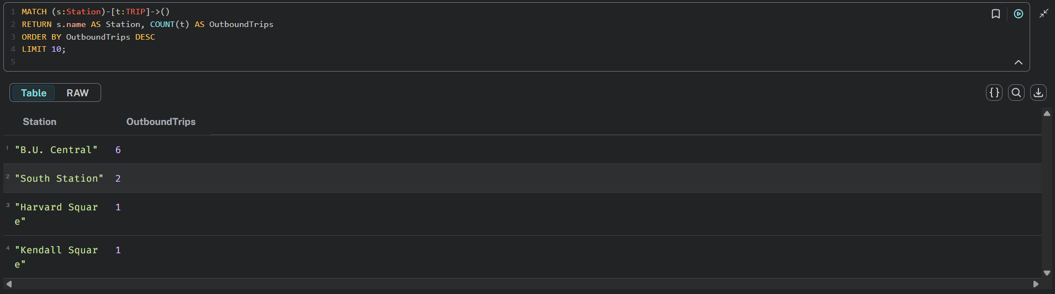

1. **List top 10 stations with most inbound trips (Show station name and number of trips)**

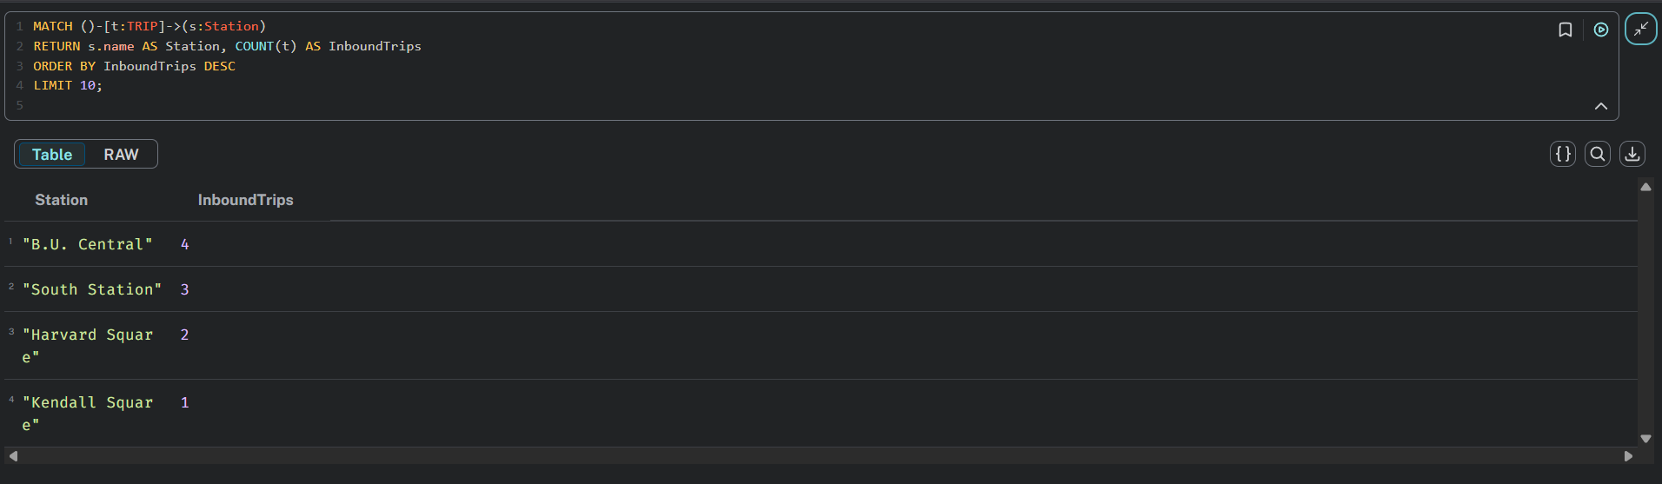

**c. List top 5 routes with most trips (Show starting station name, ending station name and number of trips) (4) List the hour number (for example 13 means 1pm -2pm) and number of trips which start from the station "B.U. Central"**

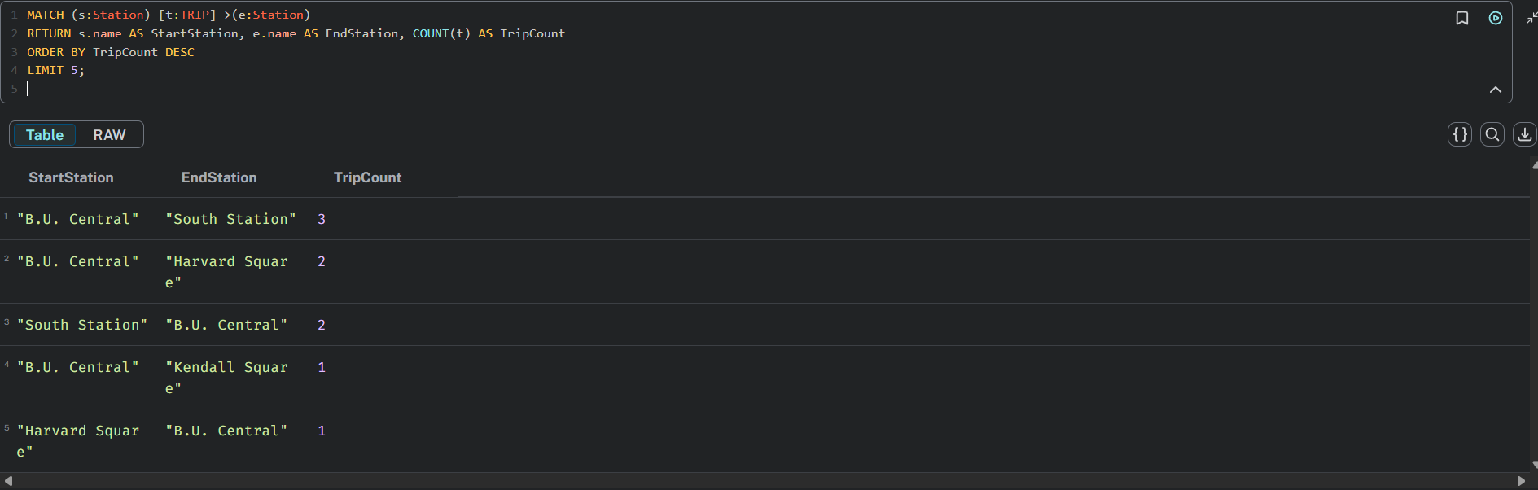

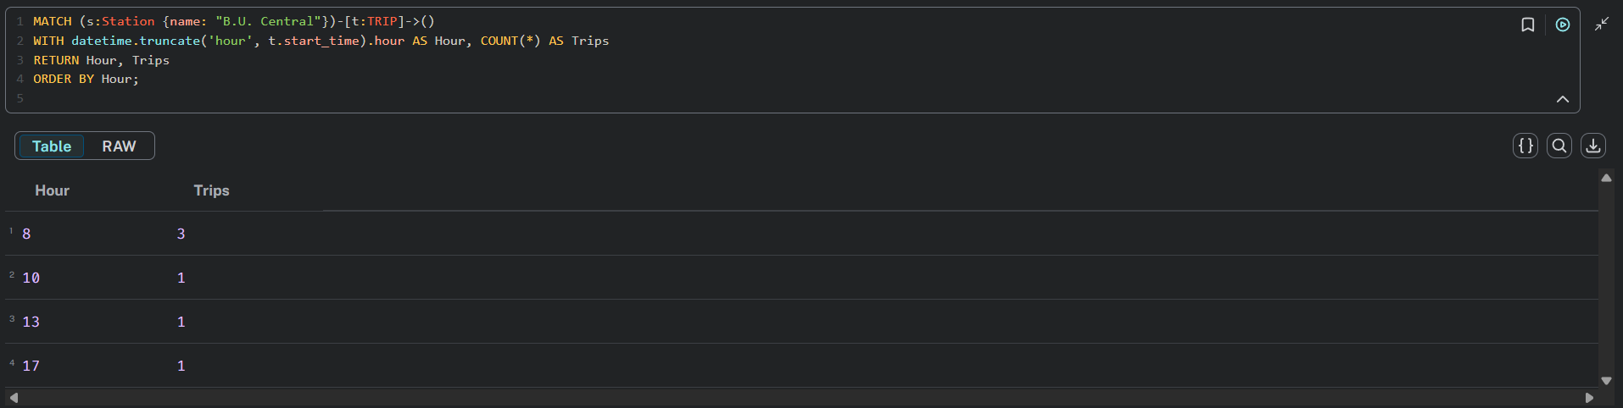

1. **List the hour number (for example 13 means 1pm -2pm) and number of trips which end at the station "B.U. Central" 2.**

