EXP-7
Bank
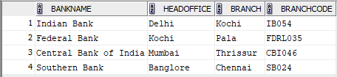
TCL Commands
1.Commit
Insert Into Bank Values('Indian Bank', 'Delhi', 'Kochi', 'IB054');

Commit;

2.SAVEPOINT
Insert Into Bank Values('Federal Bank', 'Kochi', 'Pala', 'FDRL035');
Insert Into Bank Values('Central Bank of India', 'Mumbai', 'Thrissur', 'CBI046');
savepoint sp1;


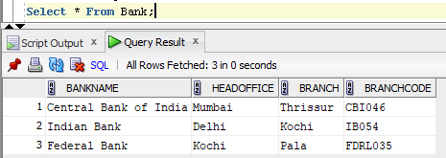

3.ROLLBACK
Insert Into Bank Values('Southern Bank', 'Banglore', 'Chennai', 'SB024');
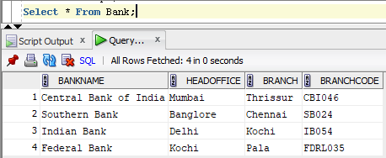

Rollback To Sp1;

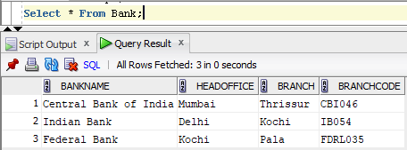

DCL Commands
Grant
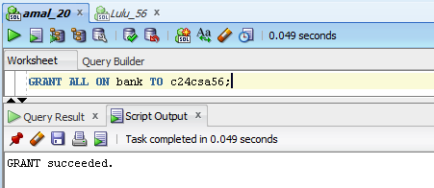
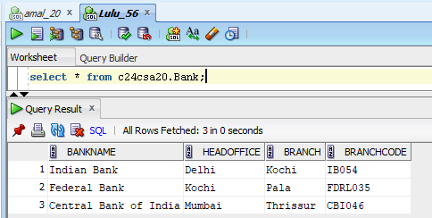
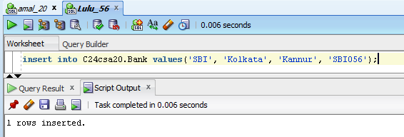
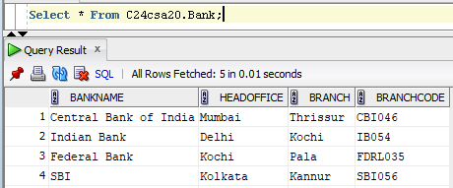

Revoke
