COURSES
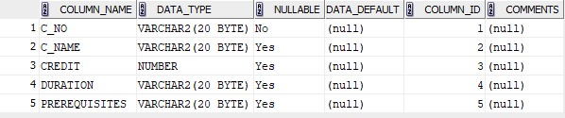

DEPARTMENT
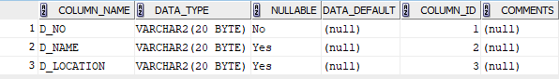

INSTRUCTOR
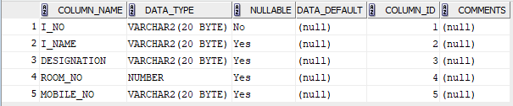

STUDENT
