EXP-2
Tables
Instructor
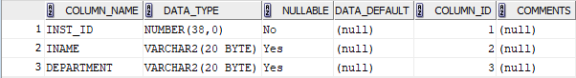

Courses
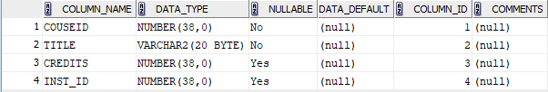
Student
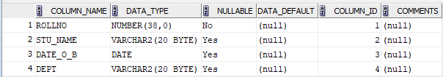
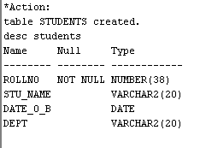
Enollment
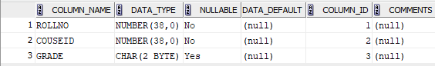
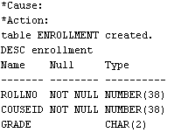
Indexing
