EXP-5
Customers
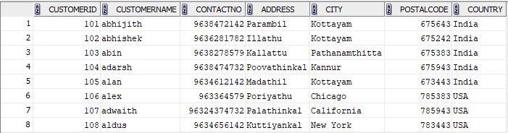

Employees
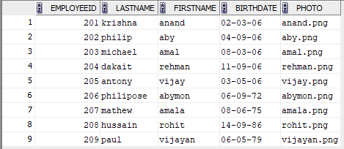

Orders
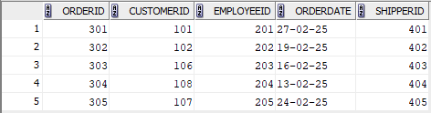
1.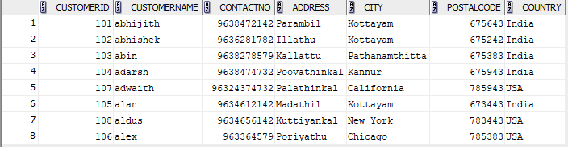
2. 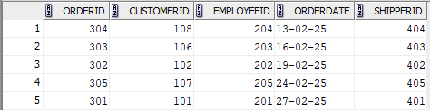

3. 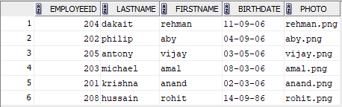
4. 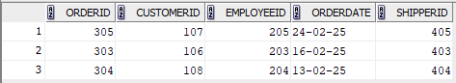
5.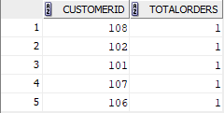
6.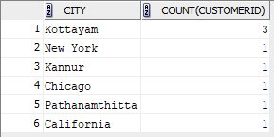
7.
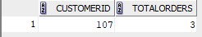

8.
