EXP-6
Items
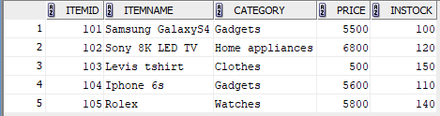

Customers
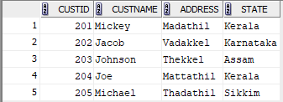

Orders
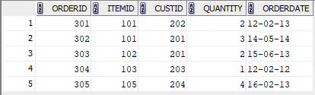

Delivery
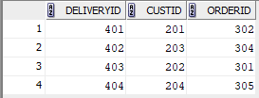

1.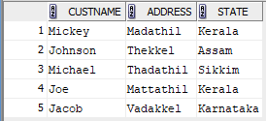

2.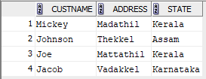

3.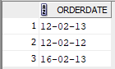

4.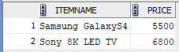

create table items(itemid int primary key, Itemname varchar(50), category varchar(50), Price decimal(10, 2), Instock int);
create table customers_6(custid int primary key, Custname varchar(20), Address varchar(50), state varchar(30));
create table orders_6(orderid int primary key, itemid int, custid int, foreign key (itemid) references items, foreign key (custid) references customers_6, Quantity int, Orderdate date);
create table delivery(deliveryid int primary key, custid int, orderid int, foreign key (custid) references customers_6, foreign key (orderid) references orders_6);

insert into items values(101, 'Samsung GalaxyS4', 'Gadgets', 5500.00, 100);
insert into items values(102, 'Sony 8K LED TV', 'Home appliances', 6800.00, 120);
insert into items values(103, 'Levis tshirt', 'Clothes', 500.00, 150);
insert into items values(104, 'Iphone 6s', 'Gadgets', 5600.00, 110);
insert into items values(105, 'Rolex', 'Watches', 5800.00, 140);
select * from items;

insert into customers_6 values(201, 'Mickey', 'Madathil', 'Kerala');
insert into customers_6 values(202, 'Jacob', 'Vadakkel', 'Karnataka');
insert into customers_6 values(203, 'Johnson', 'Thekkel', 'Assam');
insert into customers_6 values(204, 'Joe', 'Mattathil', 'Kerala');
insert into customers_6 values(205, 'Michael', 'Thadathil', 'Sikkim');
select * from customers_6;

insert into orders_6 values(301, 101, 202, 2, '12/02/2013');
insert into orders_6 values(302, 101, 201, 3, '14/05/2014');
insert into orders_6 values(303, 102, 201, 2, '15/06/2013');
insert into orders_6 values(304, 103, 203, 1, '12/02/2012');
insert into orders_6 values(305, 105, 204, 4, '16/02/2013');
select * from orders_6;

insert into delivery values(401, 201, 302);
insert into delivery values(402, 203, 304);
insert into delivery values(403, 202, 301);
insert into delivery values(404, 204, 305);
select * from delivery;

select distinct(custname), address, state from customers_6 left join orders_6 on orders_6.custid=customers_6.custid;
select distinct(custname), address, state from customers_6 inner join delivery on delivery.custid=customers_6.custid;
select orderdate from orders_6 inner join customers_6 on orders_6.custid = customers_6.custid where customers_6.custname like 'J%';
select itemname, price from items inner join orders_6 on items.itemid=orders_6.itemid inner join customers_6 on orders_6.custid=customers_6.custid where custname='Mickey';
select distinct(custname), address from customers_6 inner join orders_6 on orders_6.custid = customers_6.custid inner join delivery on orders_6.custid=delivery.custid where orderdate > '31/01/2013' and delivery.custid is null;

