# attendence_calculator

Simple program to calculate how much attendance per subject is lost

3 Simple Steps to Follow:

**Step 1: Open any text editor or online Python interpreter**

I use GDB online(https://www.onlinegdb.com/online_python_compiler)

Copy paste my main.py code into your online gdb main.py

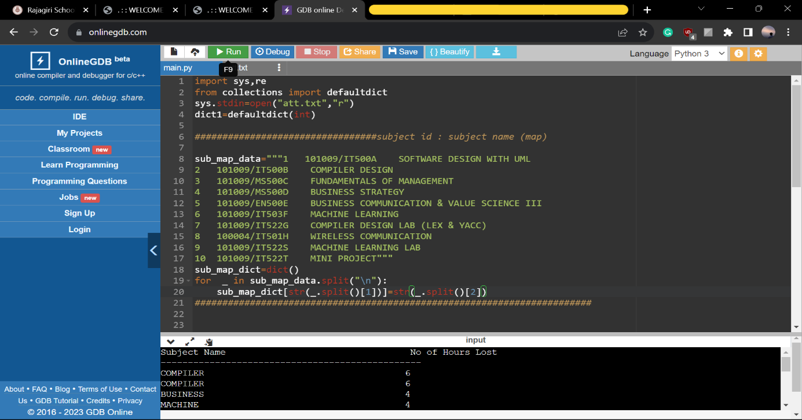

create a new file named “att.txt” (without quotes)  
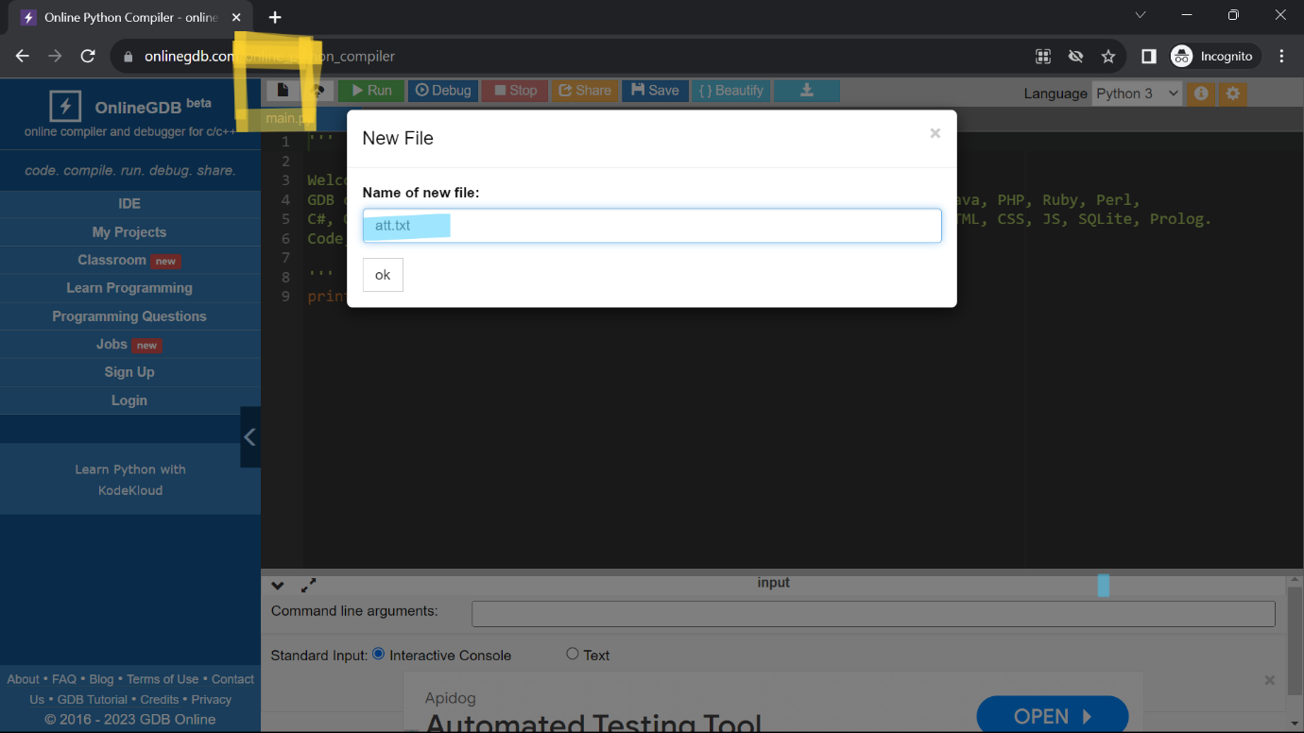

**STEP 2: COPY PASTE YOUR LOST ATTENDENCE FROM RSMS TO att.txt LIKE SHOWN IN THE IMAGE**

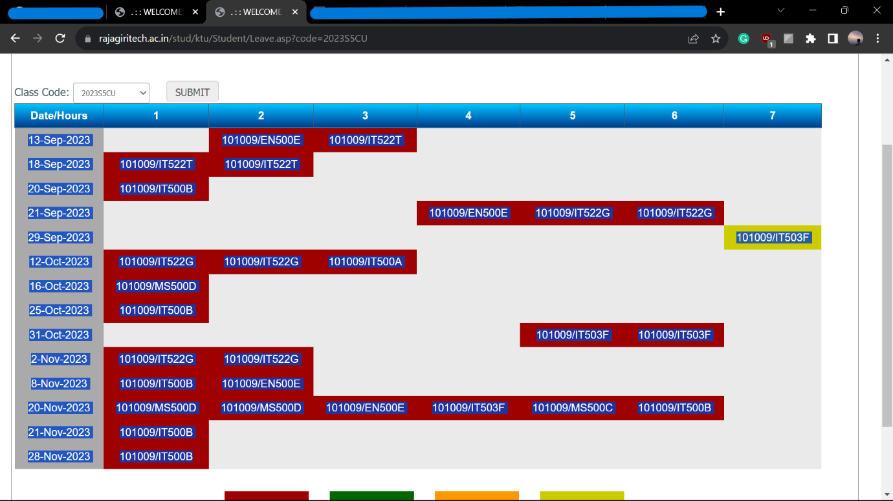

Now, the att.txt should look like this

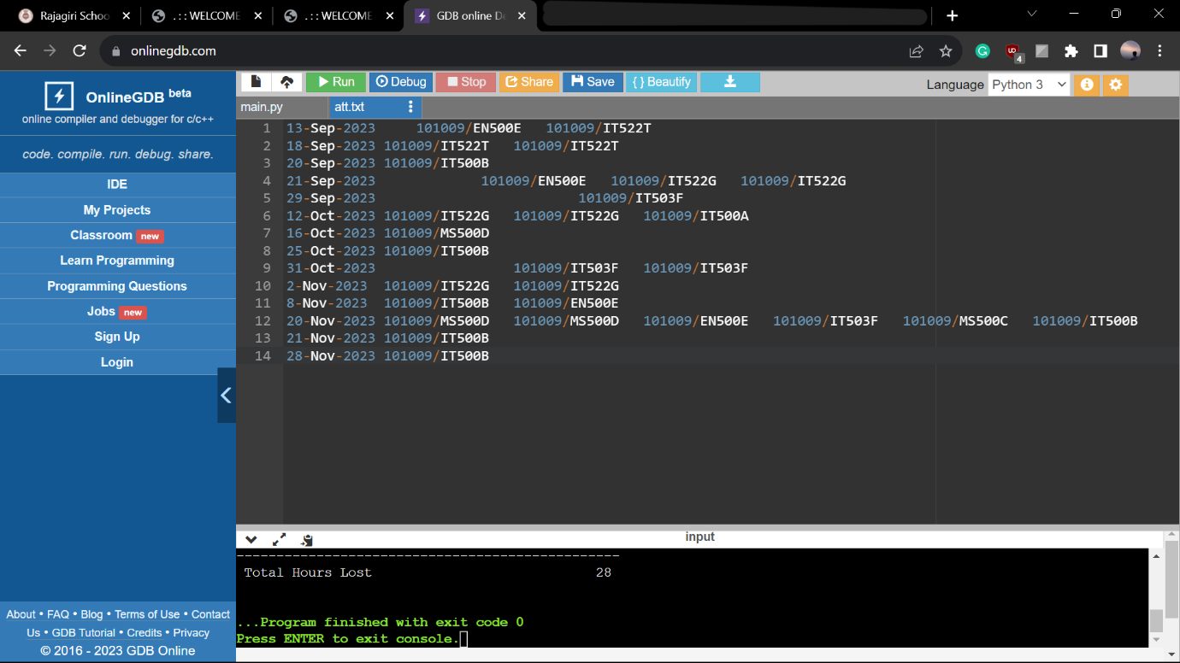

**Step 3: Go back to main.py and run the code  
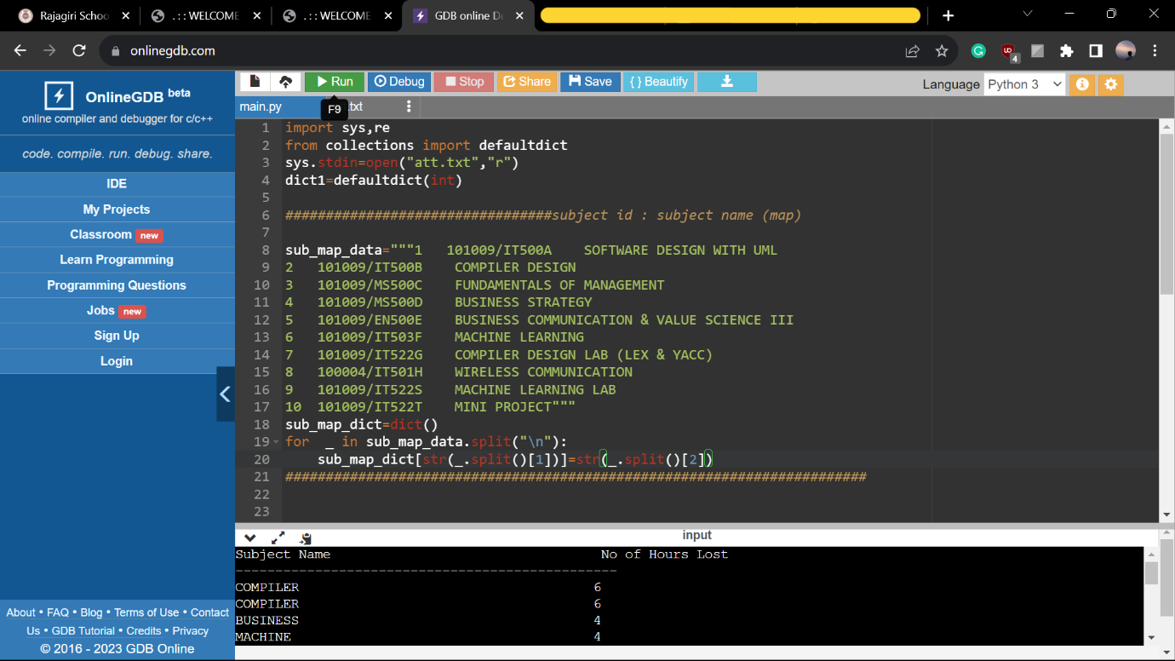  
  
Final Result:**

rrrrrr

rrrrrr

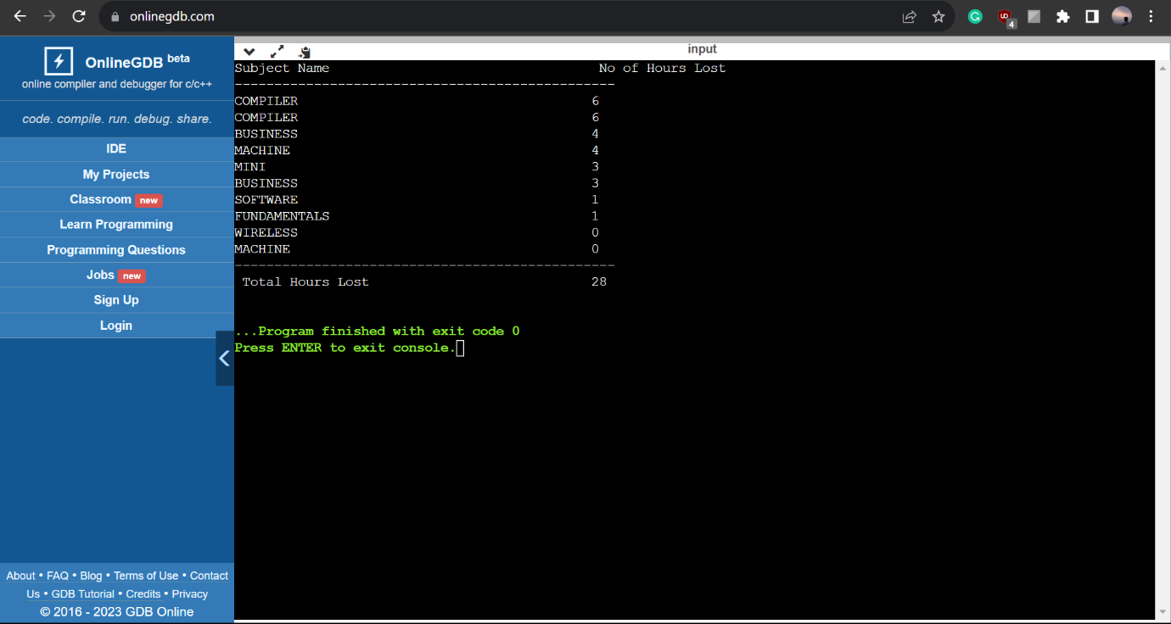

**<Ignore for S5 CSBS subjects>**

**To provide a new subject code -> subject name map, go to sessional marks page and copy paste the data in the sub_map_data variable in main.py.   
make sure to leave the 3 quotes untouched and data must come between them without any spaces at top and bottom**

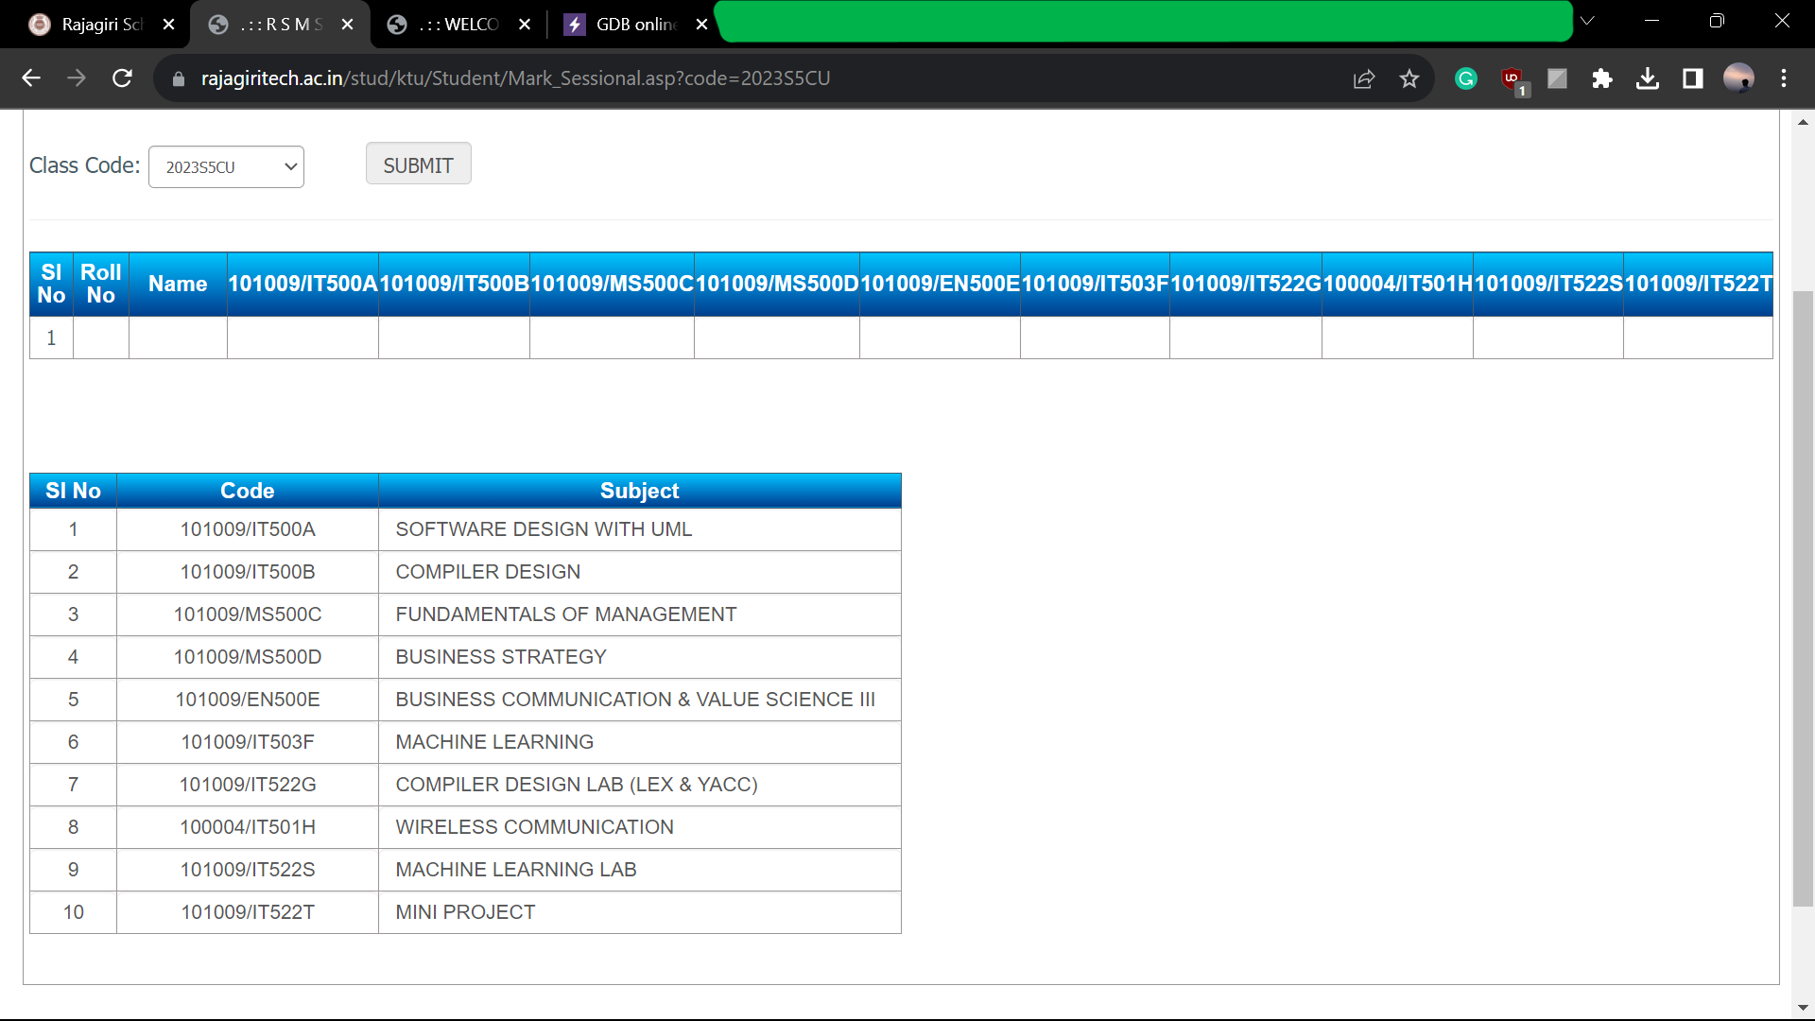

Copy and paste this entire table below . (mind ………the position of quotes)