**Experiment No.: 1**

**Aim**

Define a class ‘product’ with data members pcode, pname and price. Create 3 objects of

the class and find the product having the lowest price.

**CO1**

Understand object-oriented concepts and design classes and objects to solve problems.

**Procedure**

import java.util.*;

public class product {

int pcode;

String pname;

int price;

public void get() {

Scanner value = new Scanner(System.in);

System.out.print("Enter product code: ");

pcode = value.nextInt();

System.out.print("Enter product name: ");

pname = value.next();

System.out.print("Enter product price: ");

price = value.nextInt();

}

public void out(){

System.out.println("Product code is: " + pcode );

System.out.println("Product name: " + pname);

System.out.println("Product price: " + price);

}

public static void main(String[] args) {

product p1 = new product();

product p2 = new product();

product p3 = new product();

p1.get();

p2.get();

p3.get();

p1.out();

p2.out();

p3.out();

if(p1.price<p2.price && p1.price<p3.price)

{

System.out.println("P1 has the lowest price.");

}

else if(p2.price<p1.price && p2.price<p3.price)

{

System.out.println("P2 has the lowest price.");

}

else

{

System.out.println("P3 has the lowest price.");

}

}

}

**Output Screenshot**

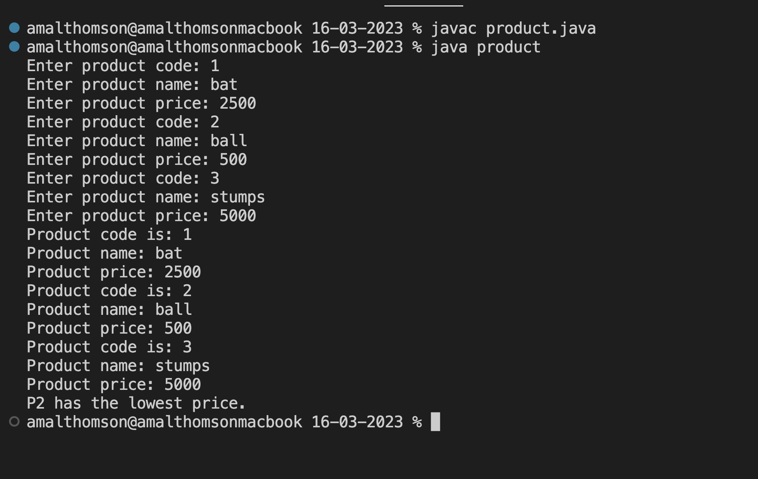

**Result**

The program was executed and the result was successfully obtained. Thus CO1 was obtained.

**Experiment No.: 2**

**Aim**

Read 2 matrices from the console and perform matrix addition.

**CO1**

Understand object-oriented concepts and design classes and objects to solve problems.

**Procedure**

import java.util.*;

public class matrix {

public static void main (String[] args) {

Scanner value = new Scanner(System.in);

int i,j;

System.out.println("Enter number of rows:");

int row = value.nextInt();

System.out.println("Enter number of columns:");

int col = value.nextInt();

int arr1[][] = new int[row][col];

System.out.println("Enter Matrix_1 Elements ");

for (i=0;i<row;i++)

{

for(j=0;j<col;j++)

{

arr1[i][j] = value.nextInt();

}

}

System.out.println("Matrix_1 Elements are: ");

for (i=0;i<row;i++)

{

for(j=0;j<col;j++)

{

System.out.print(arr1[i][j]+"\t");

}

System.out.println();

}

int arr2[][] = new int[row][col];

System.out.println("Enter Matrix_1 Elements ");

for (i=0;i<row;i++)

{

for(j=0;j<col;j++)

{

arr2[i][j] = value.nextInt();

}

}

System.out.println("Matrix_1 Elements are: ");

for (i=0;i<row;i++)

{

for(j=0;j<col;j++)

{

System.out.print(arr2[i][j]+"\t");

}

System.out.println();

}

int arr3[][] = new int[row][col];

System.out.println("Addition of Matrix_1 & Matrix_2 is: ");

for (i=0;i<row;i++)

{

for(j=0;j<col;j++)

{

arr3[i][j] = arr1[i][j] + arr2[i][j];

}

}

for (i=0;i<row;i++)

{

for(j=0;j<col;j++)

{

System.out.print(arr3[i][j]+"\t");

}

System.out.println();

}

}

}

**Output Screenshot**

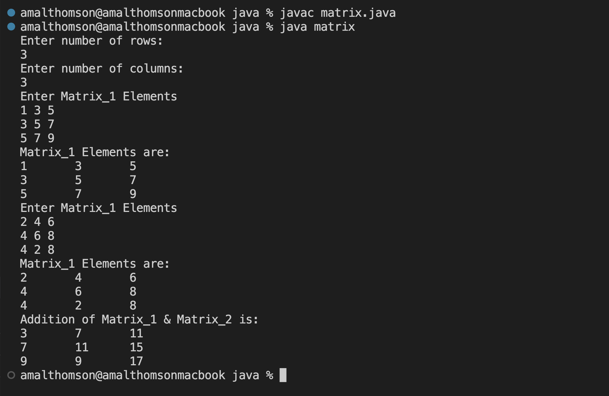

**Result**

The program was executed and the result was successfully obtained. Thus CO1 was obtained.

**Experiment No.: 3**

**Aim**

Add complex numbers.

**CO1**

Understand object-oriented concepts and design classes and objects to solve problems.

**Procedure**

import java.util.*;

public class complex {

public static void main(String[] args){

Scanner value = new Scanner(System.in);

System.out.println("Enter first complex number: ");

int r1 = value.nextInt();

int i1 = value.nextInt();

System.out.println(“Complex Number 1 is: ”+r1+"+"+i1+"i");

System.out.println("Enter second complex number: ");

int r2 = value.nextInt();

int i2 = value.nextInt();

System.out.println(“Complex Number 1 is: ”+r2+"+"+i2+"i");

System.out.println("Sum of two complex numbers are: ");

System.out.println(r1+r2 + "+" + (i1+i2) + "i");

}

}

**Output Screenshot**

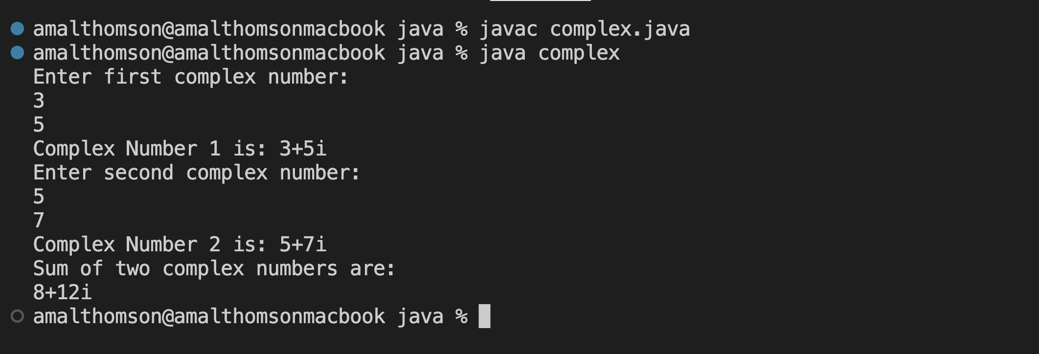

**Result**

The program was executed and the result was successfully obtained. Thus CO1 was obtained.

**Experiment No.: 4**

**Aim**

Read a matrix from the console and check whether it is symmetric or not.

**CO1**

Understand object-oriented concepts and design classes and objects to solve problems.

**Procedure**

import java.util.*;

public class symmetric{

public static void main(String[] args){

Scanner value = new Scanner(System.in);

System.out.print("Enter the dimension of the matrix :");

int dim = value.nextInt();

int array1[][] = new int[dim][dim];

int array2[][] = new int[dim][dim];

System.out.println("Enter the elements in matrix :");

for(int i=0;i<dim;i++){

for(int j=0;j<dim;j++){

array1[i][j] = value.nextInt();

}

}

System.out.println("The matrix is: ");

for(int i=0;i<dim;i++){

for(int j=0;j<dim;j++){

System.out.print(array1[i][j] + " ");

}

System.out.println(" ");

}

System.out.println("The Transpose of the matrix: ");

for(int i=0;i<dim;i++){

for(int j=0;j<dim;j++){

array2[i][j]=array1[j][i];

}

}

for(int i=0;i<dim;i++){

for(int j=0;j<dim;j++){

System.out.print(array2[i][j] + " ");

}

System.out.println(" ");

}

int flag=0;

for(int i=0;i<dim;i++){

for(int j=0;j<dim;j++){

if(array1[i][j] != array2[i][j]){

flag=1;

break;

}

}

}

if(flag==1){

System.out.println("The matrix is not symmetric");

}

else{

System.out.println("The matrix is symmetric");

}

}

}

**Output Screenshot**

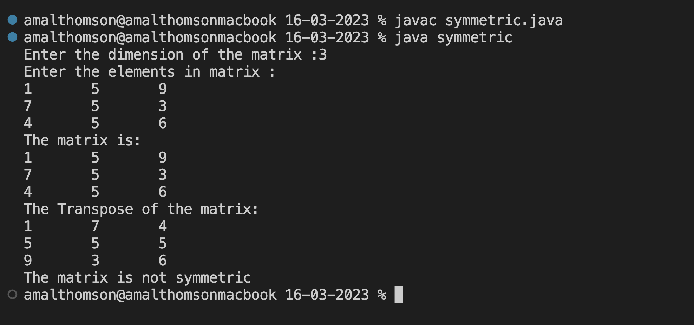

**Result**

The program was executed and the result was successfully obtained. Thus CO1 was obtained.

**Experiment No.: 5**

**Aim**

Create CPU with attribute price. Create inner class Processor (no. of cores, manufacturer)

and static nested class RAM (memory, manufacturer). Create an object of CPU and print

information of Processor and RAM.

**CO1**

Understand object-oriented concepts and design classes and objects to solve problems.

**Procedure**

import java.util.*;

class CPU {

class processor{

int noc;

String man;

void get(){

Scanner sc= new Scanner(System.in);

System.out.print("Enter no.of cores: ");

noc=sc.nextInt();

System.out.print("Enter manufacturer name: ");

man=sc.next();

}

void disp(){

System.out.println("No. of cores: "+ noc);

System.out.println("Processor Manufacturer: "+ man);

}

}

static class ram {

int mem;

String manf;

void get1(){

Scanner sc=new Scanner(System.in);

System.out.print("Enter memory: ");

mem=sc.nextInt();

System.out.print("Enter manufacturer: ");

manf=sc.next();

}

void disp1(){

System.out.println("Memory: "+mem);

System.out.println("Ram Manufacturer: "+manf);

}

}

public static void main(String args[]){

CPU c= new CPU();

Scanner sc=new Scanner(System.in);

System.out.print("Enter price: ");

int price=sc.nextInt();

CPU.processor p = c.new processor();

p.get();

CPU.ram r = new CPU.ram();

r.get1();

System.out.println();

System.out.print("Details");

System.out.println();

System.out.print("Price: "+ price);

p.disp();

r.disp1();

}

}

**Output Screenshot**

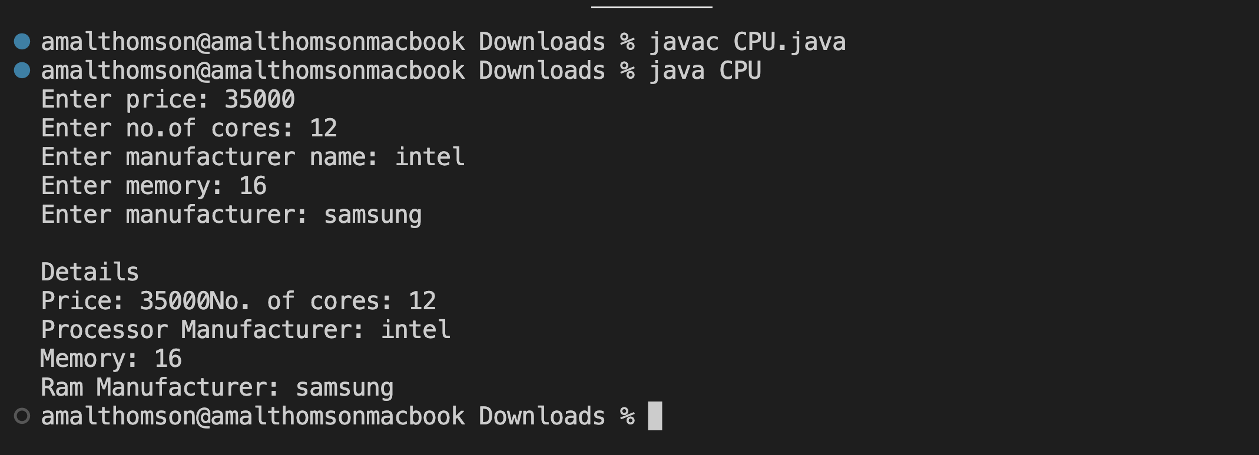

**Result**

The program was executed and the result was successfully obtained. Thus CO1 was obtained.

**Experiment No.: 6**

**Aim**

Program to Sort strings

**CO2**

Implement arrays and strings.

**Procedure**

import java.util.*;

public class sort {

public static void main(String[] args) {

Scanner value = new Scanner(System.in);

int i,j;

String temp;

String array[] = new String[5];

System.out.println("Enter any 5 elements into the Array");

for (i=0;i<5;i++)

{

array[i] = value.nextLine();

}

System.out.println("\n"+"The Array is: ");

for (i=0;i<5;i++)

{

System.out.println(array[i]);

}

for (i=0;i<5;i++)

{

for (j=i+1;j<5;j++)

if (array[i].compareTo(array[j])>0)

{

temp = array[i];

array[i] = array[j];

array[j] = temp;

}

}

System.out.println("\n"+"The Sorted Array is: ");

for (i=0;i<5;i++)

{

System.out.println(array[i]);

}

}

}

**Output Screenshot**

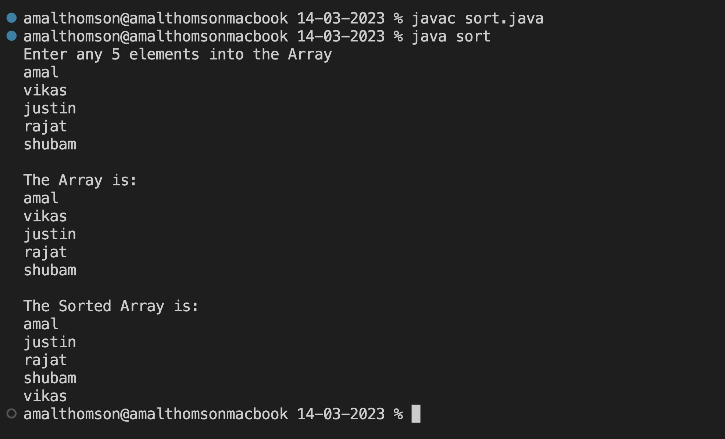

**Result**

The program was executed and the result was successfully obtained. Thus CO2 was obtained.

**Experiment No.: 7**

**Aim**

Search an element in an array.

**CO2**

Implement arrays and strings.

**Procedure**

import java.util.*;

public class search {

public static void main (String[] args) {

Scanner value = new Scanner(System.in);

int i;

int arr[] = new int[5];

System.out.println("Enter Array Elements ");

for (i=0;i<arr.length;i++)

{

arr[i] = value.nextInt();

}

System.out.println("Array Elements are: ");

for (i=0;i<arr.length;i++)

{

System.out.println(arr[i]);

}

int flag = 0;

System.out.print("Enter Element to be searched: ");

int element = value.nextInt();

for (i=0;i<arr.length;i++)

{

if(arr[i] == element)

{

flag++;

System.out.println("Element Found !!!");

System.out.println("Element Found at Position: "+ (i+1));

}

}

if (flag==0)

{

System.out.println("Element not found");

}

}

}

**Output Screenshot**

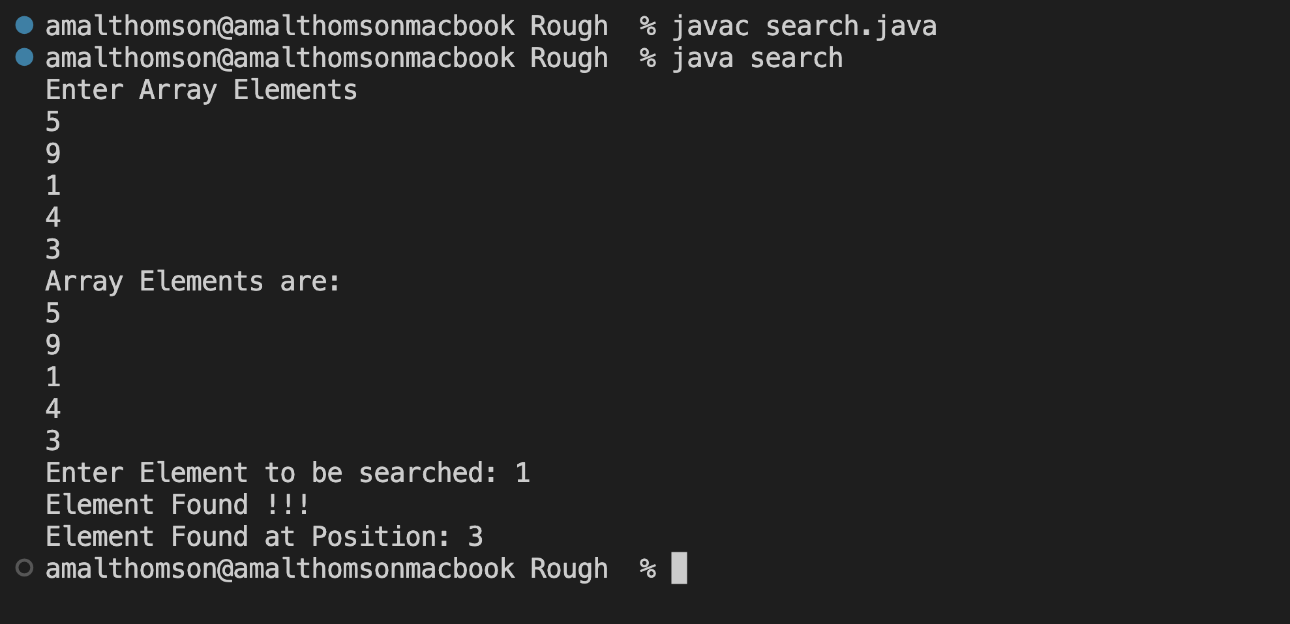

**Result**

The program was executed and the result was successfully obtained. Thus CO2 was obtained.

**Experiment No.: 8**

**Aim**

Perform string manipulations

**CO2**

Implement arrays and strings.

**Procedure**

import java.util.*;

public class strings {

public static void main (String[] args){

Scanner value = new Scanner(System.in);

System.out.print("Enter String 1: ");

String var1 = value.nextLine();

System.out.print("Enter String 2: ");

String var2 = value.nextLine();

System.out.println("Concat: "+var1.concat(var2));

if (var1 == var2)

{

System.out.println("Strings are same");

}

else

{

System.out.println("Strings are not same");

}

System.out.println("Strings are Equat: "+var1.equals(var2));

System.out.println("Length of String: "+var1.length());

int var3 = var1.length();

int var4 = var2.length();

if (var3 == var4)

{

System.out.println("length is same");

}

else

{

System.out.println("length are not same");

}

System.out.println("To Upper Case: " + var1.toUpperCase());

System.out.println("Compare: "+var1.compareTo(var2));

System.out.println("Substring: "+var1.substring(0,2));

System.out.print("Enter String that is to located: ");

String var5 = value.nextLine();

System.out.println("Index: "+var1.indexOf(var5));

}

}

**Output Screenshot**

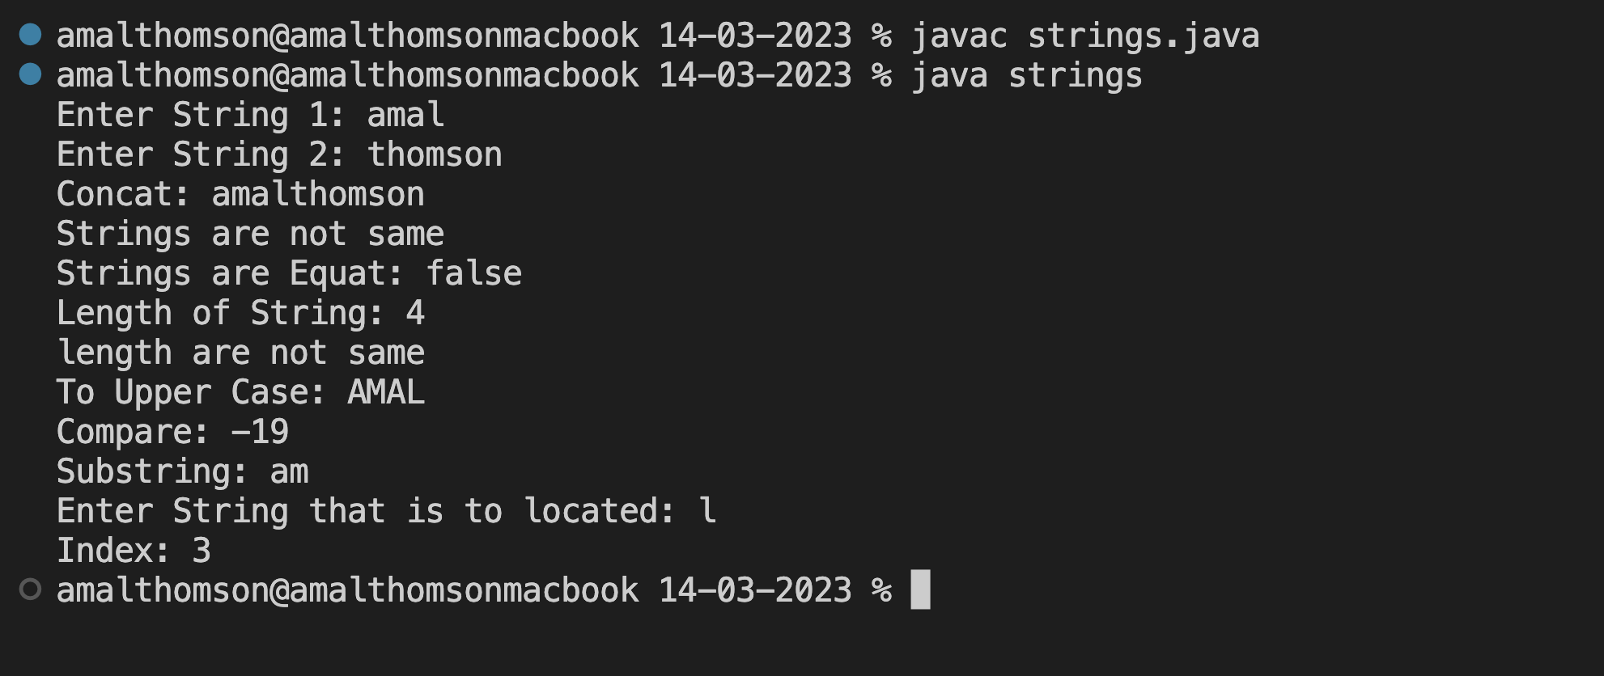

**Result**

The program was executed and the result was successfully obtained. Thus CO2 was obtained.

**Experiment No.: 9**

**Aim**

Program to create a class for Employee having attributes eNo, eName eSalary. Read n

employ information and Search for an employee given eNo, using the concept of Array of

Objects.

**CO2**

Implement arrays and strings.

**Procedure**

import java.util.*;

public class employee {

int eNo;

String eName;

int eSalary;

public void get() {

Scanner value = new Scanner(System.in);

System.out.print("Enter Employee No: ");

eNo = value.nextInt();

System.out.print("Enter Employee name: ");

eName = value.next();

System.out.print("Enter Employee salary: ");

eSalary = value.nextInt();

}

public void out(){

System.out.println("Employee no is: " + eNo );

System.out.println("Employee name: " + eName);

System.out.println("Employee salary: " + eSalary);

}

public static void main(String[] args) {

Scanner value = new Scanner(System.in);

System.out.print("Enter the number of Employees: ");

int size = value.nextInt();

employee array[] = new employee[size];

System.out.println("Enter the Employee Details: ");

for (int i=0;i<size;i++)

{

array[i] = new employee();

array[i].get();

}

System.out.println("The Employees Details are: ");

for (int i=0;i<size;i++)

{

array[i].out();

}

int flag = 0;

System.out.print("Enter eNo of Employee to be searched: ");

int item = value.nextInt();

System.out.println("The Employee searched is: ");

for (int i=0;i<size;i++)

{

if(array[i].eNo == item)

{

array[i].out();

flag = flag+1;

break;

}

}

if (flag==0)

{

System.out.println("Employee Not Foound");

}

}

}

**Output Screenshot**

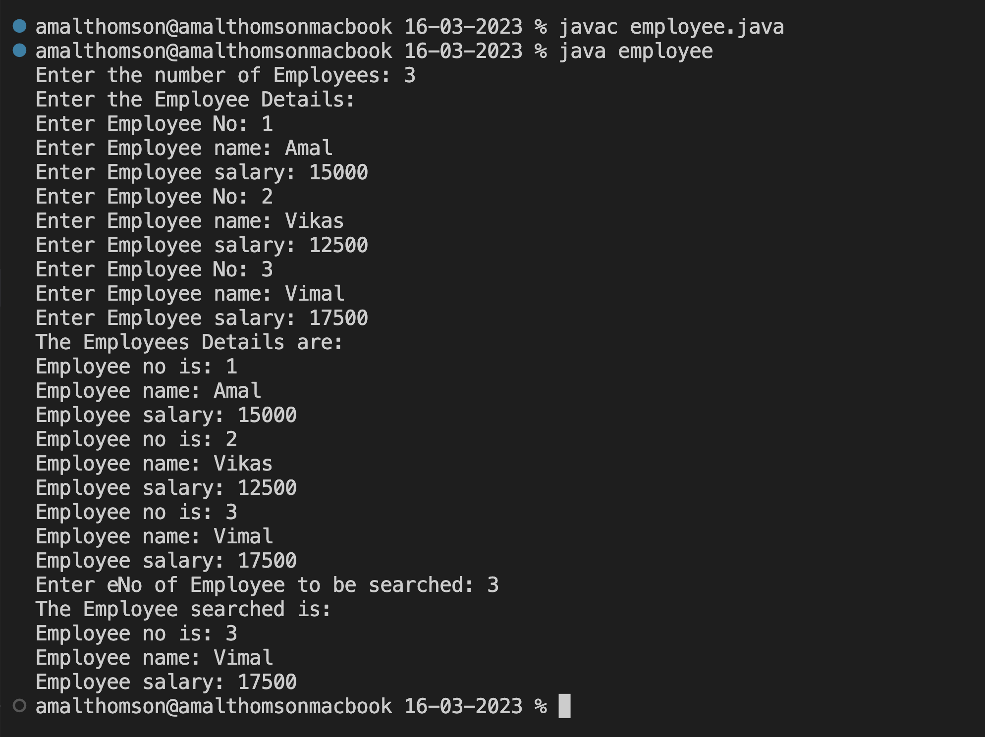

**Result**

The program was executed and the result was successfully obtained. Thus CO2 was obtained.