1. **Create a class ‘Employee’ with data members Empid, Name, Salary, Address and constructors to initialize the data members. Create another class ‘Teacher’ that inherit the properties of class employee and contain its own data members department, Subjects taught and constructors to initialize these data members and also include display function to display all the data members. Use array of objects to display details of N teachers.**

**Source Code:**

import java.util.Scanner;

class Employee {

int eid;

String ename, eaddress;

double esal;

Employee(int id, String name, double sal, String address) {

eid = id;

ename = name;

eaddress = address;

esal = sal;

}

}

class Teacher extends Employee {

String tdept, tsub;

Teacher(String dept, String sub, String name, int id, String address, double sal) {

super(id, name, sal, address);

tdept = dept;

tsub = sub;

}

void display() {

System.out.println();

System.out.println("Employee Details");

System.out.println("Employee id is: " + eid);

System.out.println("Employee name is: " + ename);

System.out.println("employee salary is: " + esal);

System.out.println("employee address is: " + eaddress);

System.out.println("Department is: " + tdept);

System.out.println("Subject is: " + tsub);

}

}

public class co3p2 {

public static void main(String[] args) {

int count, id;

String name, dept, sub, address;

double sal;

Scanner value = new Scanner(System.in);

System.out.print("enter the number of teachers: ");

count = value.nextInt();

Teacher[] object = new Teacher[count];

for (int i = 0; i < count; i++) {

System.out.print("enter the id: ");

id = value.nextInt();

System.out.print("enter the Emp name: ");

name = value.next();

System.out.print("enter the address: ");

address = value.next();

System.out.print("enter the salary: ");

sal = value.nextInt();

System.out.print("enter the department: ");

dept = value.next();

System.out.print("enter the subject: ");

sub = value.next();

object[i] = new Teacher(dept, sub, name, id, address, sal);

}

for (int i = 0; i < count; i++) {

object[i].display();

}

}

}

**Output:**

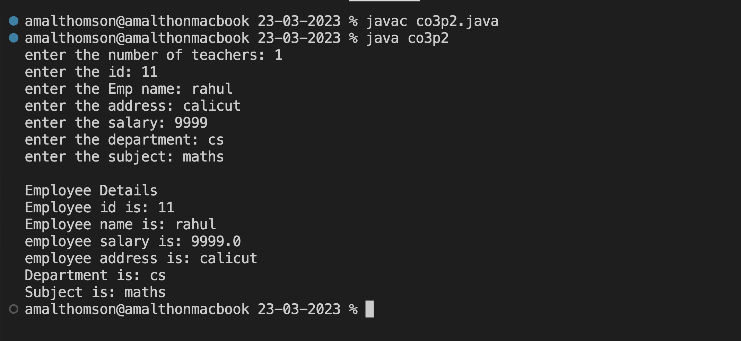

1. **Create a class ‘Person’ with data members Name, Gender, Address, Age and a constructor to initialize the data members and another class ‘Employee’ that inherits the properties of class Person and also contains its own data members like Empid, Company name, Qualification, Salary and its own constructor. Create another class ‘Teacher’ that inherits the properties of class Employee and contains its own data members like Subject, Department, Teacherid and also contain constructors and methods to display the data members. Use array of objects to display details of N teachers.**

**Source Code:**

import java.util.Scanner;

class Person1{

int page;

String pname,paddress,pgender;

Person1(String name,String address, int age, String gender){

page=age;

pname=name;

paddress=address;

pgender=gender;

}

}

class Employee1 extends Person1{

String ecname, equalification;

int eid;

double esal;

Employee1(int id, String qualification, String comanyname, double sal, String name,String address, int age, String gender){

super(name,address,age,gender);

ecname=comanyname;

equalification=qualification;

eid=id;

esal=sal;

}

}

class Teacher1 extends Employee1{

String tdept,tsub;

int tid;

Teacher1(String dept, String sub, int trid, int id, String qualification, String comanyname, double sal, String name,String address, int age, String gender){

super(id, qualification, comanyname, sal, name, address, age, gender);

tdept=dept;

tsub=sub;

tid=trid;

}

void display(){

System.out.println();

System.out.println("Details");

System.out.println("person Name is: "+pname);

System.out.println("person gender is: "+pgender);

System.out.println("person age is: "+page);

System.out.println("person address is: "+paddress);

System.out.println("Emp id is: "+eid);

System.out.println("Emp qualification is: "+equalification);

System.out.println("Emp sal is: "+esal);

System.out.println("Emp company name is: "+ecname);

System.out.println("tchr id is: "+tid);

System.out.println("tchr sub is: "+tsub);

System.out.println("tchr dept is: "+tdept);

}

}

public class co3p3 {

public static void main(String[] args){

int count,eid,tid,page;

String pname,tdept,tsub,paddress,pgender,qualification,cname;

double sal;

Scanner s=new Scanner(System.in);

System.out.println("enter the number of teachers");

count=s.nextInt();

Teacher1 [] obj=new Teacher1[count];

for(int i=0;i<count;i++){

System.out.print("enter the Emp name: ");

pname=s.next();

System.out.print("enter the Emp age: ");

page=s.nextInt();

System.out.print("enter the Emp address: ");

paddress=s.next();

System.out.print("enter the Emp gender: ");

pgender=s.next();

System.out.print("enter the id: ");

eid=s.nextInt();

System.out.print("enter the company name: ");

cname=s.next();

System.out.print("enter the salary: ");

sal=s.nextDouble();

System.out.print("enter the qualification: ");

qualification=s.next();

System.out.print("enter the subject: ");

tsub=s.next();

System.out.print("enter the dept: ");

tdept=s.next();

System.out.print("enter the tchr id: ");

tid=s.nextInt();

obj[i]=new Teacher1(tdept,tsub,tid, eid,qualification,cname, sal,pname,paddress, page,pgender);

}

for(int i=0;i<count;i++){

obj[i].display();

}

}

}

**Output:**

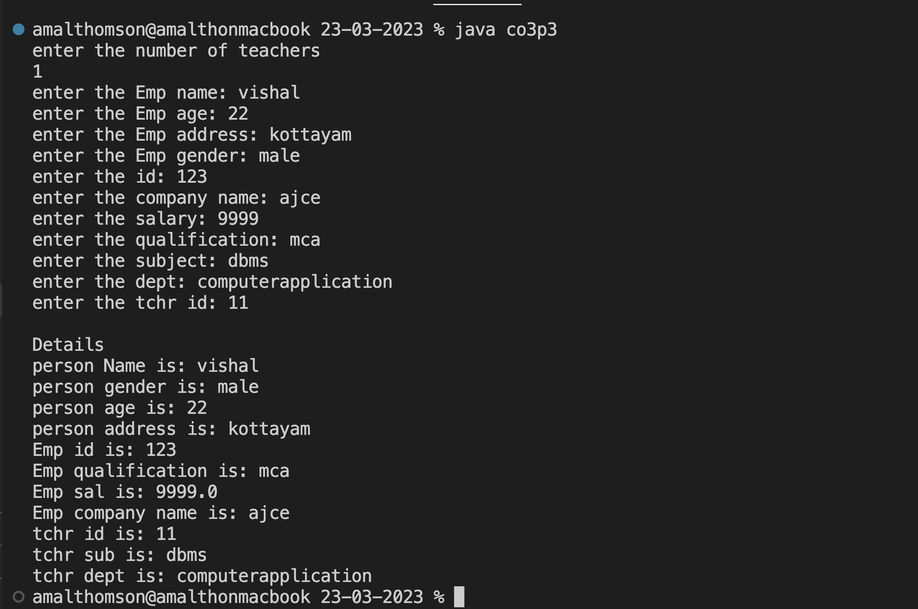

1. Wap using overloaded function to find the largest of

a) two numbers

b) three numbers

**Source Code:**

import java.util.*;

public class largest{

int a,b,c;

void largest(int m, int n){

if(m>n){

System.out.println(m+" is largest");

}

else{

System.out.println(n+" is largest");

}

}

void largest(int x,int y,int z){

if(x>y && x>z){

System.out.println(x+" is largest");

}

else if(y>x && y>z){

System.out.println(y+" is largest");

}

else {

System.out.println(z+" is largest");

}

}

public static void main(String[] args){

largest out = new largest();

out.largest(3,5,7);

out.largest(3,9);

}

}

**Output:**

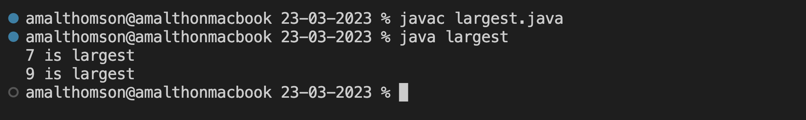

1. Wap using overloaded function to perform different types of sum such as

a) sum of two numbers b) sum of digits of a number

c) sum of 2 strings

**Source Code:**

import java.util.*;

public class sum{

void sum(int a,int b){

System.out.println("Sum of two numbers: "+(a+b));

}

void sum(int c){

int rem = 0;

int sum = 0;

while(c>0){

rem = c%10;

sum = sum + rem;

c = c/10;

}

System.out.println("Sum of digit is: "+sum);

}

void sum(String x,String y){

System.out.println("Sum of two String: "+(x+y));

}

public static void main(String[] args){

sum out = new sum();

Scanner value = new Scanner(System.in);

System.out.print("Enter number 1: ");

int a = value.nextInt();

System.out.print("Enter number 2: ");

int b = value.nextInt();

System.out.print("Enter the digit: ");

int c = value.nextInt();

System.out.print("Enter string 1: ");

String x = value.next();

System.out.print("Enter string 2: ");

String y = value.next();

out.sum(a,b);

out.sum(c);

out.sum(x,y);

}

}

**Output:**

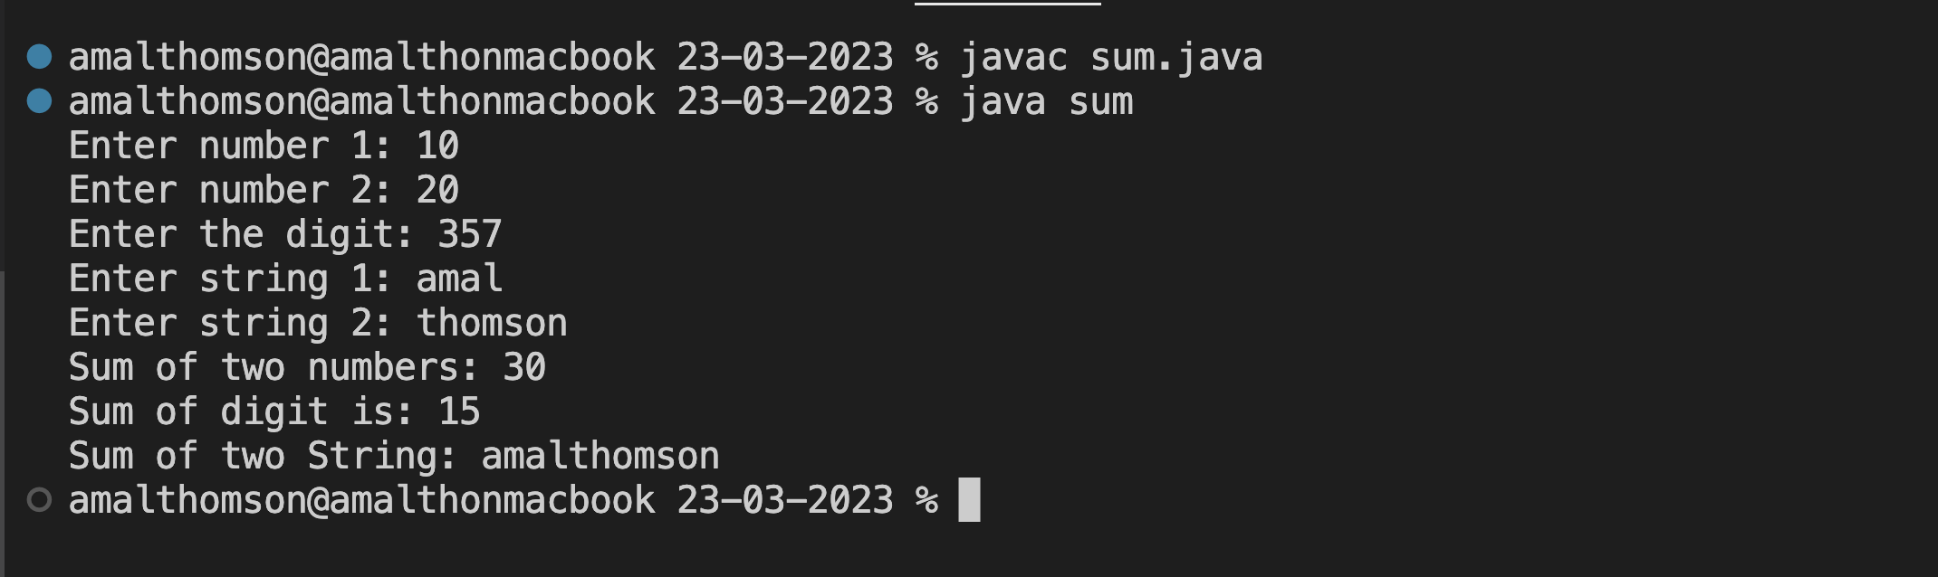

1. Overload a function ‘average’ to find average of two integers, two double values and three float values.

**Source Code:**

import java.util.*;

public class average{

void average(int a,int b){

System.out.println("Average of two integers: "+((a+b)/2));

}

void average(double x,double y){

System.out.println("Average of two double values: "+((x+y)/2));

}

void average(float m,float n){

System.out.println("Average of two float values: "+((m+n)/2));

}

public static void main(String[] args){

average out = new average();

Scanner value = new Scanner(System.in);

System.out.println("Enter two integers: ");

int a = value.nextInt();

int b = value.nextInt();

System.out.println("Enter two double values: ");

double x = value.nextDouble();

double y = value.nextDouble();

System.out.println("Enter two float valus: ");

float m = value.nextFloat();

float n = value.nextFloat();

out.average(a,b);

out.average(x,y);

out.average(m,n);

}

}

**Output:**

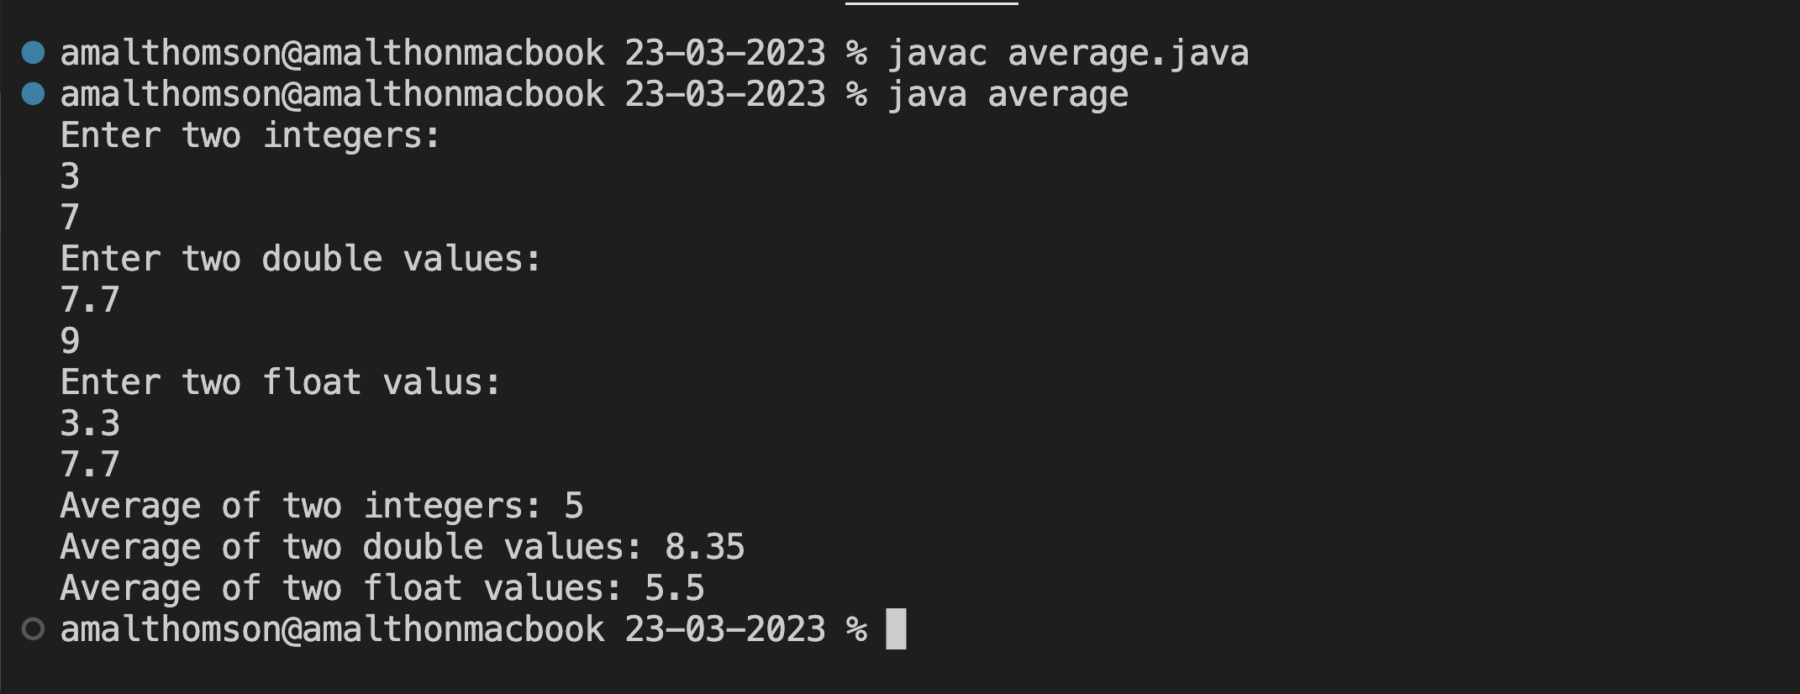

1. **Wap to define a class ‘student’ having data members rollno, name. Derive a class ‘marks’ from ‘student’ having data members m1, m2, m3, total and percentage. Accept and display data of one student.**

**Source Code:**

import java.util.*;

class Student{

int rollno;

String name;

Student(){

Scanner value = new Scanner(System.in);

System.out.print("Enter rollno:");

rollno = value.nextInt();

System.out.print("Enter Name :");

name = value.next();

}

}

class Marks extends Student{

int m1,m2,m3,t,p;

Marks(){

Scanner value = new Scanner(System.in);

System.out.print("Enter Mark1 :");

m1 = value.nextInt();

System.out.print("Enter Mark2 :");

m2 = value.nextInt();

System.out.print("Enter Mark3 :");

m3 = value.nextInt();

}

void result(){

t = (m1+m2+m3);

p = (t / 300) * 100;

System.out.println("Rollno :"+rollno);

System.out.println("Name :"+name);

System.out.println("Total mark obtained :"+t);

System.out.println("Total persentage obtained :"+p);

}

}

class studentmark{

public static void main(String args[])

{

Marks obj = new Marks();

obj.result();

}

}

**Output:**

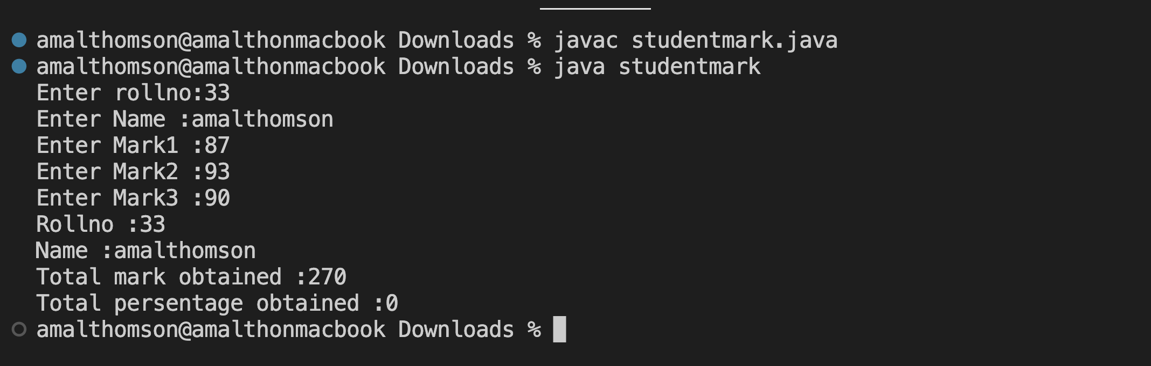

1. **Wap to define a class ‘employee’ having data members emp_id, emp_name and emp_designation. Derive a class ‘salary’ from ‘employee’ having data members basic, HRA, DA, gross_salary. Accept and display data of one employee.**

**DA=basic*35/100**

**HRA=basic*15/100**

**GS=basic+DA+HRA**

**Source Code:**

import java.util.*;

class Employee{

int empid;

String name;

String des;

Employee(){

Scanner value = new Scanner(System.in);

System.out.print("Enter Emp id :");

empid = value.nextInt();

System.out.print("Enter Name :");

name = value.next();

System.out.print("Enter designation :");

des = value.next();

}

}

class Salary extends Employee{

double b,hra,da,gross;

Salary(){

Scanner value = new Scanner(System.in);

System.out.print("Enter Basic :");

b = value.nextDouble();

da =b*35/100;

hra = b*15/100;

gross = b+da+hra;

}

void display(){

System.out.println("Emp id: "+empid);

System.out.println("Emp name: "+name);

System.out.println("Emp designation: "+des);

System.out.println("DA: "+da);

System.out.println("hra: "+hra);

System.out.println("Emp gross: "+gross);

}

}

class gross{

public static void main(String args[]){

Salary obj = new Salary();

obj.display();

}

}

**Output:**

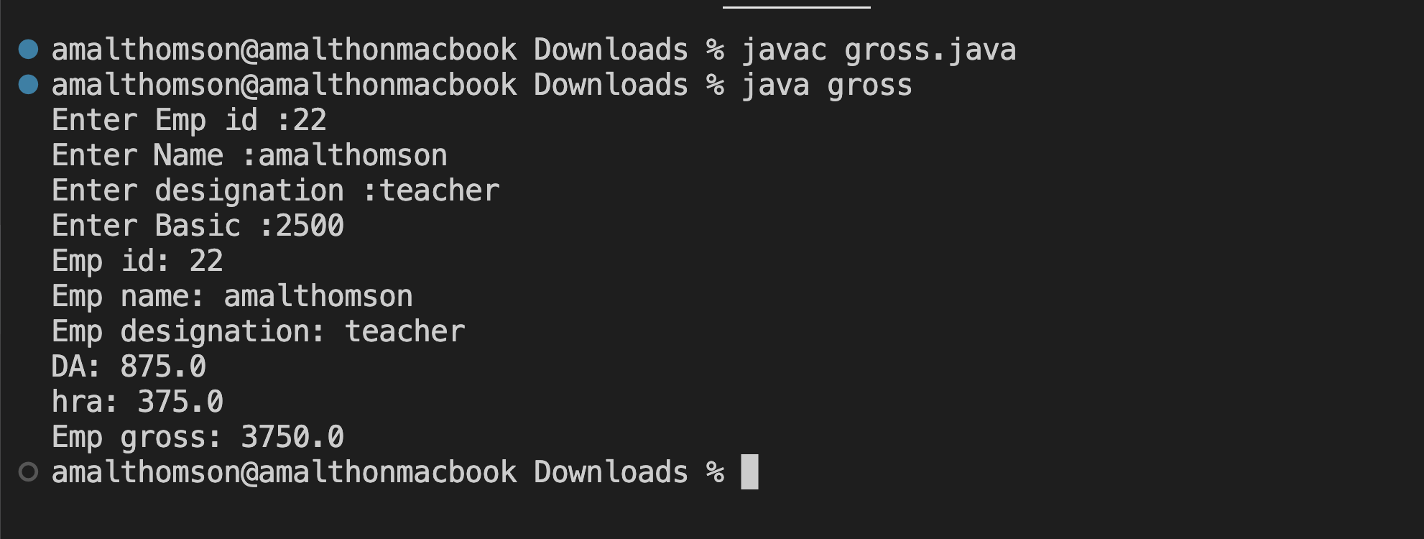

1. **Declare a class ‘box’ having data members length, width and height. Derive a class ‘cupboard’ from ‘box’ having data members no of shelves. Wap to accept and display this data for one cupboard object.**

**Source Code:**

import java.util.*;

class Box{

int length,width,height;

Box(){

Scanner value = new Scanner(System.in);

System.out.print("Enter length: ");

length = value.nextInt();

System.out.print("Enter width: ");

width = value.nextInt();

System.out.print("Enter height: ");

height = value.nextInt();

}

}

class Cupboard extends Box{

int shelves;

Cupboard(){

Scanner value = new Scanner(System.in);

System.out.print("Enter no of shelves: ");

shelves = value.nextInt();

}

void display(){

System.out.println();

System.out.println("length: "+length);

System.out.println("width: "+width);

System.out.println("height: "+height);

System.out.println("no of shelves: "+shelves);

}

}

class cupboardx{

public static void main(String args[])

{

Cupboard obj = new Cupboard();

obj.display();

}

}

**Output:**

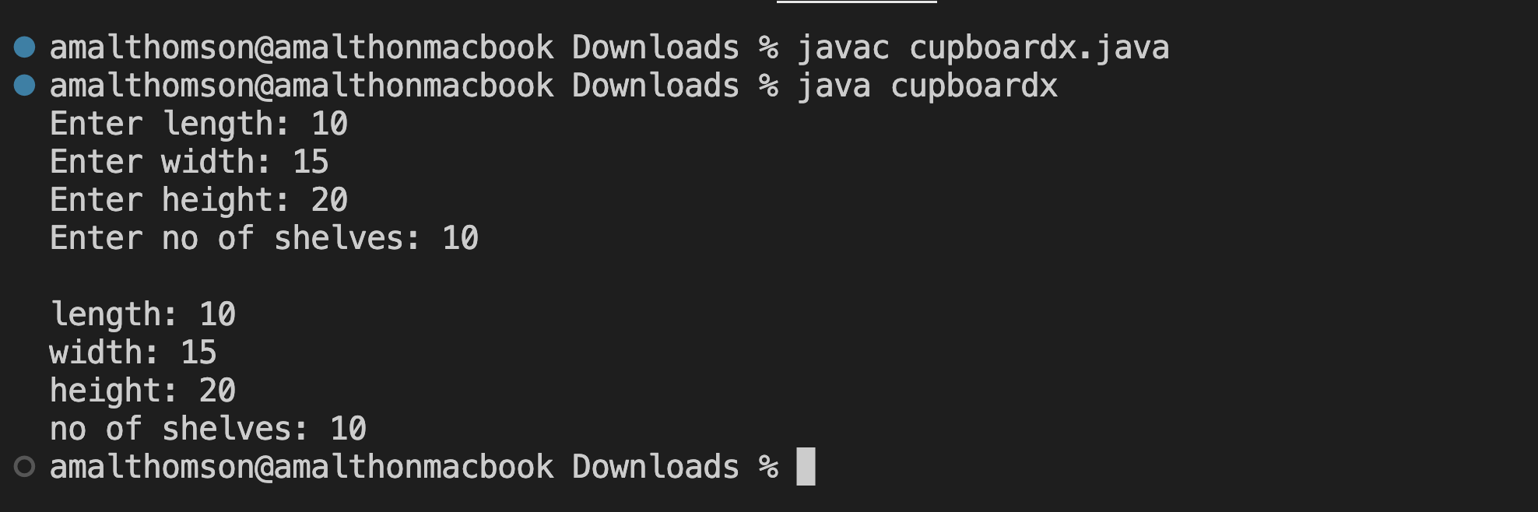

1. **Wap to define a class ‘employee’ having data members emp_id and emp_name. Derive a class ‘worker’ from ‘employee’ having data members daily_wages. Accept and display data of one worker.**

**Source Code:**

import java.util.*;

class Employee{

int empid;

String name;

Employee(){

Scanner value = new Scanner(System.in);

System.out.print("Enter Emp id: ");

empid = value.nextInt();

System.out.print("Enter Name: ");

name = value.next();

}

}

class Worker extends Employee{

int wage;

Worker(){

Scanner value = new Scanner(System.in);

System.out.print("Enter Daily Wage: ");

wage = value.nextInt();

}

void display(){

System.out.println();

System.out.println("Emp id: "+empid);

System.out.println("Emp name: "+name);

System.out.println("Emp wage: "+wage);

}

}

class empworker{

public static void main(String args[]){

Worker obj = new Worker();

obj.display();

}

}

**Output:**

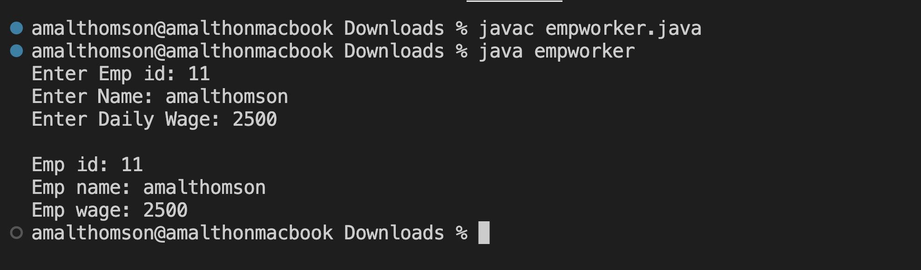

1. **Wap to find the total marks obtained and percentage scored by a student.**

**Source Code:**

import java.util.*;

class Student{

int rollno;

String name;

Student(){

Scanner value = new Scanner(System.in);

System.out.print("Enter Student id: ");

rollno = value.nextInt();

System.out.print("Enter Name: ");

name = value.next();

}

}

class Test extends Student{

int mark1;

int mark2;

Test(){

Scanner value = new Scanner(System.in);

System.out.print("Enter mark1: ");

mark1 = value.nextInt();

System.out.print("Enter mark2: ");

mark2 = value.nextInt();

}

}

class Result extends Test{

int total,per;

void total(){

total = mark1+mark2;

per = (total / 200)*100;

System.out.println("Rollno: "+rollno);

System.out.println("Name: "+name);

System.out.println("Total mark obtained: "+total);

System.out.println("Total mark obtained: "+per);

}

}

class stumarks{

public static void main(String args[])

{

Result obj = new Result();

obj.total();

}

}

**Output:**

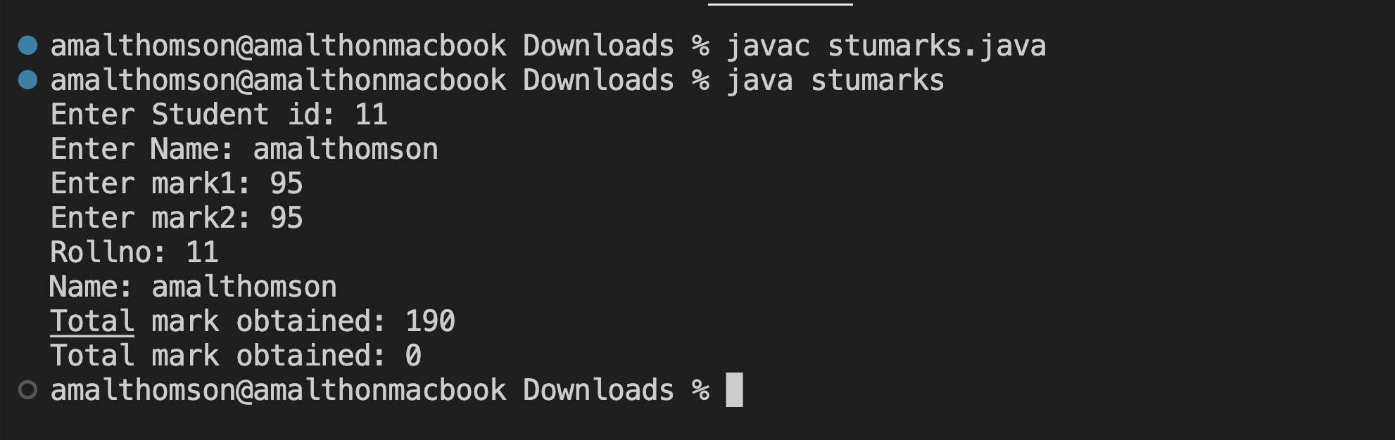

1. **Area of shapes**

**Source Code:**

**Output:**

1. **Volume of shapes**

**Source Code:**

**Output:**