**EXPERIMENT: 1**

**AIM**: To study various DDL commands - CREATE

Create the following Tables

Table 1: DEPOSIT

ACTNO VARCHAR2(5) PRIMARY KEY, FIRST LETTER MUST START WITH ‘D’

CNAME VARCHAR2(15) FOREIGN KEY REFERENCES CUSTOMER

BNAME VARCHAR2(20) FOREIGN KEY REFERENCES BRANCH

AMOUNT NUMBER (8,2) NOT NULL, CANNOT BE 0

ADATE DATE

Table 2: BRANCH

BNAME VARCHAR2(20) PRIMARY KEY

CITY VARCHAR2(30) NOT NULL , any one of NAGPUR, DELHI, BANGALORE,

BOMBAY

Table 3: CUSTOMER

CNAME VARCHAR2(15) PRIMARY KEY

CITY VARCHAR2(20) NOT NULL ,

Table 4: BORROW

LOANNO VARCHAR2(8) PRIMARY KEY / FIRST LETTER MUST START WITH ‘L’

CNAME VARCHAR2(15) FOREIGN KEY REFERENCES CUSTOMER

BNAME VARCHAR2(20) FOREIGN KEY REFERENCES BRANCH

AMOUNT NUMBER(8,2) NOT NULL, CANNOT BE 0

**PROCEDURE:**

**Table-branch**

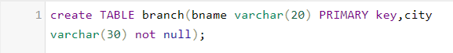

**Table-customer**

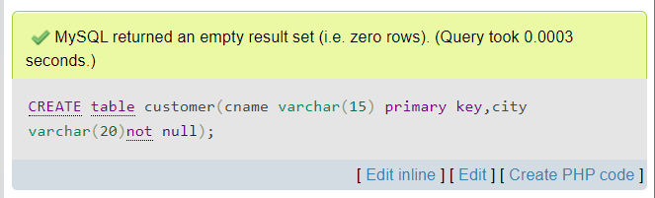

**Table-deposit**

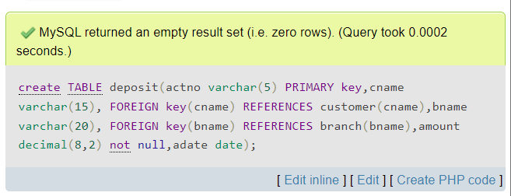

**Table-borrow**

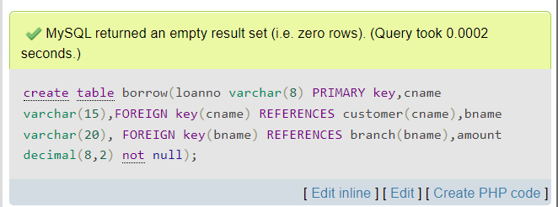

**1. Insert into branch**

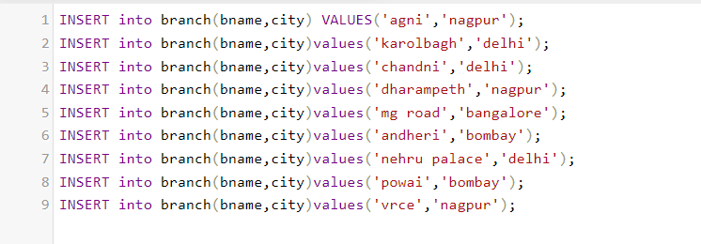

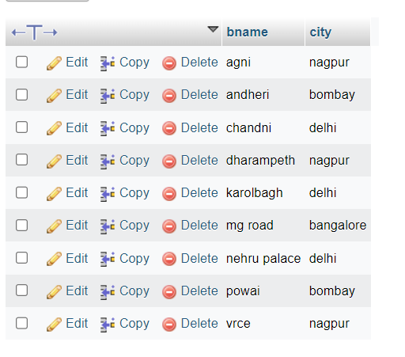

**2. Insert into customer table**

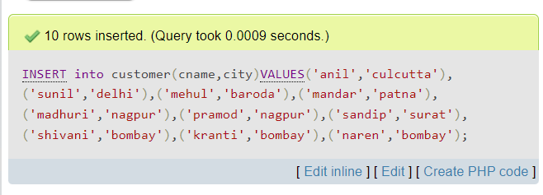

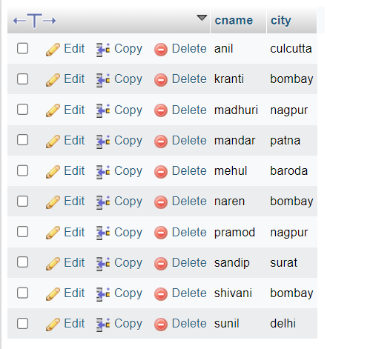

**3. Insert into deposit table**

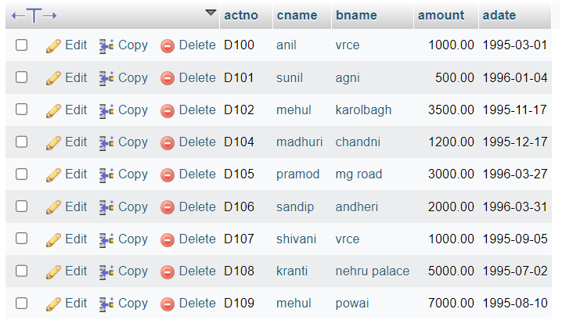

**4. Insert into borrow table**

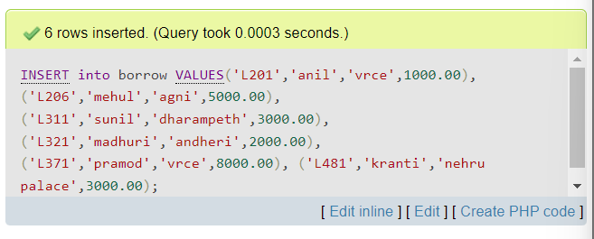

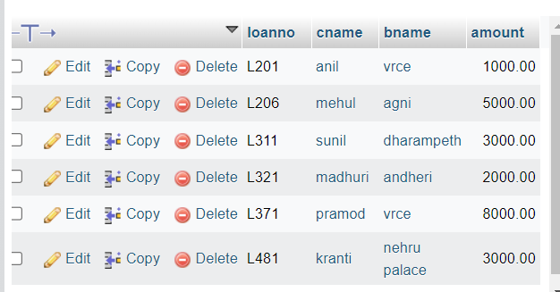

**Experiment: 2**

**Aim**: To familiarize with selecting data from single table

1. List all data from table deposite
2. List all data from borrow
3. List all data from customer
4. List all data from branch
5. Give account no and amount of deposite
6. Give customer name and account no of depositors
7. Give name of customers
8. Give name of branches
9. Give name of borrows
10. Give names of customer living in city Nagpur
11. Give names of depositors having amount greater than 4000
12. Give account date of Anil
13. Give name of all branches located in Bombay
14. Give name of borrower having loan number l205
15. Give names of depositors having account at VRCE
16. Give names of all branched located in city Delhi
17. Give name of the customers who opened account date ‘1-12-96’
18. Give account no and deposit amount of customers having account opened between dates ‘1-12-96’ and ‘1-5-96’
19. Give name of the city where branch KAROLBAGH is located Give details of customer ANIL

**Procedure:**

1. List all data from table deposits.

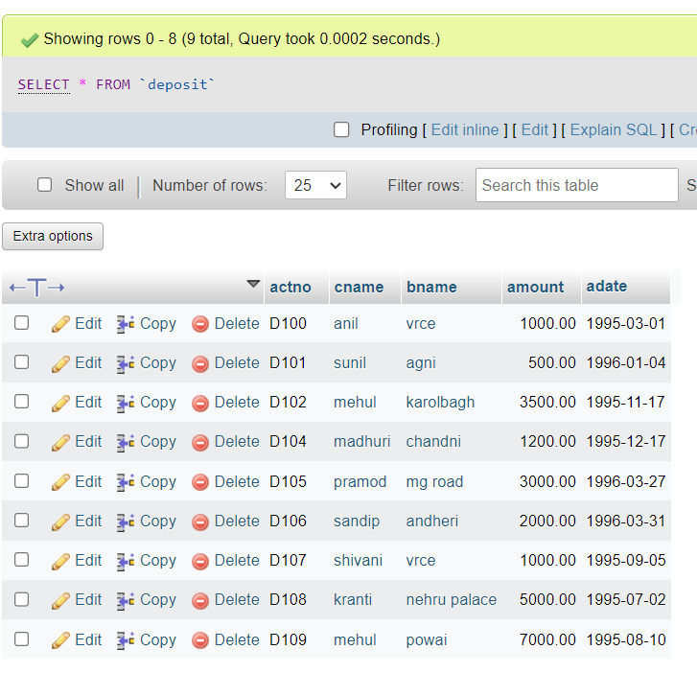

2. List all data from borrow

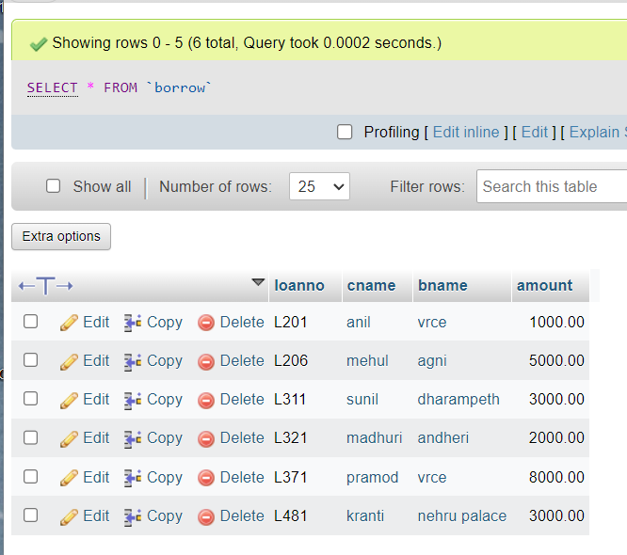

3.List all data from customer

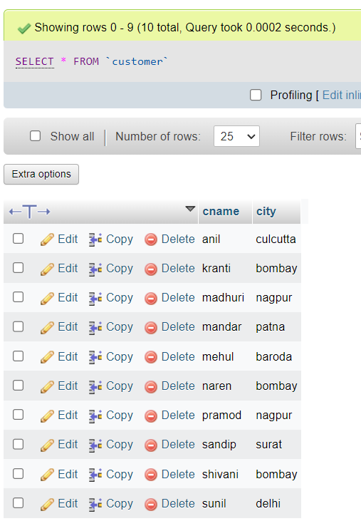

4. List all data from branch

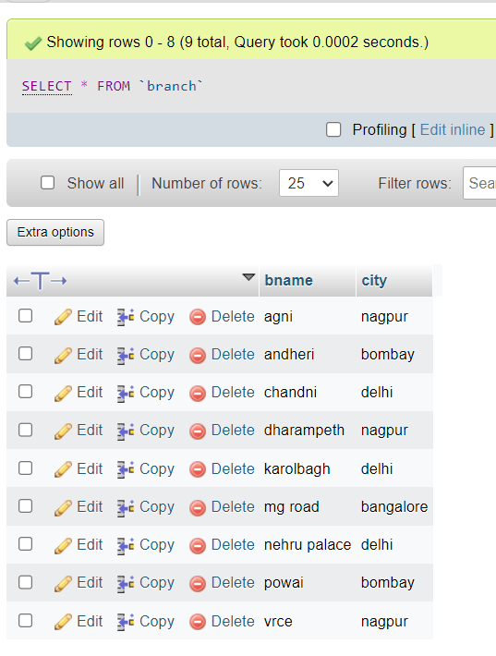

5.Give account no and amount of deposit

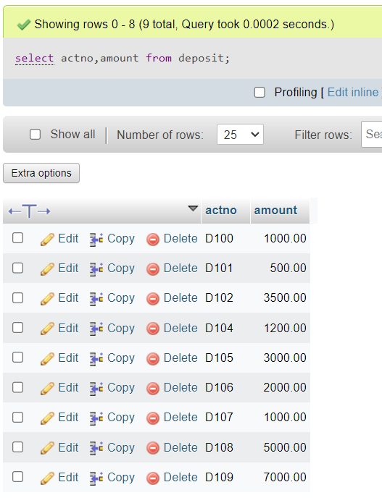

6.Give customer name and account no of depositors

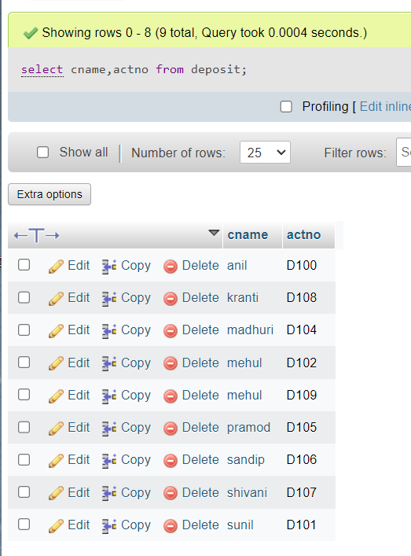

7.Give name of customers

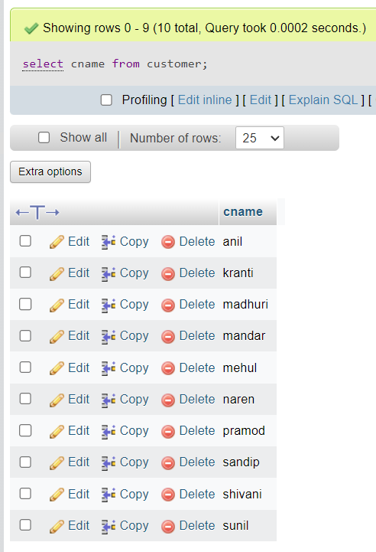

8.Give name of branches

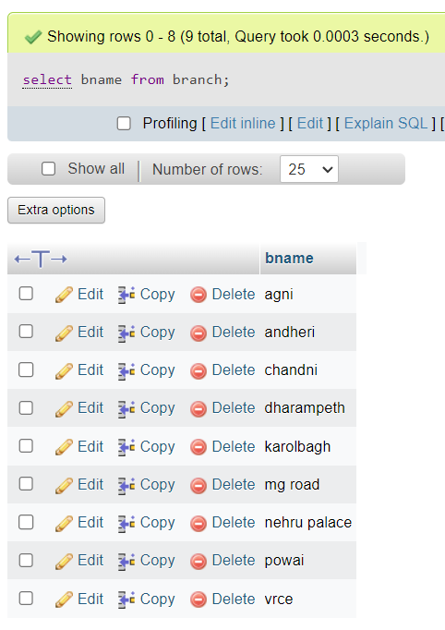

9.Give name of borrows

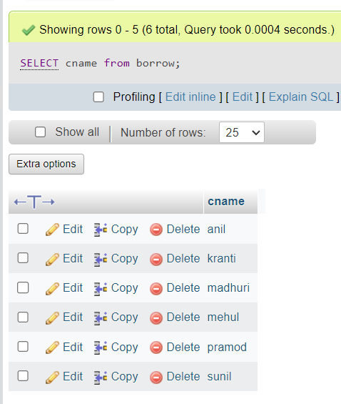

10.Give names of customer living in city Nagpur

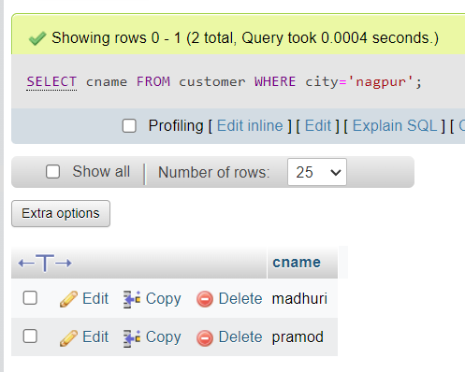

11.Give names of depositors having amount greater than 4000

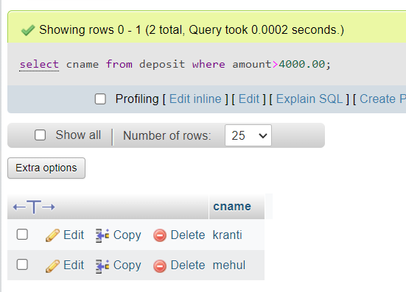

12.Give account date of Anil

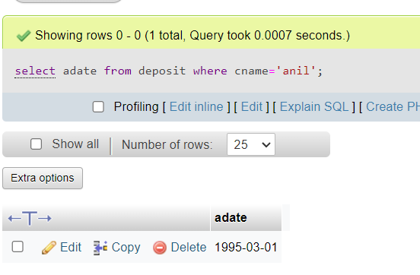

13.Give name of all branches located in Bombay

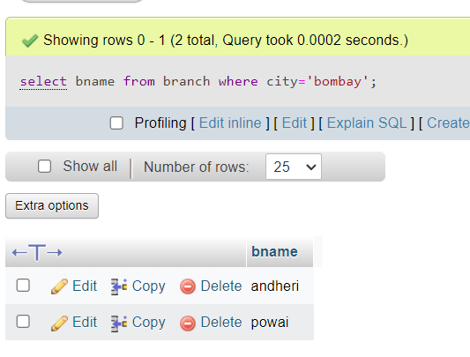

15.Give names of depositors having account at VRCE

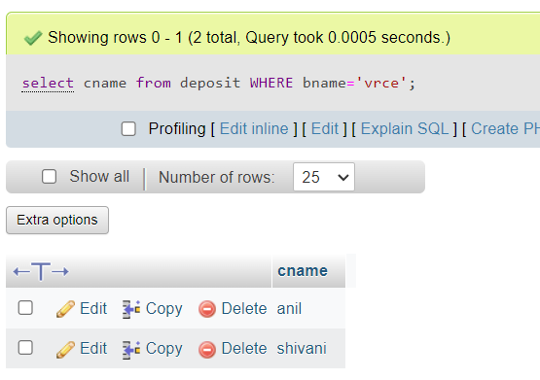

16.Give names of all branched located in city Delhi

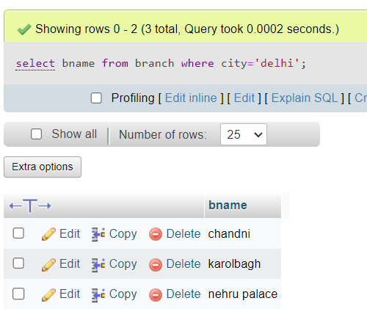

19.Give name of the city where branch KAROLBAGH is located

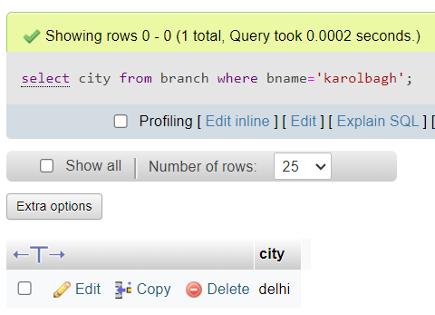

20.Give details of customer ANIL

