**Experiment No.: 3**

**Aim**

Familiarization of Linux Commands.

**CO2**

Perform system administration tasks.

**Procedure**

1. **pwd** – used to print the working directory. After execution it shows the absolute path.

Syntax: $ pwd

Output:

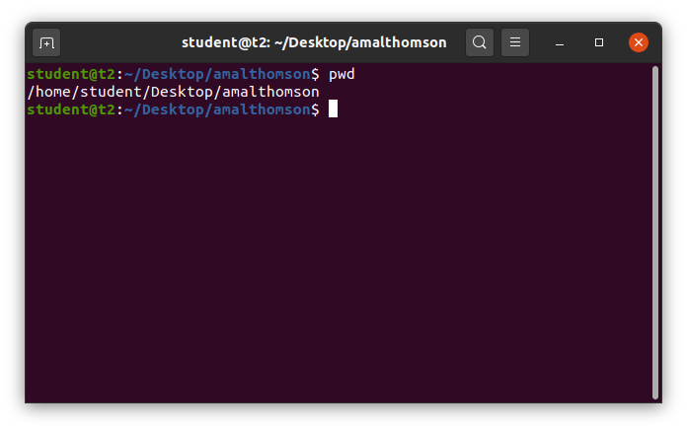

1. **ls** – used to list the files and content in the directory.

Syntax: $ ls

Output:

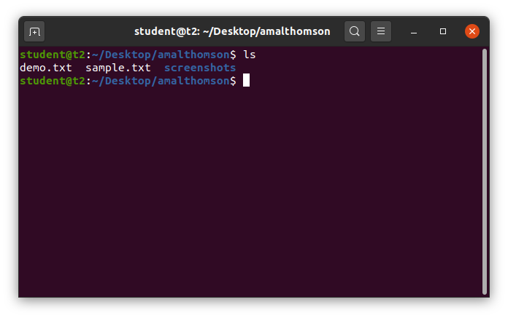

**Options of ls command.**

1. **ls -R** – used to list the directory as well as the subdirectory.

Syntax: $ ls -R

Output:

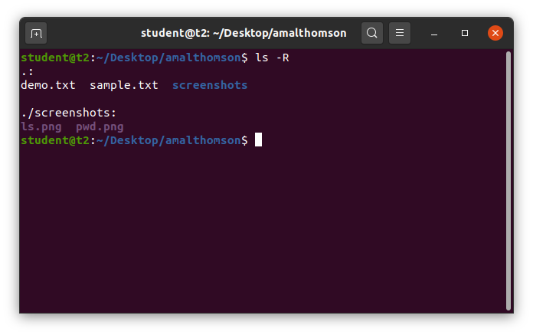

1. **ls -l** – used to view the long list of directory.

Syntax: $ ls -l

Output:

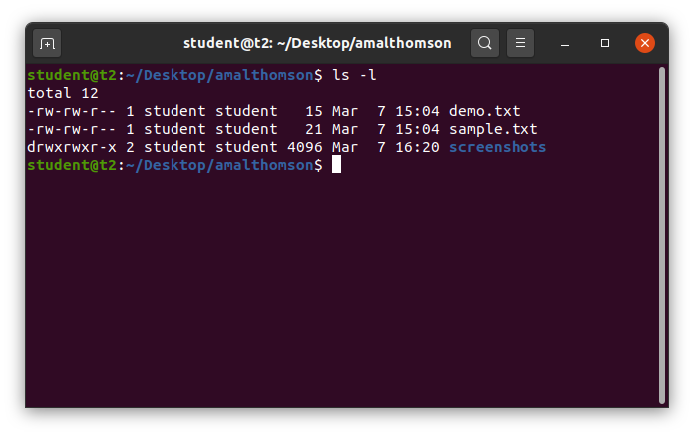

1. **ls -a** – used to view the list in directory along with hidden files.

Syntax: $ ls -a

Output:

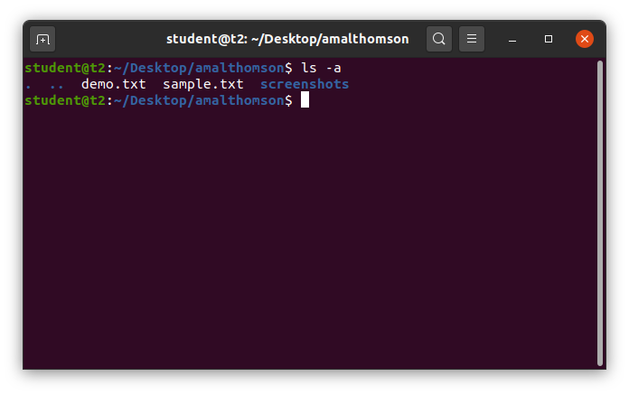

1. **ls -al** – used to view the list in directory with detailed information along with hidden files.

Syntax: $ ls -al

Output:

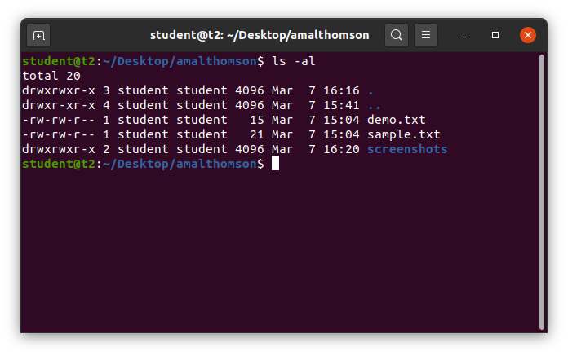

1. **ls -t** – used to view the list in sorted order of last modified.

Syntax: $ ls -t

Output:

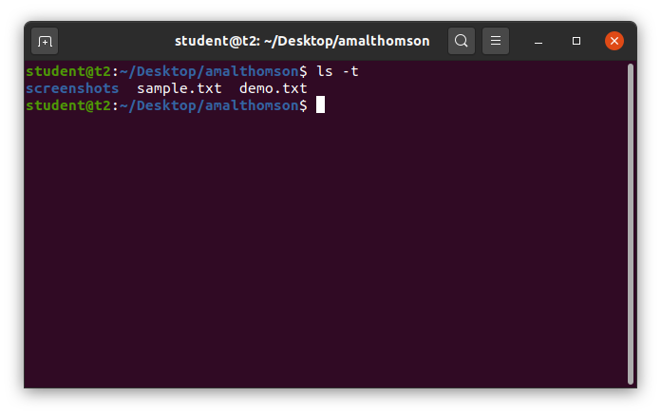

1. **ls -r** – used to view the list in reverse order of last modified.

Syntax: $ ls -r

Output:

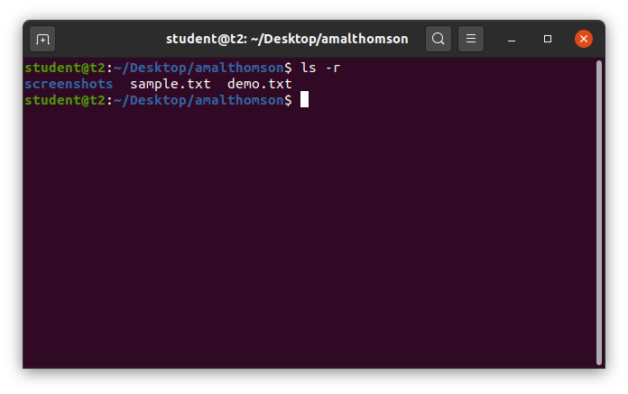

1. **man** - used to learn and understand the existing commands we can learn and understand about different write from the shell using man command.

Syntax: $ man mkdir

Output:

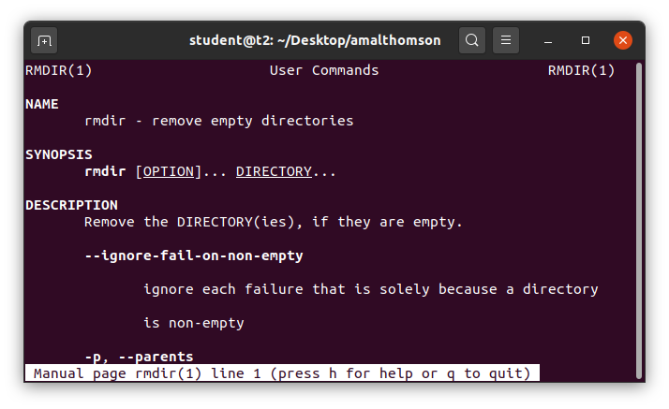

1. **cd** – used to navigate through directory.

**Options of cd commands**:

1. cd – used to switch to home directory.

Syntax: $ cd

Output:

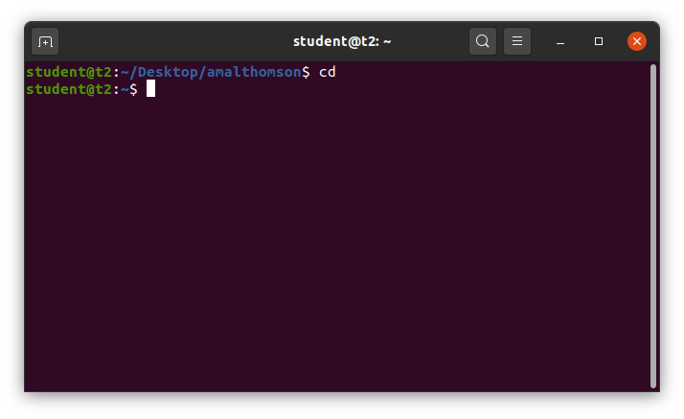

1. **cd <path>** - used to change to a particular path or directory

Syntax: $ cd *<directory_path>*

Output:

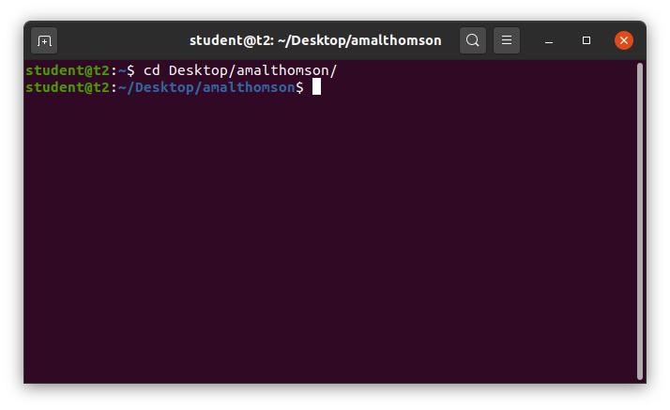

1. **cd ..** – used to switch back to previous directory or one directory back from the current directory

Syntax: $ cd ..

Output:

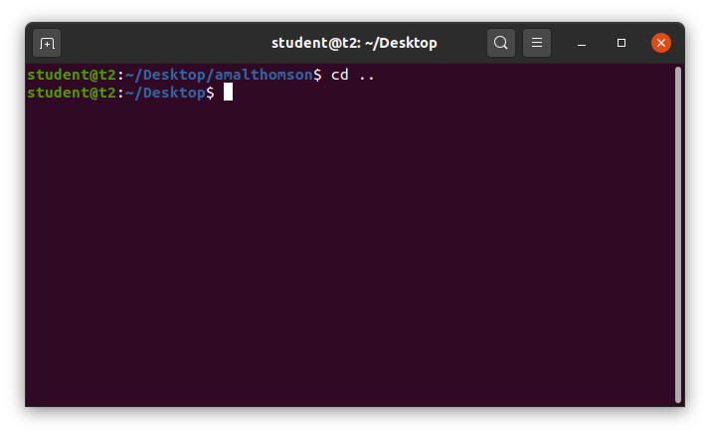

1. **mkdir** – Used to make new directory.

Syntax: $ mkdir *<directory_name>*

Output:

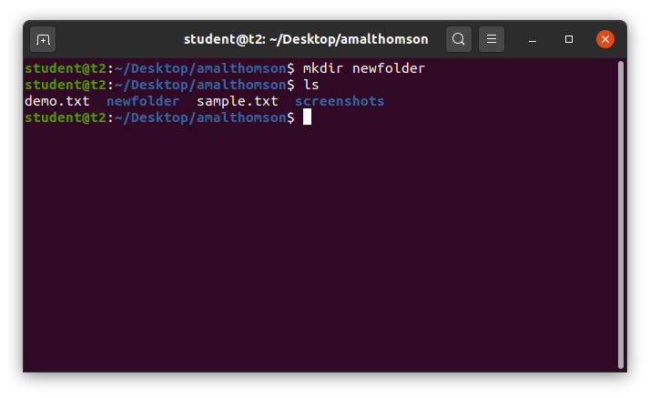

1. **rmdir** – used to remove a directory.

Syntax: $ rmdir <*directory_name*>

Output:

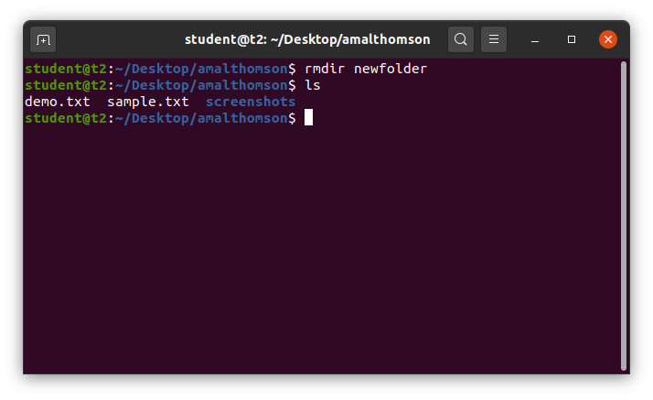

1. **history** – used to view the list of commands executed in a certain period of time.

Syntax: $ history

Output;

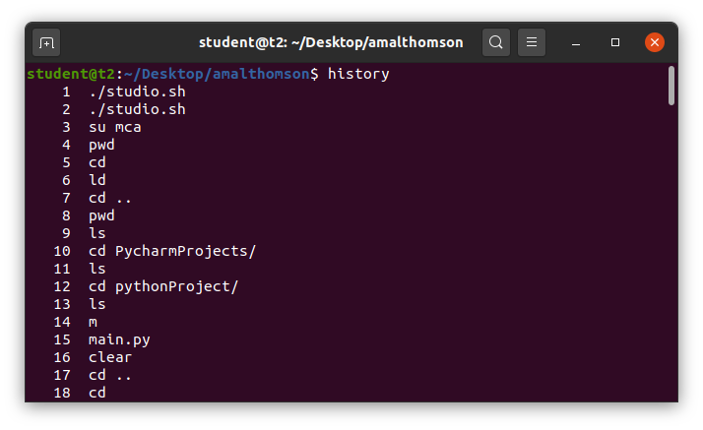

1. **touch** – used to create a new blank file.

Syntax: $ touch <*filename*>

Output:

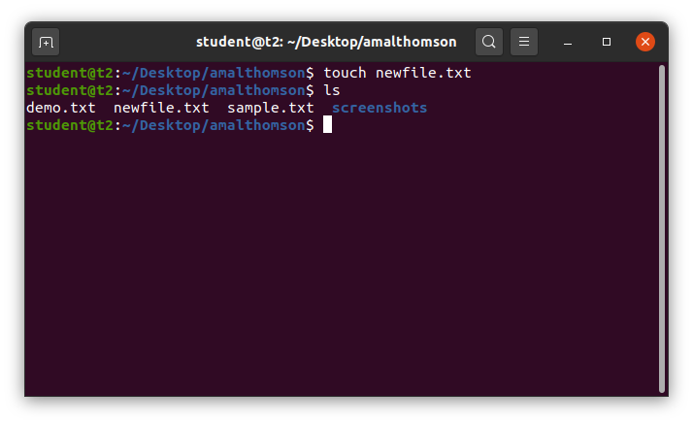

1. **cat –** usedto create a new blank file and also to add contents to the file.

**Options of cat commands:**

1. **cat >** – used to create a new blank file and also to add contents to the file.

Syntax: $ cat > <*filename*>

Output:

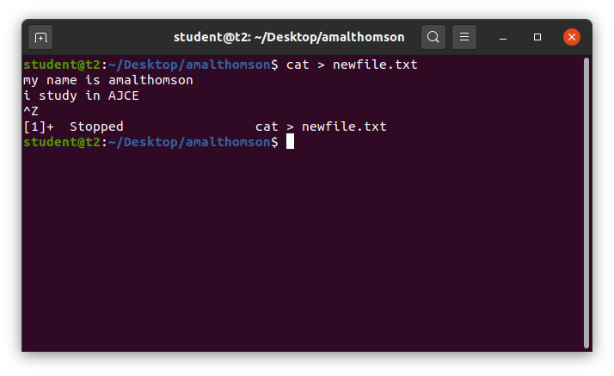

1. **cat >>** – used to append new contents to existing file.

Syntax: $ cat >> <*filename*>

Output:

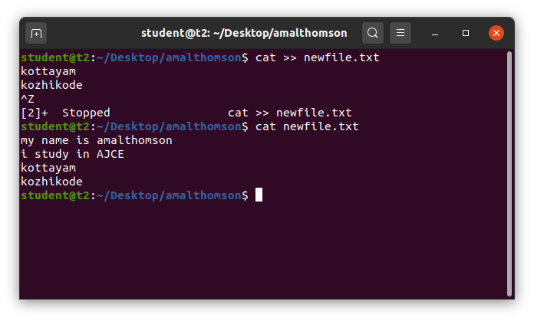

1. **cat file1 file2 > file3** – copy contents of two files to a third file.

Syntax: $ cat *<filename><filename> > <filename>*

Output:

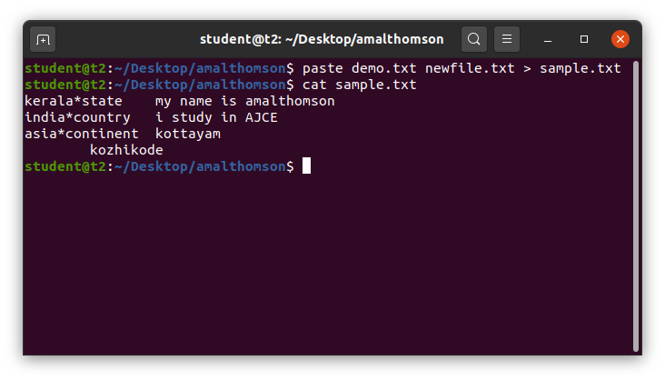

1. **cat -n** – to display the contents with line numbers.

Syntax: $ cat -n <*filename*>

Output:

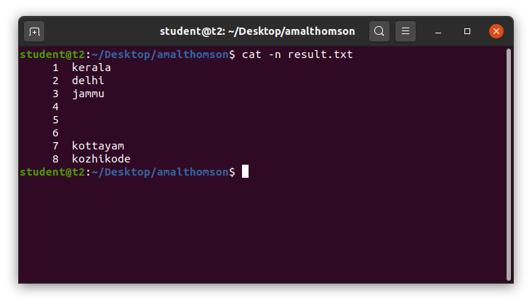

1. **cat -b** – to remove numbering for empty lines.

Syntax: $ cat -n <*filename>*

Output:

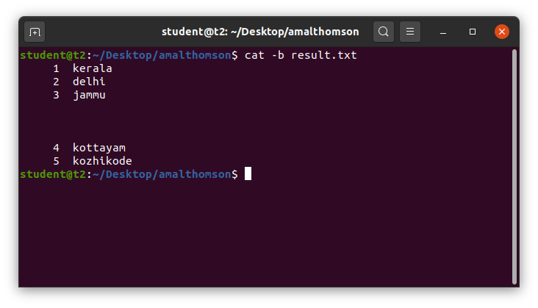

1. **cat *<filename> |* tr a-z A-Z > <*filename>*** – converts the contents of a file to UpperCase and saves into another file.

Syntax: $ cat <*filename>* | tr a-z A-Z > <*filename*>

Output:

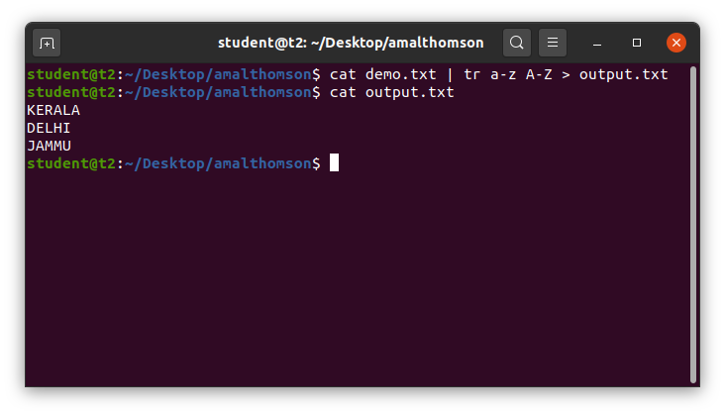

1. **cat *<filename> |* tr A-Z a-z > <*filename>*** – converts the contents of a file to LowerCase and saves into another file.

Syntax: $ cat <*filename>* | tr A-Z a-z > <*filename*>

Output:

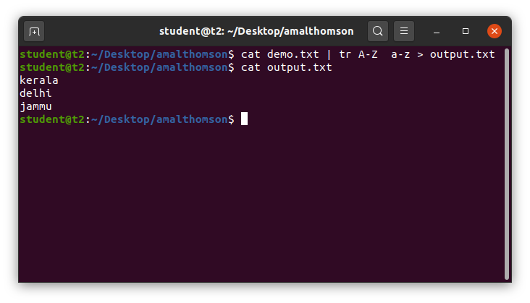

**Result**

The program was executed and the result was successfully obtained. Thus CO2 was obtained.

**Experiment No.: 4**

**Aim**

Familiarization of Linux Commands.

**CO2**

Perform system administration tasks.

**Procedure**

1. **cut** – to cut the contents of the file.

**Options of cut command**:

1. **cut -b1** – to cut the contents of a file by byte position.

Syntax: $ cut -b1 <*filename*>

Output:

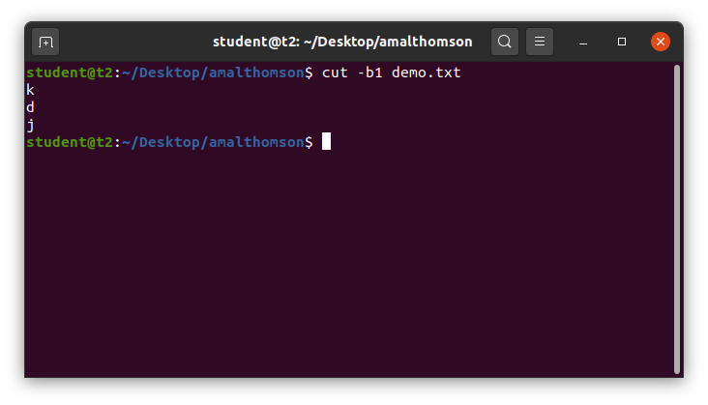

1. **cut -c3** – to cut the contents of a file by character position.

Syntax: $ cut -c3 <*filename*>

Output:

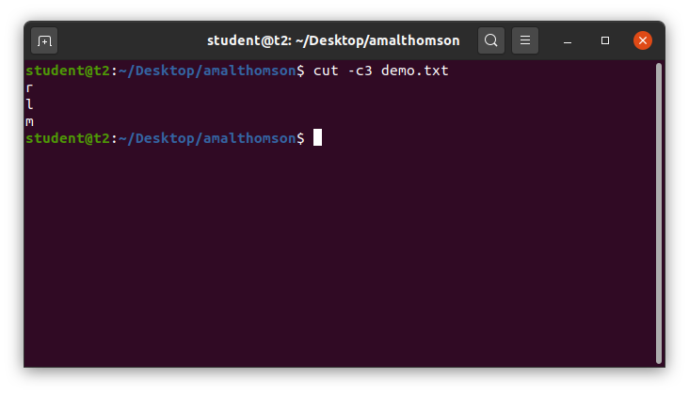

1. **cut –d - -f1** – used delimiter to cut the contents at ‘-‘ in the first column which is given by –f1.

Syntax: $ cut –d ‘*’ -f1 <*filename*>

Output:

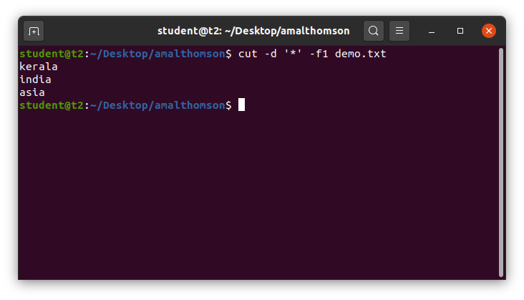

1. **cut –c** – to cut the characters from a specified position in a file.

Syntax: $ cut -c [1,3] <*filemane*>

Output:

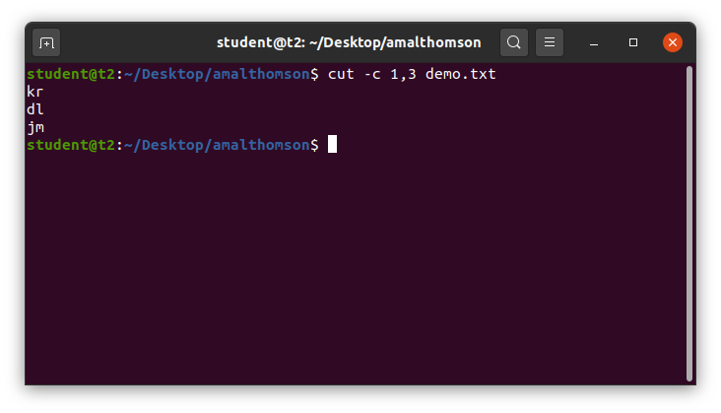

1. **paste** – to paste the content of a file to another.

**Options of paste command**

1. **paste <*filename*> <*filename*>** – to paste the contents in file1 to file2.

Syntax: $ paste <*filename*> <*filename*>

Output:

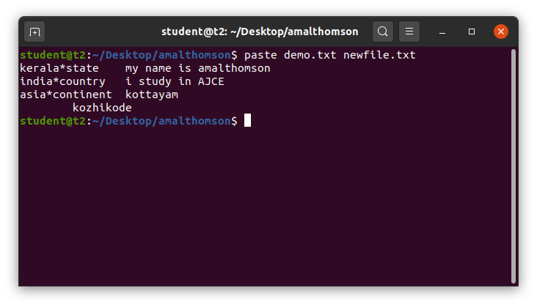

1. **paste *<filename> <filename> > <filename>*** *–* to paste the contents of two files to a third file.

Syntax: $ paste *<filename> <filename> > <filename>*

Output:

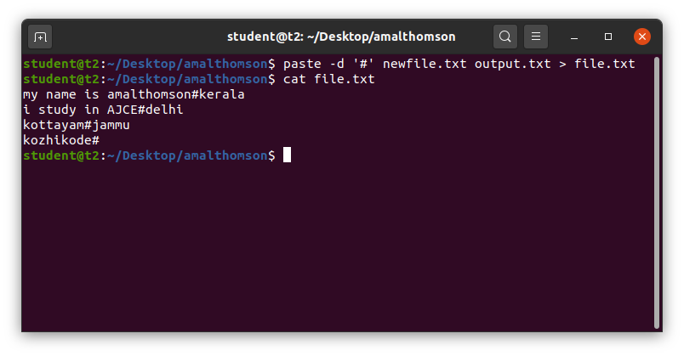

1. **paste –d ‘#’ <filename> <filename>** – to paste # and join the contents of a file with another file.

Syntax: $ paste –d ‘#’ *<filename> <filename>*

Output:

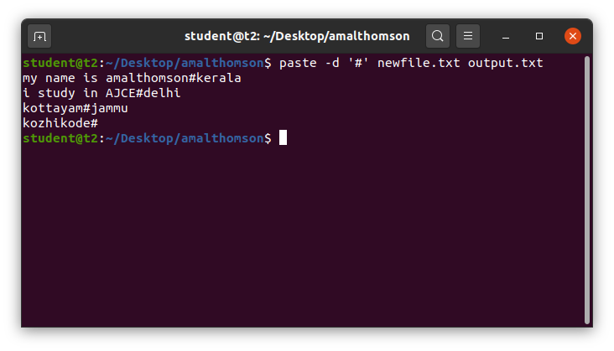

1. **paste -s** – to show all contents of a file in a single line.

Syntax: $ paste -s <*filename*>

Output:

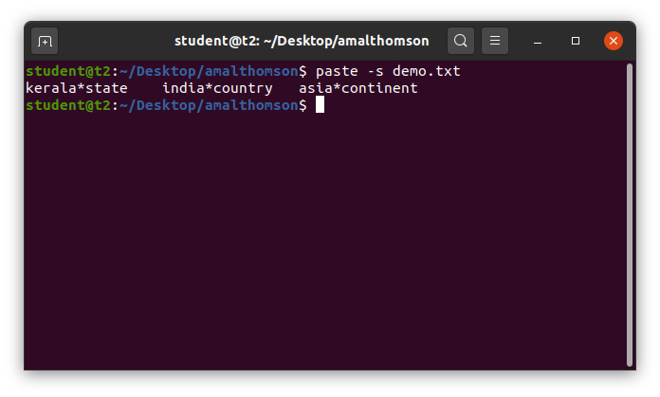

1. **cp** – to copy the contents of a file.

Options of cp command:

1. **cp *<filename> <filename>*** *–* to copy the contents of a file into another file or a new file.

Syntax: $ cp *<filename> <filename>*

Output:

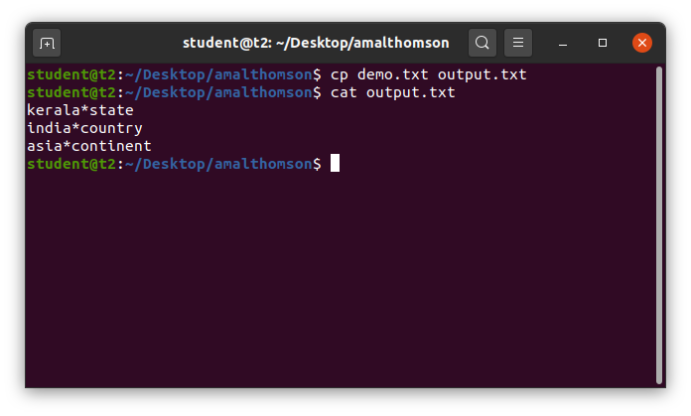

1. **cp <*filename*> <*directory*>** - to copy a file to a directory.

Syntax: $ cp <*filename*> <*directory*>

Output:

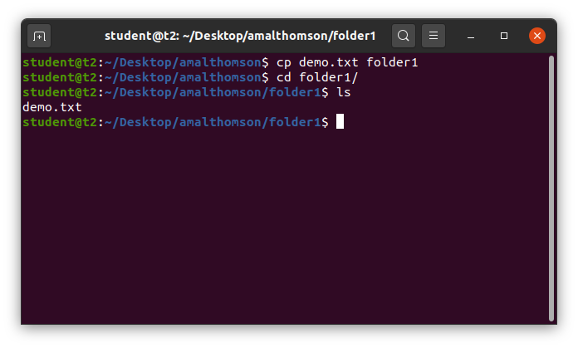

1. **cp -r** - to copy a directory and its contents to another directory.

Syntax: $ cp -r <*directory*> <*directory*>

Output:

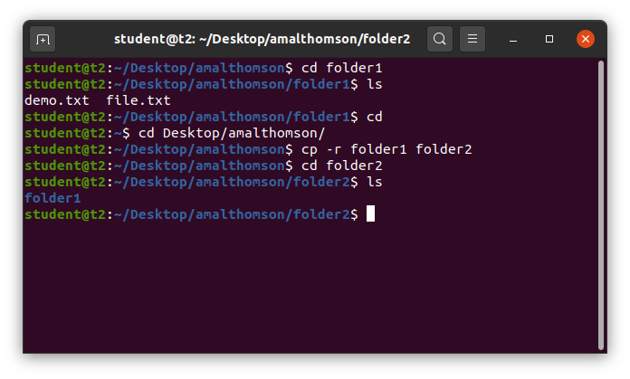

**Result**

The program was executed and the result was successfully obtained. Thus CO2 was obtained.