**Experiment 1**

**Aim:**

**CO1:**

Design and develop user interfaces for mobile apps using basic building blocks, UI components and application structure using Emulator

**Procedure:**

**activity_main.xml**

<?xml version="1.0" encoding="utf-8"?>

<LinearLayout xmlns:android="http://schemas.android.com/apk/res/android"

xmlns:app="http://schemas.android.com/apk/res-auto"

xmlns:tools="http://schemas.android.com/tools"

android:layout_width="match_parent"

android:layout_height="match_parent"

android:background="@color/teal_700"

android:orientation="vertical"

tools:context=".MainActivity">

<TextView

android:layout_width="wrap_content"

android:layout_height="wrap_content"

android:text="@string/str"

app:layout_constraintBottom_toBottomOf="parent"

app:layout_constraintEnd_toEndOf="parent"

app:layout_constraintStart_toStartOf="parent"

app:layout_constraintTop_toTopOf="parent" />

<ImageView

android:layout_width="wrap_content"

android:layout_height="404dp"

android:src="@drawable/pexels" />

<Button

android:id="@+id/btn1"

android:layout_width="match_parent"

android:layout_height="wrap_content"

android:text="Submit" />

</LinearLayout>

**MainActivity.java**

package com.example.application1;

import androidx.appcompat.app.AppCompatActivity;

import android.os.Bundle;

import android.view.View;

import android.widget.Button;

import android.widget.Toast;

public class MainActivity extends AppCompatActivity {

Button b;

@Override

protected void onCreate(Bundle savedInstanceState) {

super.onCreate(savedInstanceState);

setContentView(R.layout.activity_main);

b=findViewById(R.id.btn1);

b.setOnClickListener(new View.OnClickListener() {

@Override

public void onClick(View view) {

Toast.makeText(MainActivity.this, "Hello User”, Toast.LENGTH_SHORT).show();

}

});

}

**Output:**  
 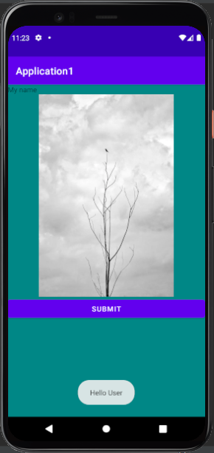

**Result:**

Output displayed successfully and CO1 was obtained

**Experiment 2**

**Aim:**

**CO1:**

Design and develop user interfaces for mobile apps using basic building blocks, UI components and application structure using Emulator

**Procedure:**

**activity_main.xml**

<?xml version="1.0" encoding="utf-8"?>

<TableLayout xmlns:android="http://schemas.android.com/apk/res/android"

xmlns:app="http://schemas.android.com/apk/res-auto"

xmlns:tools="http://schemas.android.com/tools"

android:layout_width="match_parent"

android:layout_height="match_parent"

android:orientation="vertical"

tools:context=".MainActivity">

<TableRow

android:layout_width="wrap_content"

android:layout_height="wrap_content">

<TextView

android:layout_width="wrap_content"

android:layout_height="wrap_content"

android:text="@string/num1"/>

<EditText

android:id="@+id/eid1"

android:layout_width="wrap_content"

android:layout_height="wrap_content"

android:inputType="number" />

</TableRow>

<TableRow

android:layout_width="wrap_content"

android:layout_height="wrap_content">

<TextView

android:layout_width="wrap_content"

android:layout_height="wrap_content"

android:text="@string/num2"/>

<EditText

android:id="@+id/eid2"

android:layout_width="wrap_content"

android:layout_height="wrap_content"

android:inputType="number" />

</TableRow>

<TableRow

android:layout_width="wrap_content"

android:layout_height="wrap_content">

<Button

android:id="@+id/btn1"

android:layout_width="wrap_content"

android:layout_height="wrap_content"

android:text="Compute" />

<TextView

android:id="@+id/tid1"

android:layout_width="wrap_content"

android:layout_height="wrap_content"

android:text="@string/res" />

</TableRow>

</TableLayout>

**strings.xml**  
<resources>

<string name="app_name">SumOf</string>

<string name="num1">Enter the first number: </string>

<string name="num2">Enter the second number: </string>

<string name="res">Sum: </string>

</resources>

**MainActivity.java**  
package com.example.sumof;

import androidx.appcompat.app.AppCompatActivity;

import android.os.Bundle;

import android.view.View;

import android.widget.Button;

import android.widget.EditText;

import android.widget.TextView;

import android.widget.Toast;

public class MainActivity extends AppCompatActivity {

Button b;

EditText ed1, ed2;

TextView tv1;

@Override

protected void onCreate(Bundle savedInstanceState) {

super.onCreate(savedInstanceState);

setContentView(R.layout.activity_main);

ed1=findViewById(R.id.eid1);

ed2=findViewById(R.id.eid2);

tv1=findViewById(R.id.tid1);

b=findViewById(R.id.btn1);

b.setOnClickListener(new View.OnClickListener() {

@Override

public void onClick(View view) {

String num1 = ed1.getText().toString();

String num2 = ed2.getText().toString();

Integer a = Integer.parseInt(num1);

Integer b = Integer.parseInt(num2);

Integer sum = a + b;

//Toast.makeText(MainActivity.this, "Sum "+ sum, Toast.LENGTH_SHORT).show();

//Toast.makeText(MainActivity.this, String.valueOf(sum), Toast.LENGTH_SHORT).show();

//tv1.setText("Sum: "+ sum);

tv1.setText(sum.toString());

}

});

}

}

**Output:**  
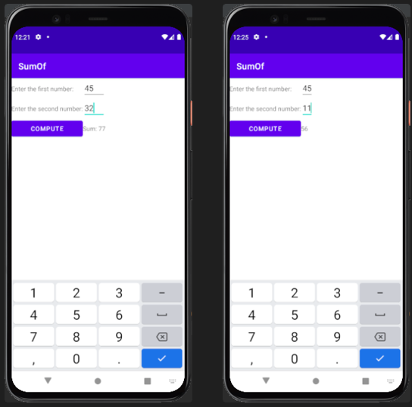

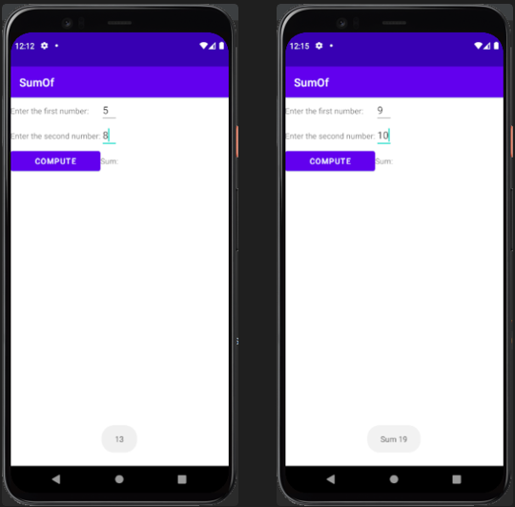

**Result:**

Output displayed successfully and CO1 was obtained

**Experiment 3**

**Aim:**

**CO1:**

Design and develop user interfaces for mobile apps using basic building blocks, UI components and application structure using Emulator

**Procedure:**

**MainActivity.java**  
package com.example.oddoreven;

import androidx.appcompat.app.AppCompatActivity;

import android.os.Bundle;

import android.view.View;

import android.widget.Button;

import android.widget.EditText;

import android.widget.TextView;

public class MainActivity extends AppCompatActivity {

Button b;

EditText ed1;

TextView tv1;

@Override

protected void onCreate(Bundle savedInstanceState) {

super.onCreate(savedInstanceState);

setContentView(R.layout.activity_main);

ed1=findViewById(R.id.eid1);

tv1=findViewById(R.id.tid1);

b=findViewById(R.id.btn1);

b.setOnClickListener(new View.OnClickListener() {

@Override

public void onClick(View view) {

String num1 = ed1.getText().toString();

Integer a = Integer.parseInt(num1);

if ( a == 0){

tv1.setText("Result: " + String.valueOf(a) + " is neither Odd or Even");

}

else if ( a % 2 == 0){

tv1.setText("Result: " + String.valueOf(a) + " is Even");

}

else {

tv1.setText("Result: " + String.valueOf(a) + " is Odd");

}

}

});

}

}

**activity_main.xml**

<?xml version="1.0" encoding="utf-8"?>

<TableLayout xmlns:android="http://schemas.android.com/apk/res/android"

xmlns:app="http://schemas.android.com/apk/res-auto"

xmlns:tools="http://schemas.android.com/tools"

android:layout_width="match_parent"

android:layout_height="match_parent"

android:orientation="vertical"

tools:context=".MainActivity">

<TableRow

android:layout_width="wrap_content"

android:layout_height="wrap_content">

<TextView

android:layout_width="wrap_content"

android:layout_height="wrap_content"

android:text="@string/num1"/>

<EditText

android:id="@+id/eid1"

android:layout_width="wrap_content"

android:layout_height="wrap_content"

android:inputType="number" />

</TableRow>

<TableRow

android:layout_width="wrap_content"

android:layout_height="wrap_content">

<Button

android:id="@+id/btn1"

android:layout_width="wrap_content"

android:layout_height="wrap_content"

android:text="Check Odd/Even" />

<TextView

android:id="@+id/tid1"

android:layout_width="wrap_content"

android:layout_height="wrap_content"

android:text="@string/res" />

</TableRow>

</TableLayout>

**strings.xml**

<resources>

<string name="app_name">Odd/Even Checker</string>

<string name="num1">Enter the number: </string>

<string name="res">Result: </string>

</resources>

**Output:**

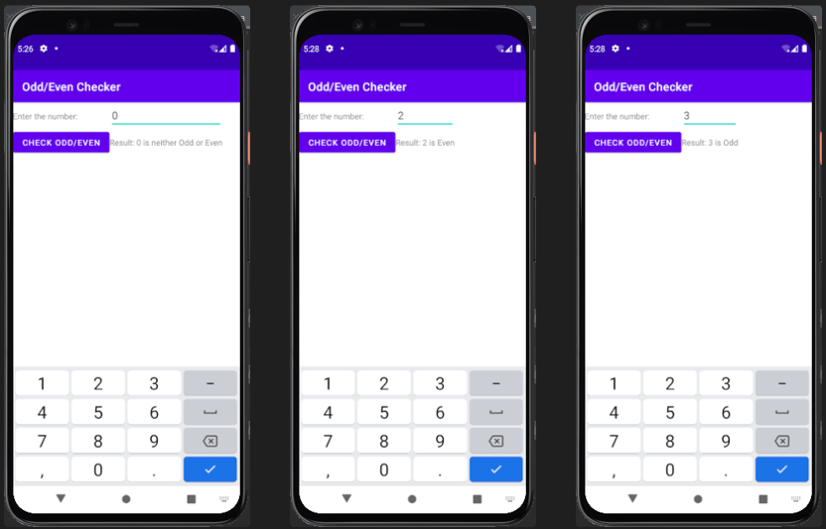

**Result:**

Output displayed successfully and CO1 was obtained

**Experiment 4**

**Aim:**

Design a Login Form with username and password using LinearLayout and toast valid credentials

**CO1:**

Design and develop user interfaces for mobile apps using basic building blocks, UI components and application structure using Emulator

**Procedure:**

**activity_main.xml**

<?xml version="1.0" encoding="utf-8"?>

<LinearLayout xmlns:android="http://schemas.android.com/apk/res/android"

xmlns:app="http://schemas.android.com/apk/res-auto"

xmlns:tools="http://schemas.android.com/tools"

android:layout_width="match_parent"

android:layout_height="match_parent"

android:orientation="vertical"

tools:context=".MainActivity">

<TextView

android:layout_width="wrap_content"

android:layout_height="wrap_content" />

<ImageView

android:layout_width="120dp"

android:layout_height="135dp"

android:layout_gravity="center"

android:contentDescription="Profile Picture"

android:scaleType="centerCrop"

android:src="@drawable/profile" />

<TextView

android:layout_width="match_parent"

android:layout_height="wrap_content"

android:text="@string/un" />

<EditText

android:id="@+id/user"

android:layout_width="match_parent"

android:layout_height="wrap_content"

android:hint="Sreerag" />

<TextView

android:layout_width="match_parent"

android:layout_height="wrap_content"

android:text="@string/ps" />

<EditText

android:id="@+id/pass"

android:layout_width="match_parent"

android:layout_height="wrap_content"

android:hint="password"

android:inputType="textPassword" />

<Button

android:id="@+id/btn"

android:layout_width="wrap_content"

android:layout_height="wrap_content"

android:text="Login" />

</LinearLayout>

**MainActivity.java**

package com.example.login;

import androidx.appcompat.app.AppCompatActivity;

import android.os.Bundle;

import android.view.View;

import android.widget.Button;

import android.widget.EditText;

import android.widget.Toast;

public class MainActivity extends AppCompatActivity {

Button b;

EditText ed1, ed2;

@Override

protected void onCreate(Bundle savedInstanceState) {

super.onCreate(savedInstanceState);

setContentView(R.layout.activity_main);

ed1 = findViewById(R.id.user);

ed2 = findViewById(R.id.pass);

b = findViewById(R.id.btn);

b.setOnClickListener(new View.OnClickListener() {

@Override

public void onClick(View view) {

String txt1 = ed1.getText().toString().trim();

String txt2 = ed2.getText().toString().trim();

if(txt1.isEmpty() || txt2.isEmpty()){

Toast.makeText(MainActivity.this, "Please input Username and Password", Toast.LENGTH_SHORT).show();

}

else if(txt1.equals("Sreerag") || txt2.equals("root")) {

Toast.makeText(MainActivity.this, "Login Successful", Toast.LENGTH_LONG).show();

}

else{

Toast.makeText(MainActivity.this, "Login Failed", Toast.LENGTH_SHORT).show();

}

}

});

}

}

**strings.xml**  
<resources>

<string name="app_name">Login</string>

<string name="un">User Name: </string>

<string name="ps">Password: </string>

</resources>

**Output:**

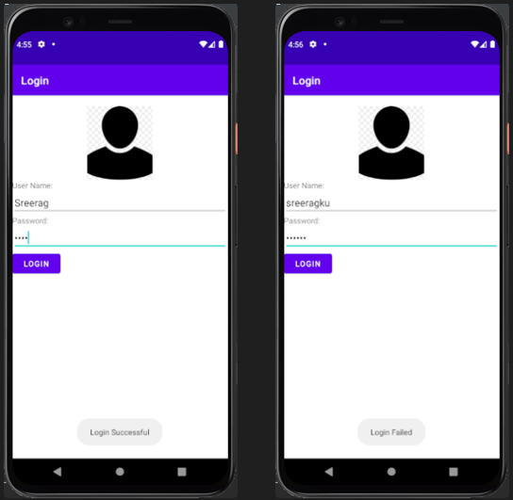

**Result:**

Output displayed successfully and CO1 was obtained

**Experiment 5**

**Aim:**

Implementing basic arithmetic operations of a simple calculator

**CO1:**

Design and develop user interfaces for mobile apps using basic building blocks, UI components and application structure using Emulator

**Procedure:**

**activity_main.xml**<?xml version="1.0" encoding="utf-8"?>

<TableLayout xmlns:android="http://schemas.android.com/apk/res/android"

xmlns:app="http://schemas.android.com/apk/res-auto"

xmlns:tools="http://schemas.android.com/tools"

android:layout_width="match_parent"

android:layout_height="match_parent"

android:orientation="vertical"

tools:context=".MainActivity">

<TableRow

android:layout_width="wrap_content"

android:layout_height="wrap_content">

<TextView

android:layout_width="wrap_content"

android:layout_height="wrap_content"

android:text="@string/num1"

/>

<EditText

android:id="@+id/num1"

android:layout_width="wrap_content"

android:layout_height="wrap_content"

/>

</TableRow>

<TableRow

android:layout_width="wrap_content"

android:layout_height="wrap_content">

<TextView

android:layout_width="wrap_content"

android:layout_height="wrap_content"

android:text="@string/num2"

/>

<EditText

android:id="@+id/num2"

android:layout_width="wrap_content"

android:layout_height="wrap_content"

/>

</TableRow>

<TableRow

android:layout_width="match_parent"

android:layout_height="match_parent">

<Button

android:id="@+id/plus"

android:layout_width="wrap_content"

android:layout_height="wrap_content"

android:text="+" />

<Button

android:id="@+id/minus"

android:layout_width="wrap_content"

android:layout_height="wrap_content"

android:text="-" />

</TableRow>

<TableRow

android:layout_width="match_parent"

android:layout_height="match_parent">

<Button

android:id="@+id/star"

android:layout_width="wrap_content"

android:layout_height="wrap_content"

android:text="*" />

<Button

android:id="@+id/slash"

android:layout_width="wrap_content"

android:layout_height="wrap_content"

android:text="/" />

</TableRow>

<TableRow

android:layout_width="match_parent"

android:layout_height="match_parent">

<Button

android:id="@+id/C"

android:layout_width="wrap_content"

android:layout_height="wrap_content"

android:text="C" />

</TableRow>

<TableRow>

<TextView

android:id="@+id/res"

android:layout_width="match_parent"

android:layout_height="match_parent"

android:text="Result: " />

</TableRow>

</TableLayout>

**strings.xml**<resources>

<string name="app_name">Arithmetic Operations</string>

<string name="num1">Enter the first number</string>

<string name="num2">Enter the second number</string>

<string name="res">Result: </string>

</resources>

**MainActivity.java**package com.example.arithmetic;

import androidx.appcompat.app.AppCompatActivity;

import android.os.Bundle;

import android.view.View;

import android.widget.Button;

import android.widget.EditText;

import android.widget.TextView;

public class MainActivity extends AppCompatActivity {

EditText ed1, ed2;

Button plus, minus, multiply, divide, clear;

TextView result;

@Override

protected void onCreate(Bundle savedInstanceState) {

super.onCreate(savedInstanceState);

setContentView(R.layout.activity_main);

ed1 = findViewById(R.id.num1);

ed2 = findViewById(R.id.num2);

plus = findViewById(R.id.plus);

minus = findViewById(R.id.minus);

multiply = findViewById(R.id.star);

divide = findViewById(R.id.slash);

clear = findViewById(R.id.C);

result = findViewById(R.id.res);

plus.setOnClickListener(new View.OnClickListener() {

@Override

public void onClick(View view) {

calculate('+');

}

});

minus.setOnClickListener(new View.OnClickListener() {

@Override

public void onClick(View view) {

calculate('-');

}

});

multiply.setOnClickListener(new View.OnClickListener() {

@Override

public void onClick(View view) {

calculate('*');

}

});

divide.setOnClickListener(new View.OnClickListener() {

@Override

public void onClick(View view) {

calculate('/');

}

});

clear.setOnClickListener(new View.OnClickListener() {

@Override

public void onClick(View view) {

ed1.setText("");

ed2.setText("");

result.setText("Result: ");

}

});

}

public void calculate(char operator) {

String num1 = ed1.getText().toString();

String num2 = ed2.getText().toString();

if (num1.isEmpty() || num2.isEmpty()) {

result.setText("Result: Please enter both numbers.");

return;

}

double num1 = Double.parseDouble(num1);

double num2 = Double.parseDouble(num2);

double resVal = 0.0;

switch (operator) {

case '+':

resVal = num1 + num2;

break;

case '-':

resVal = num1 - num2;

break;

case '*':

resVal = num1 * num2;

break;

case '/':

if (num2 == 0) {

result.setText("Result: Cannot divide by zero.");

return;

}

resVal = num1 / num2;

break;

}

result.setText("Result: " + resVal);

}

}

**Output:**

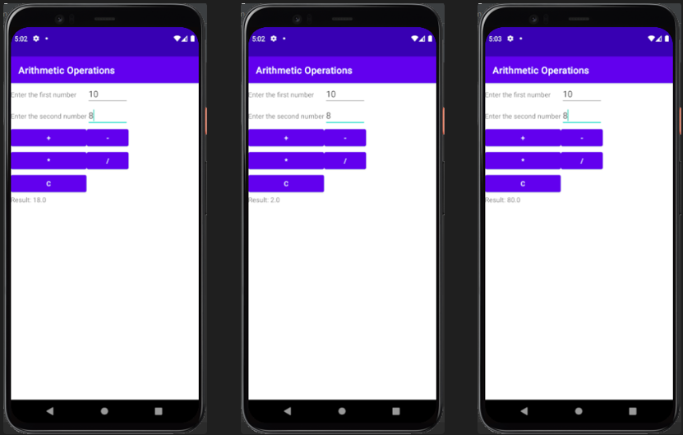

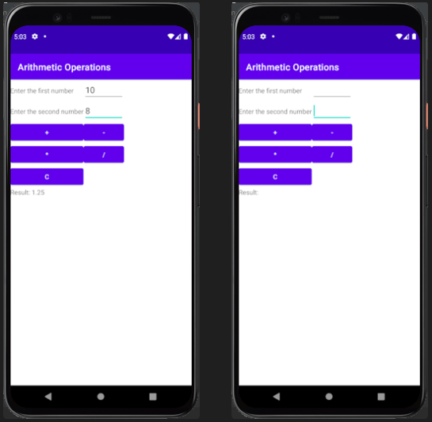

**Result:**

Output displayed successfully and CO1 was obtained

**activity_main.xml**  
<?xml version="1.0" encoding="utf-8"?>

<LinearLayout

xmlns:android="http://schemas.android.com/apk/res/android"

xmlns:app="http://schemas.android.com/apk/res-auto"

xmlns:tools="http://schemas.android.com/tools"

android:layout_width="match_parent"

android:layout_height="match_parent"

android:orientation="vertical"

android:gravity="center_horizontal"

tools:context=".MainActivity">

<LinearLayout

android:layout_width="match_parent"

android:layout_height="wrap_content"

android:orientation="horizontal"

android:gravity="center">

<TextView

android:layout_width="wrap_content"

android:layout_height="wrap_content"

android:text="COMPANY NAME"

android:textSize="24dp" />

<ImageView

android:layout_width="84dp"

android:layout_height="87dp"

android:src="@drawable/my_image" />

</LinearLayout>

<View

android:layout_width="match_parent"

android:layout_height="1dp"

android:background="#000000" />

<TextView

android:layout_width="wrap_content"

android:layout_height="wrap_content"

android:text="Name"

android:textSize="16dp"

android:layout_margin="8dp" />

<TextView

android:layout_width="wrap_content"

android:layout_height="wrap_content"

android:text="Job Title"

android:textSize="16dp"

android:layout_margin="8dp" />

<TextView

android:layout_width="wrap_content"

android:layout_height="wrap_content"

android:text="Phone Number"

android:textSize="16dp"

android:layout_margin="8dp" />

<TextView

android:layout_width="wrap_content"

android:layout_height="wrap_content"

android:text="Address"

android:textSize="16dp"

android:layout_margin="8dp" />

<TextView

android:layout_width="wrap_content"

android:layout_height="wrap_content"

android:text="Email, website, for details"

android:textSize="16dp"

android:layout_margin="8dp" />

</LinearLayout>