In-sanity, All about Healthcare

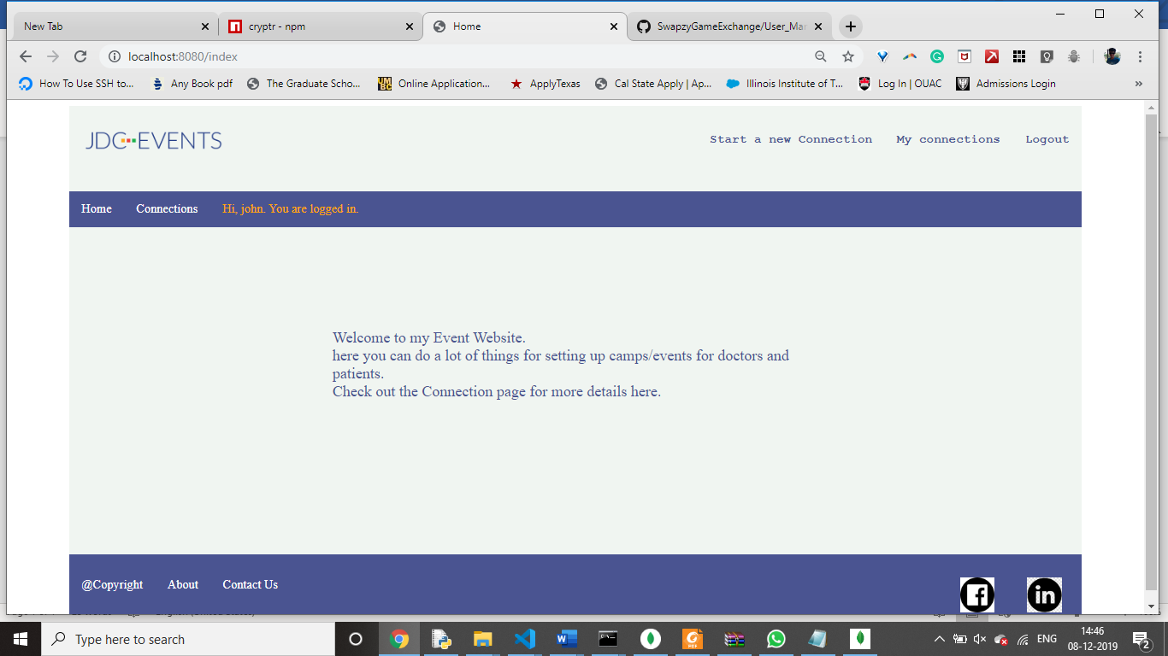

# ITIS 5166 - Network-Based Application Development

# Under guidance of Dr. Nadia Najjar

|  |  |  |
| --- | --- | --- |
| Student Id: 801063733 | Name:Amal vaishnav | Semester:Fall 2019 |

**Introduction**

In-sanity is a Healthcare website where a user can create Healtcare related events, manage schedules/ RSVP in the portal. We have made it interactive, Dynamic and Responsive using Node.js, Expreess.js and MongoDb. User can create Connections/Events using Form, Add-Update-Delete their response and many more. We also added login/signup facility and it is 100 percent secure so that no unauthorized user can swoop in.

The web application is designed in a way that provides easy access to its users. The user and site navigations are designed in a simple way to provide an easy navigation through out the application.



Sign In

The Sign In page consists of a basic form with – User ID and Password fields. The two mandatory details needed for a user to sign in. If the data doesn’t match with the one in database, it throws an error saying Invalid or no User/Password provided. If user ID or password is not entered it gives field specific error. If User ID format is incorrect it gives validation errors as shown below:

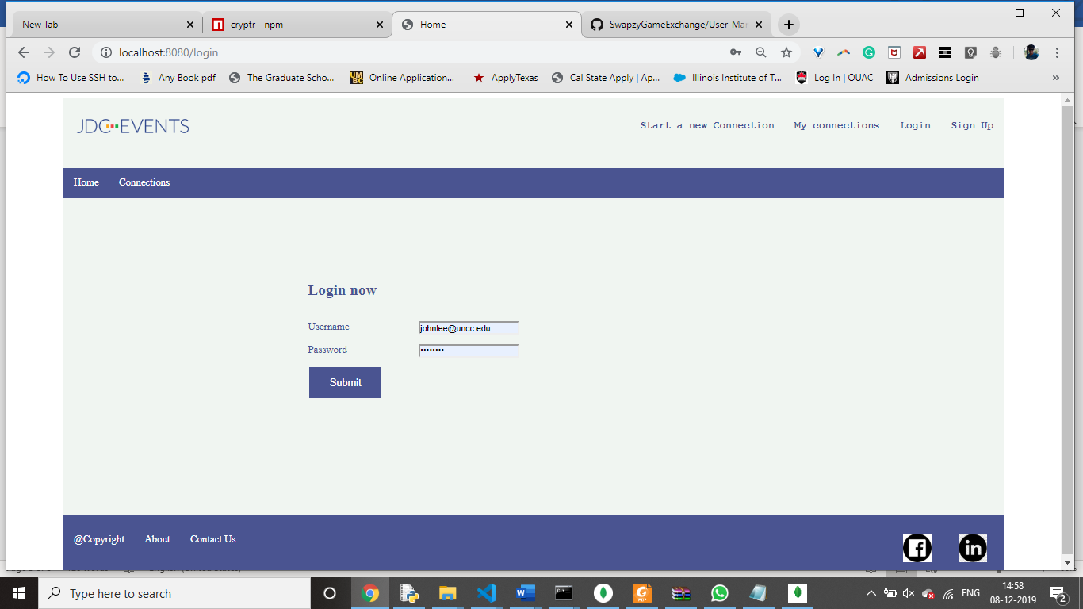

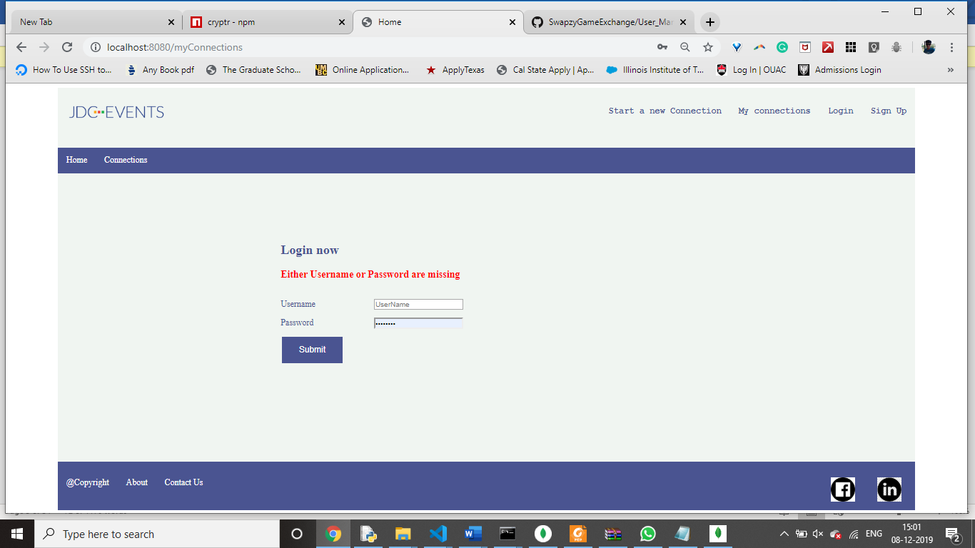

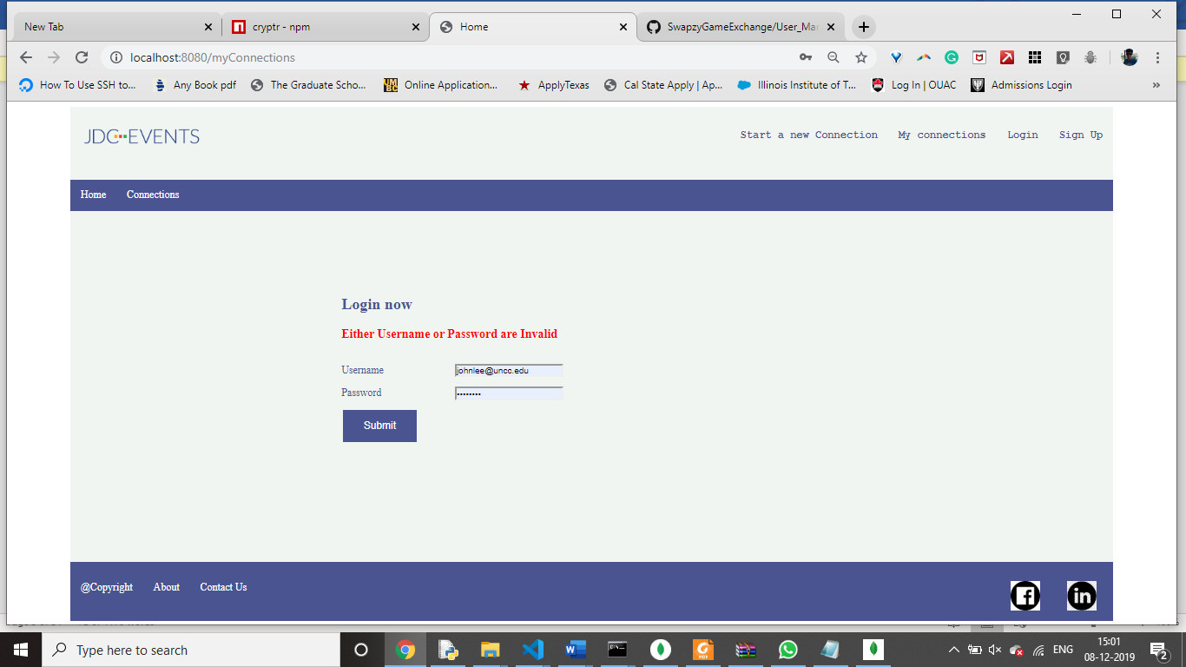

After successfully entering correct credentials, it leads the user to MyConnections page where he can manage his own connections an RSVP to it Or Update/delete them.

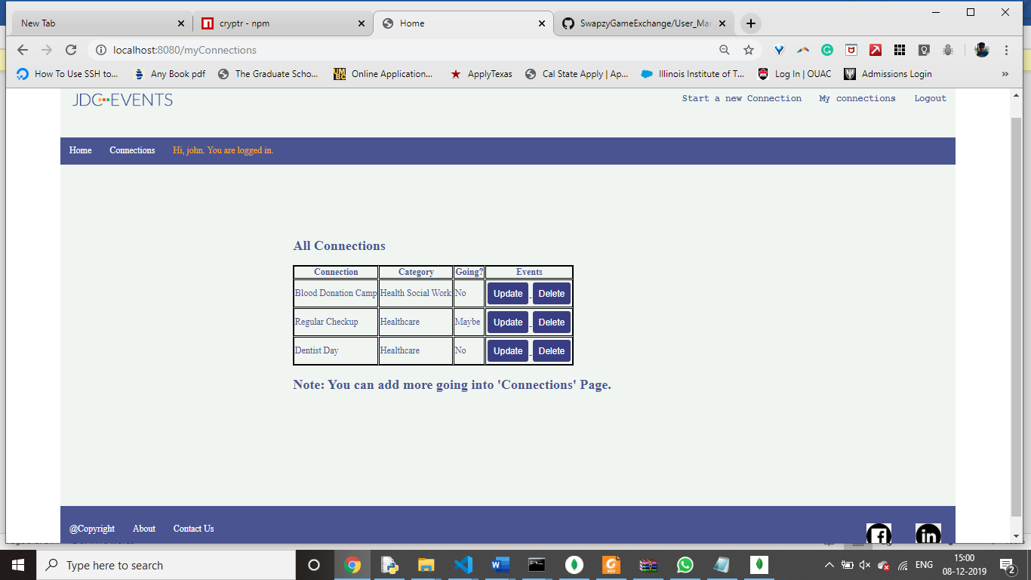

Register

If user enter details with invalid/blank fields, we show a popup box dictating that error as shown below.

If with same email id and password, if the record already exists, we change all of it and update that record with those email passwords. Shown below.

If the user is successful logging in, we lead it to login page and ask the user to log back in.

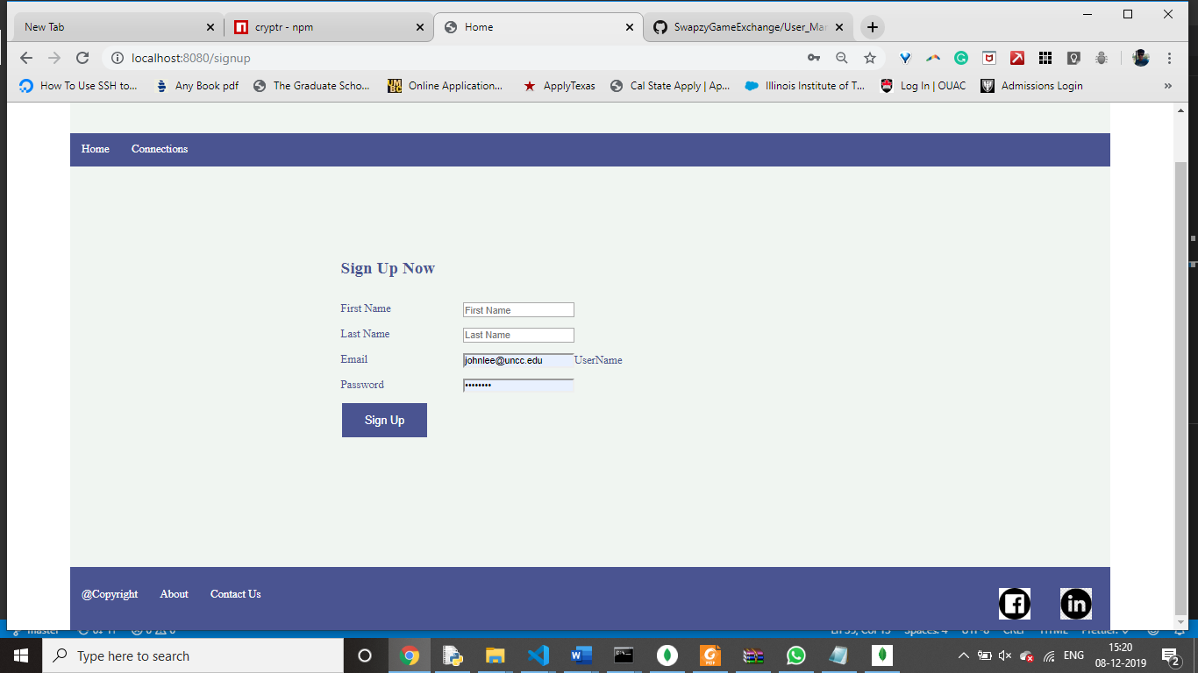

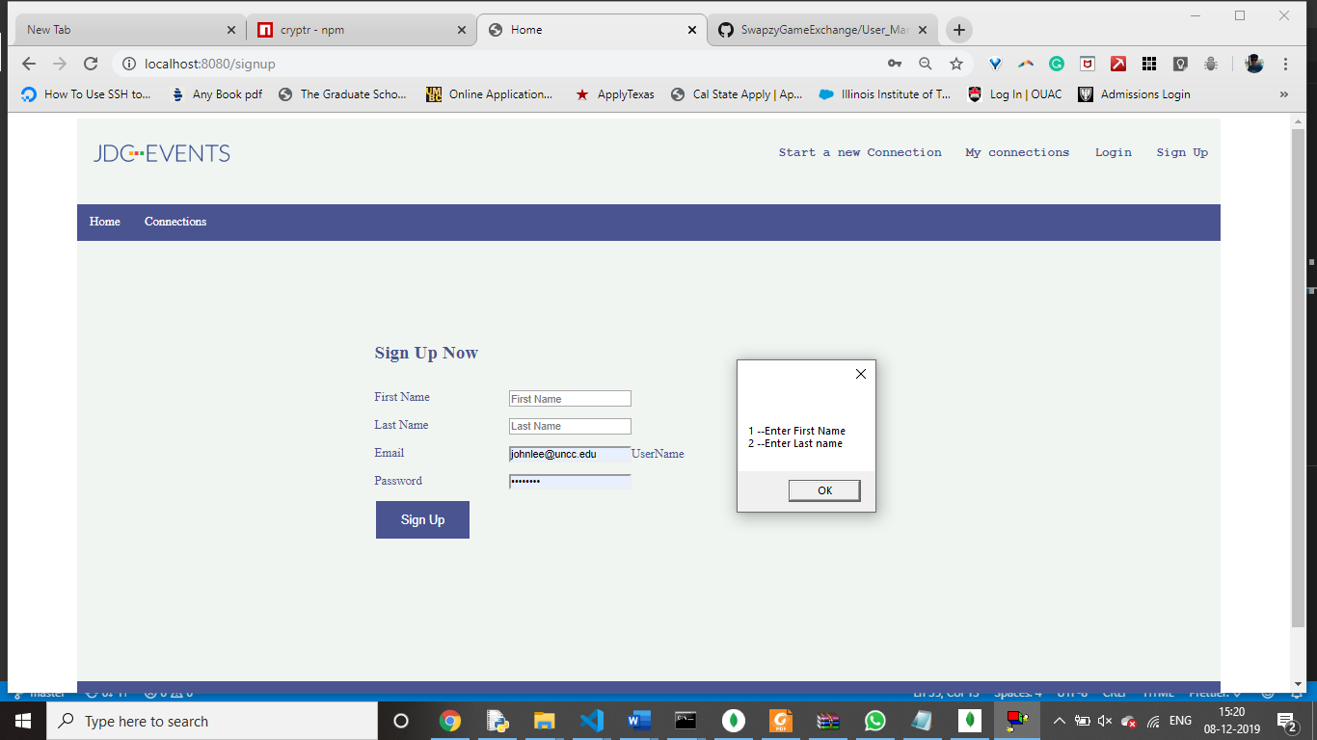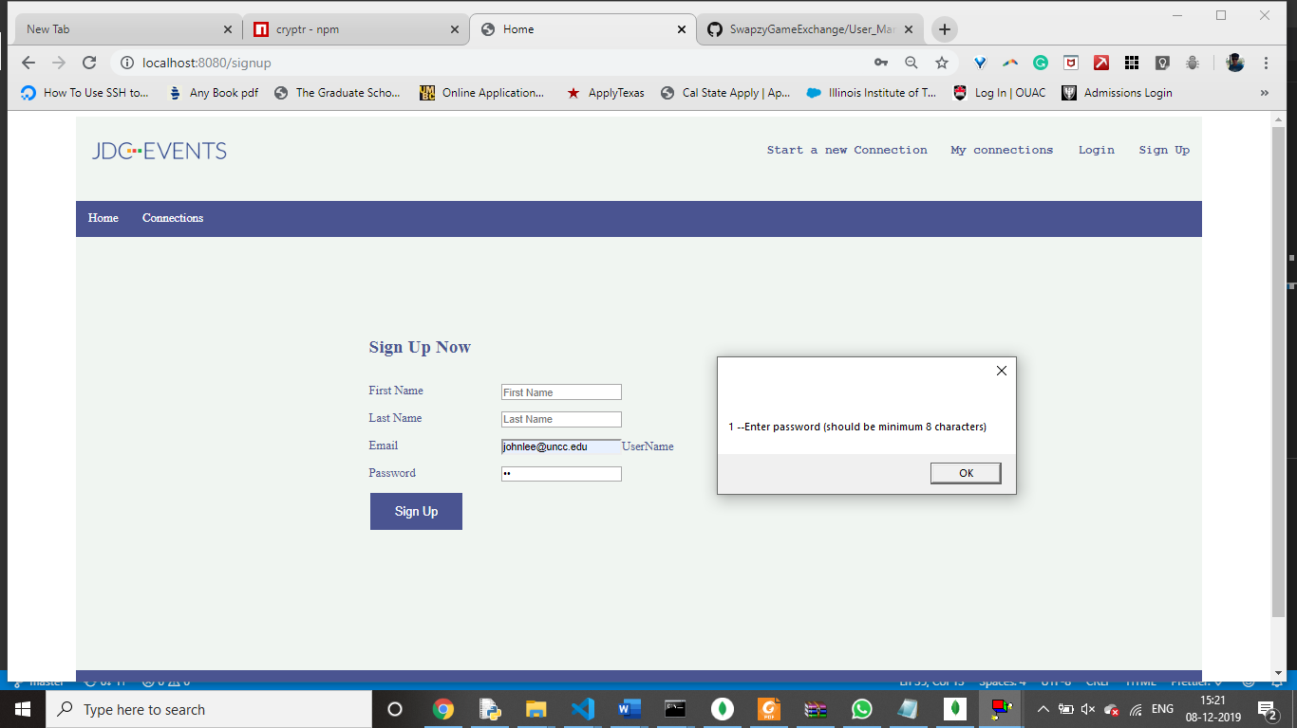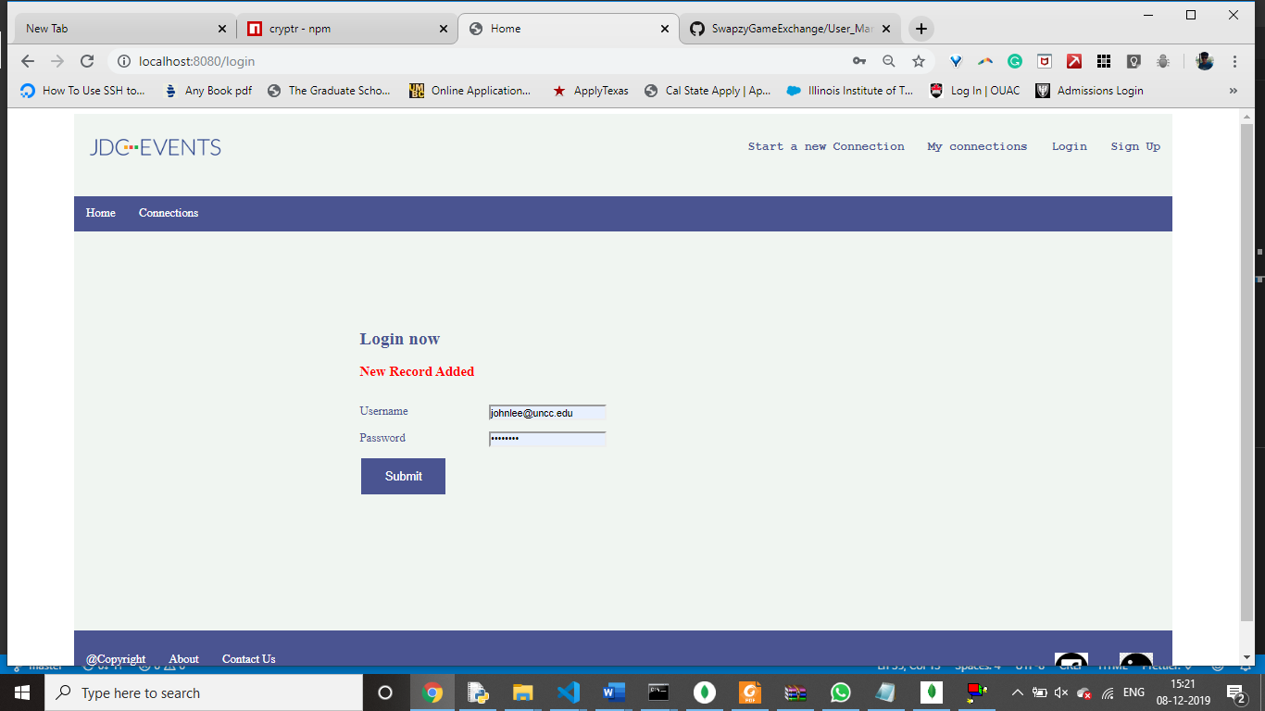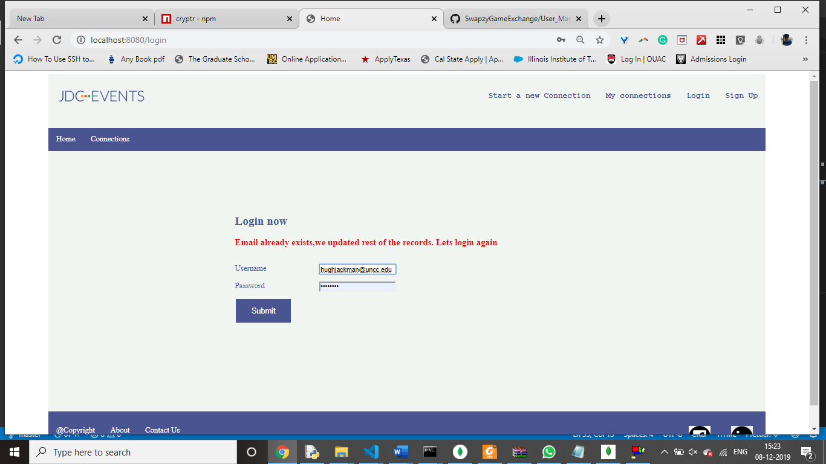

Connection Page

We are displaying all the connections/events a user can attend in the list category wise. We have Health category and Fitness as well.

