Scraping Data from Google Maps using Python
In this project we are scrapping Google Maps to get all business details of any user queries and to implement this project we have designed following modules.
- New User Register: user can sign up with the application
- User Login: user can login to system
- Scrape Google Maps: using this module user can enter any queries and then application will utilize internet connection to scan Google Maps to get all possible business details related to given query.
SCREEN SHOTS
Install python 3.7.2 and then install all packages given in requirements.txt file and then install MYSQL and then copy content from ‘database.txt’ file and paste in MYSQL console to create database
To run project double click on ‘runWebServer.bat’ file to start python server and then will get below page
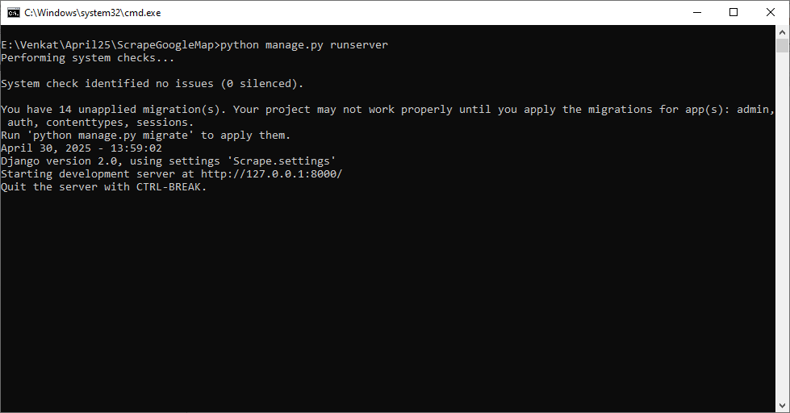
In above screen python server started and now open browser and enter URL as http://127.0.0.1:8000/index.html and then press enter key to get below page
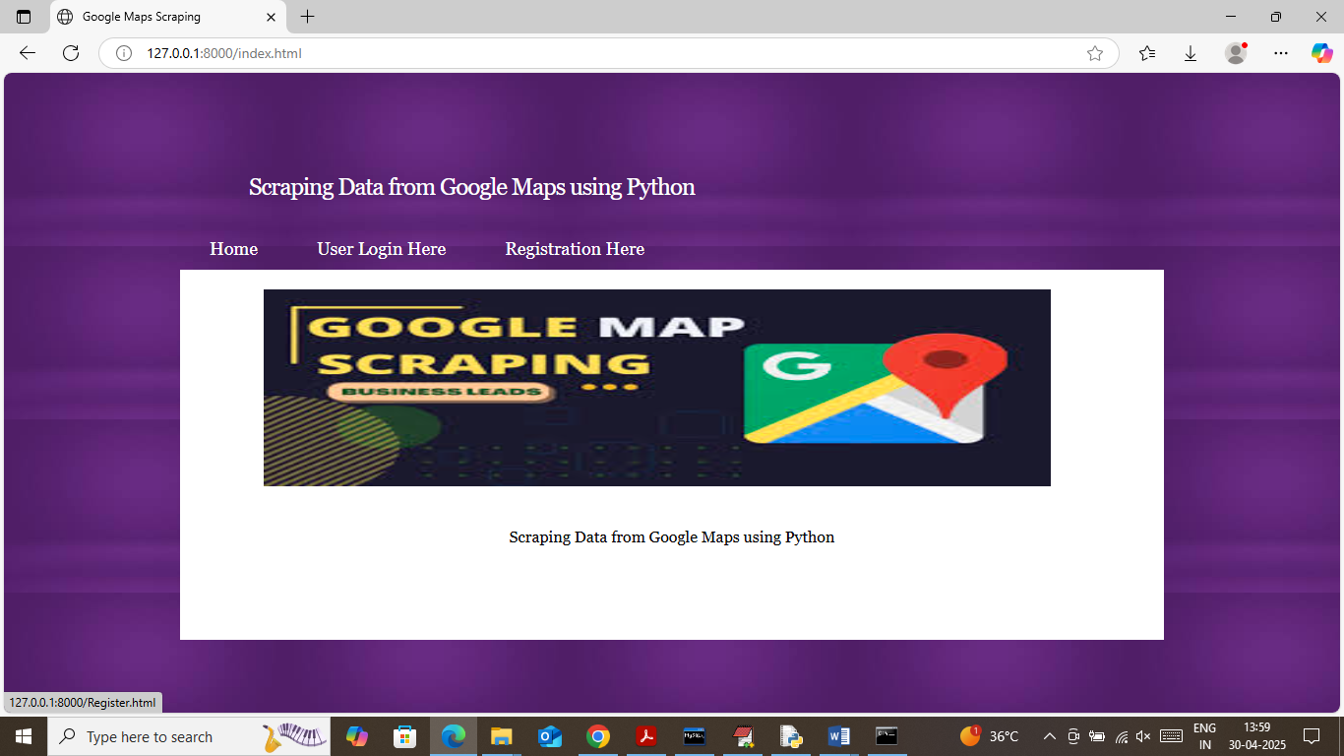
In above screen click on ‘Registration Here’ link to get below page
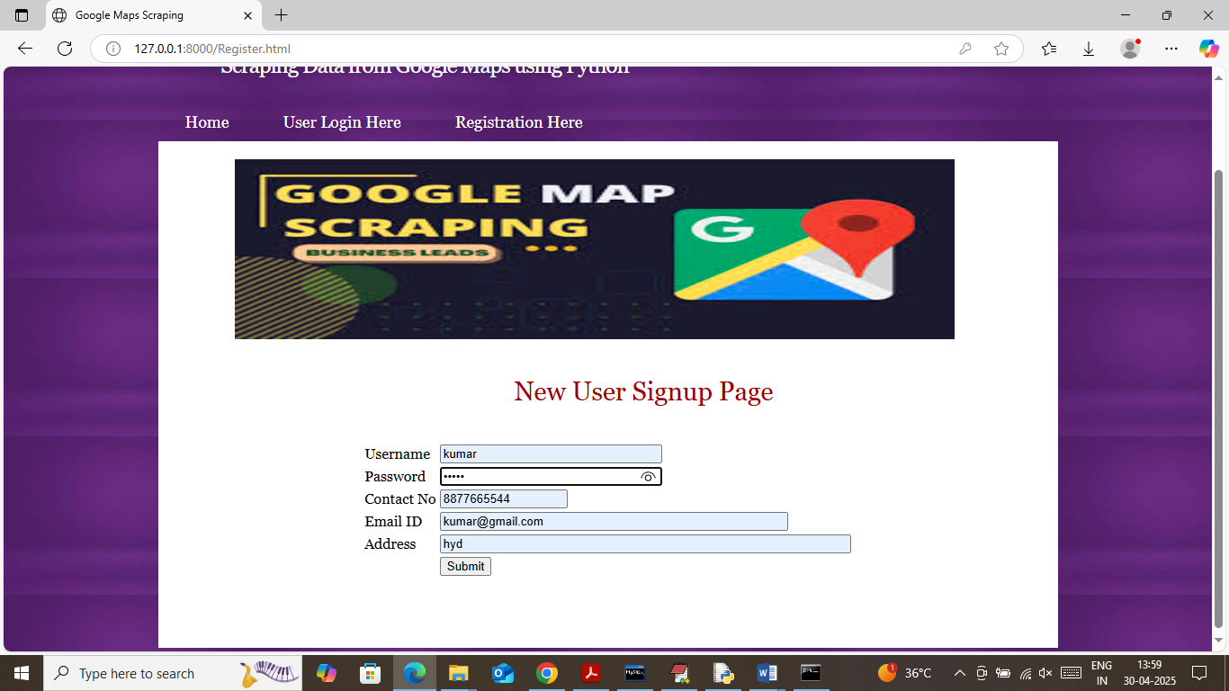
In above screen user is entering sign up details and then press button to get below page
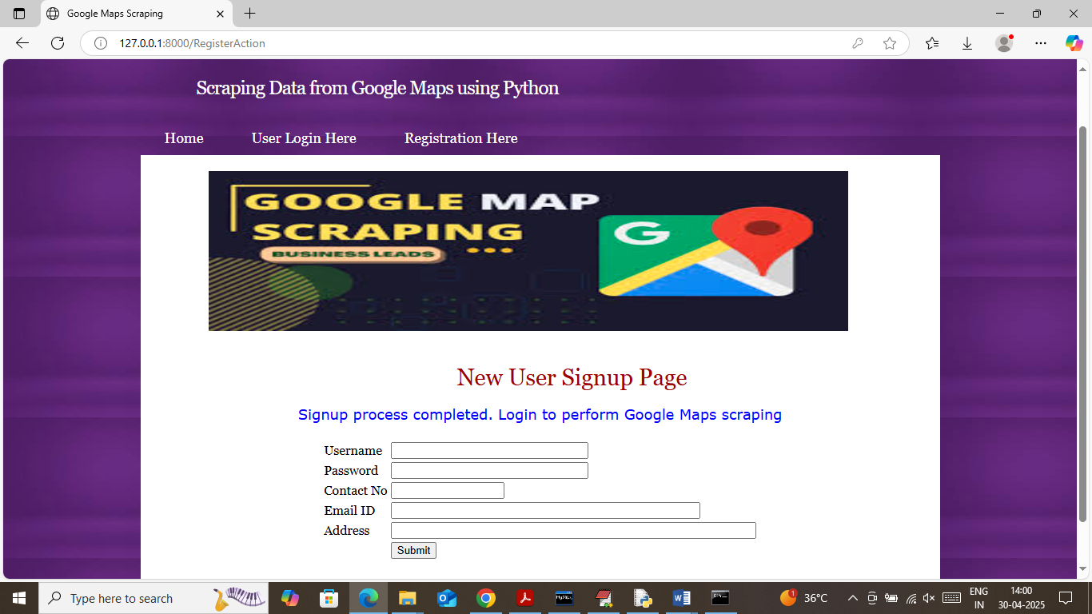
In above screen user sign up process completed and now click on ‘User Login Here’ link to get below page
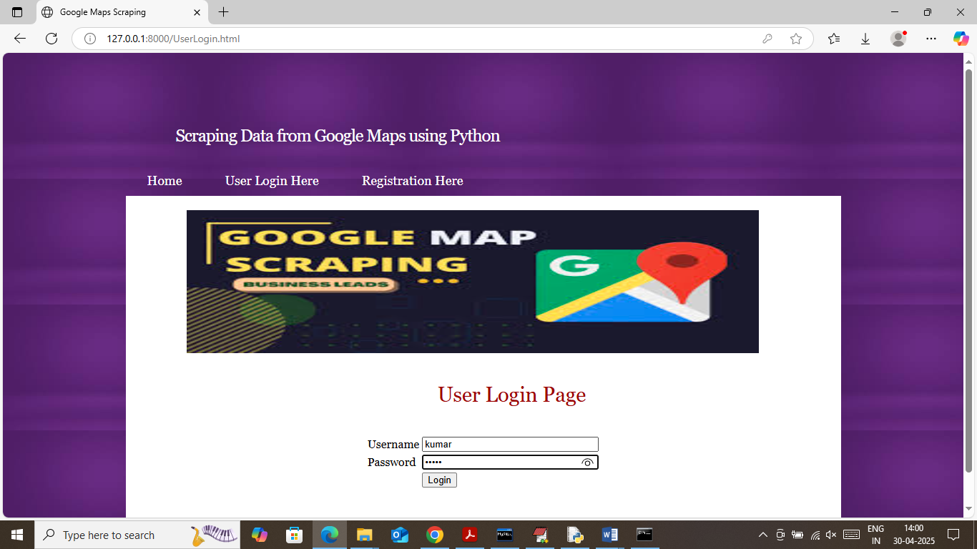
In above screen user is login and after login will get below page
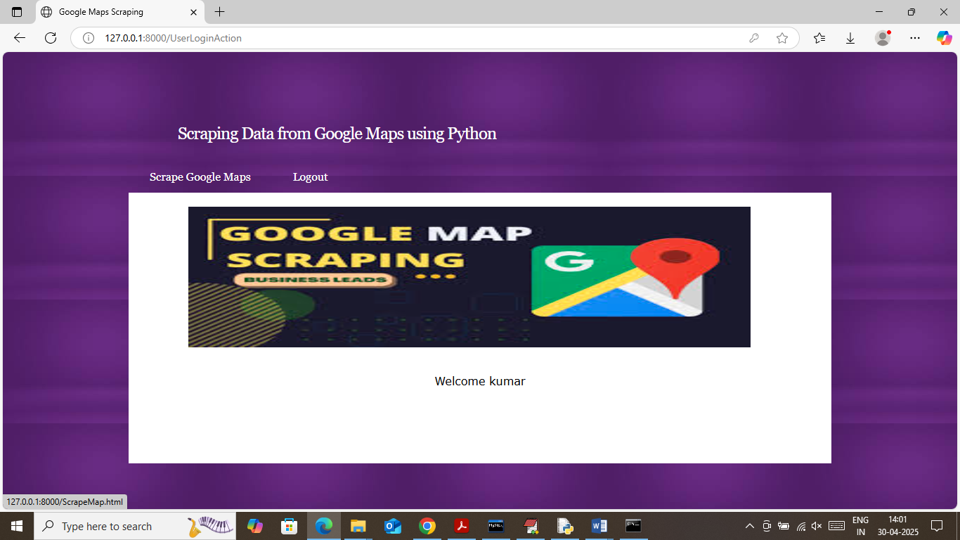
In above screen user can click on ‘Scrape Google Map’ link to get below page
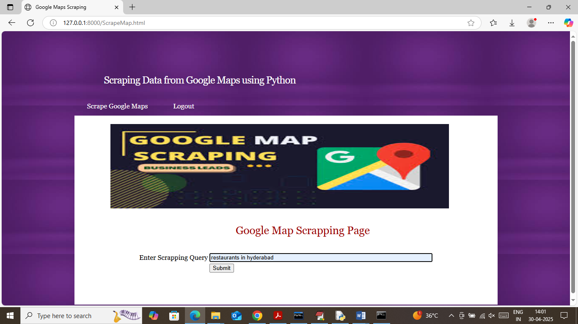
In above screen I am giving some query to get restaurants business details and then press button to get below page
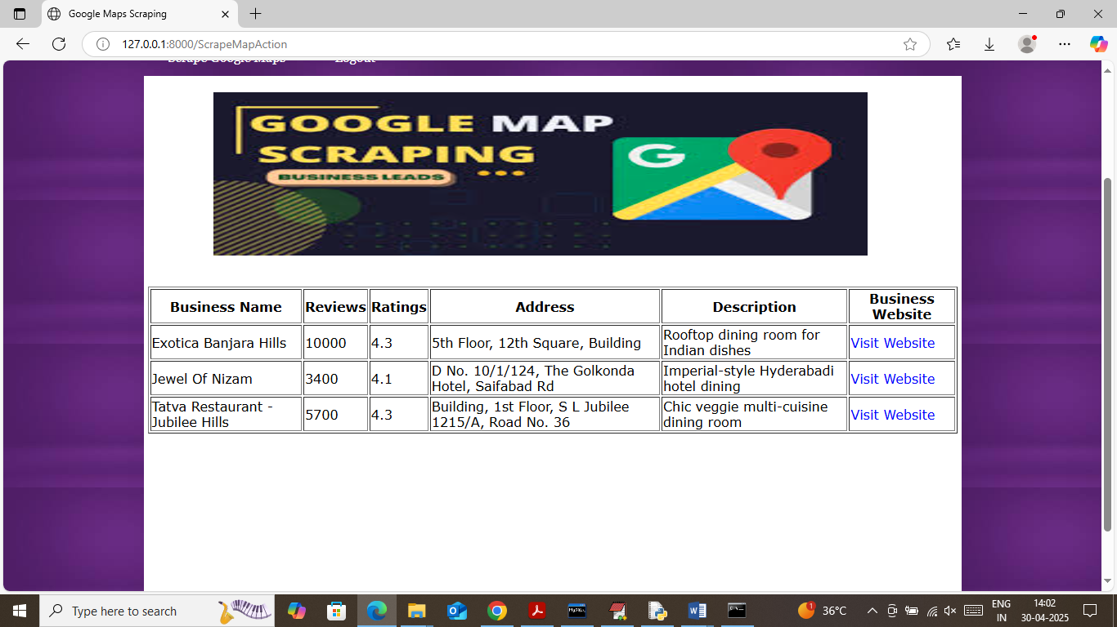
In above screen got some search result for given query along with reviews, ratings, address and can click on ‘View Website’ link to view reviews and other details
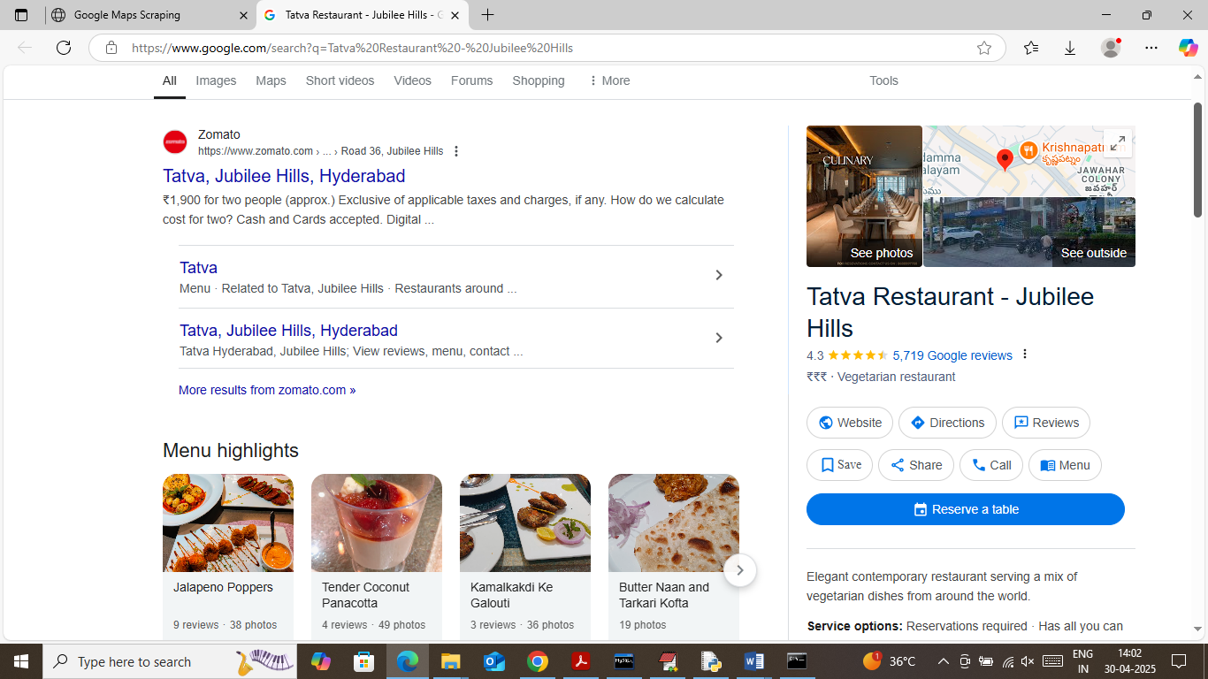
In above screen for selected restaurant user can view all Google reviews and can view website details. Similarly enter any other query and get scrape output. in below screen trying another query
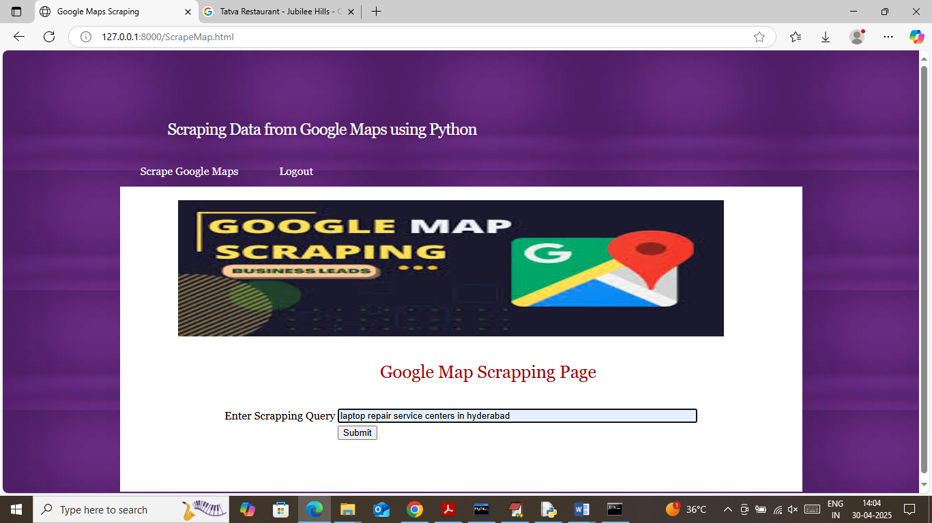
In above screen giving another query and below is the output
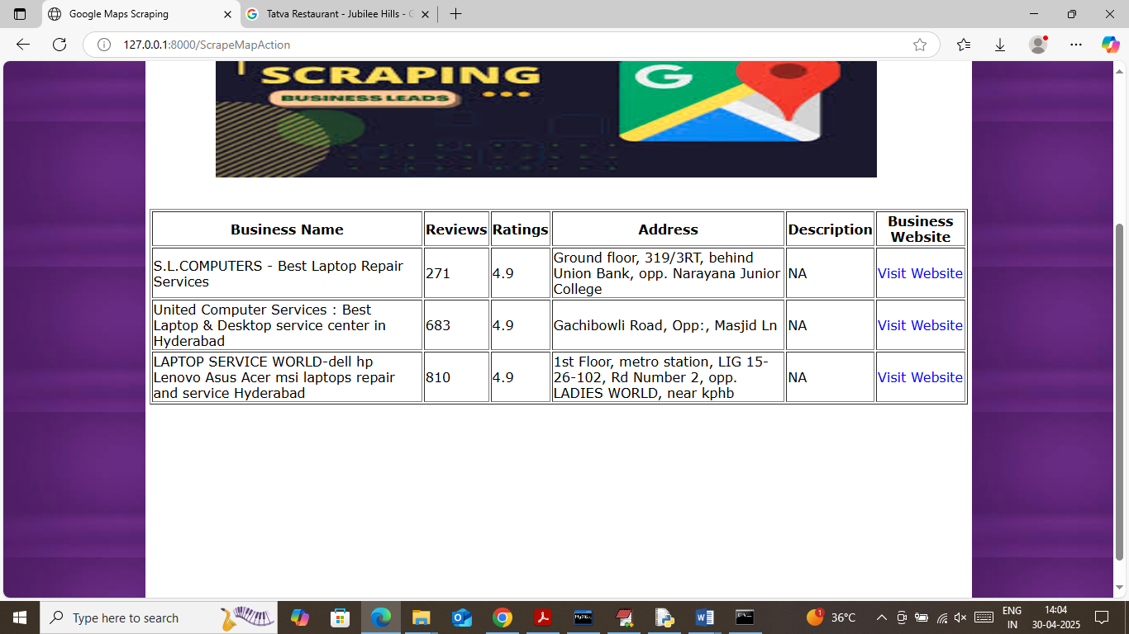
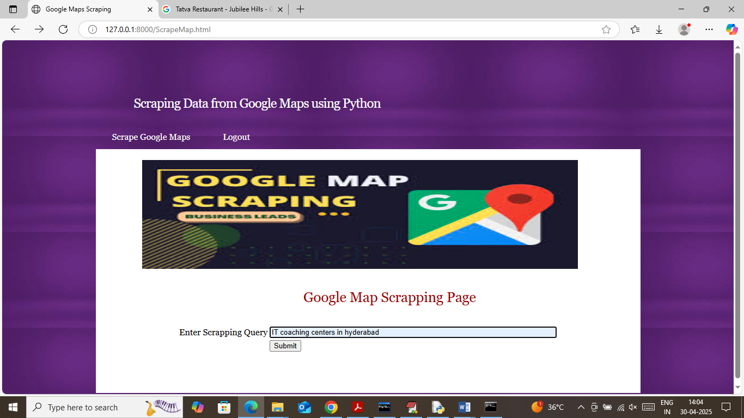
In above screen giving another query and below is the output
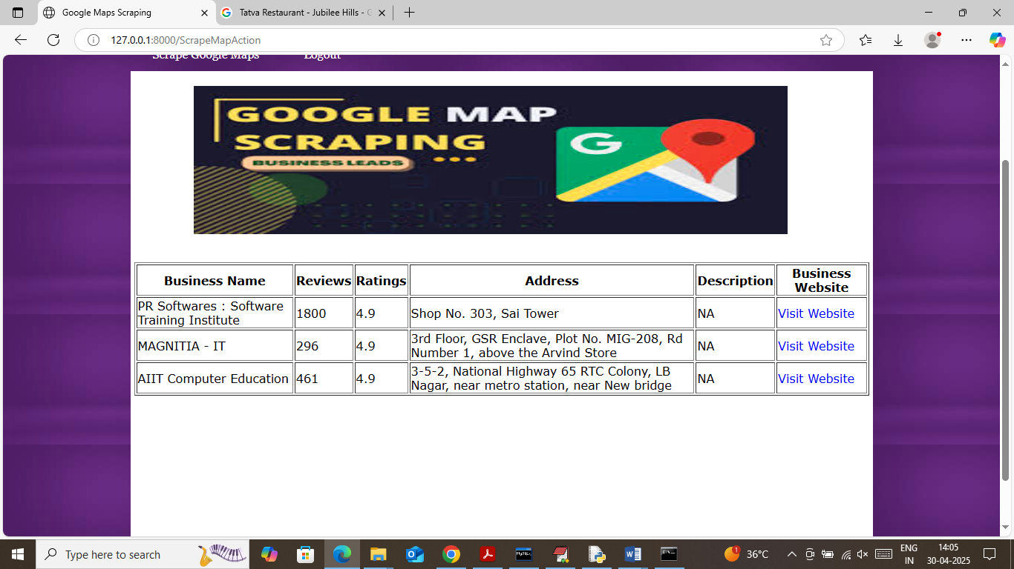
Similarly give query and get output
Note: as we know now-a-days Google services are not free of cost even for scrapping so when we search with free codes then Google will give few search results and in paid versions we can get many search outputs.

