Submitted by:

**21SW029, 21SW059**

**(SECTION 2)**

**MAD CEP ASSIGNMENT**

**Recipe Sharing Application**

**(Detailed Development Report)**

**Table of Contents**

1. Real World Problem Identification 2

1.1 Key Problems Identified: 2

2. Proposed Solution 3

2.1 Key Features of the Proposed Solution: 3

3. Responsive User Interfaces 4

3.1 Design Principles: 4

3.2 Key UI Components: 4

3.3 Screenshots: 5

4. Data Storage 5

4.1 Firebase Challenges: 5

4.2 Transition to Custom API: 5

4.3 Justification for Custom API: 5

5. APIs, Packages, and Plug-ins 6

5.1 APIs: 6

5.2 Packages and Plug-ins: 6

5.3 Justifications: 7

6. Issues and Bugs Encountered and Resolved During Development 7

6.1 Firebase Token Expiration: 7

6.2 Image Upload Performance: 7

6.3 UI Responsiveness: 8

6.4 Data Fetching Latency: 8

7. Critical Analysis and Future Recommendations 8

7.1 Critical Strengths: 8

7.2 Areas for Future Improvement: 8

7.3 Future Technical Enhancements: 9

8. Conclusion 9

# 1. Real World Problem Identification

In the fast-paced, digitally-driven world of today, individuals and communities are increasingly seeking platforms that not only provide access to information but also encourage collaboration and interaction around shared interests. Food and cooking, as a universal language, have emerged as focal points of digital communities, where users share their culinary journeys, recipes, and experiences.

However, despite the existence of numerous recipe platforms, many fail to create a cohesive ecosystem that marries user-generated content with meaningful interactions. These platforms typically focus on providing recipes but lack features that allow users to engage deeply with one another. In addition, managing such platforms comes with a multitude of challenges, from securing user data and handling multimedia content (such as recipe images) to scaling the infrastructure to accommodate a growing number of users.

### 1.1 Key Problems Identified:

* **Limited Interaction on Existing Platforms**: While users can browse recipes, the opportunity for personal interaction is minimal, leaving a gap for a more socially engaging experience.
* **Inefficient Data Management**: Handling user authentication, storing recipes with multimedia content, and ensuring secure, scalable storage remain challenges for developers of such applications.
* **Lack of Personalization and Recommendations**: Existing platforms often fail to offer tailored content, making the user experience generic and not personalized to individual preferences.

This project aims to bridge these gaps by creating a **Recipe Sharing Application** that facilitates a community-driven approach to recipe management, enabling users to interact with each other’s content, share their culinary creations, and engage in a rich, personalized experience.

# 2. Proposed Solution

The **Recipe Sharing Application** presents a comprehensive solution designed to address the limitations of current platforms while introducing unique features that elevate the user experience. The app is built with a focus on providing an interactive, responsive, and community-driven platform that prioritizes both user engagement and technological efficiency.

### 2.1 Key Features of the Proposed Solution:

* **Interactive Recipe Sharing**: Users can create and upload detailed recipes that include instructions, ingredient lists, and accompanying images. These recipes are presented in a visually appealing and structured format that allows for easy browsing.
* **Social Engagement**: The platform enables users to like, comment on, and save their favorite recipes, fostering a sense of community and interaction. This helps build a network of food enthusiasts who can share tips, ideas, and feedback on each other’s culinary creations.
* **User Authentication and Data Security**: A robust authentication system ensures that all users are verified, contributing to the platform’s credibility. Security measures such as encryption and token-based authentication have been implemented to protect sensitive data.
* **Cross-Platform Responsiveness**: The app is designed to work seamlessly across multiple platforms and devices, ensuring an optimal user experience whether accessed from a mobile phone, tablet, or desktop.
* **Custom Backend for Scalability**: Initially implemented with Firebase, the backend was later migrated to a custom API solution to provide greater control over user data, improve scalability, and resolve performance issues.

The app not only enhances the user experience but also introduces innovative backend solutions for managing data, ensuring security, and scaling effectively as the user base grows.

# 3. Responsive User Interfaces

Creating a seamless, user-friendly interface is crucial for any application, particularly one focused on social interaction and content sharing. The UI for the Recipe Sharing Application was built using **Flutter**, a cross-platform framework known for its flexibility and ability to create visually stunning applications that work across different screen sizes and operating systems.

### 3.1 Design Principles:

* **Simplicity and Intuitiveness**: The interface is designed with simplicity in mind, ensuring that users of all technical proficiencies can easily navigate the app. Clear, concise labels and intuitive icons guide users through the app’s core functionalities.
* **Visual Hierarchy**: The layout emphasizes a clear visual hierarchy, where the most important actions, such as creating a recipe or liking a post, are easily accessible. Recipes are presented in card-style views, with featured images prominently displayed to grab users' attention.
* **Cross-Platform Consistency**: Ensuring consistent behavior and appearance across different devices was a critical design requirement. The use of **Flutter’s** widget system allowed for easy scaling of UI elements, ensuring that users have the same experience whether on mobile, tablet, or web-based platforms.

### 3.2 Key UI Components:

* **Onboarding Screens**: Upon opening the app for the first time, users are greeted with onboarding screens that walk them through the app’s core features.
* **Home Feed**: The home feed is a curated list of the latest recipes from users. Each recipe card contains a preview of the recipe, an image, the user’s name, and options to like or save the post.
* **Recipe Detail Screen**: Clicking on a recipe takes users to a detailed view that includes the full recipe, step-by-step instructions, and an option to leave comments or rate the recipe.
* **Profile Management**: Users can access their profiles to see the recipes they have posted, saved recipes, and their personal details.

### 3.3 Screenshots:

### C:\Users\hp\AppData\Local\Microsoft\Windows\INetCache\Content.Word\2c270045-6e10-4466-a4e4-c214157b62d0.jpegMOBILE APP SCREEN VIEW:

### C:\Users\hp\AppData\Local\Microsoft\Windows\INetCache\Content.Word\a12e5ee6-5c40-4a68-85c8-75e958535f7d.jpeg

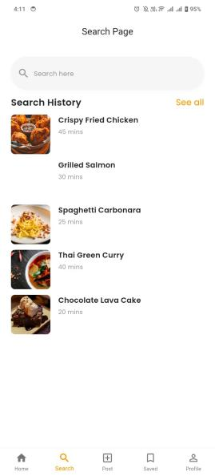

### C:\Users\hp\AppData\Local\Microsoft\Windows\INetCache\Content.Word\8d57c108-4877-41d9-b6c0-4eb6a348b69d.jpegC:\Users\hp\AppData\Local\Microsoft\Windows\INetCache\Content.Word\93c390b1-18d1-40ea-b16d-88ebd62b2e53.jpegC:\Users\hp\AppData\Local\Microsoft\Windows\INetCache\Content.Word\92d7c224-8a91-405c-8e96-5ff4800d591a.jpegC:\Users\hp\AppData\Local\Microsoft\Windows\INetCache\Content.Word\e571b7ed-f83f-4ad4-9f08-0af8b85c2072.jpeg

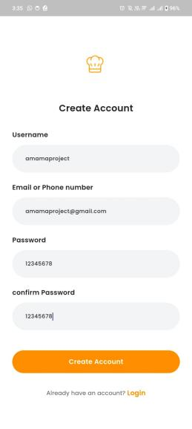

### C:\Users\hp\AppData\Local\Microsoft\Windows\INetCache\Content.Word\b3d3d462-4351-45e5-a458-be00506d60e9.jpegWEB VIEW:

### C:\Users\hp\AppData\Local\Microsoft\Windows\INetCache\Content.Word\7ec74331-2deb-4c76-b1e7-85f817a16c7d.jpegC:\Users\hp\AppData\Local\Microsoft\Windows\INetCache\Content.Word\81798e5c-7e74-4d3b-b348-a8652a8c7f4b.jpeg

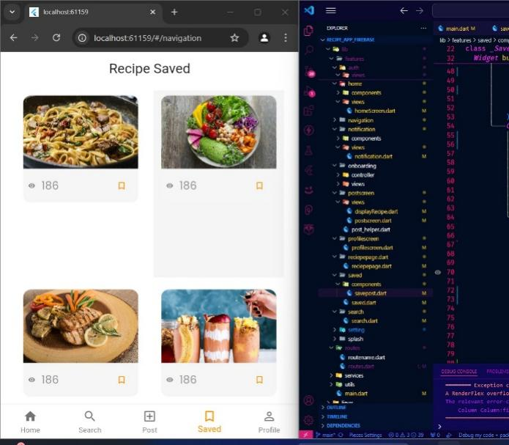

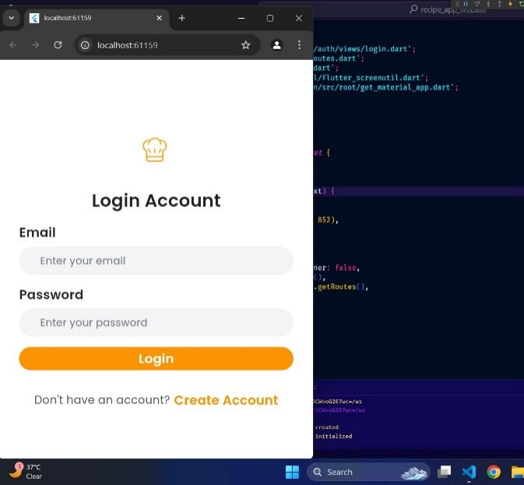

# 4. Data Storage

Handling large amounts of user-generated content, particularly multimedia (such as recipe images), demands an efficient and secure data storage solution. Initially, **Firebase** was chosen for its simplicity and built-in user authentication and real-time database functionalities. However, as development progressed and more features were integrated, certain limitations became evident.

### 4.1 Firebase Challenges:

* **Token Expiration Issues**: Firebase's token-based authentication system presented issues with session management, causing frequent logouts and poor user experience.
* **Scalability Constraints**: While Firebase offers an excellent starting point for smaller applications, its performance and cost-effectiveness declined as the number of users and recipes increased. Scaling Firebase to accommodate thousands of users would lead to significant cost increases without the corresponding control over data.

### 4.2 Transition to Custom API:

Recognizing these challenges, we migrated to a **custom-built API** solution. This allowed for greater control over how user data, recipes, and multimedia content are handled. The custom API is built using **Node.js** for high scalability and performance, and **MongoDB** serves as the primary database for storing recipes, user interactions, and images.

### 4.3 Justification for Custom API:

* **Enhanced Control**: Unlike Firebase, which is largely managed by third-party services, the custom API allowed for better control over authentication, session management, and data handling.
* **Cost Efficiency**: As the user base grows, using a custom API reduces the long-term operational costs, particularly for media storage and data retrieval processes.
* **Security**: The custom solution provides more robust encryption and security measures, including stricter token management and encrypted data transmission.

Media files are stored separately using a cloud storage service, and all interactions (like, save, comment) are handled by the backend, ensuring data integrity and security.

# 5. APIs, Packages, and Plug-ins

In order to ensure seamless operation, various APIs, packages, and plug-ins were integrated into the application. Each was chosen with careful consideration of its role in improving the app’s performance, usability, and scalability.

### 5.1 APIs:

* **Custom User Authentication API**: Responsible for handling secure login, registration, and session management.
* **Recipe Management API**: Allows users to create, edit, and delete recipes. This API also handles the interaction between users and the database for fetching recipe data.
* **Post Interaction API**: Manages user interactions such as likes, comments, and saving recipes. Each interaction is stored in the database and linked to the user's profile.

### 5.2 Packages and Plug-ins:

* **GetX**: A popular state management solution used to manage the app’s state efficiently. It simplifies the handling of reactive data and navigation.
* **Image Picker**: Integrated to allow users to upload images with their recipes. It provides an easy-to-use interface for selecting images from a user’s gallery or taking a new photo.
* **Firebase Messaging**: Initially included to handle push notifications, though this was later moved to a custom messaging API for better control and customization.
* **Shared Preferences**: Used for local data persistence, allowing users to access certain features (e.g., saved posts) even when offline.

### 5.3 Justifications:

* **GetX**: Chosen for its lightweight and reactive state management, which ensures efficient performance and cleaner code architecture.
* **Image Picker**: Necessary for enabling users to upload recipe images, an essential feature for creating an engaging visual experience within the app.
* **Shared Preferences**: Provides a mechanism for offline storage, improving the user experience by allowing users to access certain data without relying on a constant internet connection.

# 6. Issues and Bugs Encountered and Resolved During Development

Developing an interactive, multimedia-rich application presented various technical and design challenges, which were systematically addressed throughout the development process.

### 6.1 Firebase Token Expiration:

Initially, Firebase’s authentication system caused issues with token expiration, which led to frequent user logouts. This was particularly frustrating for users as they had to repeatedly log back in. The solution was a complete migration to a custom authentication system that provided better session management, including automatic token renewal and session persistence.

### 6.2 Image Upload Performance:

Handling large images resulted in slower uploads, particularly on slower network connections. The solution involved implementing **image compression** before uploading, reducing file sizes while maintaining acceptable image quality. Additionally, a progress bar was introduced to enhance the user experience by providing visual feedback during the upload process.

### 6.3 UI Responsiveness:

Early tests showed that certain UI elements did not render correctly on tablet screens, resulting in poor user experiences on larger devices. This issue was resolved by making extensive use of **Flutter’s** responsive design principles, particularly using the MediaQuery and LayoutBuilder widgets to adapt the layout dynamically based on screen size.

### 6.4 Data Fetching Latency:

Fetching data, particularly user interactions such as comments or likes, caused noticeable latency. To resolve this, **asynchronous loading** and **pagination** were introduced, ensuring that data is fetched and displayed incrementally rather than loading everything at once, thus improving performance and responsiveness.

# 7. Critical Analysis and Future Recommendations

The Recipe Sharing Application represents a significant step forward in creating an interactive, community-driven platform that addresses the gaps in existing recipe-sharing applications. The migration to a custom API solution improved both scalability and performance, while the responsive, intuitive UI provided a strong user experience.

### 7.1 Critical Strengths:

* **Engagement-Driven**: The integration of social features such as likes, comments, and saved posts helps foster a vibrant user community.
* **Scalability**: The decision to move from Firebase to a custom API positions the app to handle a growing user base without compromising on performance or cost-efficiency.
* **Cross-Platform Accessibility**: **Flutter** ensured that users can enjoy the app on multiple devices with consistent functionality and appearance.

### 7.2 Areas for Future Improvement:

* **Enhanced Personalization**: The app could further improve by incorporating **machine learning algorithms** that recommend recipes based on users' previous interactions or preferences.
* **Advanced Social Features**: Features such as recipe sharing within groups or the ability to create collaborative recipes would increase engagement and provide more value to users.
* **Monetization Strategies**: While the app is currently free to use, introducing premium features or a subscription model for advanced functionalities (such as access to exclusive content or priority posting) could offer a sustainable business model.

### 7.3 Future Technical Enhancements:

* **AI-Powered Recipe Suggestions**: Implementing a recommendation engine that analyzes user behavior and suggests recipes based on trends, user preferences, and past interactions.
* **Video Integration**: Allowing users to upload short video clips to complement their recipes, adding a more dynamic multimedia experience.

# 8. Conclusion

The Recipe Sharing Application successfully addresses the challenges inherent in existing platforms by introducing a socially interactive, scalable, and responsive solution. Through the strategic use of Flutter, custom APIs, and robust backend architecture, the app offers a seamless user experience while ensuring efficient data handling and secure authentication. Future enhancements, including AI-powered features and advanced social capabilities, will further solidify the app’s position as a go-to platform for recipe sharing and community building.

# GitHub Link:

<https://github.com/amamavirk03/fire_app>