Budgeted Incident Detection for Cloud Microservice On-Call
(Alert Fatigue Reduction in Cloud Microservice Operations)
Final report Author: Aishah Mohamed Alyammahi Course: Software Engineering and Programming Date: [Date]
Numbers come from scripts under app/ and are checked by python run_validate.py. Every file is listed in VALIDATION.md. The review that led to this version is CODE_REVIEW.md; the plan is ROADMAP.md.

1. Problem
On a cloud microservice platform, many small services raise thousands of alerts a day, and the person on duty can check only a few. Real faults are missed because attention runs out, not because the monitor was silent.
The usual rule — fixed log severity plus deleting exact copies — reads only logs. On the dataset used here, 82% of injected faults never write a log line during the fault. They only show up in metrics.
Goal. Under a fixed daily budget of K items, catch more injected faults than the rules a team would already run, in real time (no item may be chosen using information from later in the day), with fewer false items.
Sector. Cloud microservice operations only.

2. Design
One queue, at most K items a day, first come, first served:
- Metric jumps. A point is hot when it is more than 0.5 GB above the median of the previous 15 minutes on the same service. Two hot points no more than two minutes apart confirm a jump. A jump is shown at its confirmation point, and only if its rise at that point is at least a threshold learned on the training window (0.62 GB on week 1).
- Slow leaks. The same rule with a 3-hour median and 10 minutes of hot points catches memory that climbs over hours, which the 15-minute rule cannot see. Leaks that overlap a fast jump are dropped.
- Monitoring gaps. A service with no metric point for 10 minutes is shown as a gap item ("we are blind here"). Gaps that start together on several services are one item.
- Log alerts may use at most a quarter of the slots (5 of 20). An alert on a service whose shown jump is still running rides on that jump and uses no slot (one incident, one item).
Nothing in the queue looks at a later point, the end of a jump, or its final peak. A missed fault costs 10× a false item; both learned thresholds (jump confirmation, alert escalation) minimise that cost on the training window only.
For metrics that are not memory in bytes, a relative mode marks a point hot when it is, say, 30% above its recent median (JUMP_MODE=relative). Days can start at any hour (DAY_OFFSET_HOURS), and every per-day budget uses the same cut.
Full design: design_specification.md.

3. Implementation
Layer | What it is
app/src/ | Library: GAIA loader, jump / leak / gap detectors, metric baselines, causal queue, jump ranker, alert classifier, policy, statistics
app/src/experiment.py | One train/test window, every system, one scorer — used by every GAIA results script
app/src/generic.py | The same evaluation for any data: column detection, per-series split, tuning, report
app/run_*.py | One script per experiment; writes app/results/
app/tests/ | 90 automated tests
app/product/ | Web app — queue, Evaluate my data page, shadow mode, Real/Noise marks, Alertmanager webhook, Prometheus, PagerDuty — and a CLI (score, evaluate, tune)

Log lines are China time and are converted to UTC so they line up with the metric files (src/gaia_loader.py).

4. Training
Data. GAIA MicroSS (CloudWise), July–August 2021: 34,863 log lines, 1,367 injected faults. Every fault is the same program: it holds 1 GB of extra memory for 600 s on one service, so the correct answer is known.
Train window. The first 7 days. Test window. The next 55 days: 1,223 faults. Days are never shuffled; one split time is used for alerts, faults and metrics alike.
What is learned | How
Jump size 0.5 GB | Chosen on week 1 only (run_memory.py --sweep; 0.3 and 0.5 GB tie on week-1 detection, 0.5 GB has half the false jumps)
Jump confirmation threshold | Rise at confirmation with the lowest week-1 cost → 0.62 GB
Alert classifier | Logistic regression on week-1 alerts; a miss weighs 10× a false alarm
Alert escalation threshold | Lowest week-1 cost
Jump ranker (Phase 3) | Logistic regression on week-1 jumps, features known at confirmation
Static-rule baseline | Week-1 99th percentile per service

5. Testing
Caught = a shown jump or leak on the fault's service overlaps the injection window, or a shown alert carries the fault's id. Gap items never count as catches.
Baselines are the rules a team would already have, all scored with the same causal queue:
System (K = 20 items a day) | Caught | Share of best possible | Items / day | False / day | Precision
Log severity + exact duplicates | 0.0% | 0% | 0.8 | 0.8 | 0%
Static rule: memory > week-1 p99 | 57.2% | 67% | 16.0 | 3.0 | 81%
Rate rule: delta(mem[5m]) > 0.5 GB | 68.9% | 81% | 17.4 | 2.1 | 88%
Jump rule, first come | 67.8% | 80% | 17.5 | 2.4 | 86%
Jump rule + learned threshold (detector alone) | 72.6% | 86% | 17.1 | 1.0 | 94%
Full queue (jumps + leaks + gaps + alerts) | 70.2% | 83% | 17.6 | 1.6 | 91%
Old headline: day's jumps ranked by final peak (not real time) | 72.9% | 86% | 17.5 | 1.3 | 93%

Best possible at K = 20 is 84.9%: GAIA injects 22 faults a day, more than 20 on 34 of 55 days.
At K = 5 / 10 / 50 the full queue catches 19.5% / 38.6% / 85.8% (rate rule: 19.3% / 38.6% / 86.0%). Its advantage is at the realistic budget K = 20, where slots are scarce, and in false items (1.0–1.6 a day vs 2.1).
Why the full queue scores below the detector alone on GAIA. Every GAIA fault is a 1 GB memory fault, so leak items (0.2 a day), gap items (0.4 a day) and log alerts spend slots that jumps would have used. On a platform with leaks, outages, and CPU, disk or code faults, those are the parts that catch them (Section 7). Both rows are reported; the detector comparison is the first claim, the full queue is what the tool runs.
The old ranking needed the whole day in advance. Replacing it with a learned confirmation threshold keeps the score (72.6% vs 72.9%), cuts false items (1.0 vs 1.3 a day), and makes the queue usable live.
Time to confirm. Median 0.72 minutes from fault start to the confirming point (p90 0.93). Metrics are sampled every 30 seconds.
Chance check. If each service's jumps are shifted by a random 1–6 hours, only 2.6% of faults still overlap one.
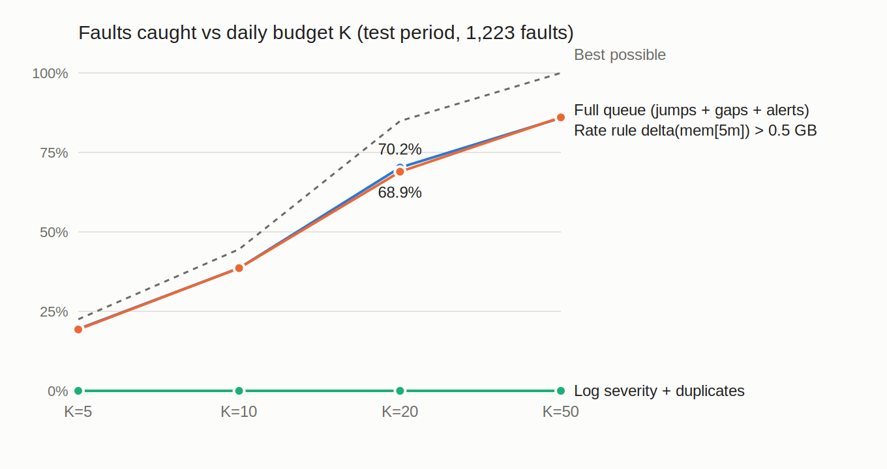
Faults caught versus daily budget K

Where the misses come from
The full queue misses 364 of the 1,223 test faults at K = 20 (results/miss_causes_gaia.csv):
Cause | Faults | Share of misses
No metric data during the fault (monitoring outage) | 166 | 46%
A qualifying jump existed, but the day's 20 slots were used | 191 | 52%
Metric data, but no jump overlapped | 4 | 1%
A jump overlapped, but below the confirmation threshold | 3 | 1%

Only 2% of misses are the detector's fault. The rest are data outages (which the queue flags as gap items) and a budget smaller than the fault rate.

6. Validation (walk-forward)
Before each later week, everything learned is re-learned from the past only — the classifier, its threshold, the jump ranker and the jump confirmation threshold (0.62–0.75 GB across folds). That week is then scored once. run_walkforward.py, K = 20.
Fold | Test week | Faults | With metric data | Rate rule | Detector alone | Full queue
1 | 8–15 Jul | 161 | 100% | 77.6% | 84.5% | 82.0%
2 | 15–22 Jul | 134 | 91% | 73.9% | 81.3% | 77.6%
3 | 22–29 Jul | 162 | 94% | 72.2% | 77.2% | 71.0%
4 | 29 Jul–5 Aug | 163 | 82% | 67.5% | 69.3% | 67.5%
5 | 5–12 Aug | 162 | 84% | 69.1% | 71.6% | 71.0%
6 | 12–19 Aug | 139 | 92% | 75.5% | 79.1% | 77.0%
7 | 19–26 Aug | 173 | 61% | 51.4% | 52.0% | 52.0%
8 | 26–31 Aug | 129 | 91% | 78.3% | 83.7% | 82.2%
Mean |  |  |  | 70.7% | 74.8% | 72.5% (95% CI 65.7–78.3%)

- The detector (jump rule + learned threshold) beats the rate rule in 8/8 weeks (sign test p = 0.0039).
- The full queue beats it in 6 weeks, loses 1 and ties 1 (p = 0.0625, not significant at 5%). On GAIA its extra item types cost slots; see Section 5.
- The comparison is against a real rule. The log-severity rule scores 0% every week, so a test against it would prove nothing.
Fold 7 is weak because of a monitoring outage: every service's metrics stop from 20 Aug 13:18 UTC for 2 days 12 hours, so only 61% of that week's faults have any metric data. The full queue shows this outage as a gap item within 10 minutes. No metric-based method could catch those faults.
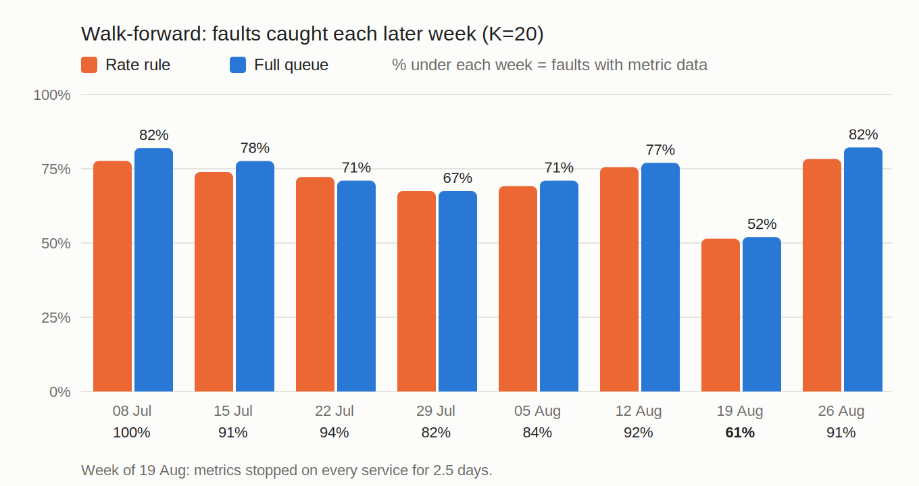
Walk-forward detection by later week

7. Robustness: does it only work because every fault is 1 GB?
run_robustness.py adds synthetic faults of other shapes to the real GAIA memory series (120 per shape, at least an hour from any real fault) and asks whether each detector fires, with no budget:
Injected shape | Jump rule 0.5 GB | + learned threshold | Relative +30% | Rate rule | Jump + leak rule
Step +0.25 GB, 10 min | 1% | 0% | 8% | 1% | 1%
Step +0.5 GB, 10 min | 99% | 0% | 58% | 99% | 99%
Step +1 GB, 10 min (GAIA shape) | 100% | 98% | 95% | 100% | 100%
Step +2 GB, 10 min | 100% | 100% | 100% | 100% | 100%
Spike +1 GB, 1 min | 98% | 98% | 92% | 100% | 98%
Ramp +1 GB over 30 min | 1% | 1% | 6% | 0% | 99%
Leak +1 GB over 3 h | 12% | 3% | 6% | 8% | 73%
Nothing injected (control) | 6% | 3% | 6% | 6% | 6%

What this shows:
- Faults smaller than the jump size are invisible (0.25 GB). A team must set the size for its own services.
- The learned threshold over-fits the benchmark: trained on 1 GB faults, it rejects every 0.5 GB fault. The tool therefore uses no confirmation threshold unless it is trained on the team's own incidents.
- Leaks and ramps defeat both the jump rule and the Prometheus rate rule. The leak rule catches 99% of 30-minute ramps and 73% of 3-hour leaks, at a cost of 0.3 extra items a day on real GAIA data (none of them near a fault), and no extra hits on the control windows.

8. Phase 3 queue options
Option (K = 20) | Caught | Items / day | Walk-forward mean | Verdict
Full queue (reference) | 70.2% | 17.6 | 72.5% | —
Learned jump ranker instead of the rise threshold | 70.2% | 17.6 | 73.2% | No gain: the rise threshold already gives 94% precision, so there is little left to learn from service, time of day or nearby logs
Group metric items within 2 min on other services into one slot | 71.5% | 17.5 | 74.0% | Small gain; one item may then name two services
Confirm level per series (learned on week 1; off in the headline) | 70.0% | 17.5 | 71.8% | Mixed: the detector alone keeps 72.6% with fewer false items (0.8 vs 1.0 a day), but the levels reject real faults — 25 misses below threshold instead of 3, and 84.1% vs 85.9% at K = 50. The web app uses it; the published tables use the single gate
Carry over up to 10 unused slots to the next day | 74.4% | 18.6 | 76.9% | Largest gain; the average stays under K. The same carry-over lifts the rate rule to 72.5% (walk-forward 74.3%); the full queue still wins 8/8 weeks (p = 0.0039)

Carry-over and grouping are off by default (CARRY_OVER_MAX, GROUP_MINUTES): they change what "20 a day" means for the on-call team, so it is their choice.

9. Beyond microservices: any metric, any team
The engine is not tied to GAIA. src/generic.py takes any metrics table (time, value, optional series; long or wide; column names detected), optional events (alerts, tickets, notifications) and optional past problems (start, end, series). For each series it tunes on the first part and scores the rest once, and every system — static threshold, rate rule, a unit-free robust jump rule, the user's own alerts — is tuned with the same cost and scored through the same causal queue. The detector with the lowest training cost becomes the user's queue. A chance line (the same items at random times) is reported so wide labels cannot flatter the result.
This runs from the web app (Evaluate my data: upload or pick a dataset → read the report → Use these settings for my live queue → Show this data in the queue) and from the CLI (evaluate, tune). The guide for end users is USE_YOUR_DATA.md.
Results on data that is not microservices (tuned on the first half of each series, K = 2 items a day; run_nab.py, results/nab_eval.csv):
Dataset | Domain | Test problems | Queue caught | Chance | Items / day
Online shop (synthetic; K = 5, 30% tuning) | e-commerce orders + notifications | 11 | 91% | 1% | 1.3
NAB realAWSCloudwatch | cloud servers | 17 | 71% | 58% | 0.3
NAB realAdExchange | online advertising | 6 | 83% | 58% | 1.4
NAB realKnownCause | machine temperature, taxi demand, CPU | 13 | 38% (static rule 54%) | 15% | 0.04
NAB realTraffic | road traffic sensors | 11 | 45% | 13% | 0.4
NAB realTweets | Twitter mention volume | 11 | 36% | 36% | 1.7

On the shop data the monitoring view catches 10 of 11 problems where the notification stream by severity catches 3. On NAB the queue is clearly above chance on traffic and machine data, modestly on cloud servers and ads (NAB's anomaly windows are wide, so chance is high), and no better than chance on Twitter volume. The test sets are small (6–17 problems), and on one dataset the detector chosen on the tuning part was not the best on the test part. These are exactly the facts a new user needs before relying on it, which is why the app shows them.

10. What "success" means on this data
run_stats.py splits the 1,223 test faults by the signal they left:
Signal | Count | Share | What can catch it
Jump, no log | 868 | 71.0% | Metric rule only
Log and jump | 185 | 15.1% | Either path
Log, no jump | 34 | 2.8% | Alerts only
No log, no metric data (monitoring gap) | 132 | 10.8% | Nothing — shown as a gap item
No log, data but no jump | 4 | 0.3% | Nothing

- Where metric data exists, the jump rule overlaps 99.6% of faults (1,053 / 1,057).
- 170 test faults start inside a monitoring gap. At K = 20 the gap items shown cover 159 of them (all 170 at K = 50).
- False jumps are not mislabelled faults. 24.6% of the 256 false jumps start within 10 minutes of a fault on another service; random times do so 27.2% of the time. There is no sign that GAIA logged faults under the wrong service.
- A log-only classifier is capped near 17.9% (the faults that leave any log). That is why the early 95% target was wrong.
Early target | Measured | Verdict
95% detection at K=20 | 70–73% (ceiling 84.9%) | Not possible at K=20: more faults per day than slots. 83–86% of the ceiling
Beat the usual rule | Detector +3.7 points over a rate rule, 8/8 weeks; log severity 0% | Met, against a fair rule
Fewer false items | 1.0–1.6 vs 2.1 a day (rate rule) | Met
Works on every service | Jump overlap 81–91% on all ten | Met
Walk-forward not lucky | Means 72.5–74.8%, CI 65.7–78.3% | Met
Real-time | Confirmed in 0.72 min, no look-ahead | Met
Works beyond 1 GB faults | 0.5–2 GB steps and spikes ≥ 98%; leaks 73–99% with the leak rule; 0.25 GB not | Partly — stated

Per service (test period):
Service | Faults | With a log | With a jump
dbservice1 | 129 | 0.8% | 91.5%
dbservice2 | 148 | 2.0% | 81.1%
logservice1 | 126 | 2.4% | 87.3%
logservice2 | 108 | 1.8% | 87.0%
mobservice1 | 124 | 84.7% | 83.9%
mobservice2 | 116 | 87.1% | 87.1%
redisservice1 | 111 | 2.7% | 82.0%
redisservice2 | 114 | 0.0% | 86.0%
webservice1 | 122 | 0.8% | 85.2%
webservice2 | 125 | 0.0% | 90.4%

11. Limits (say these if asked)
- Every GAIA fault is the same 1 GB, 600 s memory program. The robustness replay (Section 7) tests other sizes and shapes; Section 9 tests other domains (NAB, a shop), with small test sets and a chance line. CPU, disk or code faults inside microservices are still not measured.
- The win over a plain Prometheus rate rule is modest (+3.7 points for the detector; +1.3 for the full queue, not significant weekly). The larger gains are fewer false items, a real-time queue, leak and gap coverage, and carry-over.
- K = 20 is below the fault rate (22 a day), so no method can exceed 84.9%.
- Learned thresholds do not transfer. One learned on GAIA's 1 GB faults rejects 0.5 GB faults. Rules-only mode works without labels. When a batch has a training window and faults, the queue now also learns a confirm level per series on that window only (same cost: 10 × miss + false) and freezes it. Series with too little training signal keep the single global level. This is the metric-side learner. The sklearn classifier is still only for log alerts. The headline table above is the earlier single threshold (0.62 GB on week 1); it has not been re-measured with per-series gates.
- run_m1, run_m2, run_m4, run_stretch are alerts-only experiments. Do not quote them as the system result.
Future work. Benchmarks with other fault types (for example RCAEval or TrainTicket-based sets). A per-series confirm gate is in the product; a hot-point size below the global 0.5 GB rule, learned per series, is not — a 0.25 GB fault is still invisible.

12. How to reproduce
cd app
$env:PYTHONPATH = (Get-Location).Path
python -m pytest -q
python run_memory.py --metrics data/gaia_metrics --gaia-run data/gaia_raw/run/run --sweep
python run_queue_eval.py
python run_walkforward.py
python run_stats.py
python run_robustness.py
python ../tools/fetch_nab.py # needs internet, ~15 MB
python run_nab.py
python make_figures.py
python run_validate.py

Needs the GAIA files at app/data/gaia_raw/run/run and app/data/gaia_metrics (not in git; they are large). Without GAIA: python examples/make_example.py, then python -m product.cli score --alerts examples/alerts.csv --metrics examples/metrics.csv.

13. Deliverables
Item | Where
Design | design_specification.md
Plan / roadmap | project_plan.md, ROADMAP.md
Validation record | VALIDATION.md
Review of the earlier version | CODE_REVIEW.md
This report | FINAL_REPORT.md
Code + tests | app/
Result tables | app/results/
Figures | figures/detection_vs_k.svg, figures/walkforward.svg
Tool | Web app docker compose up (http://127.0.0.1:8080/, /evaluate for your own data), CLI python -m product.cli
End-user guide | USE_YOUR_DATA.md

