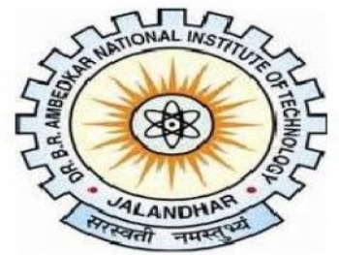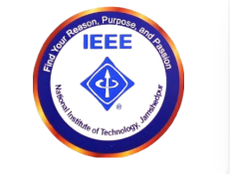

2027 IEEE International Conference on
Intelligent Power, Energy and Sustainable Systems (IIPESS-2027)
NIT Jalandhar, Punjab, India | 26–28 March 2027
Dr. B R Ambedkar National Institute of Technology, Jalandhar — An Institute of National Importance

Special Session (SS) Proposal
IIPESS-2027

1. Special Session Title
2. A Brief Description of the Area of Concern and Objectives (Approx. 300 words)

3. Scope and Topics of Interest

4. Details of Session Chairs / Organisers
Organizer Name | Essential Information | Photo

Submitted for consideration as a Special Session at IIPESS-2027, NIT Jalandhar.

