VIT-AP UNIVERSITY, ANDHRA PRADESH

CSE4011 – INTERNET OF THINGS



PROJECT WORK

TEAM:

22MIC7059 - AKSHATA DESAI
22MIC7062 - AMAN LODHA

SLOT: E1+TE1

IoT-Based Smart Cart with Enhanced Inventory Management

Problem Statement
Traditional shopping systems are still reliant on manual product scanning and billing, leading to long queues,
inaccurate inventory updates, and poor customer satisfaction. Although previous RFID-based systems improved
checkout times, they lacked end-to-end automation and failed to address supplier coordination or customer
engagement. The need for a comprehensive IoT-enabled solution that manages inventory, notifies suppliers,
and enhances accessibility is evident.

Objectives
The objectives of this project are as follows:
• To automate product identification and checkout using RFID and IoT.
• To provide real-time inventory updates and analytics through cloud dashboards.
• To send automated SMS alerts for low-stock, restock, and invoice confirmations.
• To implement wishlist functionality for out-of-stock items and notify both suppliers and customers.
• To integrate a secure payment gateway for seamless transactions.
• To ensure accessibility and usability for all customers, including senior citizens.

Related Work
Several IoT-based systems have been proposed for retail automation. Research works such as "Design of an
Intelligent Shopping Basket using IoT" (ResearchGate, 2019) and IEEE papers (e.g., 9045336) demonstrate RFID
use in smart carts. However, they lack integrated inventory analytics, SMS-based supplier notification, and
cloud dashboards. Our approach addresses these gaps by merging IoT communication, GSM notifications, and
cloud analytics to create a holistic retail management system.

Proposed Model
The proposed model integrates multiple hardware and software modules to automate retail shopping and
inventory management. It combines RFID-based product recognition with NodeMCU ESP8266 for IoT connectivity,
and GSM for SMS communication. The cloud-based dashboard allows real-time monitoring and visualization
of stock levels, sales trends, and supplier responses.
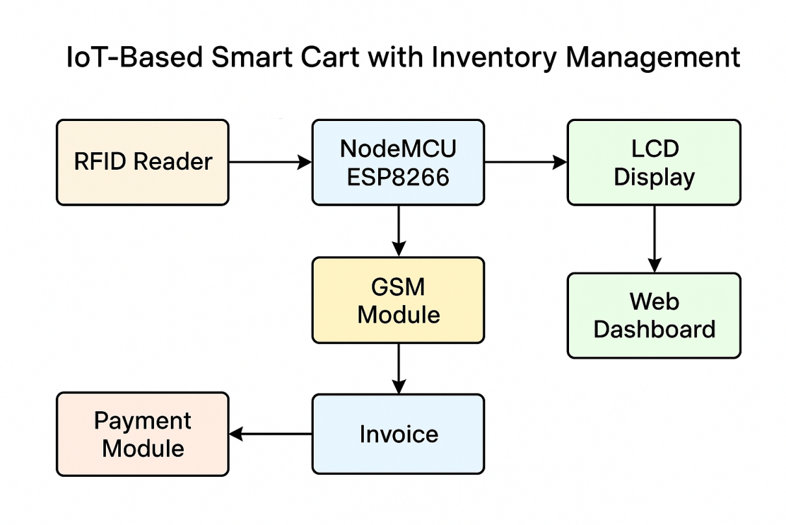
Figure 1: Block Diagram of IoT-Based Smart Cart with Inventory Management
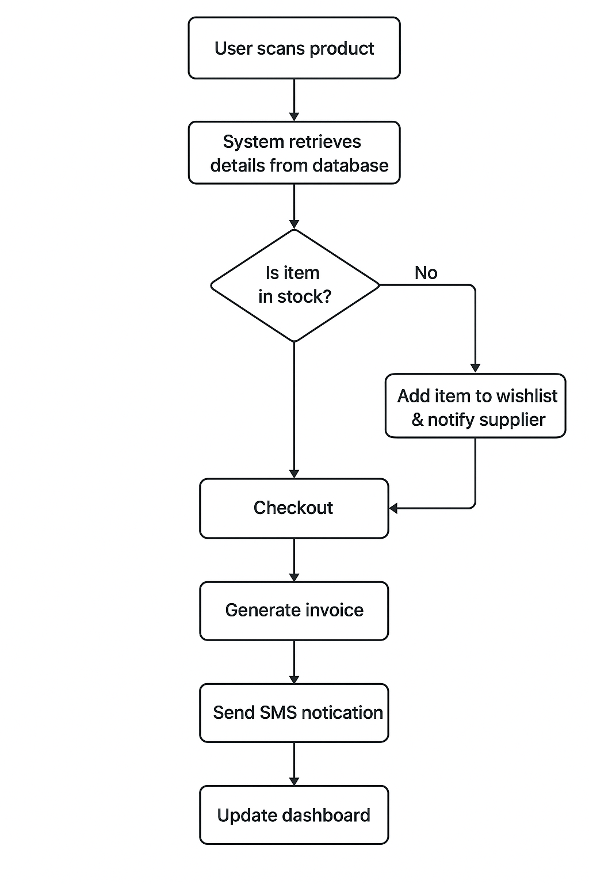
Figure 2: Flow Diagram of Smart Cart System Operation

Proposed Algorithm
Step 1: Initialize system components – RFID Reader, NodeMCU Wi-Fi module, and GSM modem.
Step 2: Detect RFID tag and retrieve product details from the database.
Step 3: Check stock availability.
→ If available: Add item to cart, display details on LCD, and update inventory in real-time.
→ If unavailable: Prompt user to add product to wishlist and trigger SMS alert to supplier.
Step 4: During checkout, generate invoice automatically and store transaction in database.
Step 5: Process payment through the integrated static payment gateway.
Step 6: Send invoice confirmation via SMS and update sales analytics.
Step 7: Once supplier restocks, system updates inventory and sends SMS notification to waiting users.

Proposed Model Description / Methodology
The system design follows a modular IoT approach involving both hardware and software integration.
Hardware Components:
• NodeMCU ESP8266 – serves as the microcontroller managing communication between devices.
• RFID Reader and Tags – used for automatic identification of items.
• LCD Display – shows product information in real-time.
• GSM Module – handles SMS-based notifications to suppliers and customers.
• Power Supply Unit – ensures uninterrupted hardware operation.
Software Components:
• Arduino IDE – for programming microcontroller and integrating hardware functions.
• PHP Backend & MySQL Database – manage product data, invoices, and stock levels.
• HTML, CSS, JavaScript – for creating responsive dashboards and user interfaces.
• Netlify – hosts the admin and user dashboards securely.
Workflow Summary:
The customer scans the item using the RFID reader. The NodeMCU fetches data from the database and updates
the LCD display. If the product is unavailable, the system automatically adds it to the wishlist and notifies
the supplier through SMS. The user proceeds to checkout where an invoice is generated and payment processed.
Once stock is replenished, users are notified through SMS.

Current Status of Implementation
• RFID-based scanning and LCD interfacing completed and tested.
• NodeMCU successfully connected to cloud dashboard and database.
• Admin Panel, Payment Page, and Sales Analytics deployed on Netlify.
• Ongoing work includes improving database synchronization and dashboard visualization.
• SMS gateway configured using GSM module for real-time alerts.

Pseudo Code:
- Initialize Components
Start Program
Initialize LCD (16x2)
Initialize GSM module (SIM900)
Connect to WiFi using SSID and Password
Start Web Server (port 80)
Display “WELCOME TO SMART CART” on LCD
Wait until WiFi connects
Show “WiFi Connected” and IP Address on LCD
Then display “PLEASE ADD ITEMS TO CART”
- Define Global Variables
Items = ["Biscuits", "Soap", "Rice (1KG)", "Tea (50g)"]
Prices = [35, 38, 55, 45]
Stock = [5, 5, 5, 5]
Quantities = [0, 0, 0, 0]
TotalAmount = 0
ShopkeeperNumber = "+919492425254"
CustomerNumber = "+919024303698"
Wishlist[4][15] // 2D array: up to 15 wishlisters per item
WishlistCount[4] = 0
- Main Loop (Continuous Operation)
Loop Forever:
If RFID Tag is Scanned:
Read Tag Code
Identify Item Based on Tag
If Tag = Checkout Tag:
Call SEND_TOTAL_SMS_AND_RESET()
Else:
Call PROCESS_ITEM()
Handle Web Requests (server.handleClient)
End Loop

- PROCESS_ITEM(ItemName, Price, Index)
If Stock[Index] > 0:
Display "<ItemName> Added" on LCD
Display "Price: Rs <Price>"
Increase Quantities[Index] by 1
Increase TotalAmount by Price
Decrease Stock[Index] by 1
If Stock[Index] becomes 0:
Call SEND_OUT_OF_STOCK_SMS(ItemName)
Else:
Call SEND_OUT_OF_STOCK_SMS(ItemName)
- SEND_OUT_OF_STOCK_SMS(ItemName)
Send SMS to Shopkeeper:
"<ItemName> is out of stock!"
Show “<ItemName> Out of Stock” on LCD
- SEND_TOTAL_SMS_AND_RESET()
Display "Total Items: <Sum of Quantities>" on LCD
Send SMS to Customer:
"Total bill: Rs <TotalAmount>"
Reset:
Quantities = [0,0,0,0]
Stock = [5,5,5,5]
TotalAmount = 0
Display "Thank You for Shopping!" on LCD
- WISHLIST SYSTEM
- Add to Wishlist
When an Item is Out of Stock:
Customer clicks “Wishlist” on Web Page
System adds CustomerNumber to Wishlist[Index]
Increase WishlistCount[Index]
Send SMS to Shopkeeper:
"Wishlist request for <ItemName>"
- Restock Process
Admin enters:
Item Index and Quantity → on /restock Web Form
Update Stock[Index] += Quantity
If Stock[Index] > 0 and WishlistCount[Index] > 0:
Notify all Customers in Wishlist:
"<ItemName> is back in stock!"
Clear Wishlist for that item
- WEB INTERFACE (Auto-Refresh UI)
Web Server Routes:
"/" → Homepage (HTML Table)
- Displays Item Name, Quantity, Price, Stock, Wishlist Count
- Shows “Wishlist” button for out-of-stock items
- Includes “Auto Refresh” checkbox
→ When ON: refreshes every 3 seconds
"/wishlist/add" → Add Customer to Wishlist
"/restock" → Restock items and notify wishlisters
"/wishlist/list" → Show current wishlist data (for debugging)
- SMS FUNCTIONALITY
Function SEND_SMS(Number, Message):
Try robust send:
Send AT commands → Wait for “OK” and “>”
Write message, send CTRL+Z
If fails:
Retry with legacy send method (simple delay)
- LCD Display Logic
LCD always shows:
- Connection progress
- Added Item and Price
- Out of Stock alert
- Checkout message
- Reset prompt (“ADD ITEMS TO CART”)

Project Images

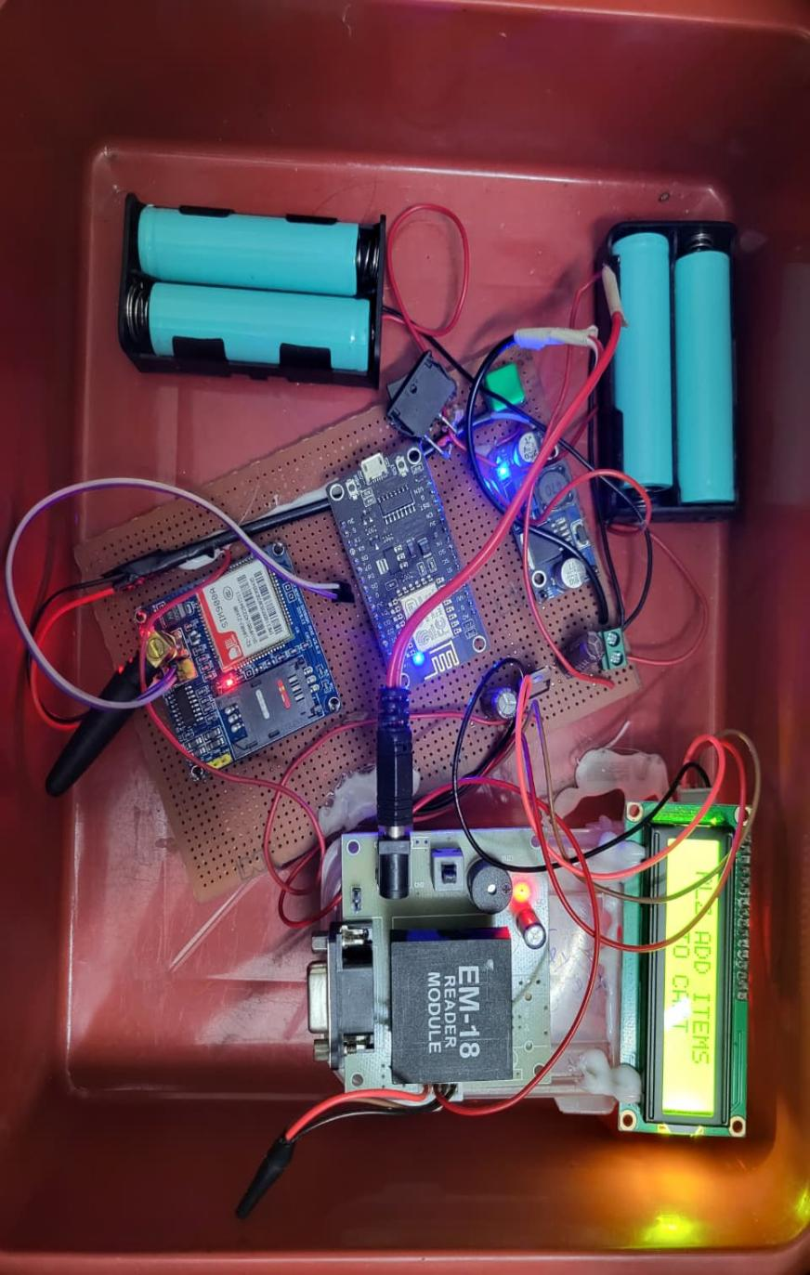
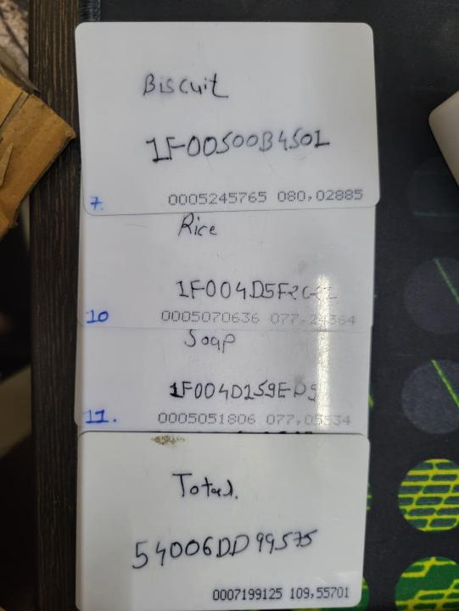

- Dashboard
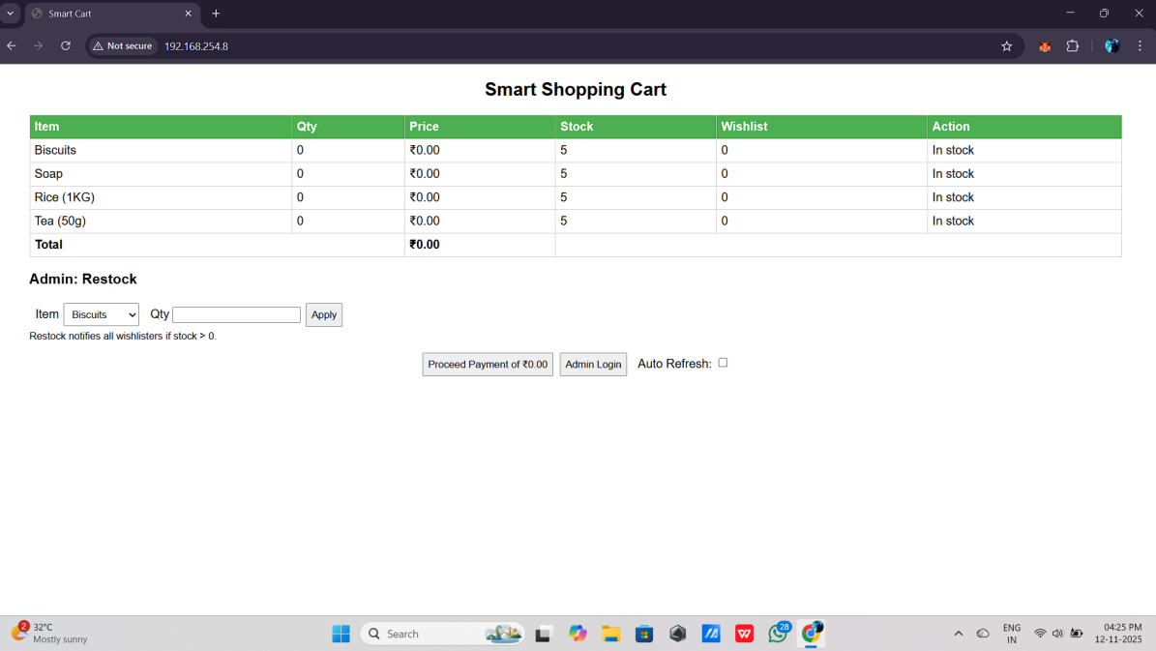

- Items added
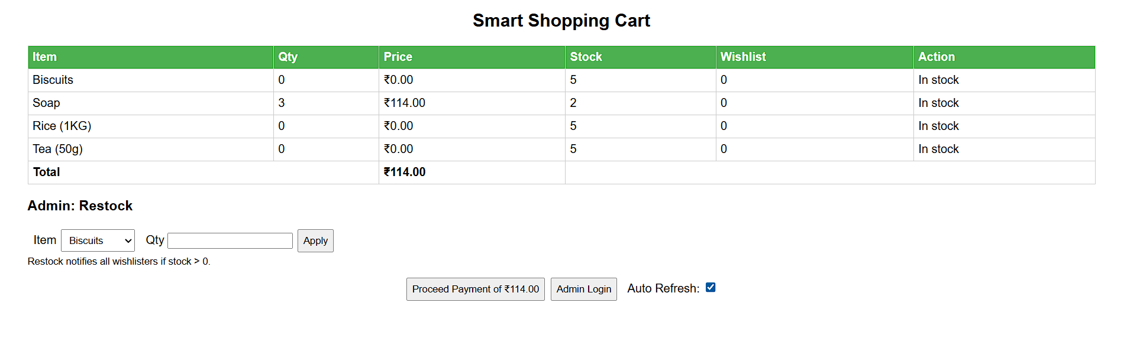
- Checkout(3 soaps)
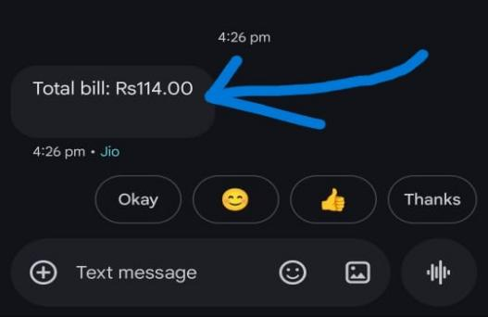
- Item out of stock (Wishlisted)
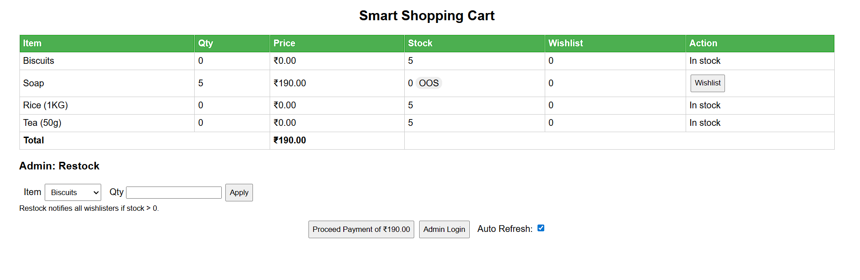
- Seller Notified
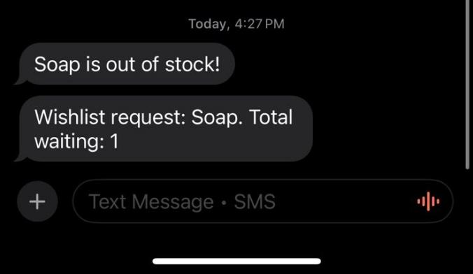
- Restocking Items

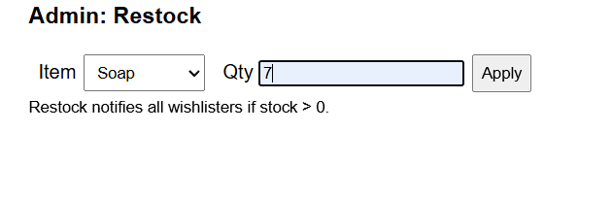

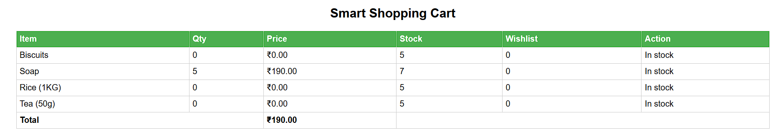

- Customer Notified

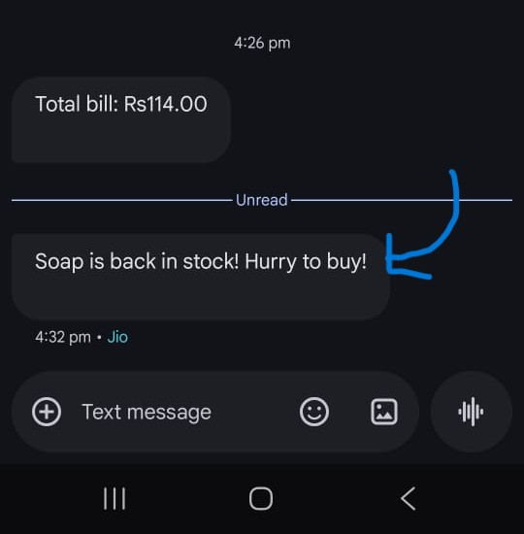

Project Completion Status

Phase | Description | Completion (%)
Hardware Assembly | Integration of RFID, NodeMCU, GSM, LCD modules | 100
Software Development | Arduino coding, backend APIs, dashboards | 100
Dashboard Integration | Admin and analytics portal | 100
Testing & Debugging | Module synchronization and data validation | 100
Deployment & Documentation | Final deployment and review report | 100
Completion date: Completed in second week of November(10-11-2025).

Conclusion
The IoT-Based Smart Cart with Enhanced Inventory Management presents a futuristic approach to automate retail
shopping and stock management using IoT and RFID technologies. The inclusion of dashboards, SMS notifications,
and automated invoicing makes the system more reliable and user-centric. It not only streamlines the checkout
process but also ensures efficient supplier coordination and data-driven decision-making. By leveraging IoT
for real-time tracking, analysis, and communication, this system demonstrates how technology can redefine
the retail shopping experience with higher efficiency and accessibility for all.

References
1. Rao, P. V. M., & Meena, N. (2019). Design of an Intelligent Shopping Basket Using IoT. *ResearchGate*.
2. IEEE Xplore. (2020). Smart Shopping Cart Based on RFID Technology (Paper ID: 9045336).
3. JETIR. (2019). Smart Shopping Cart Using RFID Technology. *JETIR, 6*(3), 933–938.
4. Krest Technology. (2019). Smart Shopping Cart Info Document.
5. YouTube. (2019). Smart Shopping Cart IoT Demo Video. Retrieved from https://www.youtube.com/watch?v=N8sdWydeZqs

