AIML Assignment 3 Mini Project Report

Breast Cancer Diagnosis Prediction using Machine Learning

Problem Statement
The objective of this project is to predict whether a breast tumor sample is malignant or benign using diagnostic measurements computed from digitized images of cell nuclei.

Dataset
- Source: UCI Wisconsin Breast Cancer dataset, accessed through sklearn.datasets.load_breast_cancer.
- Rows: 569 samples.
- Input features: 30 numeric diagnostic measurements.
- Target: diagnosis class, where 0 = malignant and 1 = benign.

Preprocessing and EDA
- Checked missing values and confirmed the dataset is ready for modeling.
- Used stratified train-test split to preserve class representation.
- Applied StandardScaler inside model pipelines to normalize numeric features.
- Generated class distribution, correlation heatmap, and feature-importance visualizations.
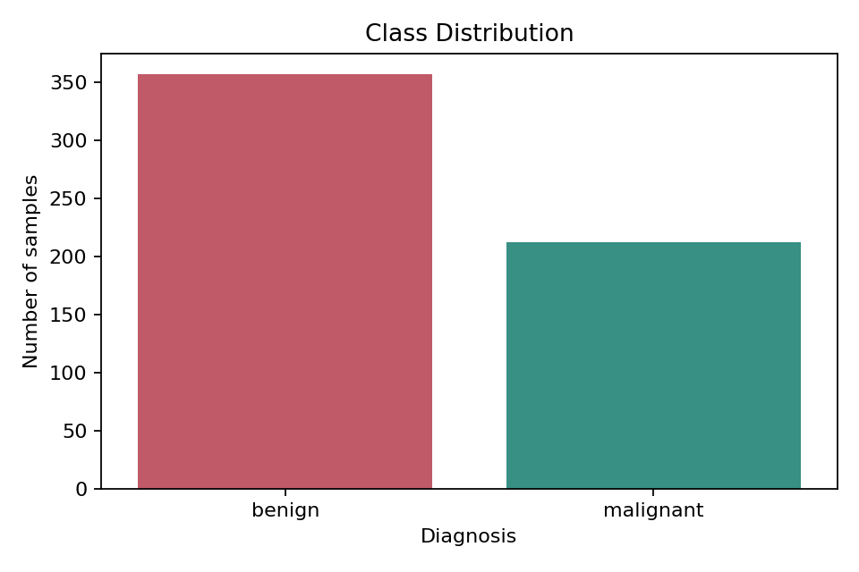
Figure 1: Class distribution
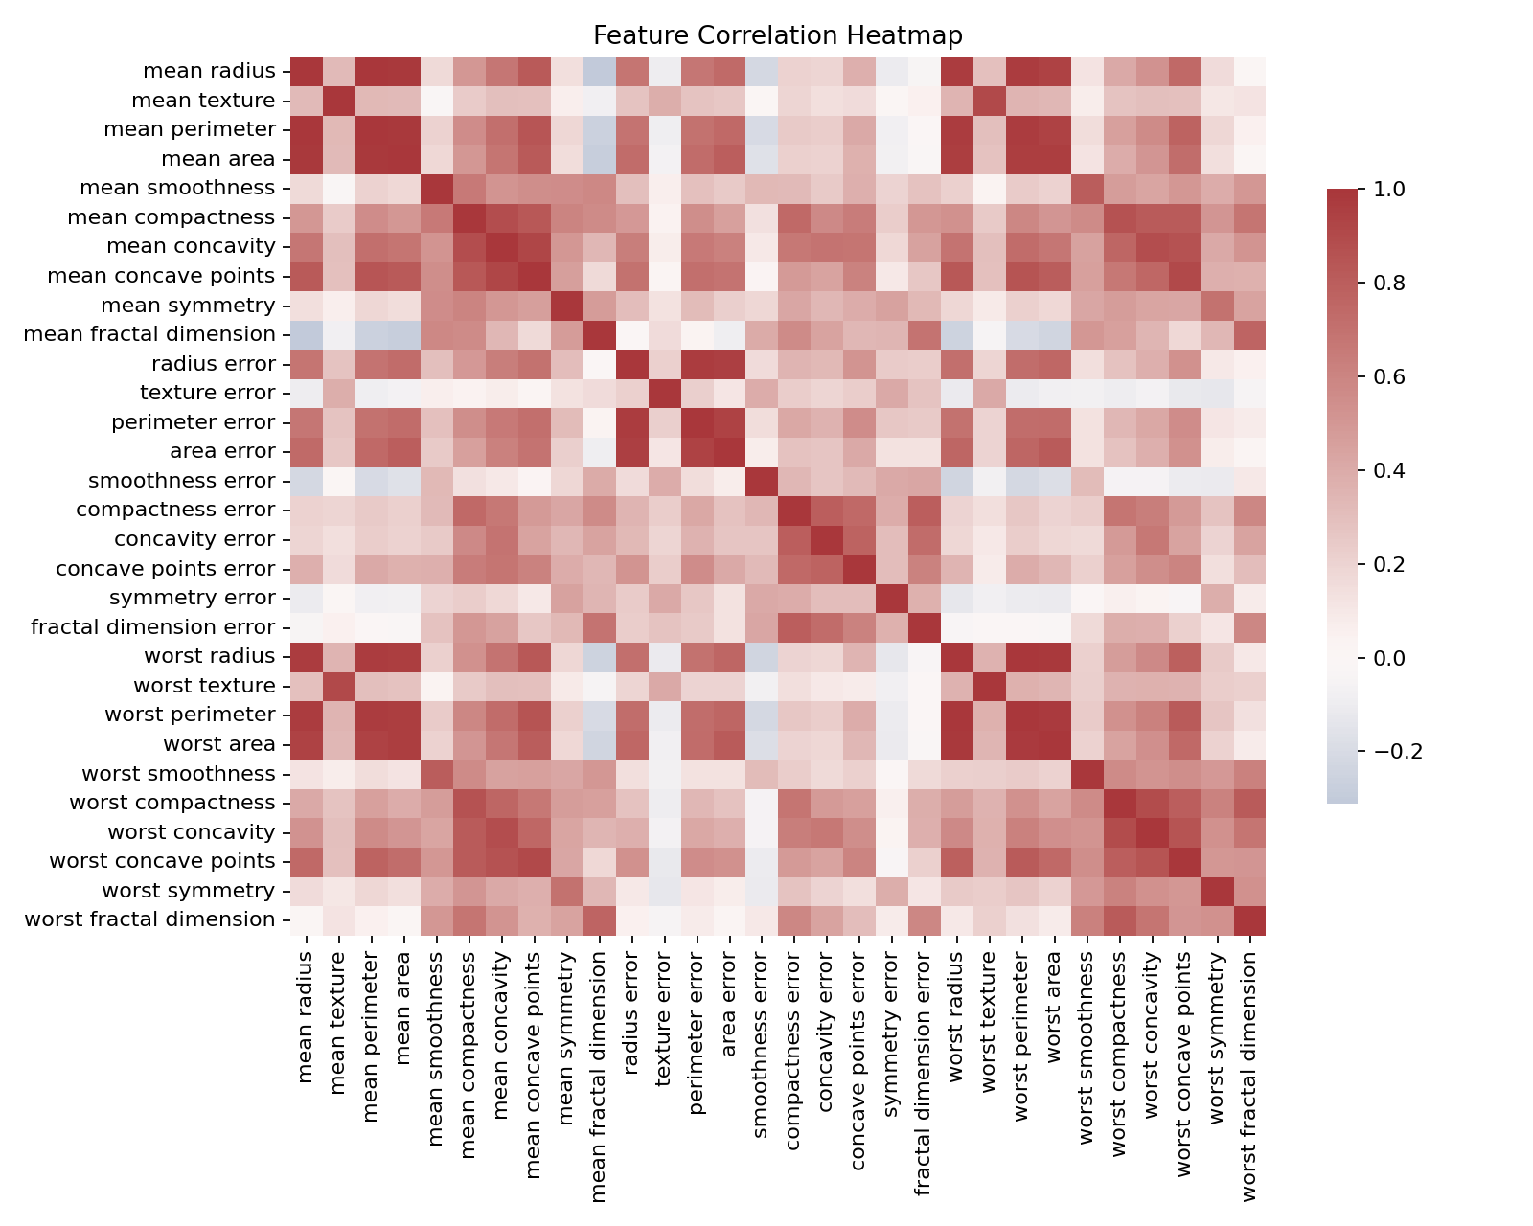
Figure 2: Feature correlation heatmap

Algorithms Used
- Decision Tree: interpretable supervised classifier.
- Random Forest: ensemble model that reduces overfitting and provides feature importance.
- Support Vector Machine: strong high-dimensional classifier after feature scaling.

Model Evaluation
Model | Accuracy | Precision | Recall | F1-score
Decision Tree | 0.9211 | 0.9116 | 0.9226 | 0.9164
Random Forest | 0.9474 | 0.9435 | 0.9435 | 0.9435
Support Vector Machine | 0.9737 | 0.9697 | 0.9742 | 0.9719
Best-performing model: Support Vector Machine
The selected model achieved accuracy 0.9737 and macro F1-score 0.9719.
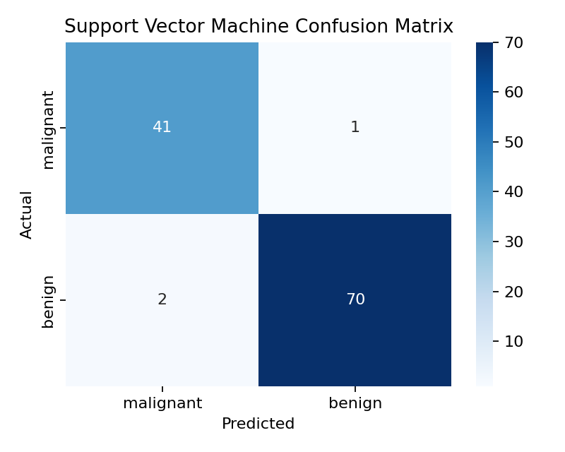
Figure 3: Best model confusion matrix
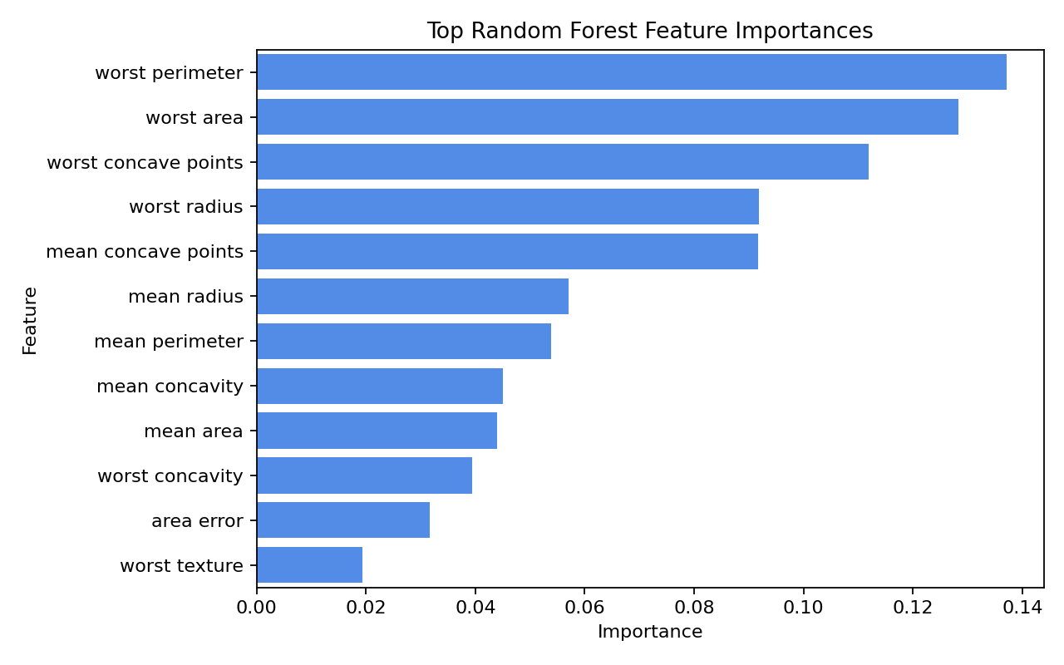
Figure 4: Random Forest feature importance

Advanced Concept: K-Means Clustering
- PCA reduced the scaled feature set to two components for visualization.
- K-Means clustering was applied to observe natural groupings in the data.
- Silhouette score: 0.5085
- Adjusted Rand Index against true labels: 0.6592
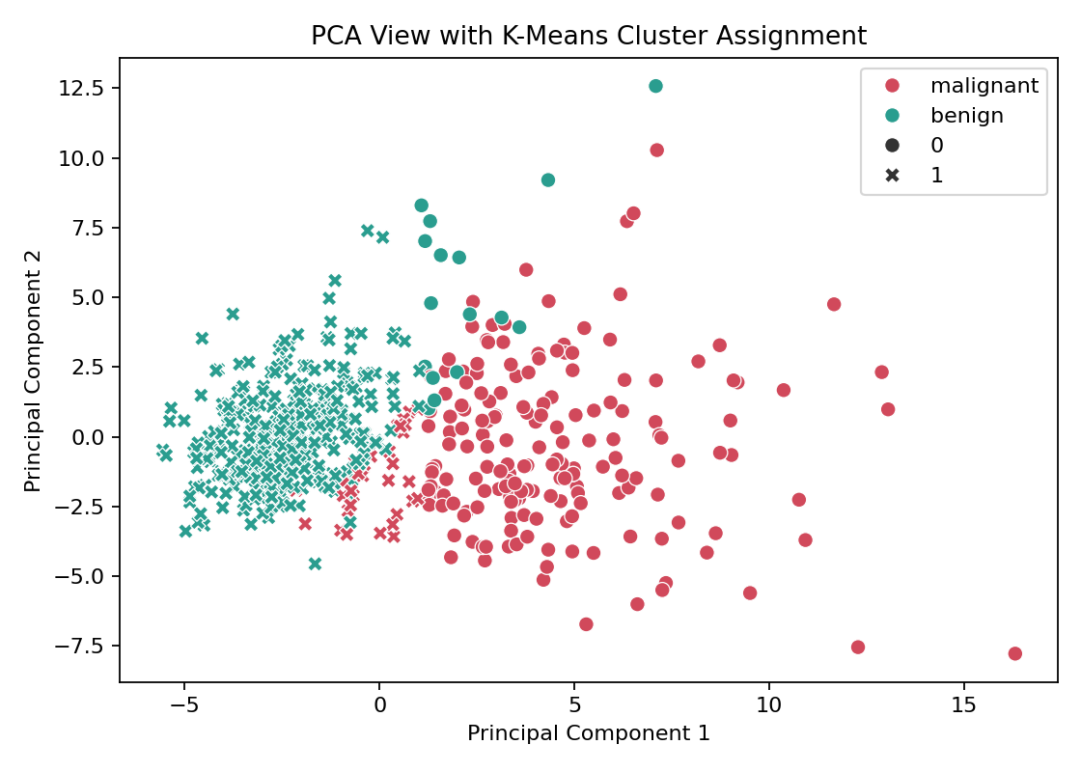
Figure 5: PCA view with K-Means clusters

Toolkit Used
Scikit-learn was used for data loading, preprocessing, model training, evaluation metrics, PCA, clustering, and pipelines. It provides a consistent API and helps prevent data leakage.

Implementation
- src/train_model.py trains and evaluates the ML models.
- src/app.py provides a local prediction API.
- static/index.html, static/styles.css, and static/app.js provide the frontend.
- artifacts/model_bundle.joblib stores the trained best model.

Reflection and Learning Outcome
This project demonstrates a complete machine learning workflow from problem definition to a usable prediction interface. The main learning outcome was understanding how preprocessing, evaluation, interpretation, and deployment-style usage connect in a real ML project.

Medical Disclaimer
This project is for educational use only and is not a replacement for professional medical diagnosis.

Detailed Live Sample Analysis
Generated at: 2026-04-26 17:18:09
Average feature deviation from dataset baseline: 0.00%
Top live input shifts versus dataset average:
Feature | Input | Dataset Mean | Deviation
mean radius | 14.1273 | 14.1273 | 0.00%
mean texture | 19.2896 | 19.2896 | 0.00%
mean perimeter | 91.9690 | 91.9690 | 0.00%
mean area | 654.8891 | 654.8891 | 0.00%
mean smoothness | 0.0964 | 0.0964 | 0.00%
mean compactness | 0.1043 | 0.1043 | 0.00%
mean concavity | 0.0888 | 0.0888 | 0.00%
mean concave points | 0.0489 | 0.0489 | 0.00%
mean symmetry | 0.1812 | 0.1812 | 0.00%
mean fractal dimension | 0.0628 | 0.0628 | 0.00%
radius error | 0.4052 | 0.4052 | 0.00%
texture error | 1.2169 | 1.2169 | 0.00%

