Breast Cancer Diagnosis Prediction

Machine Learning Diagnostic Report

Problem Statement
The objective of this project is to predict whether a breast tumor sample is malignant or benign using diagnostic measurements computed from digitized images of cell nuclei.

Dataset
- Source: UCI Wisconsin Breast Cancer dataset, accessed through sklearn.datasets.load_breast_cancer.
- Rows: 569 samples.
- Input features: 30 numeric diagnostic measurements.
- Target: diagnosis class, where 0 = malignant and 1 = benign.

Preprocessing and EDA
- Checked missing values and confirmed the dataset is ready for modeling.
- Used stratified train-test split to preserve class representation.
- Applied StandardScaler inside model pipelines to normalize numeric features.
- Generated class distribution, correlation heatmap, and feature-importance visualizations.

Figure 1: Class distribution
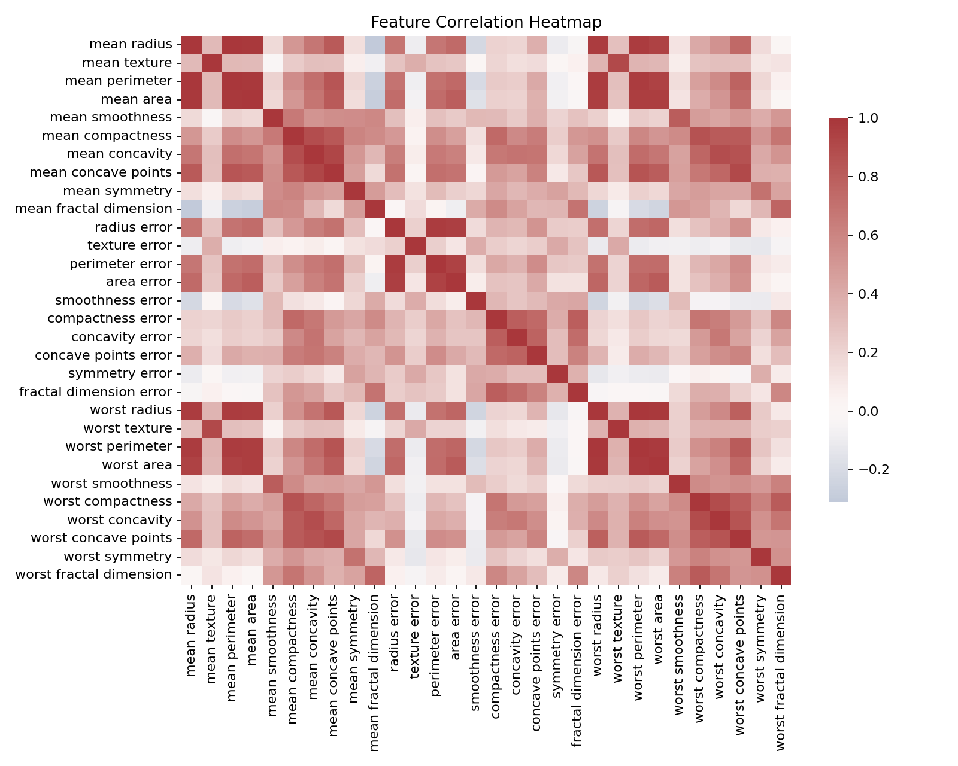
Figure 2: Feature correlation heatmap

Algorithms Used
- Decision Tree: interpretable supervised classifier.
- Random Forest: ensemble model that reduces overfitting and provides feature importance.
- Support Vector Machine: strong high-dimensional classifier after feature scaling.

Model Evaluation
Model | Accuracy | Precision | Recall | F1-score
Decision Tree | 0.9211 | 0.9116 | 0.9226 | 0.9164
Random Forest | 0.9474 | 0.9435 | 0.9435 | 0.9435
Support Vector Machine | 0.9737 | 0.9697 | 0.9742 | 0.9719
Best-performing model: Support Vector Machine
The selected model achieved accuracy 0.9737 and macro F1-score 0.9719.
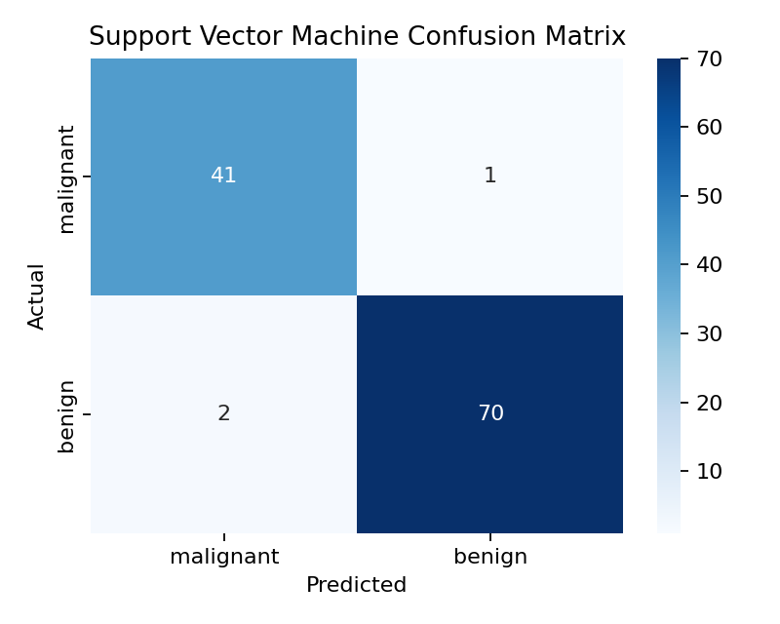
Figure 3: Best model confusion matrix
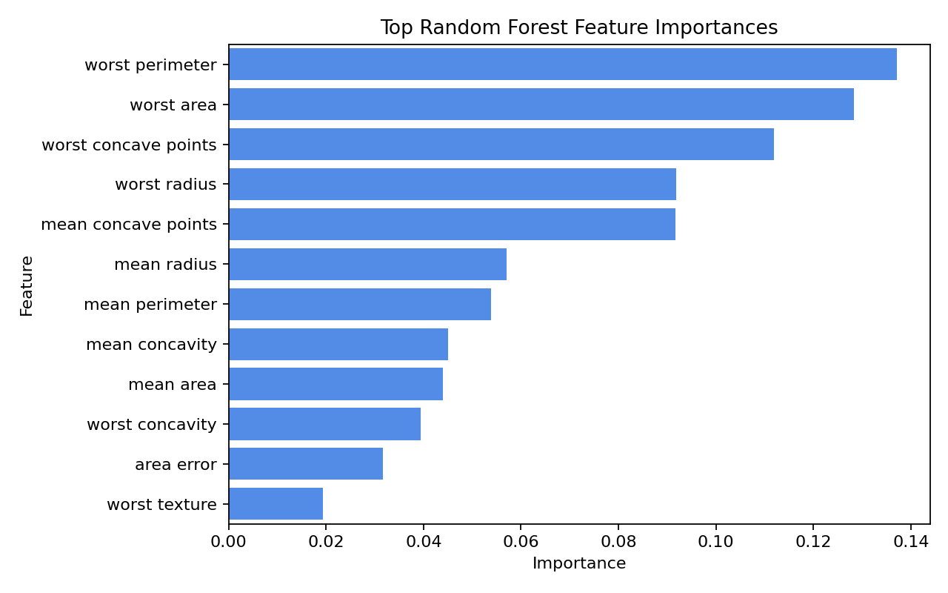
Figure 4: Random Forest feature importance

Advanced Concept: K-Means Clustering
- PCA reduced the scaled feature set to two components for visualization.
- K-Means clustering was applied to observe natural groupings in the data.
- Silhouette score: 0.5085
- Adjusted Rand Index against true labels: 0.6592
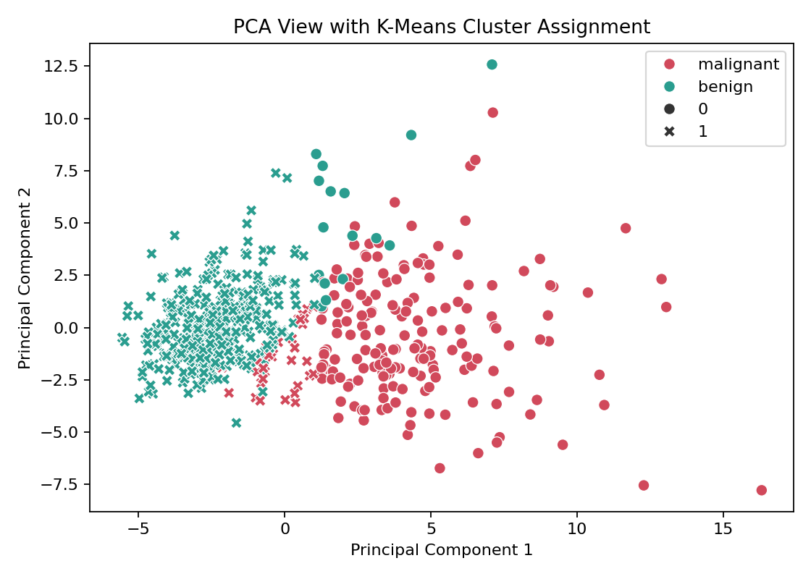
Figure 5: PCA view with K-Means clusters

Toolkit Used
Scikit-learn was used for data loading, preprocessing, model training, evaluation metrics, PCA, clustering, and pipelines. It provides a consistent API and helps prevent data leakage.

Implementation
- src/train_model.py trains and evaluates the ML models.
- src/app.py provides a local prediction API.
- static/index.html, static/styles.css, and static/app.js provide the frontend.
- artifacts/model_bundle.joblib stores the trained best model.

Model Interpretation Summary
This report summarizes model behavior from data preparation through evaluation and live prediction usage. The strongest insight is that perimeter, radius, and concavity-related features consistently drive diagnostic separation.

Medical Disclaimer
This project is for educational use only and is not a replacement for professional medical diagnosis.

Detailed Live Sample Analysis
Generated at: 2026-04-26 20:07:17
Average feature deviation from dataset baseline: 111.08%
Latest predicted diagnosis: malignant
Class | Probability
malignant | 96.81%
benign | 3.19%
Top live input shifts versus dataset average:
Feature | Input | Dataset Mean | Deviation
area error | 153.4000 | 40.3371 | 280.30%
mean concavity | 0.3001 | 0.0888 | 237.95%
mean concave points | 0.1471 | 0.0489 | 200.82%
perimeter error | 8.5890 | 2.8661 | 199.68%
radius error | 1.0950 | 0.4052 | 170.24%
mean compactness | 0.2776 | 0.1043 | 166.16%
worst compactness | 0.6656 | 0.2543 | 161.74%
worst concavity | 0.7119 | 0.2722 | 161.54%
worst concave points | 0.2654 | 0.1146 | 131.59%
worst area | 2019.0000 | 880.5831 | 129.28%
compactness error | 0.0490 | 0.0255 | 92.16%
worst perimeter | 184.6000 | 107.2612 | 72.10%

