Diagnostic Pathology Analysis Report
Case Ref: BC-20260426_200944
Generated on April 26, 2026 at 20:09
___________________________________________________________________________

Section I: Diagnostic Conclusion
PRIMARY DIAGNOSIS: BENIGN
Interpretation: The diagnostic measurements align with benign historical profiles.
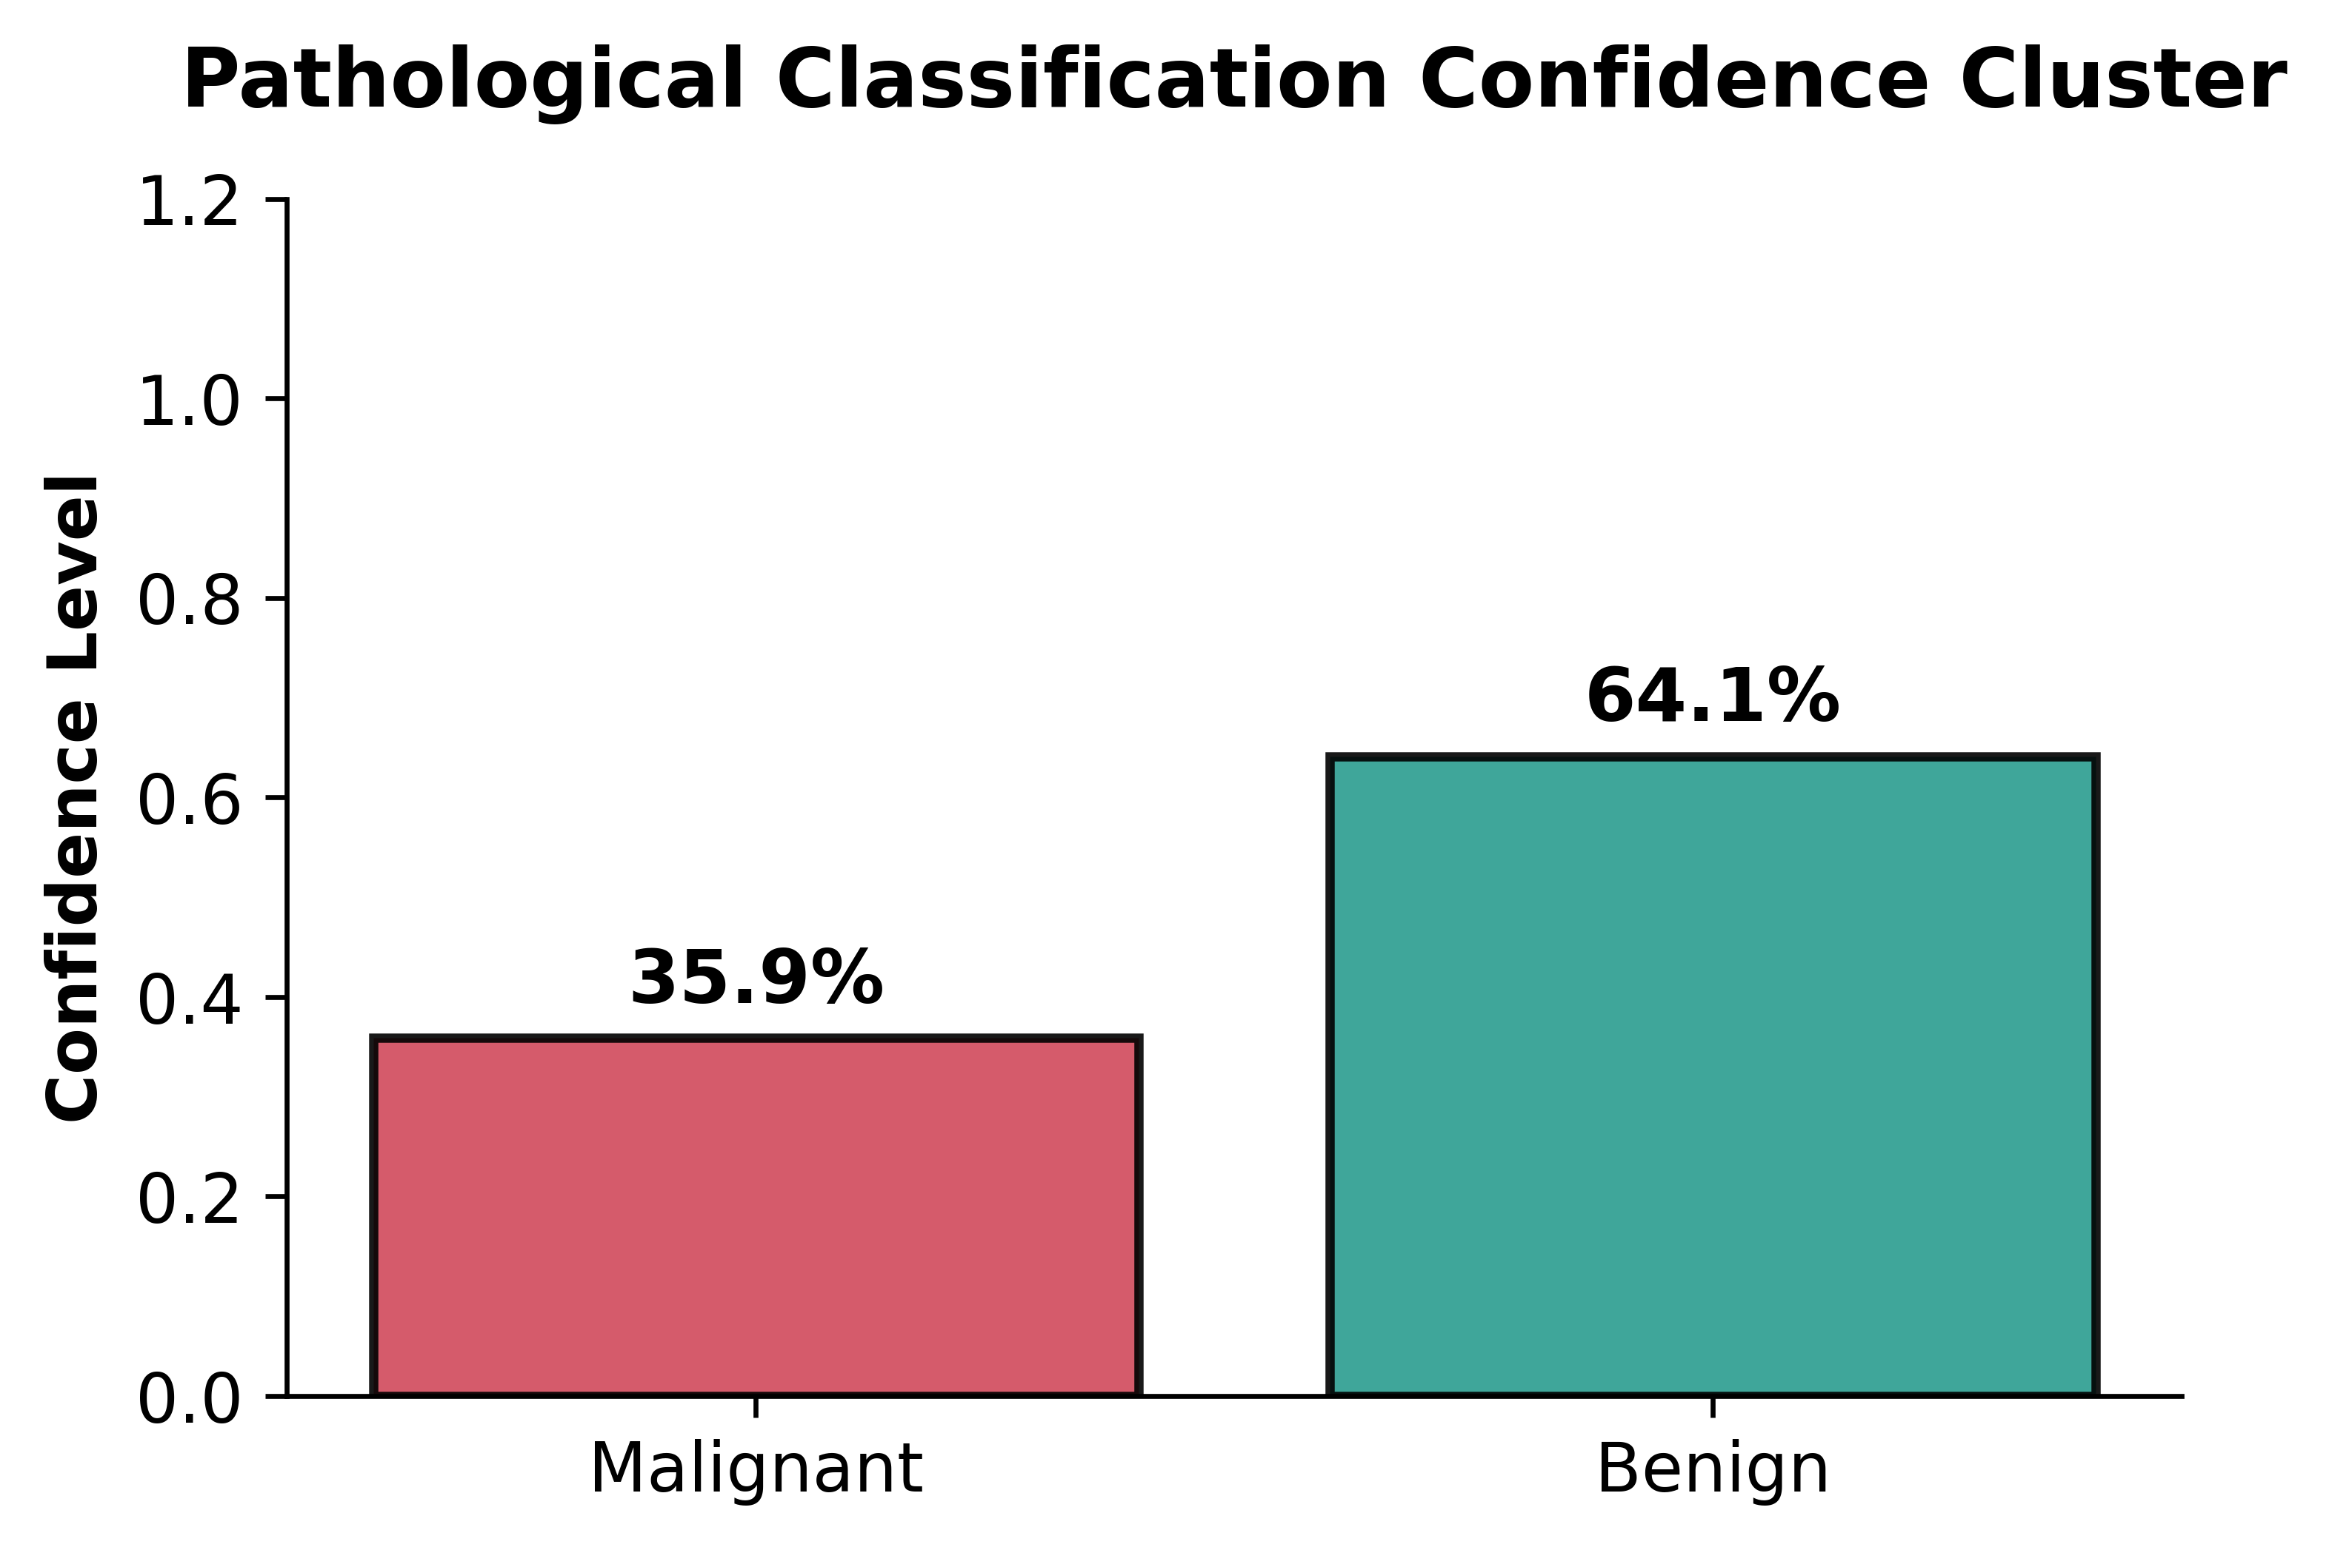
Exhibit A: Patient-Specific Diagnostic Probability Breakdown

Section II: Comparative Biological Markers
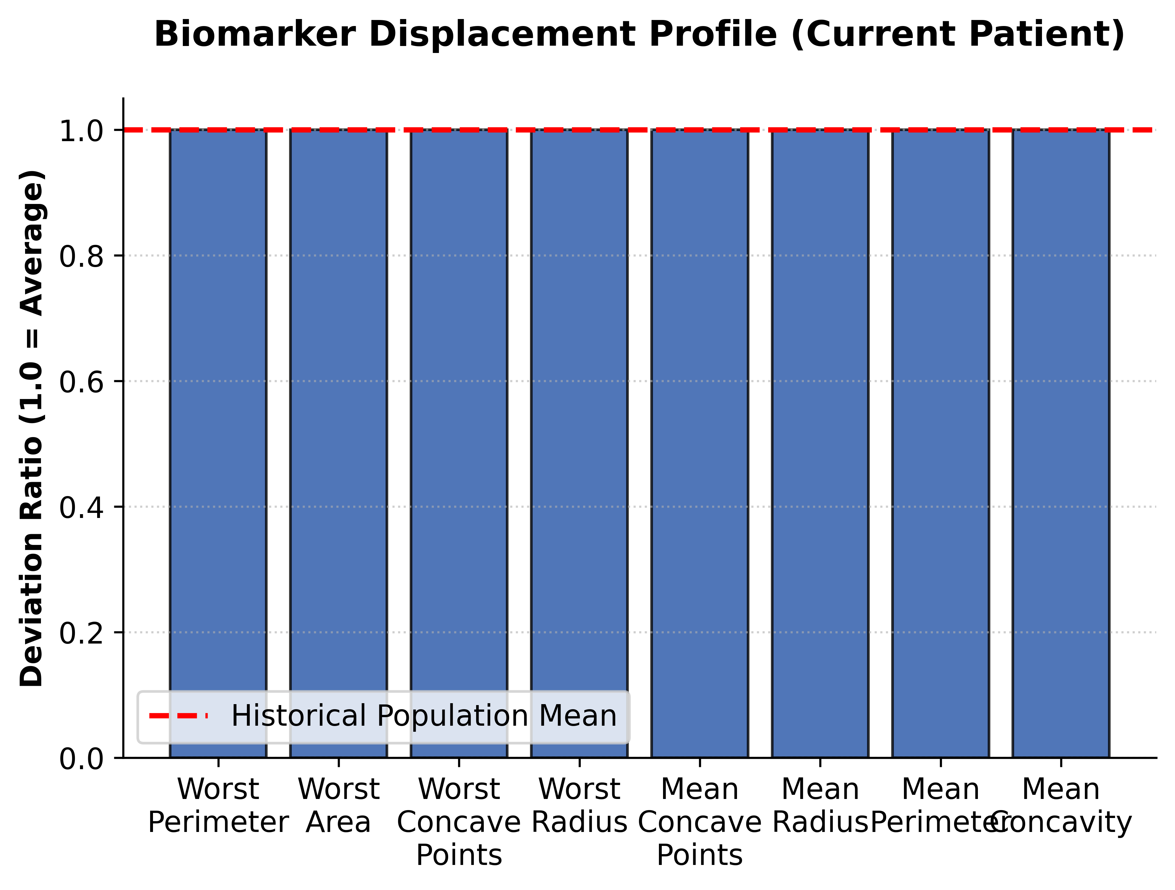
Exhibit B: Biomarker Shift Profile (Value / Dataset Mean Ratio)

Section III: Cluster Space Mapping
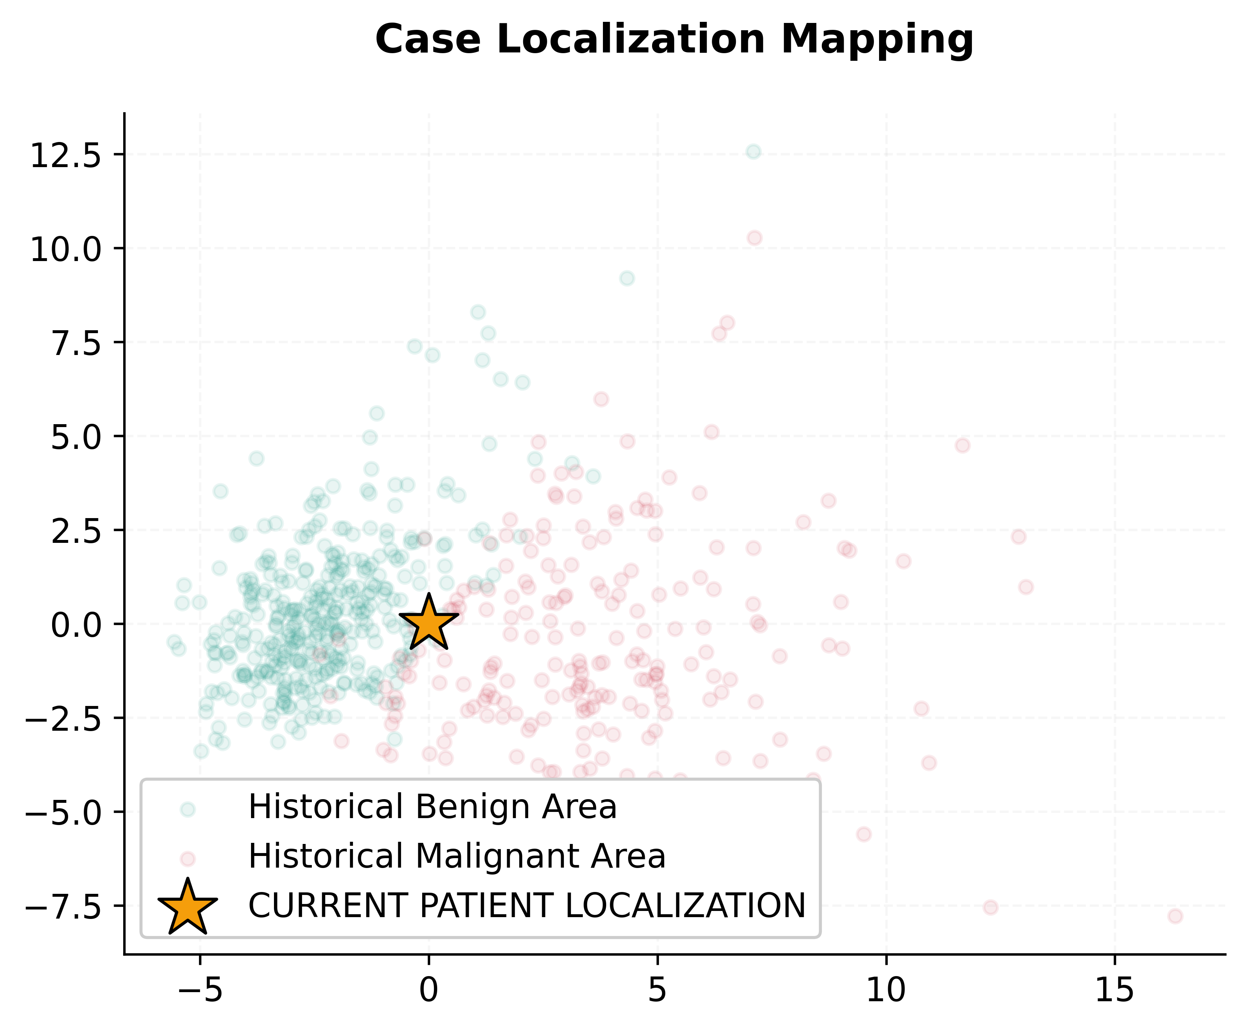
Exhibit C: Case localization relative to historical biopsies

Section IV: Quantitative Biomarker Data
Biomarker | Patient Value | Predictive Weight
Worst Perimeter | 107.26120 | 13.7%
Worst Area | 880.58310 | 12.8%
Worst Concave Points | 0.11460 | 11.2%
Worst Radius | 16.26920 | 9.2%
Mean Concave Points | 0.04890 | 9.2%
Mean Radius | 14.12730 | 5.7%
Mean Perimeter | 91.96900 | 5.4%

Section V: Medical Disclaimer
This report is an AI-assisted diagnostic aid. Final medical decisions should be made by a board-certified physician.

