# **Technical Summary**

In the development of the Power BI solution for Universal Export, three primary tasks were undertaken: data extraction, transformation, and management. Each task played a crucial role in shaping the data into a format suitable for analysis and reporting.

## **Data Extraction**

The data was extracted from five sources as listed below.

**Transactions:** The dataset provided insights into Universal Export's transactions, including transaction ID, transaction date, total price, customer ID, logistic ID, shipment details, product details, quantity, product price, and product cost.

**Customers:** The dataset contained customer information such as customer ID, customer name, address, business category, salesperson along with their contact details, and a Boolean variable indicating whether a customer joined in 2023.

**Products:** The dataset had the company’s product portfolio which included product ID, name, category, colour, price per unit, and cost.

**Logistics:** Logistics information, such as logistic ID, name, type, office location, and contact details, provided insights into the operations managed by logistic partners.

**Salespeople:** This dataset contained records pertaining to the company’s salespeople, including their ID, nationality, education, gender, and age.

## **Data Transformation**

Initially, we checked that there were no duplicates and blank rows present in all the datasets. We look into each dataset individually as shown below.

**Customers:**

In order to enhance the usability of customer-related information, we split the customer_address column into two separate columns ‘city’ and ‘country’. This will help us in performing country-wise analysis later on. We also noticed multiple spelling and abbreviation issues in these columns and made proper rectification. For instance, city names were updated from 'Bruge' to 'Bruges' and from 'Talinn' to 'Tallinn'. In country, 'UK' was updated to 'United Kingdom' to bring in consistency. We also noticed that city and country values for customer_ID 45 to 48 were wrongly placed, hence we swapped them by using conditional columns.

**Products:**

The products dataset had some missing values in PRODUCT_COLOUR, PRICE_PER_UNIT, and COST.

Using conditional columns, we resolved any inconsistencies in PRODUCT_CATEGORY and PRODUCT_COLOUR based on PRODUCT_NAME column. Missing values in PRODUCT_COLOUR was imputed based on PRODUCT_NAME. Missing values in PRICE_PER_UNIT were replaced by dividing PRODUCT_PRICE and QUANTITY from the transactions dataset for each PRODUCT_ID. Similarly, we replaced missing values in COST by dividing PRODUCT_COST and QUANTITY for each PRODUCT_ID. Using the same logic, we noticed that some values in these columns were wrongly mentioned as 7000000 and -5 which were verified and corrected to 7 and 5 respectively.

For each PRODUCT_CATEGORY, with the help of PRODUCT_NAME, we created a new column for highlighting the product sub-category.

**Logistics:**

Similar to the transformation applied to customer_address earlier, we split the LOGISTIC_OFFICE_LOCATION column to LOGISTIC_CITY and LOGISTIC_COUNTRY. There were some spelling mistakes which we resolved like changing ‘Zofia’ to ‘Sofia’, ‘Brussel’ to ‘Brussels’ for the city column and changing ‘UK’ to ‘United Kingdom’ in the country column. One of the values in CONTACT_EMAIL was incomplete and based on the office location we updated transport@fashionistic to transport@fashionistic.com. Missing values in CONTACT_EMAIL and CONTACT_NUMBER were categorised as ‘Unknown’.

**Salespeople:**

In the salespeople dataset, we changed the data type of SALES_ID to text format to transform it to a categorical variable.

**Transactions:**

In the transactions table, TRANSACTION_DATE was formatted properly by splitting, reordering, and merging back the values in Date format. We also updated the abbreviation ‘UK’ to ‘United Kingdom’ in the SHIPMENT_COUNTRY column.

A new conditional column was added to categorize transactions based on whether a transaction occurred before or after 1st July 2023.

Lastly, we verified and ensured that data type, data category, and format of all columns were correctly defined. Also, redundant columns were removed from the dataset. This helped in cleaning and pre-processing the raw data into an asset ready for analysis.

## **Data Management**

We now delve into creating relationships between the datasets and adding columns and measures that would help our analysis.

**Date Table Creation:**

A separate date table ('DateTable') was created using the ‘CALENDARAUTO()’ function to serve as a central reference for date-based analysis and visualization.

**Table Relationships:**

We created relationships between datasets based on the common fields which enables dynamic cross-filtering between tables. For instance, relationships were established between the Customers table and the Transactions table using the customer ID field, allowing for analysis of customer transaction history and behaviour. The relationships created are shown in Figure_1 and Figure_2.

Figure_: Table relationships

Figure_: Visual relationships

**Columns and Measures:**

Columns and measures were added using DAX coding to help provide deeper insights into the company’s performance and operations. These covered multiple metrics including sales and profitability, customer behaviour, and operational efficiency.

For instance, columns for profit and profit margin were created for all transactions whereas measures like overall cost, sales, profit, and profit margin were calculated. Additional measures like average monthly sales, month-on-month profit change, and month-on-month sales change were created in order to track and monitor financial performance trends over time. Similarly, measures like quantity purchased, and transaction count were created to get a glimpse of customer buying behaviour. From the operational standpoint, columns such as quantity shipped, profit per shipment, and shipment count and measures like Air shipment % were added to analyse logistics performance as shown in Figure_3.

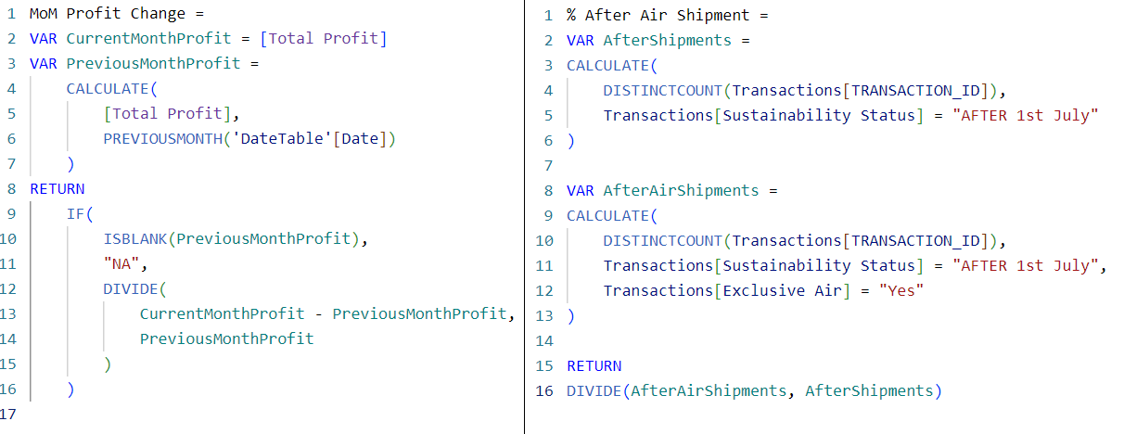

Figure_: DAX Measures

# **External Report**

Shareholders of Universal Export need to gain insight into their investment by understanding the financial health including sales performance and profitability. This report enables shareholders to assess the company's performance against strategic objectives and make informed investment decisions. Furthermore, understanding the impact of the company's sustainability initiative by reducing air shipments is crucial for shareholders to gauge the company’s alignment with environmental and social responsibility goals.

## **Overall Financial Snapshot**

In 2023, despite operating costs totalling £573 million, Universal Export achieved a total sales volume of £1040 million, accompanied by a total profit of £467 million. This resulted in a remarkable profit margin of 45% which demonstrates their robust financial performance and profitability throughout the year, showcasing its strong position in the garment manufacturing industry.

## **Monthly Profit & Sales Snapshot**

Analysing the pattern of change on a monthly basis provides deeper insights into the company's performance dynamics in 2023. The year started with a notable dip in February, with both profits and sales declining sharply. However, recovery was swift by mid-year, with profits peaking at £42 million in August and sales reaching a high of £93 million in the same month. The latter part of the year was marked by stability and a positive uptrend, closing December with robust sales of £92 million. This recovery and stability are promising indicators for sustained shareholder value and the company's robust strategic positioning.

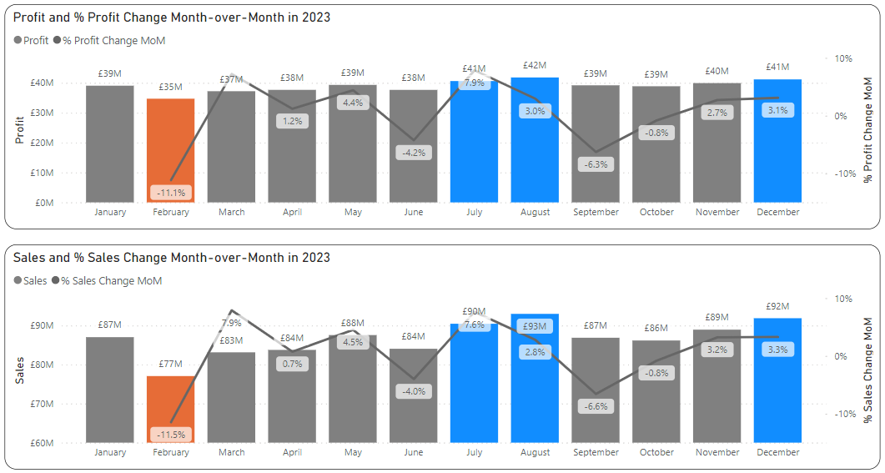

## **Weekly Profit & Sales Snapshot**

On a more micro level, the weekly snapshot captures any short-term fluctuations and trends in the company's revenues and profits. Looking at the weekly average sales & profits, we observe fluctuating patterns. Sales ranged from around £9.1 million to £9.8 million per week whereas average profit ranged from approximately £4.1 million to £4.4 million per week, indicating variability in the company's earnings throughout the year. Despite these fluctuations, there seems to be a general stability in sales & profit trends over the weeks, with occasional peaks and troughs. Overall, these weekly performance metrics provide insights into the short-term revenue and profit trends of Universal Export throughout 2023, highlighting both stability and variability in the company's financial performance over time.

## **Understanding Product Categories**

We now delve into the array of products manufactured and sold by the company in order to shed light on different aspects of the company's product performance, highlighting both strengths and weaknesses across various categories.

It is evident from this visual that the ‘Hoodie’ category emerges as the strongest product category with a profit of £152 million, constituting a profit margin of 56% through a total sales volume of £271 million. However, the ‘Sweatshirt’ category appears to lag behind, with a profit of only £22 million, resulting in a lower profit margin of 43% and hence can be treated as the weakest product category.

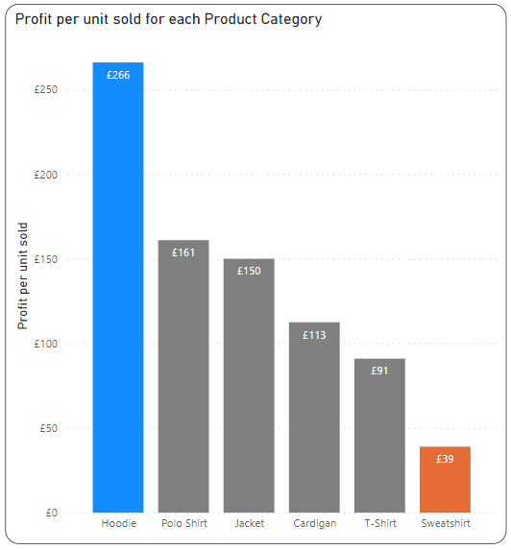Considering not only the profits, but also the quantity sold, we now focus at the profits generated from each unit sold. The chart shows that the ‘Hoodie’ category stands out yet again with the highest profit per unit sold at £266, underscoring strong profitability at the individual product level. Conversely, the ‘Sweatshirt’ category exhibits the lowest profit per unit sold at £39, indicating lower profitability compared to other categories.

When we drill down and analyse the profit margin generated from each product sub-category, we notice that ‘Xtra Sport Hoodie for Athlete’ resulted in the highest profit margin of 69% whereas ‘Alpha V2 Polo Shirt for Special Comfort’ had the lowest profit margin of 32%.

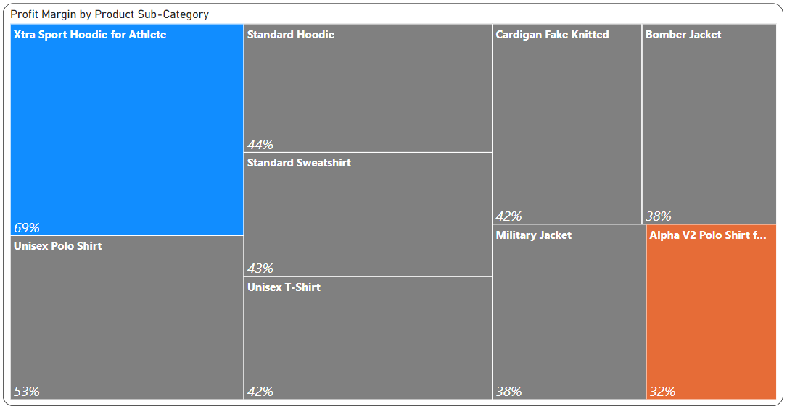

In summary, the company's strengths lie in the ‘Hoodie’ category with high sales and profitability where the ‘Xtra Sport Hoodie for Athlete’ sub-category can be seen as the star product. Conversely, the ‘Sweatshirt’ category appears to be the weaker area with low sales and profitability.

## **Geographical Understanding of Sales & Profit**

In order to understand country-wise performance, we look at the above chart which shows the total sales and profits coming in from each country. The United Kingdom stands out as the top-performing market with a staggering sale of £249 million and generating £112 million in profits which indicates the huge market demand in that region. Spain and France follow them with sales of only £98 million and £97 million respectively.

In summary, while certain countries like the United Kingdom, Spain, and France demonstrate both strong sales and profitability, others may require closer examination to identify opportunities for enhancing profitability relative to sales volume. These insights are invaluable for strategic decision-making, allowing the company to allocate resources effectively and capitalize on growth opportunities in different markets.

## **Road To Sustainable Commitment**

We now turn our focus on the company's endeavour to curtail the usage of exclusive air shipment starting from July 1st, 2023, onward until the year's end, as part of its sustainability commitment.

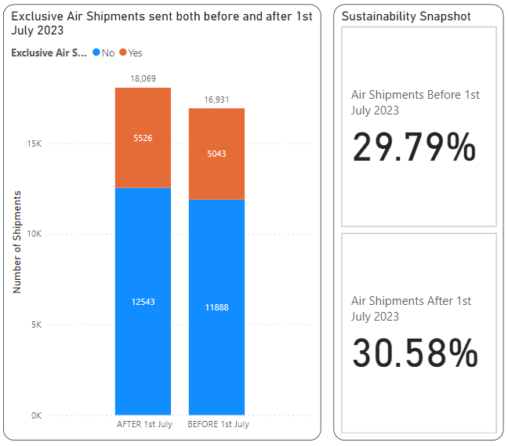

This visual illustrates the number of shipments via exclusive air both before and after July 1st, 2023. Notably, after the sustainability commitment came into effect, the number of shipments via exclusive air increased rather than decreased. Before July 1st, 2023, there were 5,043 shipments made via exclusive air, whereas after that date, the number rose to 5,526 shipments, indicating an upturn in reliance on this mode of transport. To be more precise, we can see that exclusive air shipments accounted for 29.79% of the company's operations before 1st July 2023. However, post-July 1st, 2023, the percentage of exclusive air shipments rose to 30.58%, signifying a slight increase in reliance on air transport for shipments.

A look into the individual logistic companies reveal that out of 20 companies, 6 companies (AirSat, WorldEyes, PAGL, Guichard Group, Mindaugas Air, ILA) ship only via air which increases overall carbon footprint. Shareholders should look into this and implement strategic plans in order to utilise more of those companies who can ship through land, and sea or a combination of all instead of shipping exclusively by air.

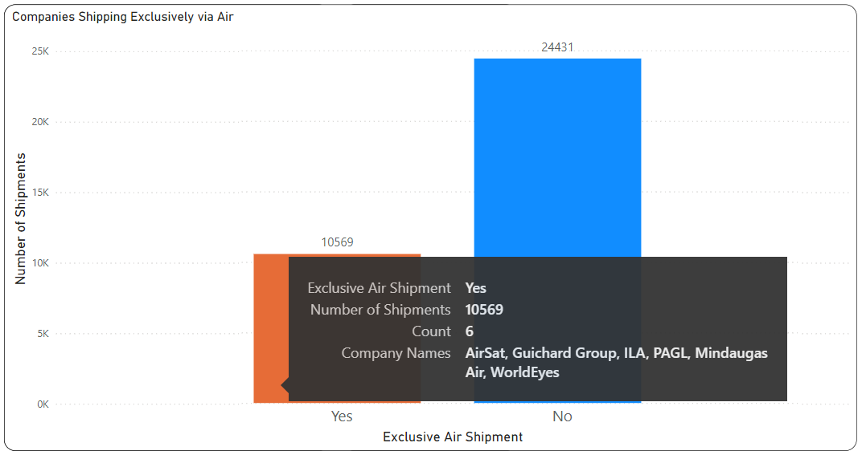

These findings suggest that despite the company's intention to reduce its exclusive air shipment usage for sustainability reasons, there hasn't been a significant decrease in air shipments. Instead, there has been an increase in the number of shipments via exclusive air, contradicting the sustainability goal. This outcome is a deviation from the sustainability objective and further action from the company might be required to address this discrepancy and realign with its sustainability commitments.

## **Summary**

This report provides stakeholders with a comprehensive overview of Universal Export's financial performance, strategic direction, and sustainability efforts. It highlights the company's robust financial performance in 2023, with impressive **sales of £1040 million** and a **profit margin of 45%**, showcasing its strong position in the garment manufacturing industry.



The analysis of monthly and weekly performance dynamics offers deeper insights into fluctuations in sales and profit, reflecting market demand and operational efficiency variations. The year initially started slowly in February, but later became stable by the summertime with August standing out as the best performing month followed by the winter season.

Additionally, an examination of product performance reveals ‘Hoodie’ as the star product by generating £152 million profit from a sale of £271 million while the ‘Sweatshirt’ category lacks behind at only £52 million sales with just £22 million profit. This would definitely need to be looked into and new strategies would need to be developed in order to bring any improvement.

The comparative sales performance across different countries highlights United Kingdom as the key market contributing to higher profitability, followed by Spain and France.

Finally, the evaluation of the company's sustainability commitment reveals challenges in reducing exclusive air shipment usage, prompting shareholders to seek clarification and action to realign with sustainability goals. A screenshot of a phone

Overall, stakeholders gain valuable insights into Universal Export's financial health, product portfolio, market performance, and sustainability efforts, empowering informed investment decisions and strategic planning.

# **Internal Report**

The purpose of this report is to provide the management team of Universal Export with insights into the performance of salespeople within the company. Specifically, the report aims to evaluate individual salespeople across various key criteria to assist in the process of determining promotions to head and deputy head of the sales department. By analysing sales and profit metrics, customer acquisition capabilities, and sales of profitable products, this report will enable the management team to identify top-performing salespeople and make strategic decisions to enhance the sales department's effectiveness and profitability.

## **Sales & Profits generated by Salespeople**

A closer look at the sales and profits generated by each salesperson shows that all salespeople contribute to a profit margin of around 45%. However, if we look at the exact figures of sales and profits generated by each salesperson, then we see a significant disparity among team members. SALES_ID 22 stands out prominently with a profit of £50 million, by achieving sales volume of £112 million thus making him a top performer in terms of profits. Following closely behind is SALES_ID 12, generating a profit of £38 million, by achieving sales volume of £85 million. These two individuals demonstrate exceptional proficiency in generating profits from their sales efforts, reflecting positively on their performance within the sales department.

## **Understanding Profitability through Salespeople Demography**

We now look into the correlation between salesperson demographics, specifically age and education, and their respective contributions to profits. Notably, salespersons aged 40 to 49, holding an undergraduate degree, stand out prominently, generating the highest profit of £156.3 million among all demographic categories. Conversely, salespersons aged 30 to 39, holding a master's degree, demonstrate the lowest profit contribution at £21.1 million. These findings highlight the importance of considering demographic factors such as age and education in understanding salesperson performance and for future promotion.

## **Customer Acquisition**

The percentage of new customers gained during the year relative to the total customer base was 8.33% (4 out of 48), which serves as a key indicator of the company's effectiveness in expanding its customer networkA close-up of a graph

This column chart below showcases the volume of sales generated by each salesperson from existing and new customers. By comparing the sales figures from new customers against total sales, it becomes evident that SALES_ID 22, 12, 4, and 5 were successful in attracting and capitalizing on new business opportunities. Although the sales generated by them from new customers are similar, however we can identify SALES_ID 22 and 12 to be the top 2 performers through total sales and also ability to acquire new customers.

## **Understanding Sales of Profitable Products**

This section offers insights into the company's profitable products and the sales performance of individual salespersons with a focus on profitable products.

When we look into all the different product sub-categories, we notice that the "Xtra Sport Hoodie for Athlete" stands out with an impressive profit margin of 69%, followed by the "Unisex Polo Shirt" with a margin of 53%. Remaining all products had a profit margin of less than 50%. We will consider this 50% profit margin as our benchmark of profitable products. Our objective is to look into those salespeople who are bringing in more sales and profits from these profitable products which have a profit margin of more than 50%.

When looking at the number of profitable products ("Xtra Sport Hoodie for Athlete" and "Unisex Polo Shirt") sold by each salesperson, we see that certain salespersons have managed to sell significant quantities of these high-margin items. For instance, SALES_ID 22 has sold the highest quantity of profitable products of around 1.72 million, followed closely by SALES_ID 12 who sold 1.31 million products. This suggests that these salespersons possess the ability to identify and effectively sell products with high-profit margins, contributing significantly to the company's overall margin performance.A screenshot of a graph

By analysing the intersection of product profitability and sales performance of individual salespersons, the company can identify top performers who excel in promoting and selling high-margin products. Recognizing and rewarding these salespeople can further incentivize them to continue focusing on profitable products, ultimately driving the company's margin growth and overall sales success.

## **Summary**

This analysis offers valuable insights into the performance of each salesperson within the company, aiding the management team in selecting candidates for promotion to head and deputy head of the sales department. Key points highlighted include significant disparities in profitability among salespersons, with individuals like SALES_ID 22 and 12 demonstrating exceptional efficiency in converting sales into profit.

Additionally, these 2 salespeople were also at the forefront when it came to acquiring new customers and bringing in sales. This provides a valuable indicator of their salesperson ability to attract and capitalize on new business opportunities.

Furthermore, the analysis of sales volume through a focus on profitable product by each salesperson underscores their proficiency in identifying and selling high-margin products, contributing significantly to the company's overall margin performance. Once again, we see that SALES_ID 22 and 12 excel at generating sales intelligently by selling more quantities of profitable products .

By considering these factors, the management team can identify SALES_ID 22 and 12 to be the top-performing salespersons deserving of promotion to the head and deputy head roles respectively.