Digital Image Analysis ( COL 783)
Report for Assignment 2

The main part of the assignment is feature detction of points. Following are the main approaches we have tried :-

(1) Firstly, we started with a very basic and simple idea. We find the Canny Image of the original image. We divided the image in grids say total 16 x 16 grids. Now, each grid will have some white pixels corresponding to edges. We choose a random point on that edge and thus we have a set of feature points from each grid.

The problem with this method is with randomness.
The point may wary in the same image from time to time. Thus, we discardrd this method.

(2) We following a similar approach, this time divided the gradient image in rows of say 100 pixels thickness. Then we calculated the rows corresponding to maximum intensity (energy/entropy). The row in the upper half of the image will correspond to eyes and the row in lower half will correspond to mouth.
So, now we have rows which contain eyes and mouths. We calculated exact location of eyes by finding variance of a small kernel in that row. The two positions with highest variance correspond to two eyes. Detection of mouth is pretty straight forward now. It is the intersection of the mouth row and angle bisector of eyes positions. The other points are detected by proportions.

(3) The method works but the only reason of its failure in some images in proportions. So, we developed a more robust approach, by detecting change in entropy at the ends of mouth row, and in the angle bisector of eyes. Thus we were able to get points corresponding to nose, mouth ends and chin. Other points at the edges of the face are pretty straight forward to calculate.

(4) Still, in some cases results were not satisfying. So, ultimately, we finalized weighted sum of feature points detcted by approach (2) and (3). Results were pretty good like the one shown below.

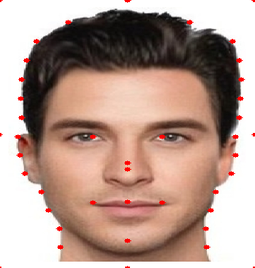
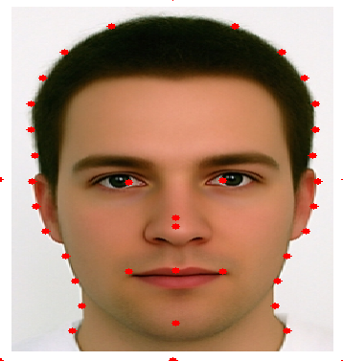

**********************END OF DOCUMENT*************************

