Image Super-resolution Assignment
Computer Vision
Aman Bhatia
18, November, 2016

Dataset Creation :

Dataset is created to train the network for scale 3. From the given images, 33x33 pixel images and their corresponding 21x21 labels are extracted at a stride of 14. This produces nearly 22000 images for training and 2500 images for testing.

Implementation :

Implemented the exact same CNN as described in the paper using lasagne library of python. Lasagne is just a wrapper around theano to make the neural network layer formation and joining easier. Input layer containing 33x33 neurons followed by a convolution layer with filter size 9x9 and no. of filters 64, followed by a relu layer, followed by a convolution layer with filter size 1x1 and no. of filters 32, followed by a relu layer, followed by a convolution layer with filter size 5x5 and no. of filters 1, which will serve as the final output layer of the network.

Following is a graph plot of the train and test errors vs no. of epochs,

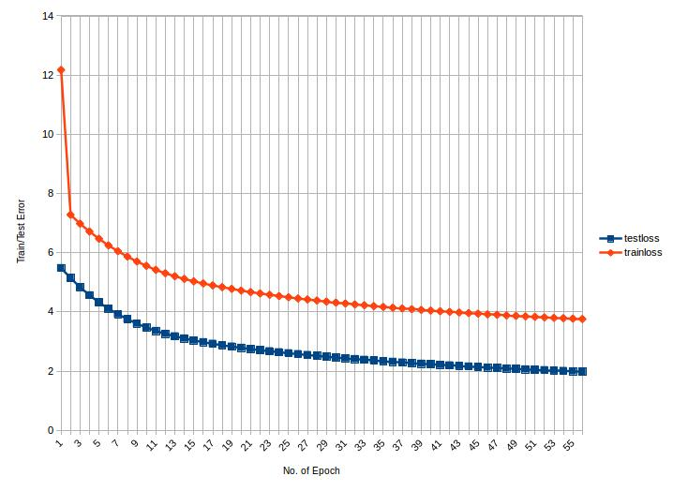

Results :

Ground Truth Network Input Network Output
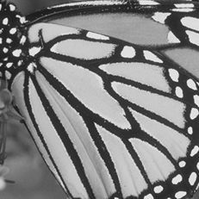
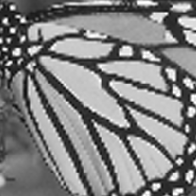
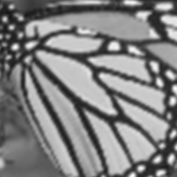

--END OF DOCUMENT--

