Lucas Kanade Assignment
Computer Vision
Aman Bhatia
23, August, 2016

Lucas Kanade :

Implemented Lucas Kanade Algorithm(both translational and affine model) using Gauss-Newton approximation. Following are some crucial observations on several videos:-

1) The translational model is highly stable. In terms of performance, when the motion is large, it does not give good results but it is stable in the sense that it does not overflow. Although it gives wrong results.

2) The affine model works really good the point we are tracking is a nice point, i.e. a sharp corner or a high contrast foregound point on low contrast background. The model is not stable because it does not uses pyramids. If the point given to track is not good, it is not able to converge and overflows out of the image.

3) The Opencv pyramidal implementation of Lucas Kanade tracker outperforms above both. Even if the motion is large, its affine transform detects the point location. This high stability is achieved by the use of pyramids.

Image Mosaicing :
I tried both the transformational and the affine models and the results are as follows:-

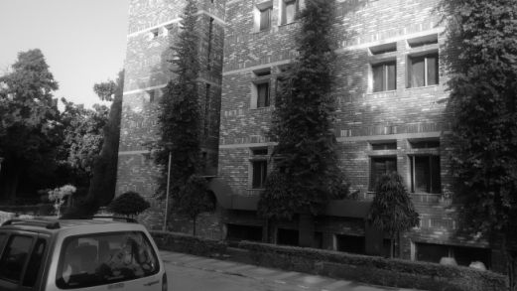
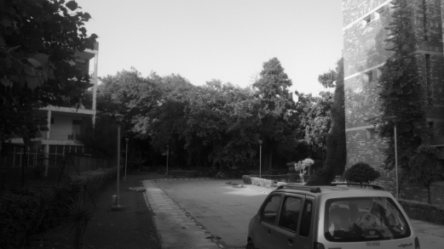

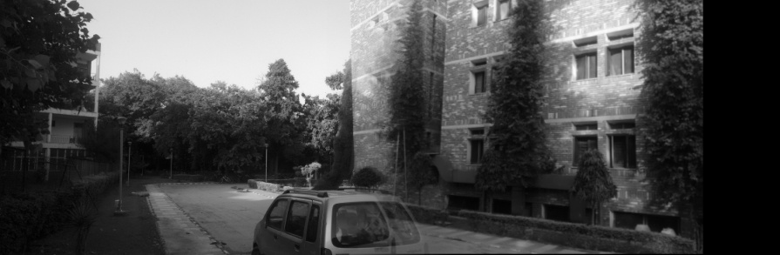
Example(1)
Translational Model

- Since it is a translational model, rotation effect can not be captured. As a result, two images of the pole can be seen in the blending part.

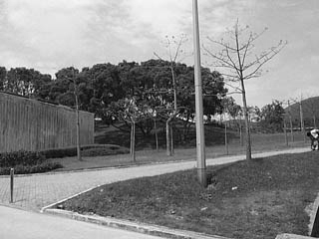
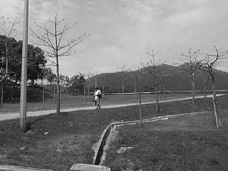

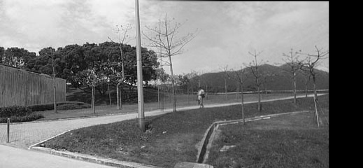
Example(2)
Translational Model

- There is almost no rotation between the two images and the translational model worked unexpectedly well in this mosaic.

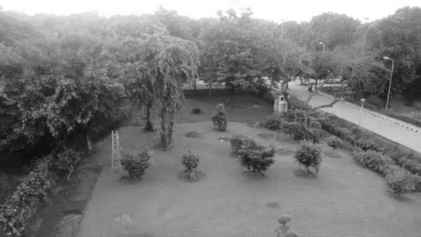
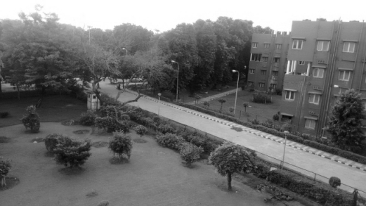

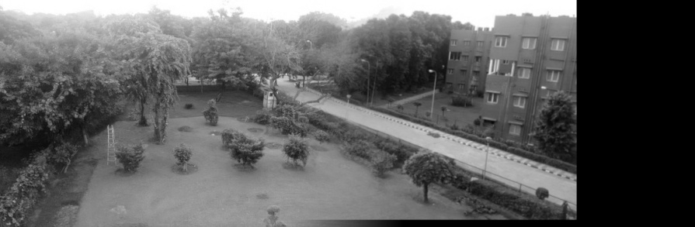
Example(3)
Translational Model

- Here also, there is rotation between the two images which is not captured in the translational model. As a result, two images of the cicled strrt light can be seen in the blending part.

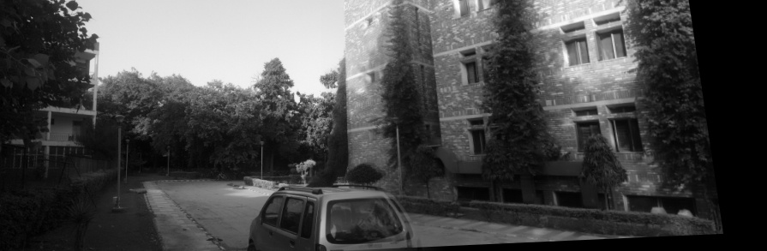
Example(1)
Affine Model

- As can be seen, second image is rotated so as to make the pole match. As a result, there is a single image of the pole and nice mosaic is generated by the model.

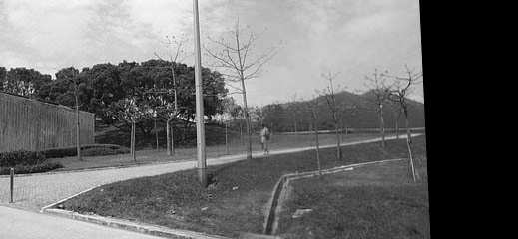

Example(2)
Affine Model

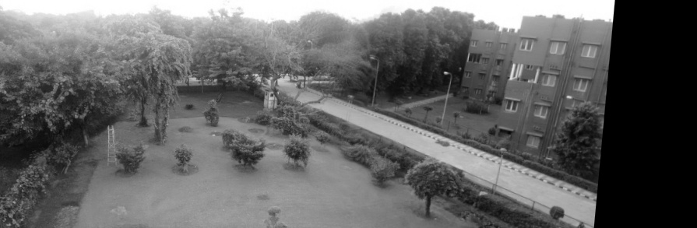
Example(3)
Affine Model

- Road is matched correctly. Single street light image. Second image is warped nicely which is giving the mosaic a single camera view.

Implementation

- A patch is selected in the mid-rightmost of the first image.
- This patch is then found at regular intervals in second image.
- Corresponding calculated affine transforms are applied on the second image and that particular transform is choosen for which the L2 norm of the error image between the original patch and the new loacted patch is minimized.
- In the resulting image, the non patch portion of the two images is copied as it is.
- For the patched portion, uniform blending is performed so as to minimize the sharp edge effect of combining images.

Observations

So, as can be seen, affine model outperforms translational model. Translational model will only perform good if there is no translation between the images

Video Stablization :
The idea as well as the stablization code is motivated from this blog(http://nghiaho.com/?p=2093). I basically smoothen the motion of a point over a span of several frames.

Implementation and Explanation:

- First a nice point is selected on the forst frame. A Nice point is a sharp corner which can be tracked nicely by our affine lucas kanade implementation.

- Then we track that point and saves its displacement(dx,dy,da) in the next frame of the video compared to the previous frame. The following graph shows dx, dy accross the frames.
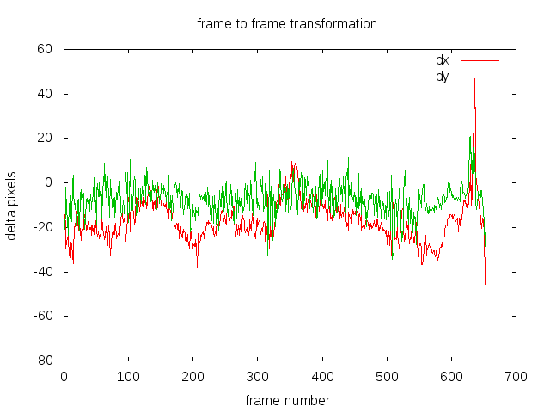

- Then we calculate the cumulative displacement i.e. the motion of the point accross the frames. The following graphs shows the motion of the point in x and y direction. This motion is then smoothed by averaging the motion over a span of few frames. The red ones shows the original motion and the green ones show the smoothed motion.
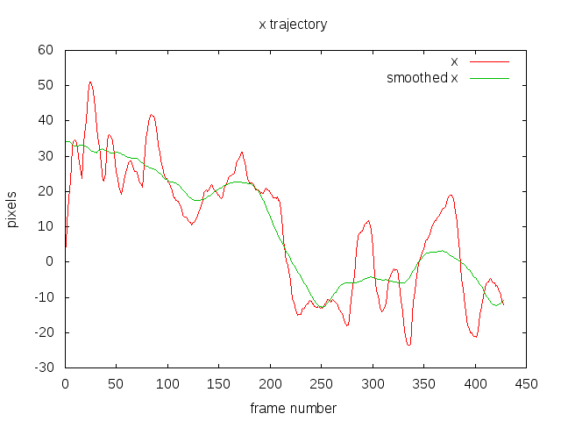
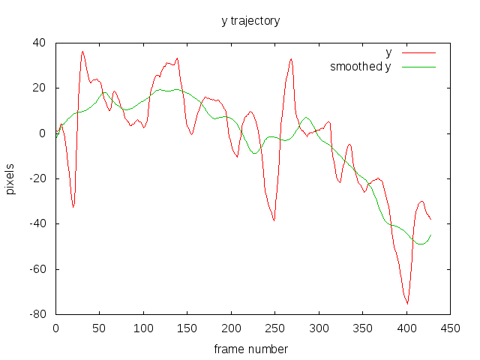
- This smoothed motion is the then projected back and the new displacement are calculated.
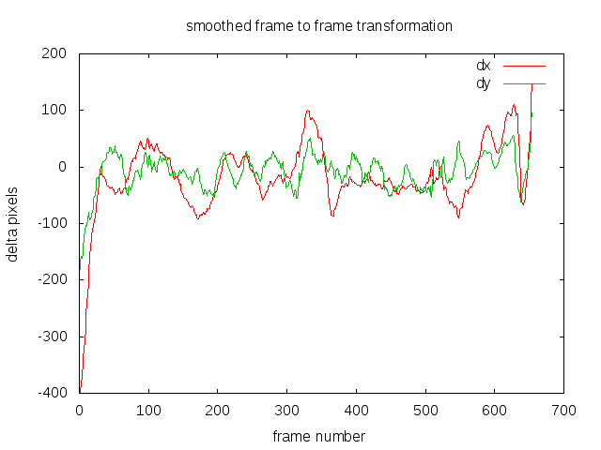

- According to these new (dx,dy,da), values, affine transformation is applied to frames of the video and video stablization is achieved.

--END OF DOCUMENT--

