# Q1 D-Separation

1. d-sep(B,D / A)

X1 = B

X3 = D

X2 = A

B A E H F D

* A is converging connection and it is in X2 ; therefore doesn’t block information
* E is diverging connection and it is not in X2 ; therefore doesn’t block information
* H is serial connection and it is not in X2 ; therefore doesn’t block information
* F is serial connection and it is not in X2 ; therefore doesn’t block information
* Therefore, for this given path, B and D are separated given A.

(According to blue path shown in figure)

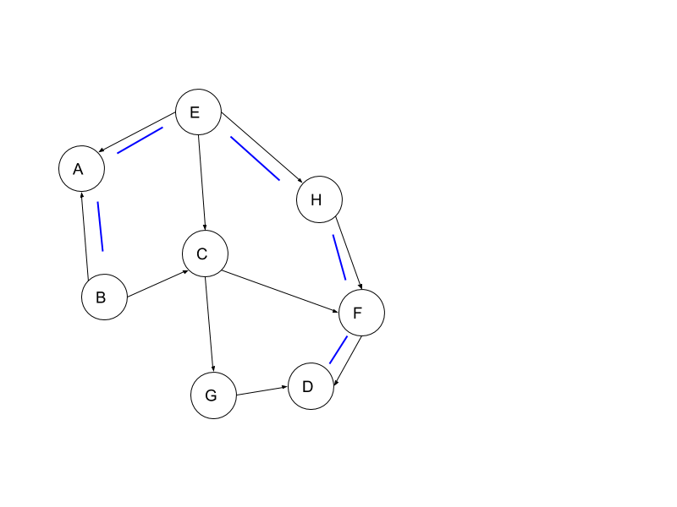

There are also other paths present which is also not blocking information.

B A E C F D

B A E C G D

B C G D

1. d-sep(A,D / {C,H})

X1 = A

X3 = D

X2 = {C,H}

A E H F D

* E is diverging connection and it is not in X2 ; therefore doesn’t block information
* H is serial connection and in X2 ; therefore does block information
* Therefore, A and D are separated by this path.

Consider this alternative path:

A E C F D

* E is diverging connection and it is not in X2 ; therefore doesn’t block information
* C is serial connection and in X2 ; therefore does block information
* Therefore, A and D are separated by this path.

Consider this alternative path:

A E C G D

* E is diverging connection and it is not in X2 ; therefore doesn’t block information
* C is serial connection and in X2 ; therefore does block information
* Therefore, A and D are separated by this path.

Consider the following alternative path:

A B C G D

A E C F D

In all above paths,

* C is serial connection and in X2 ; therefore does block information
* Therefore, A and D are separated by this path.

Therefore, A and D are d-separated given {C,H}.

1. d-sep(A,B / {F,E})

X1 = A

X3 = B

X2 = {F,E}

A E G F B

* E is serial connection and it is in X2 ; therefore does block information
* Therefore, A and B are d-separated given {F,E}.

Consider this path:

A E H F B

* E is converging connection and it is in X2 ; therefore doesn’t block information.
* H is diverging connection and not in X2 ; therefore doesn’t block information.
* F is serial connection and not in X2 ; therefore doesn’t block information.
* Therefore, A and B are not d-separated.

Therefore, we found this one path which proves A and B are not d-separated given {F,E}.

1. d-sep(C,D / {B})

X1 = C

X3 = D

X2 = {B}

C E G F D

* E is diverging connection and it is in X2 ; therefore doesn’t block information.
* G is serial connection and not in X2 ; therefore doesn’t block information.
* F is converging connection and not in X2 ; therefore does block information.
* Therefore, C and D are d-separated given {B}.

Consider this path:

C E H F D

* E is diverging connection and it is in X2 ; therefore doesn’t block information.
* H is serial connection and not in X2 ; therefore doesn’t block information.
* F is converging connection and not in X2 ; therefore does block information.
* Therefore, C and D are d-separated given {B}.

Conclusion: C and D are d-separated given {B}.

# Q5 SVM Theory

Weight Vector

Given Datapoints:

|  |  |  |
| --- | --- | --- |
| X1 | X2 | Y (Class Label) |
| 1 | 4 | 1 |
| 3 | 2 | 1 |
| 5 | 4 | 2 |
| 5 | 6 | 2 |

( I )

Class 1

Positive Hyperplane : WX1 + W0 = 1

Class 2

Positive Hyperplane : WX1 + W0 = -1

Support vector points will be (3,2), (5,4) and (5,6)

Let’s say Weight vector w = [a b]

For datapoint (3,2) Class 1,

+ W0 = 1 -> 3a + 2b + W0 = 1 ……….. (i)

+ W0 = - 1 -> 5a + 4b + W0 = -1 ……….. (ii)

+ W0 = - 1 -> 5a + 6b + W0 = -1 ……….. (iii)

(iii) - (ii)

2b = 0 …….. (iv)

(ii) - (i)

2a + 2b = -2

a = -1 ……….. (v)

substituting values of (iv) and (v) into (i)

-3 + 0 + W0 = 1

W0 = 4

Therefore, weighted vector, W = [-1 0]

Bias W0 = 4

( II ) Support Vectors and Decision Boundary

Decision Boundary : WX1 + W0 = 0

+ W0 = 0

-X1 + W0 = 0

X1  = W0

X1 = 4

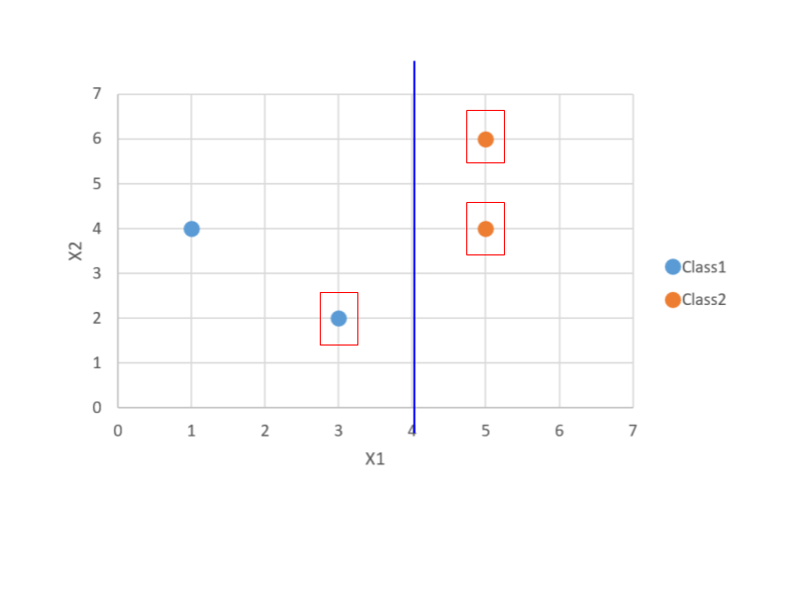

1. KTT