I don't know why, but I notice that the page is slower than usual, I have these observations:

Administration view

**PROBLEMS WITH DISPLAYED DATA**

-I update the balance or move something in the balance modification but it is not reflected in the administration panel.

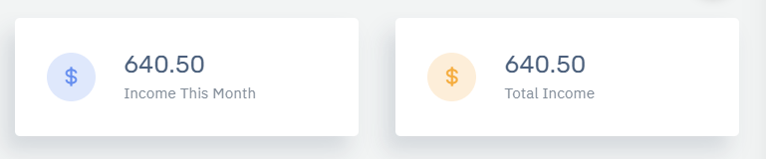

**INCORRECT BALANCE ENTRY REQUEST WHEN I WANT TO UPDATE A USER'S ACCOUNT**

-Please check when you make any update of data to a user asks you to enter the balance and if not you can not modify.

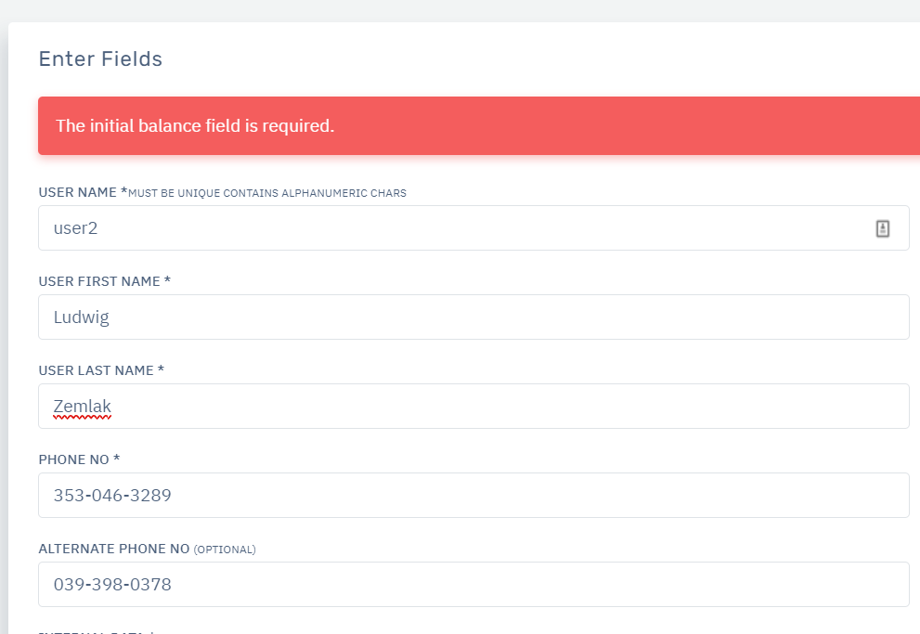

**DIFFERENTIATION IN DELIVERY LIST AND RELOADS**

-Please mark the ones that are already done in red and the ones that are pending in red to be able to notice them.

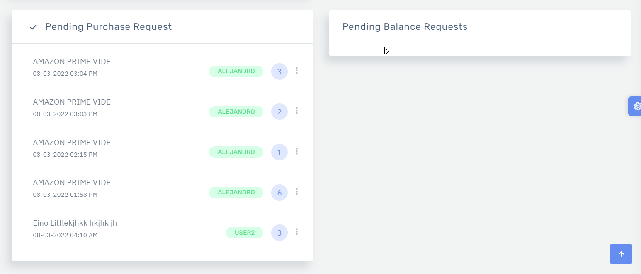

**LIMITED CHART HEIGHT**

Here the bars exceed the limit and you cannot see the other statistics.

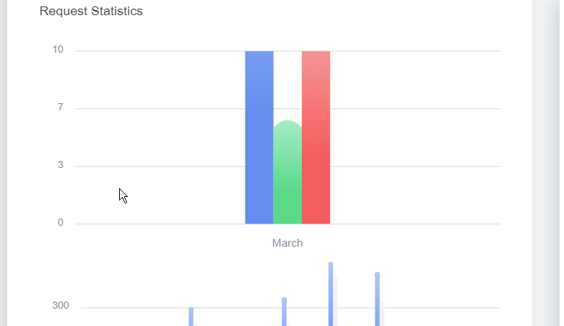

**SEE LIST OF ALL ACCOUNTS:**

Please request to have a table in which you can see all the accounts delivered, otherwise the user accounts received, this list should look something like this:

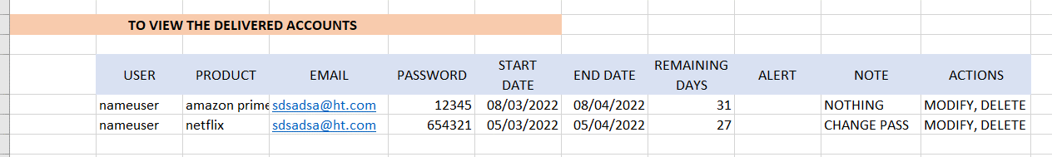

As administrator I can modify the accounts and see

to whom the accounts were delivered and see how many days the account has left, to see how many days left is calculated the current day minus the final day of the account, the user will only need to be able to see the accounts received.

**TAKE EARNINGS INTO ACCOUNT**

Please as I said before it is important to have the field to add the cost of the account (this can only be seen by the administrators) so we can calculate the sales value - cost of the account and get a list of how much has been earned.

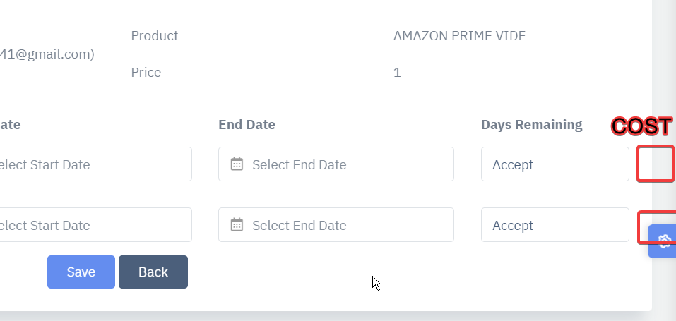

**from the user's point of view:**

**MORE ATTRACTIVE VIEW FOR THE USER**

PLEASE COULD THE USER VIEW BE LIKE THIS TO MAKE THE CUSTOMER VIEW MORE ATTRACTIVE

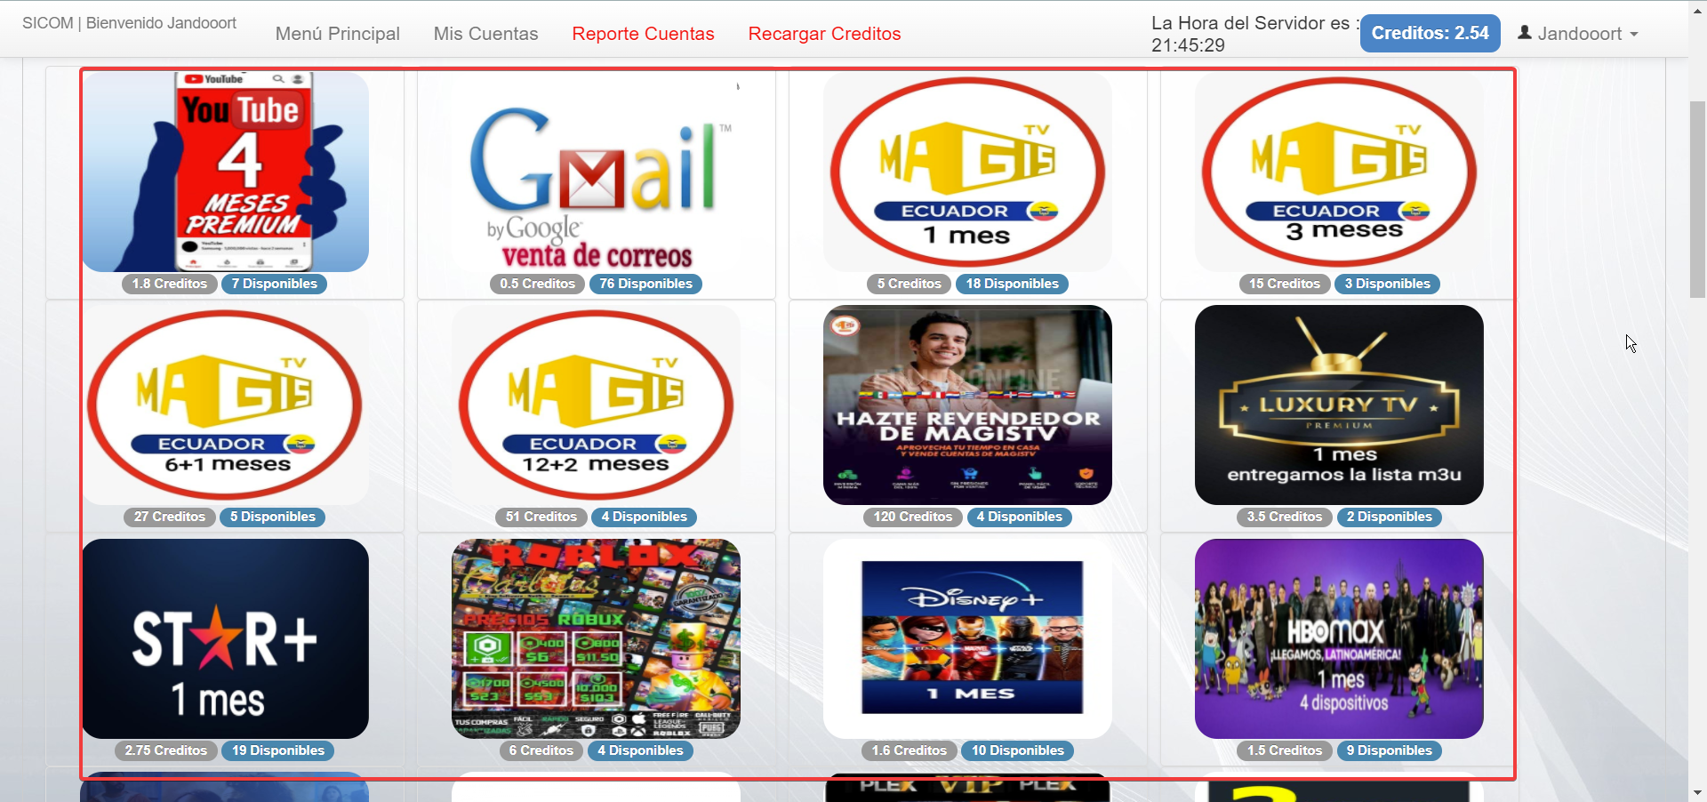

AND WHEN THE CUSTOMER CLICKS ON THE PRODUCT BOX IT OPENS A MODAL WHERE THE NAME OF THE PRODUCT, THE DESCRIPTION, THE IMAGE AND HE CAN SELECT THE QUANTITY HE WANTS.

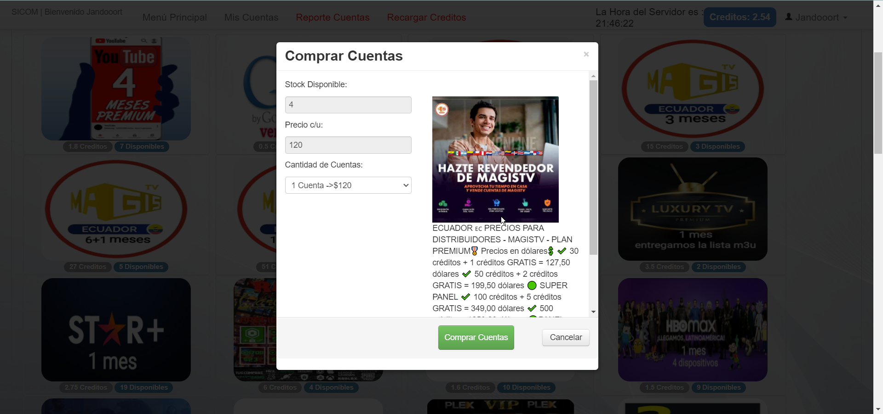

**FOR THE USER IT IS NOT NECESSARY THE STATISTICS OF THE WEB, IT IS BETTER TO MAKE EMPHASIS IN THE BALANCE THAT HAS AVAILABLE**

