AGRITECH

Problem :- As per the new laws by Indian Government, farmers are free to sell their agricultural products outside the APMC’s. With this freedom there are also several allegations on these laws that the private traders will start exploiting the farmers by underpaying them for their crops.

Solution

To overcome this, we introduce the concept of e-selling of the food crops by providing the farmers and the traders a platform to sell and purchase the products by abiding through the government laws and policies.

So we have built a web – application that allows both the traders and the farmers to post about their needs or their commodities that they want to sell in an open digital market.

Let’s talk about the functioning of the digital market and how we stand on those requirements.

* The digital market works as a medium for both the sellers and the traders to communicate.
* It provides them with the contacts of all those which they looking forward to.

Same is the functioning of our project. Let’s see

1. Every individual who is new to our interface, first have to register on that through a form that looks like

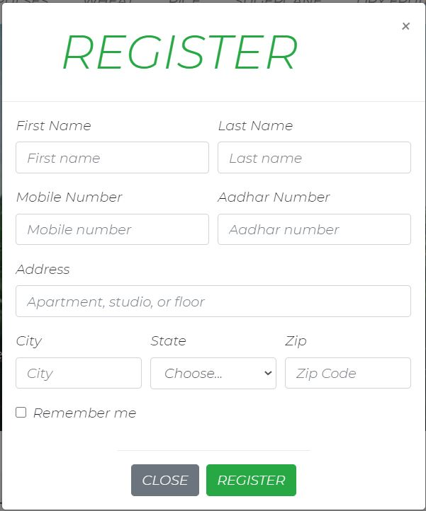

1. Now, the one is directed to the login page

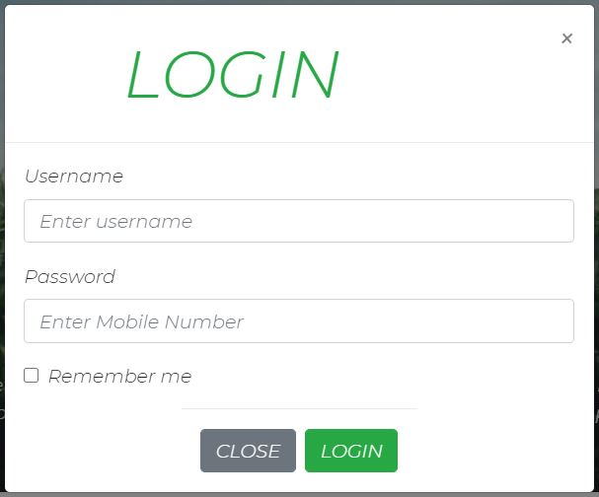

1. Now comes the main page of our project

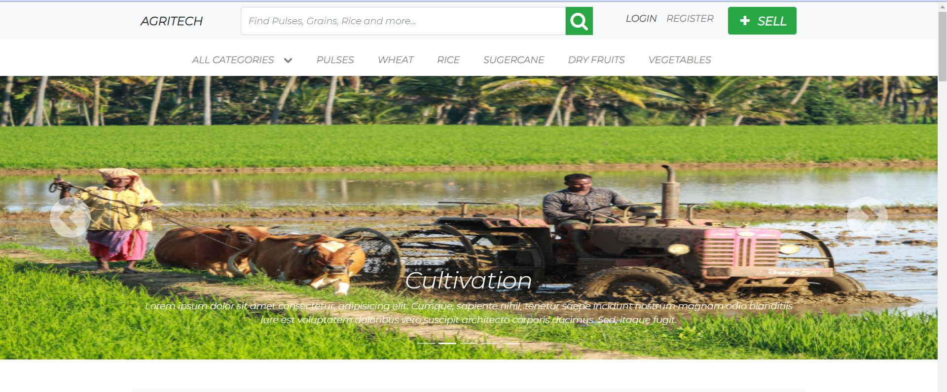

Anyone can search for any commodity that he want to buy from the search option or select from the navbar provided below.

1. He may also scroll down to see the current commodities that are mostly sold in recent time.

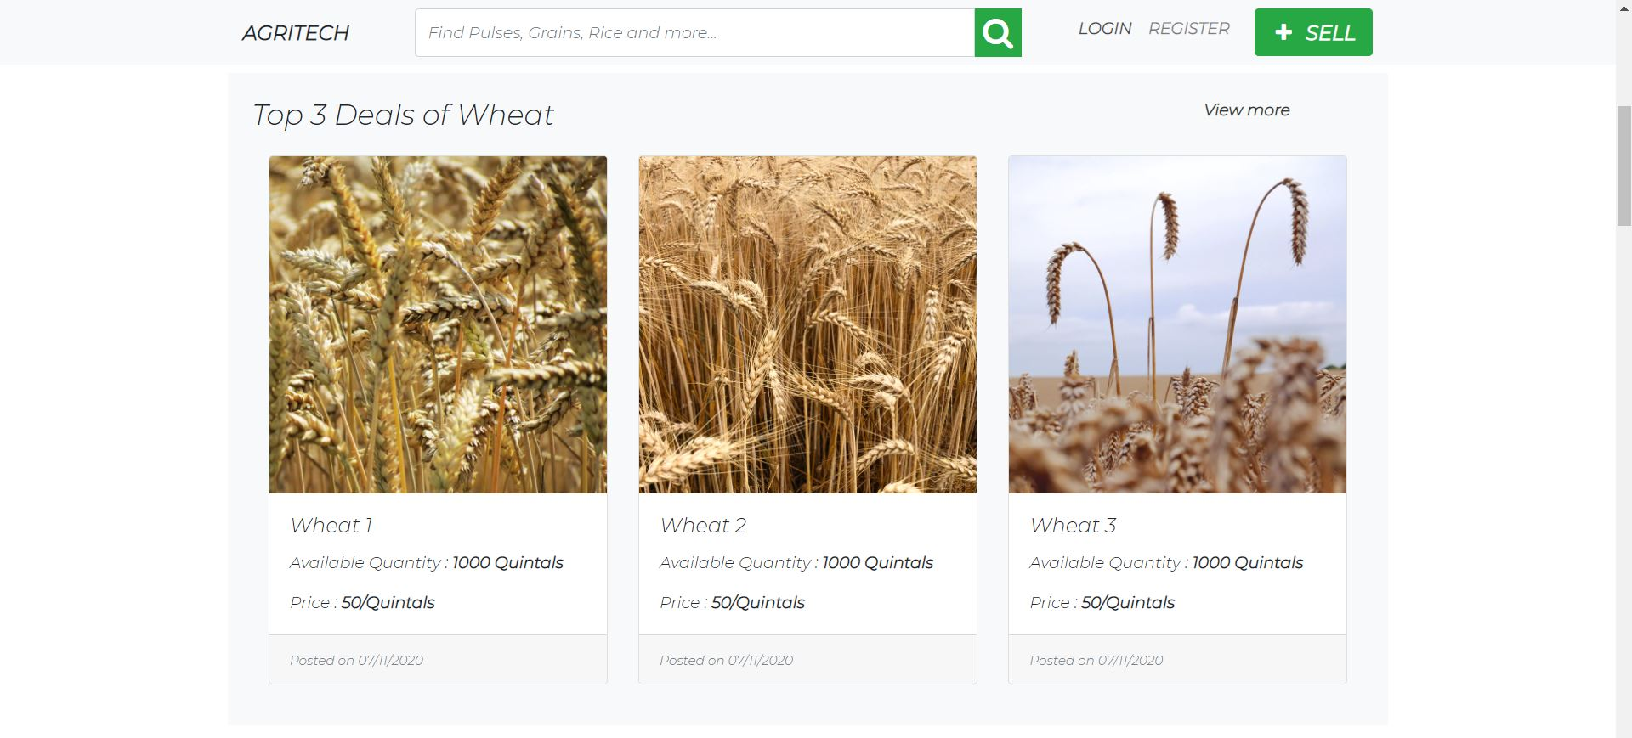

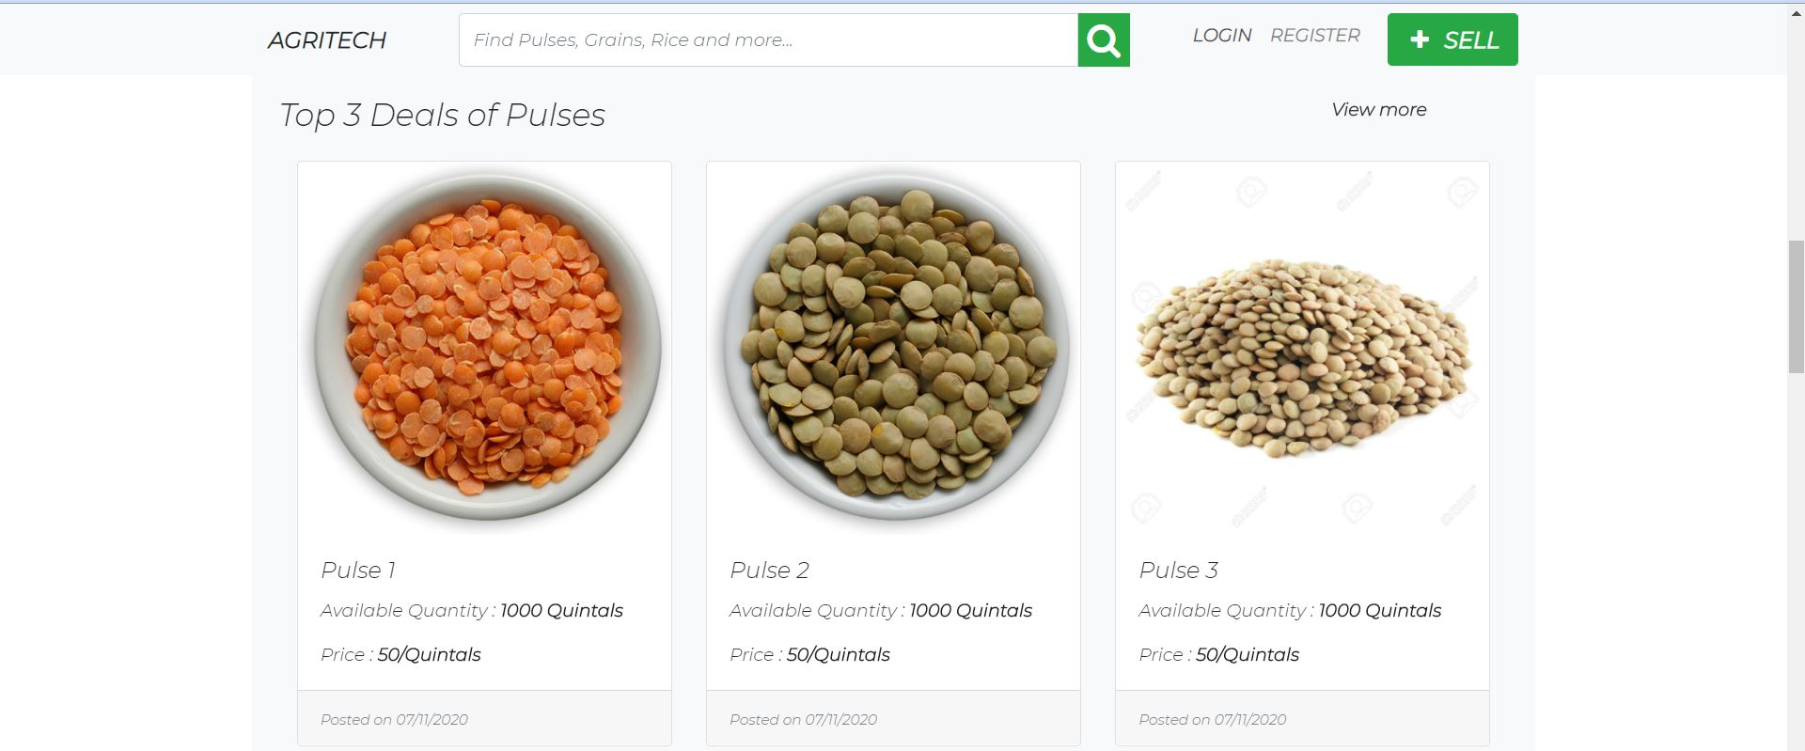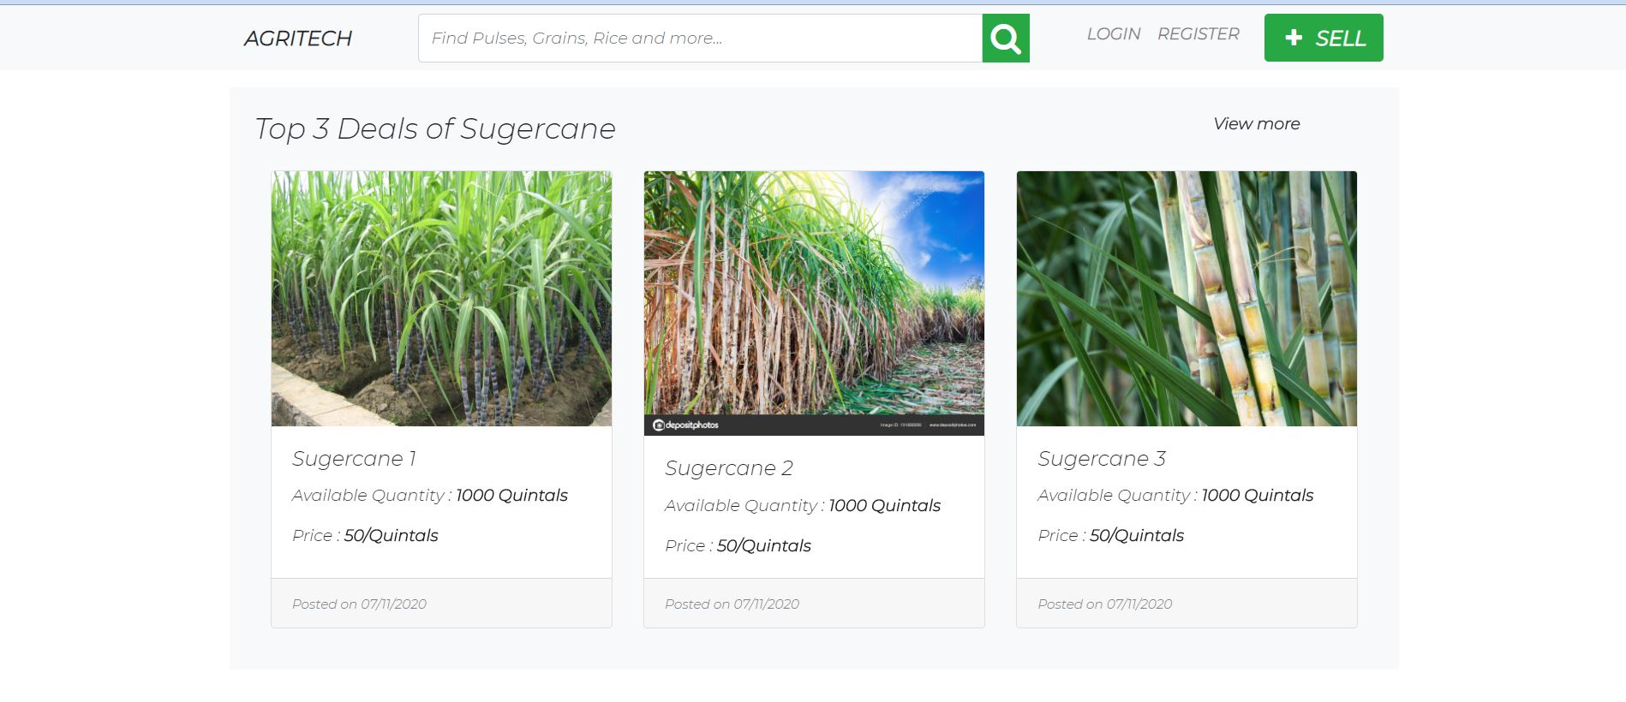

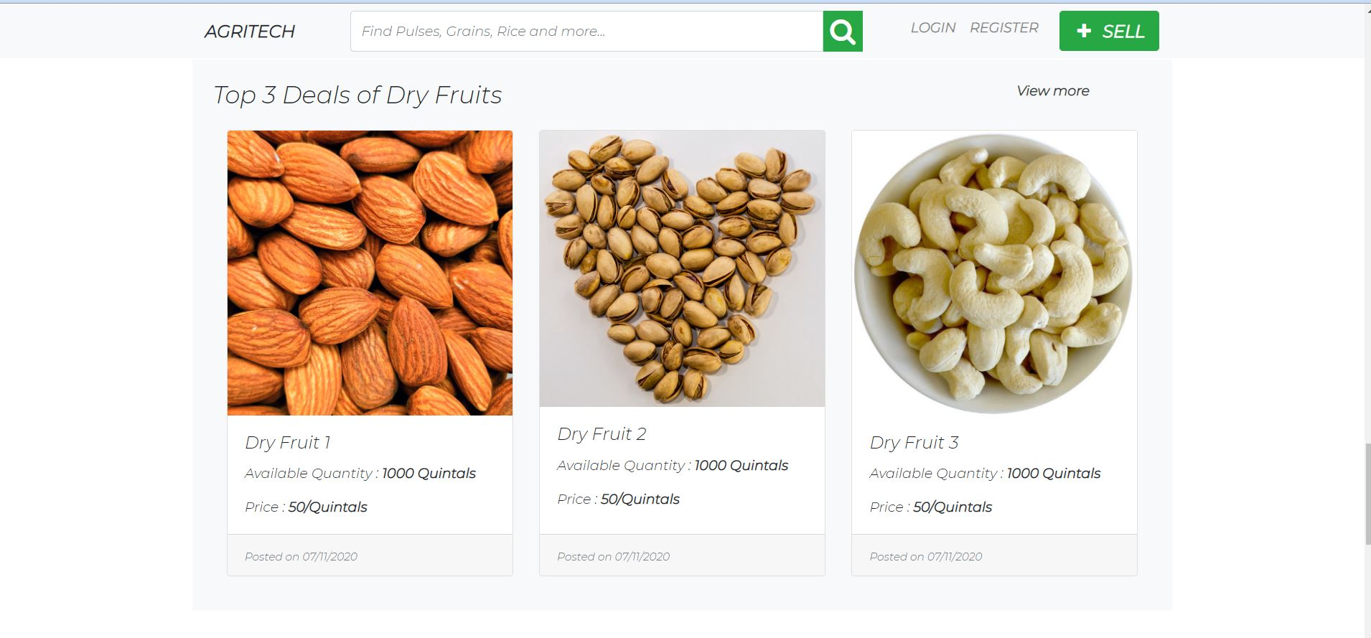

1. Now for those who want to sell their products, they should click upon the SELL(green) button at the top right corner and that will direct them to a page that looks like

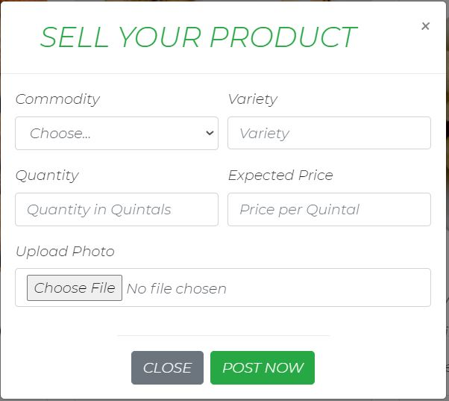

Anyone can post the commodity that they want to sell through our portal.

Future Scope:

1. We will provide the users with inbuilt payment gateway to ease their transaction.
2. We will further mandate our users to follow the government laws , so that everyone will get at least MSP(Minimum Support Price).