Sandbox Innovation Plan Template

Joint Solution/ Design Basics
Please fill out all entries marked with [*]
Design Win/Joint Solution Title * | Intelligent Document Workflow Automation Knowledge Retrieval Platform
APN Partner Name * | DocuFlow Systems
APN Partner Contact Name * | TODO
APN Partner Contact Title * | TODO
APN Partner Contact Email Address * | TODO
AWS (Partner Development Manager) PDM * | TODO
AWS Solutions Architect (SA) * | TODO

Joint Solution/ Design Win Details
Please fill out all entries marked with [*]
If this is features update of existing joint-solution, please input following:
Feature(s) Description *
Target Customer Profile *
Target Customer Pain Points *
Prospect Customer Opportunity
Plan Date of Marketplace Publish or Update
If this is a new joint-solution, please input solution information as following:
Design Win/Joint Solution Description * | Executive Summary  This proposal delivers an event-driven document workflow automation and knowledge retrieval platform deployed in the Singapore AWS Region. The platform ingests high document volumes, applies OCR and NLP enrichment, persists searchable metadata, and exposes secure APIs for integration with enterprise applications. By combining serverless processing, scalable storage, and managed search, organizations can reduce manual handling, improve turnaround time, and access institutional knowledge faster. The design is modular and reusable across legal, consulting, and operations teams, enabling phased enterprise-wide rollout.
Key Features List and Description * | • Event-driven ingestion and processing pipeline for unstructured enterprise documents  • OCR extraction with Amazon Textract for structured field capture at scale  • NLP enrichment using Amazon Comprehend for entity extraction and classification  • Serverless orchestration with AWS Lambda for elastic workflow execution  • API-based integration layer using Amazon API Gateway for internal systems  • Metadata indexing in Amazon DynamoDB for low-latency lookups  • Full-text search and relevance retrieval powered by Amazon OpenSearch Service  • Centralized observability with Amazon CloudWatch dashboards and alarms
Solution Type (Infra, Horizontal, or Vertical) * | Horizontal - Enterprise Productivity Knowledge Automation Platform
Target Customer Profile * | Enterprises, legal firms, consulting organizations, and operations teams
Target Customer Pain Points * | Organizations struggle with fragmented document workflows, manual processing, and difficulty retrieving relevant information from large volumes of unstructured data, leading to inefficiencies, delays, and knowledge silos.
Prospect Customer Opportunity
Plan Date of Marketplace Publish
Business justification and funding details
Business Justification (Why should AWS fund this?) * | This initiative creates a repeatable and scalable automation blueprint for document-heavy organizations that need faster processing and trusted knowledge retrieval. AWS funding accelerates delivery of a production-grade reference implementation with measurable operational gains, reduced manual effort, and improved knowledge accessibility across teams. The resulting platform strengthens partner co-sell readiness and supports expansion into additional enterprise workflows.
Requested Funding from AWS (USD) * | USD 85,000
APN Partner co-fund Investment (USD) * | USD 55,000
Total Cost of Work (USD) *  = AWS Funding + APN Partner Investment | USD 140,000
Simple Monthly Calculator Link / Excel Calculator (during solution development period) | https://calculator.aws/#/estimate?id=c7d4a7f484d63653d37d2723fea50b92f60e6b55
Expected Start Date (MM/DD/YYYY) * | 2027-03-01
Expected End Date (MM/DD/YYYY) * | 2027-08-31
Expected Production Date (MM/DD/YYYY) * | 2027-10-01
Public reference if project successful? * | No
Case study potential if project successful? * | Yes
Additional information to be considered | N/A

Design Win/ Joint Solution Development Plan
Please fill out all entries marked with [*]
Activity (bulleted list) | Man days | Delivery date
Discovery  Requirements alignment, document flow mapping, target architecture definition, and security baseline planning. | 12 | 2027-03-31
Foundation  Landing zone setup, core data/storage services provisioning, and baseline API and observability enablement. | 14 | 2027-04-30
Core Build  Implement OCR/NLP workflow pipelines, metadata index, search integration, and enterprise API integration patterns. | 24 | 2027-07-15
Delivery  System validation, performance tuning, operational handover, and release readiness for production rollout. | 10 | 2027-08-31

Solution Architecture / Architectural Diagram
Please attach the architecture diagram, and describe the deployment architecture on AWS, so that we can know how you want to deploy and why you need to utilize these resources.

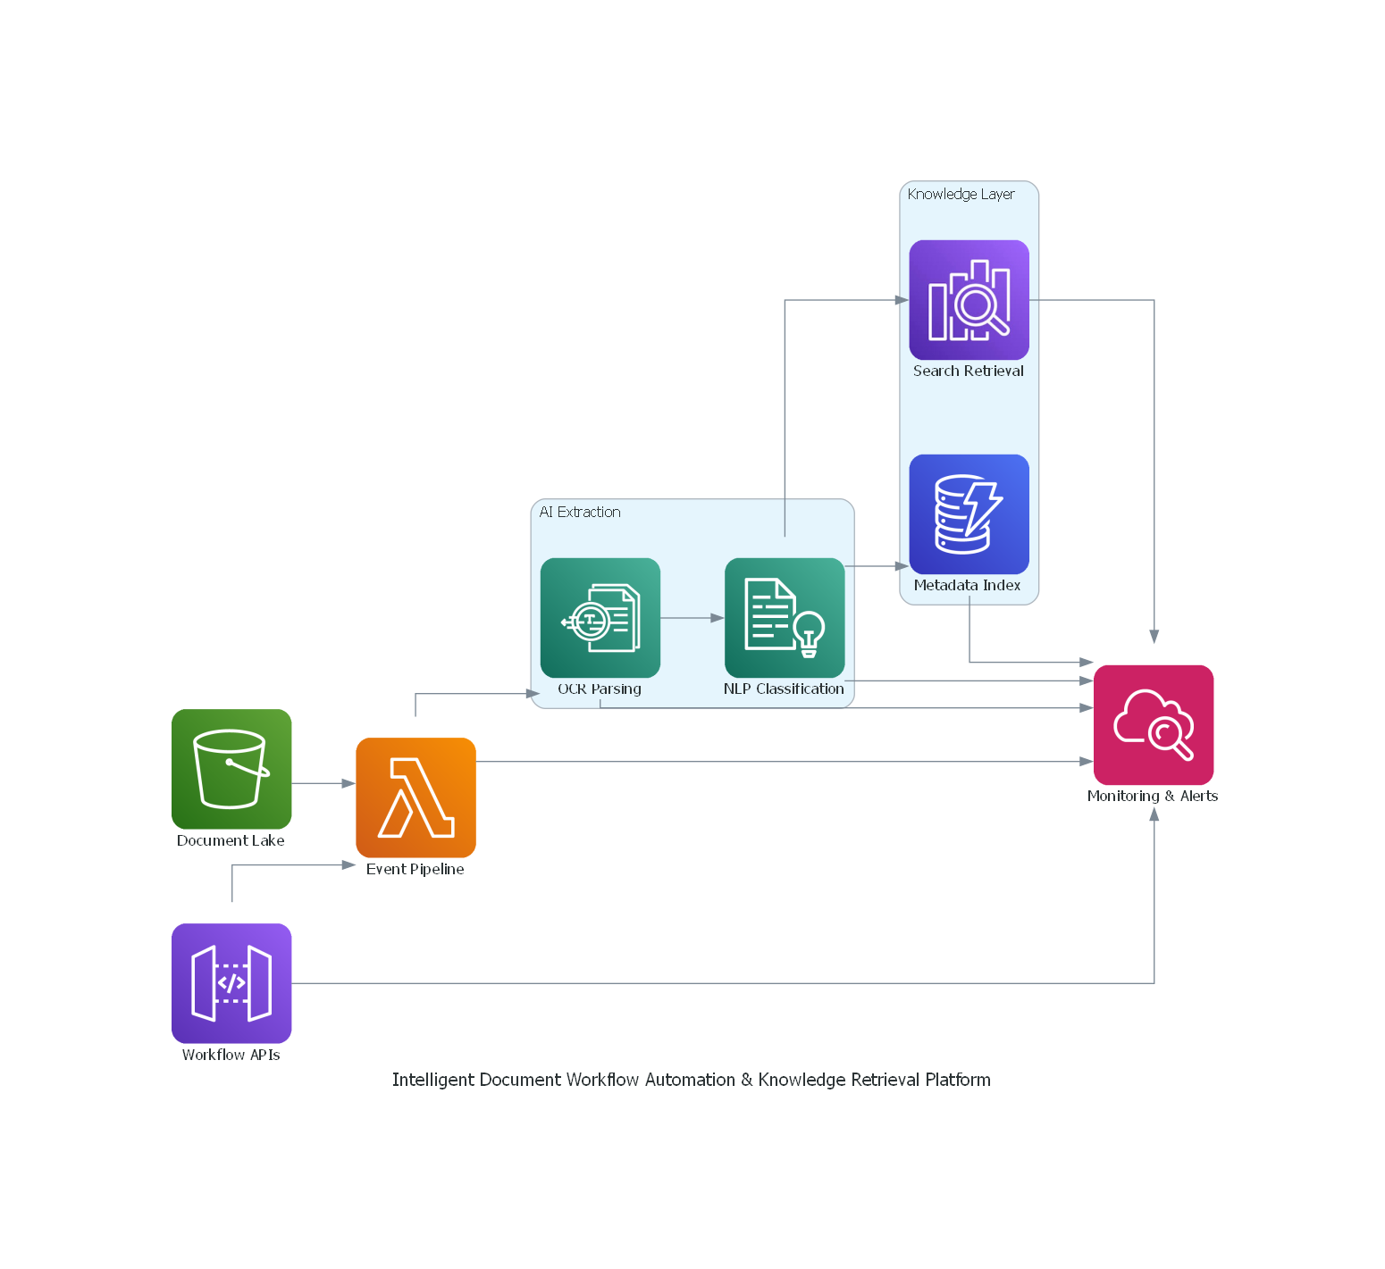
Architecture Overview
Enterprise sources upload documents to Amazon S3. Upload events invoke AWS Lambda workflows that orchestrate OCR via Amazon Textract and NLP enrichment via Amazon Comprehend. Extracted metadata is stored in Amazon DynamoDB, while indexed searchable content is written to Amazon OpenSearch Service. Amazon API Gateway exposes secure integration endpoints for enterprise applications, and Amazon CloudWatch provides centralized logs, metrics, dashboards, and alarms for operations.

