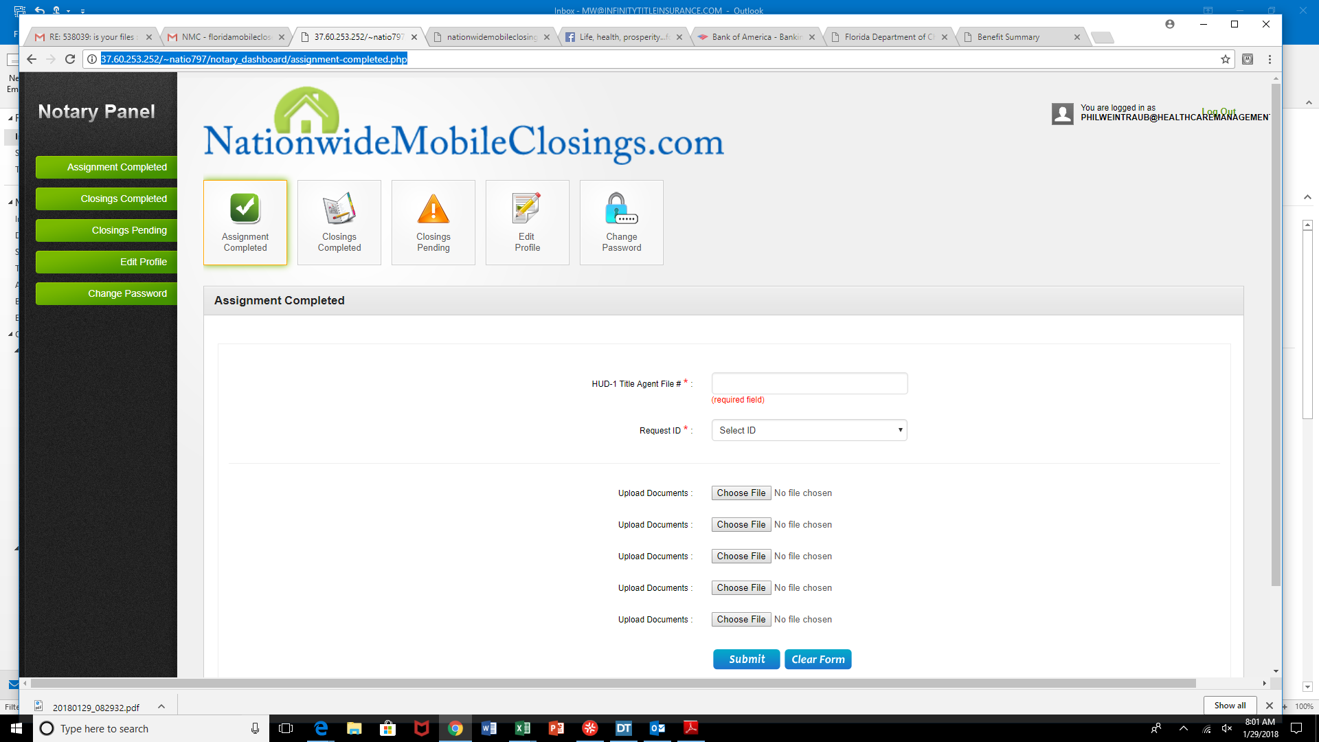

<http://37.60.253.252/~natio797/notary_dashboard/assignment-completed.php>

NEED REQUEST ID NUMBERS TO BE IN ORDER

CURRENTLY THEY ARE NOT

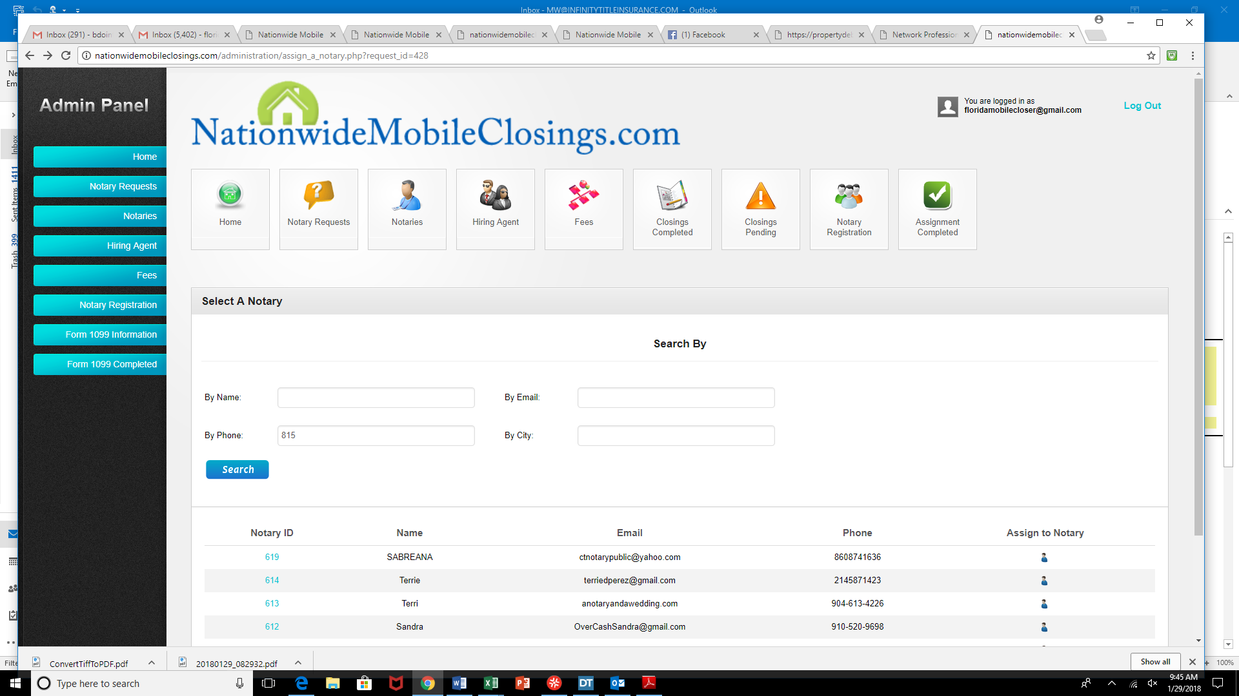

I AM UABLE TO SEARCH VIA SHORT VERSION OF A TELEPHONE NUMBER WHEN LOOKING TOASSIGN MY NOTARY SO I HAVE TO THEN GO BACK TO NAME---SEARCH SHOULD BE ABLE TO GO WITH TELEPHONE

NUMBER ALWAYS

<http://nationwidemobileclosings.com/administration/assign_a_notary.php?request_id=428>

<http://37.60.253.252/~natio797/notary_dashboard/assignment-completed.php>

Notary hits COMPLETE AND GETS A BLANK SCREEN?

<http://37.60.253.252/~natio797/request_a_notary.html>

SHLD NOT REQUIRE FOR LENDER INSTRUCTIONS WHEN THE HIRING AGENT 1ST SIGNS UP WITH UP OR THEIR CELL PHONE

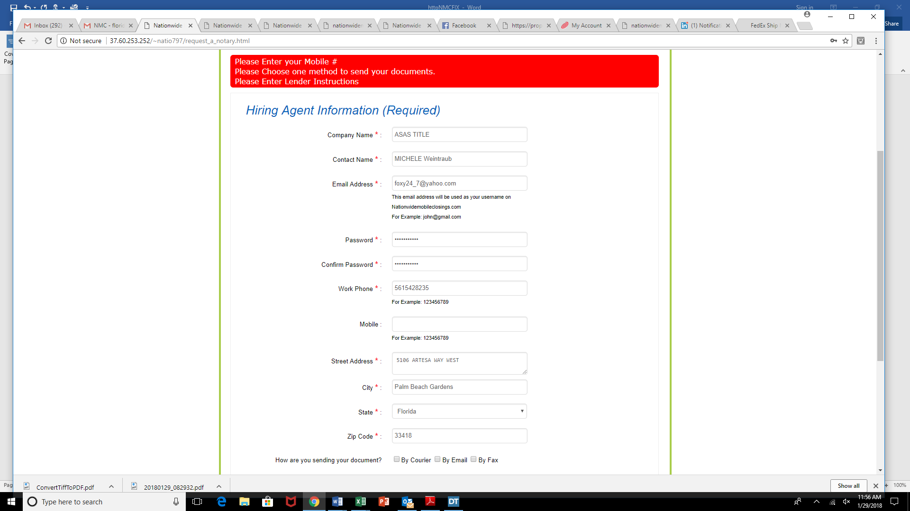

<http://37.60.253.252/~natio797/client_dashboard/thank_new_notary_request.php>

**Thank you for choosing NWMC for your notary services**

[Incorrect name-should be- **Thank you for choosing NMC for your notary services**.]

ALSO ADD HERE:

**PLEASE DO NOT REPLLY TO THIS EMAIL: THIS EMAIL DOES NOT RECEIVE REPLIES.**

**PLEASE EMAIL** [**NATIONWIDEMOBILECLOSINGS@GMAIL.COM**](mailto:NATIONWIDEMOBILECLOSINGS@GMAIL.COM)

