platform for agents

some details but u canot directly reach a buyer or seller

buyer - 1 ag

sellet - 1ag

3-5% commission for ag

100000K - 3% = 3000$/ag

post in mls (site) - realtracs.com

37027 or 37221

loan default - foreclosure ~3-5mths

you looose all equity - 10yrs ~paid off 20%

loan balance is 80000$

current property value ~150000

you loose ~70000

selleing takes about ~3mths

lucky = real good agent

unlucky = bad agent

agent = sales people

goal for the site = compare agents

buyer > agent, seller > agent

buyer , seller , agent >> meet in site.

with comparision 1 agent comes out as a leader

thsi takes place offline like real face to face contact

articles

blogs

forums

qa

realtime chat

appointemtns

reminder

notes taking

etc etc

cms like wp/joomla

no mls

no lisitng

as a buyer i am looking for a agent

buyer posts online

about his need

online shopping for agents

az= agent

bz = buyer

sz = seller

short form

search page will be very extensive

actions = support tools for az/bz/sz

like saving notes about an agents comments , reusing that in the compare

like rating any comment from az as 1-5 stars

just compare only stars or compare the stems

the compare selection will be very extensive as well. imagine selling a 400000$ home ~24000 in commission

we need a skinned down version. nothing happens other than info excange, some actions like saving info, book marking etc and using that infor for comparing az's

in ph2 we will add blogs, articles, forums

with the same idea for comparing the az's

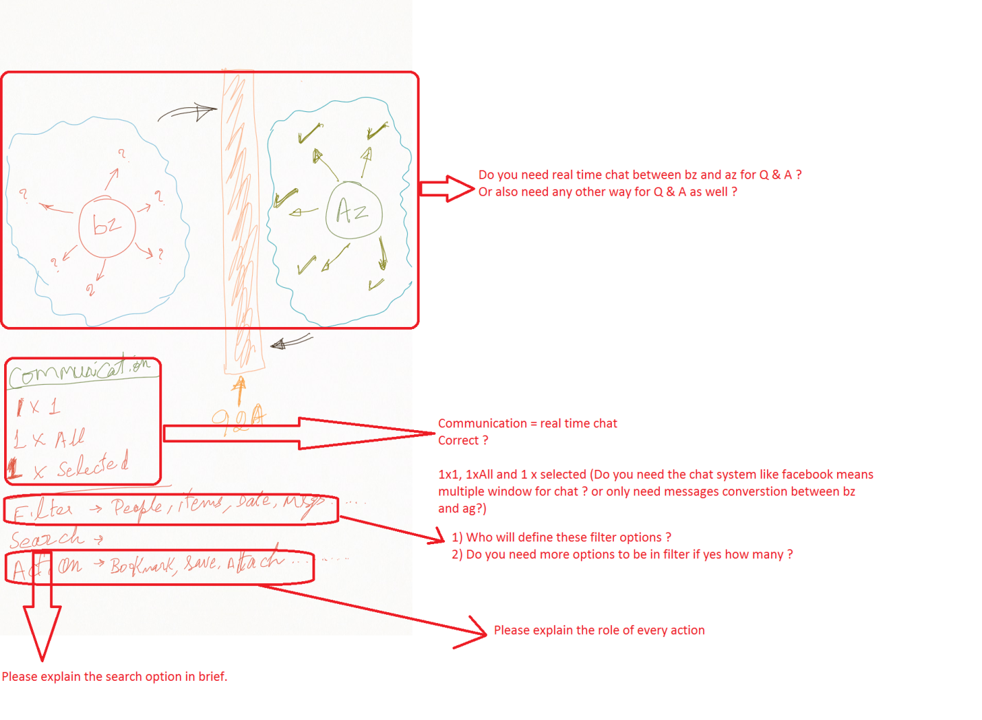

1x1 , 1xall 1xselected = bz to az(s) or az to bz(s) all info sharing like answering a question or sending a ebook or a report etc

chat = real time just 1x1 sz x az or bz x az

may be like fiverr site doesn't have to be realtime

filter = what a bz/sz/az what's to see same as a search

all msg from all az(s) on date = xyz

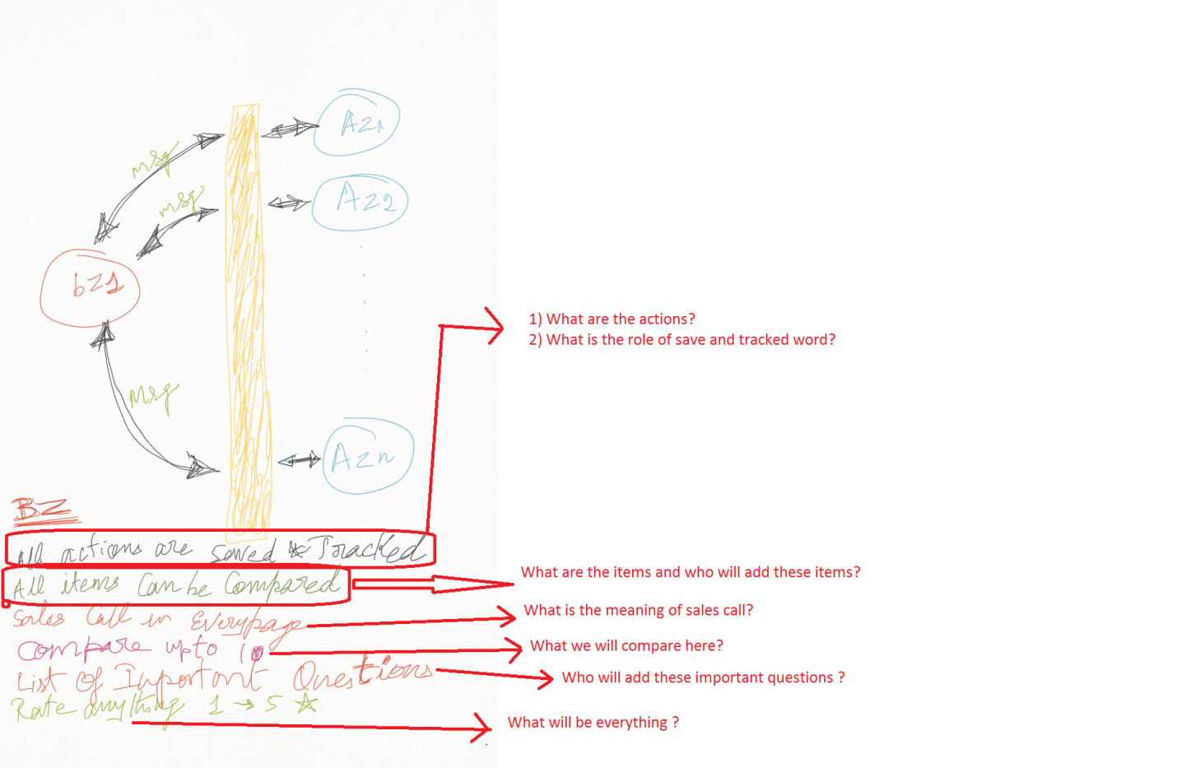

actions = helpers (anything that helps bz/sz to make a decision on a az) or anything helps az to communicate better with a sz/bz

action examples 1. az answers 10 questions, bz likes just 1. he book marks that question/answer. This book marking/flagging is an action. now az2 answers 12 questions bz like just 2 of them including the 1 above ( same quesion being answerd by 2 different agents). he book marks them now there are 3 book marks (saves) he can compare for the same question the answers from several different agents

side by side he only wants to compare the book marked ones.

so there are several different actions like this

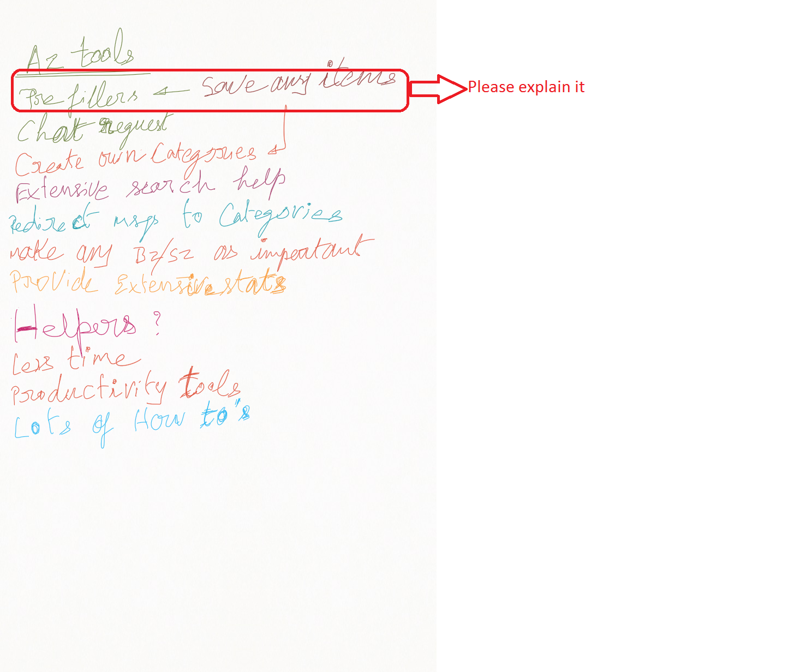

example in teh above az1 gives 1% cash back from his 3% commisision, az2 gives 1.5% cash back now if i compare these 2 side by side because these 2 are book marked by the bz what will you see it will be like questio | az1's answer | az2's answer

side by side

all items can be compared > for the start we will have several of them in a table. later when we add/mod/del these actions the site should reflect these

helpers are tools

for a ag tools are like pre-filled question answers

lets say if you are buyer shopping for a agent what would you ask. these are saved as series of qa's for the agent to use

he can save new ones , modify existing ones etc

it simplifies his life

sort of yes like FAQ’s. but when he sends to the buyer he needs to personalize them a bit

meaning editable

so each agent will have their own section of these tools

yes edit both the q & a

should be uploadable , addable

as a csv or some other means

upload the qa as a csv

categories are again helpers for the az/sz/bz like folders for differetn kinds of info

simplify the life of az. more simple for az = more az's will sign up

we will need a call to go over this.

drivers for the site

bz + az or sz + az

bz post > i need a home 2b 2bath , 150k, 37221

need to buy in 3 mths

az - bulb goes on

az < commission

bz = commssion

bz - sees 10 homes - chooses 1 - in 30days - 30+days to close (sign paper work , bank loan ect)

bz1 - fast paced buyer - he needs info now , he makes decision quick

extensive search = all sorts of things that they can search like dates , zipcodes, peope's names, contents etc etc

search page is by far the most complex i would think other than organizing info for side by side compare

