**Az_Bz_Sz_Admin_Testing**

Notes: if the issues reported for buyer check the agents and the seller as well. same thing if any issues reported for seller or agent checked the other two.

Issue 001:logged in as buyer. Where are the questions from the admin

Fixed and Tested Y/N :Please check comments

What was fixed ?:

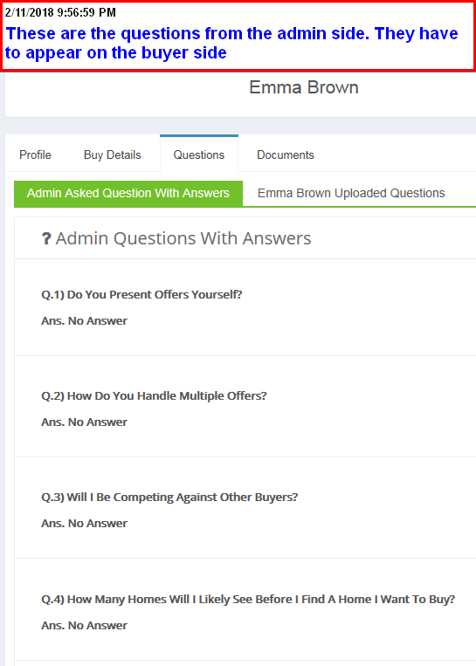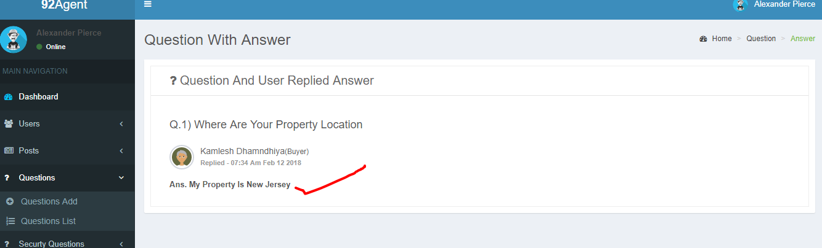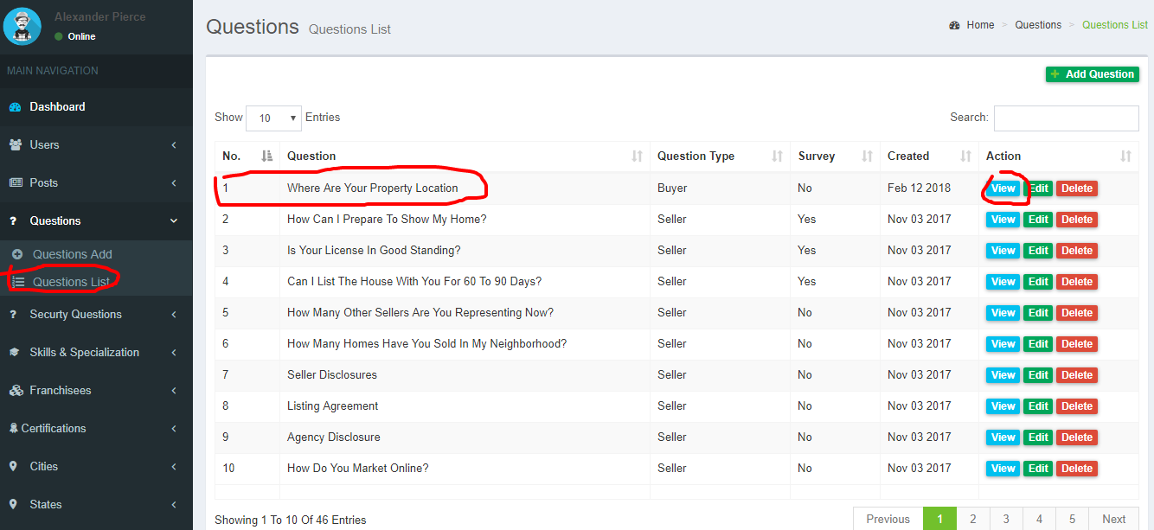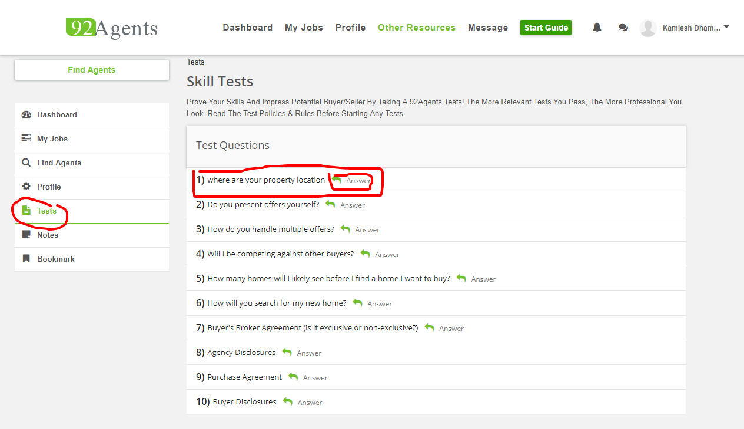

Issue 002:logged in as buyer. Side-by-side combat is missing the notes.

Fixed and Tested Y/N :Y

What was fixed ?:

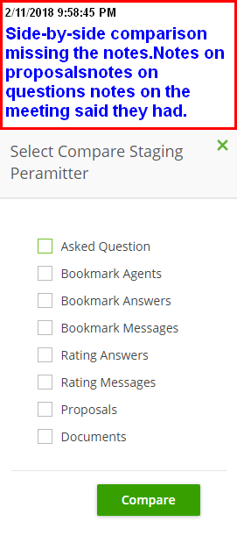

Issue 003:what question the buyer is asking?. A buyer sent a question, the notification was received by the agent but the agent don’t know what question was it

Fixed and Tested Y/N :Y

What was fixed ?:

Watch the video: “what question that a buyer is asking Video_2018-02-11_220401.wmv”

Issue 004: where is the notes for the agent/.

Fixed and Tested Y/N :Y

What was fixed ?:

Aas explained before the agents profile might say “I am a God fearing Christian ”. The buyer could be a Christian himself. The buyer will need to take notes about the agents profile or the proposal are some important things they talked about in the chat etc. these notes will later be compared in the side-by-side compare.

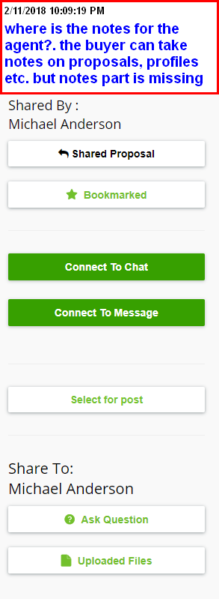

Issue 005:side-by-side compare questions are missing

Fixed and Tested Y/N : Please see vedio ((Issue 005 )Feb 12 2018 4_16 PM.webm)

What was fixed ?:

Watch the video: “Video_2side by side compare Questions missing 018-02-11_221950.wmv”

Issue 006:side-by-side compareis missing agency professional bio

Fixed and Tested Y/N :Y

What was fixed ?:

Watch the video: “Side by side compare is missing agents prof bio Video_2018-02-11_223013.wmv”

Issue 007:agent is off-line but it is showing as online

Fixed and Tested Y/N :Y

What was fixed ?:

Watch the video: “Agent online or offline Video_2018-02-11_224146.wmv”

Issue 008:logged in as the agent. I see a question in my notification

Fixed and Tested Y/N :Y

What was fixed ?:

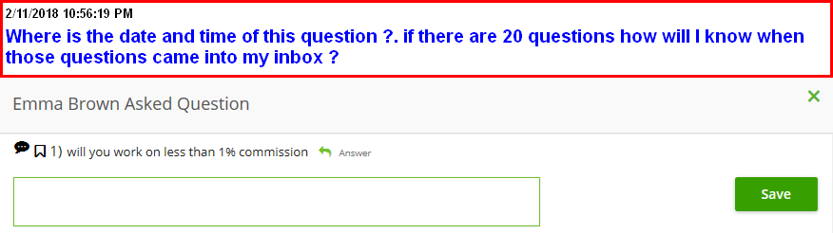

Issue 009: logged in as buyer.Side-by-side compare on questions.

Fixed and Tested Y/N :Y

What was fixed ?:

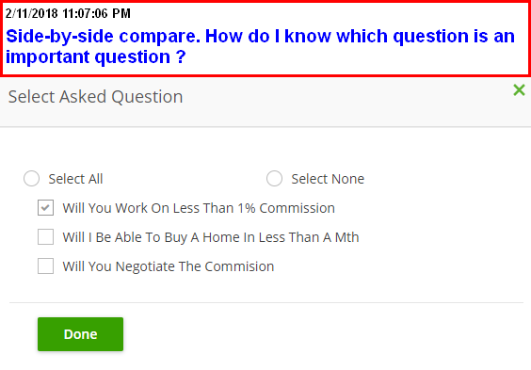

Issue 0010:sign up as a seller. The same issue exists with the buyer and agent as well.

Fixed and Tested Y/N :Y

What was fixed ?:

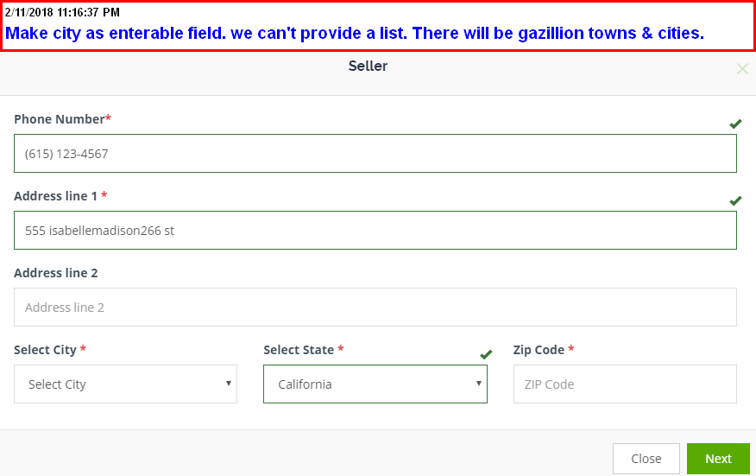

Issue 0011: sign up as a seller

Fixed and Tested Y/N :Y

What was fixed ?:

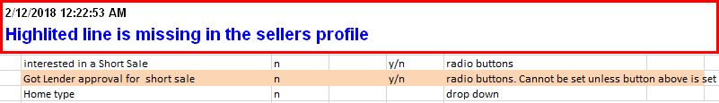

Issue 0012: from the agent side. Find jobs.

Fixed and Tested Y/N :Y

What was fixed ?:

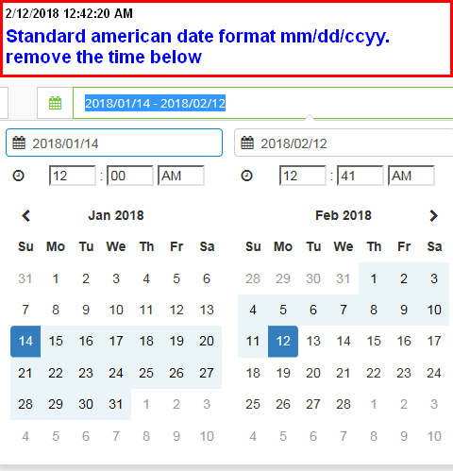

Issue 0013:Agent finding new posts

Fixed and Tested Y/N :Y

What was fixed ?:

Watch the video: “agent finding new posts Video_2018-02-12_005845.wmv”

Issue 0014:logged in as agent. Connected job shows empty

Fixed and Tested Y/N :Y

What was fixed ?:

Watch the video: “Agents Connected Jobs Empty Video_2018-02-12_224512.wmv”

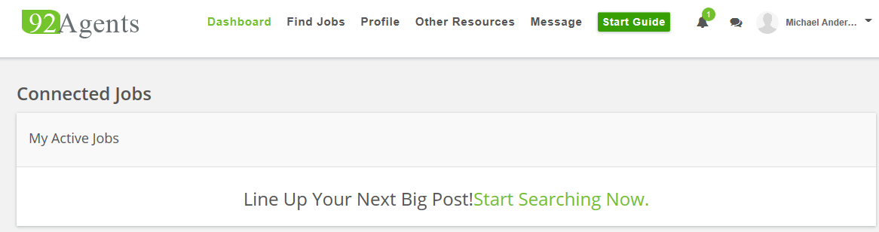

Issue 0015:logged in as agent. Agent’s personal bio

Fixed and Tested Y/N : Y

What was fixed ?:

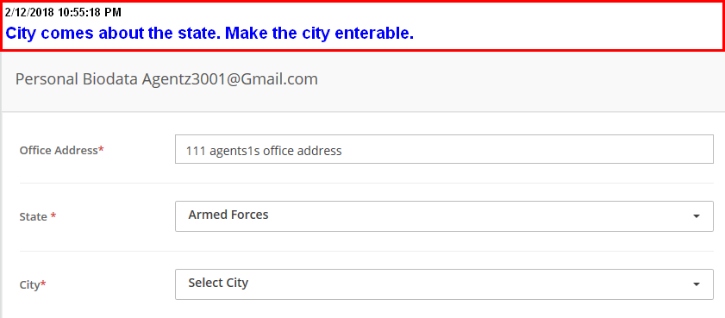

Issue 0016:logged in as an agent. Searching for a post. Found a new post can’t tell whether the seller is online or not

Fixed and Tested Y/N :Y

What was fixed ?:

What’s the video: “seller online or offline Video_2018-02-12_231838.wmv”

Issue 0017:minor annoyance on the pop-ups. Can we see the answerwithout taking the button ?

Fixed and Tested Y/N :Y

###### What was fixed ?:

What’s the video: “minor annoyance on the popups Video_2018-02-12_232513.wmv”

Issue 0018: Appearance of side-by-side comparisons

Fixed and Tested Y/N :Y

What was fixed ?:

Watch the video: “Appearance of side-by-side compare Video_2018-02-12_234401.wmv”

Issue 019:side-by-side comparison missing several fields

Fixed and Tested Y/N :Y

What was fixed ?:

Watch the video: “side-by-side compare is missing fields Video_2018-02-12_234855.wmv”

Issue 0020: Agent sharing proposal Or viewing proposal is not working. I believe it Worked before.

Fixed and Tested Y/N :Y

What was fixed ?:

Watch the video: “Agent share or view proposal not working Video_2018-02-13_174242.wmv”

###### 

Issue 0021: content for the start guide. For agent, buyer and seller

Fixed and Tested Y/N :

What was fixed ?:

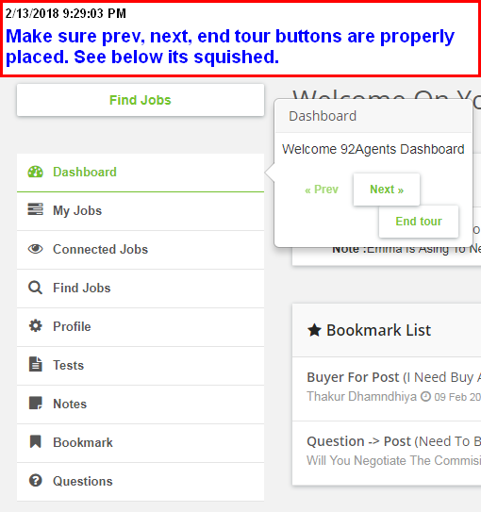

Enter the below content for the start guide. For agent, buyer and seller

Agent - Start Guide

Dashboard is where all actions come to life.

See and Do everything in one place

My Jobs

See all your buyers and sellers here.

Their Posts, Messages, Notifications etc

Connected jobs

????

Find jobs -- Search

Search all buy, sell postings and more

Example.

Search Buyer and Seller by name

Search Questions, Messages and Answers

Search posts

Search posts containing keywords like "ASAP" or "foreclosing" etc.

Search by date, partial address , city, state and ZIP Code

Profile

It has Profile,Security settings, Personal bio, Professional bio and more

Notes

Don't memorize !!!

Take note on anything important in the site. Use it for later reference

Bookmark

Bookmark anything important in the site. Use it whenever needed

Questions

Pre-written questions for buyer and the seller. share any of these when needed

Other resources

here you will create and share several key items

1. Create and upload proposals

2. Upload documents

3. Add questions to buyer and seller

4. Add a survey questions to the site admin

Message

Get all messages from buyers and sellers

----------------------------------------------------------------------

Buyer - Start Guide

Dashboard is where all actions come to life

My Posts

See all your buy posts here

Find agents -- Search

Search all Agents, Questions, Messages, Answers

Example.

Search agents by name

Search partial questions like commission

Search partial answers like 1%

Search by date, partial address , city, state and ZIP Code

Profile

It has Personal Profile,Security settings, Personal bio and Password Settings

Notes

Take note on anything in the site including messages and chats. Use it for Side-by-side Compare

Bookmark

Bookmark anything in the site including messages and chats. Use it for Side-by-side Compare

Other resources

here you will create and share several key items

1. Upload documents and share it with the agents

2. Add questions to the agents. Mark them as Important

3. Add a survey questions to the site admin

4. Share important questions to agents

Message

Get all messages from all agents

------------------------------------------------------------------------------------------------

Issue 0022: logged in as agent. search based on words in questions and answers. Example search for “commission” in questions.

Fixed and Tested Y/N :

What was fixed ?:

Watch the video: “Search based on words Video_2018-02-13_213450.wmv”

Issue 0023:. Edit post from buyer and seller

Fixed and Tested Y/N :

What was fixed ?:

What’s the video: “Buyer Seller Edit post Video_2018-02-13_215216.wmv”

Issue 0024:logged in as agent. Looking at the personal biodata

Fixed and Tested Y/N :

What was fixed ?:

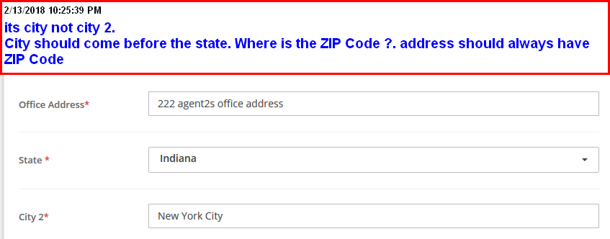

Issue 0025: Missing page. From buyer/seller to Rate agent with comments. And the Same with the agent rating the buyer/seller. Rating only happens after the agent is selected.

Fixed and Tested Y/N :

What was fixed ?:

1 review for each buy/sell posting rating the agent from a buyer/seller.

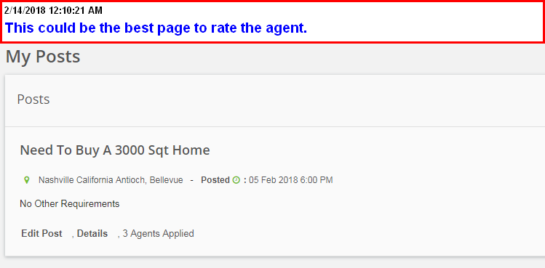

Issue 0026: Missing page. Payment page. Agent pays the site. 1 page.

Fixed and Tested Y/N :

What was fixed ?:

Standard cc payment page. Amount is calculated based on Home sale price and his commision

Sale price : text box (example 200000)

Commission Percentage : text box (he will 1 , 1.1,2,3….). Example 2

Calculated payment amount is 5% of his commission which is

200000 x 2% (he gets 2% of 200000) x 5%(site gets 5% of that 2%)

Which is

200000 x 0.2 x 0.05 = $200

He needs to enter the credit card for this amount of $200