TOSHA KHANA ANALYSIS

Sr. | Name | Roll No | Section
1. | Ahmad Naeem | 23F-0707 | BCS-4F
2. | Aman Khurram | 23F-0605 | BCS-4F
3. | Zeeshan | 23F-0652 | BCS-4F
4. | Shahzain | 23F-0686 | BCS-4F

Problem Statement:
The Toshakhana case in Pakistan involves accusations against former government officials for accepting luxury vehicles and other gifts from foreign leaders and dignitaries. This controversy revolves around a treasure trove, known as the toshakhana, where such gifts are stored. In 2018, the Supreme Court of Pakistan mandated an investigation, instructing the National Accountability Bureau (NAB) to delve into the matter. The investigation found that former presidents, prime ministers, and other officials had accepted gifts worth millions of dollars, but had not declared them to the government or paid the required taxes on them. The case has stirred controversy in Pakistan, with some arguing that the officials violated ethical and legal norms by accepting the gifts, while others defend the practice as a diplomatic courtesy.

Objective:
The objective of this analysis is to answer the following questions:
- Which affiliation has got the most gifts?
- Which items are most gifted?
- PMLN vs PTI in Tosha Khana Case
- Probability of Retentions for every affiliation/items
- Regression modelling for Assessed value vs Retention value

Data Description:
Data Link: https://www.kaggle.com/datasets/zusmani/pakistan-toshakhana-files/data
- Detail of Gifts: Details of the gifts received, such as the type of gift, its specifications, or any unique characteristics.
- Item Category: Categorizes the gifts based on their type or nature, which could include categories like vehicles, jewelry, artwork, electronics, etc.
- Name of Recipient: Lists the names of the individuals who received the gifts, which may include government officials, dignitaries, or public figures.
- Affiliation: The affiliation or position of the recipient, such as their role in the government, diplomatic status, or any relevant organizational affiliation.
- Date: The date when the gift was received or when it was officially documented in the Toshakhana records.
- Assessed Value: The estimated value or worth of the gift, which could be based on market value, appraisal, or other valuation methods.
- Retention Cost: Costs associated with storing, maintaining, or safeguarding the gift within the Toshakhana facility.
- Retained: It indicates whether the gift was retained or kept within the Toshakhana inventory, or if it was disposed of, returned, or transferred elsewhere.
- Remarks: Additional notes, comments, or explanations related to the gifts, recipients, or any other relevant information that may not fit into the other columns.

Results:
Home Page containing a navigation bar for accessing other pages
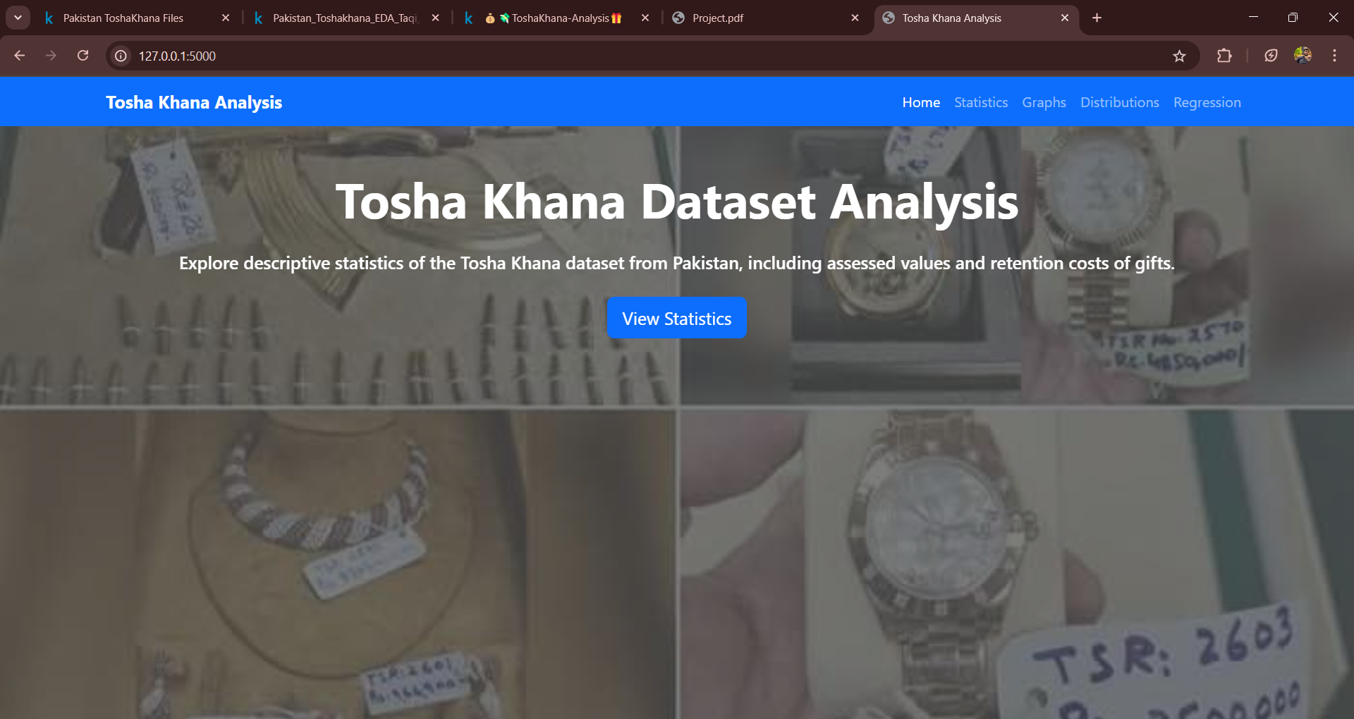
Statistics containing basic description of data containing mean, median, mode etc
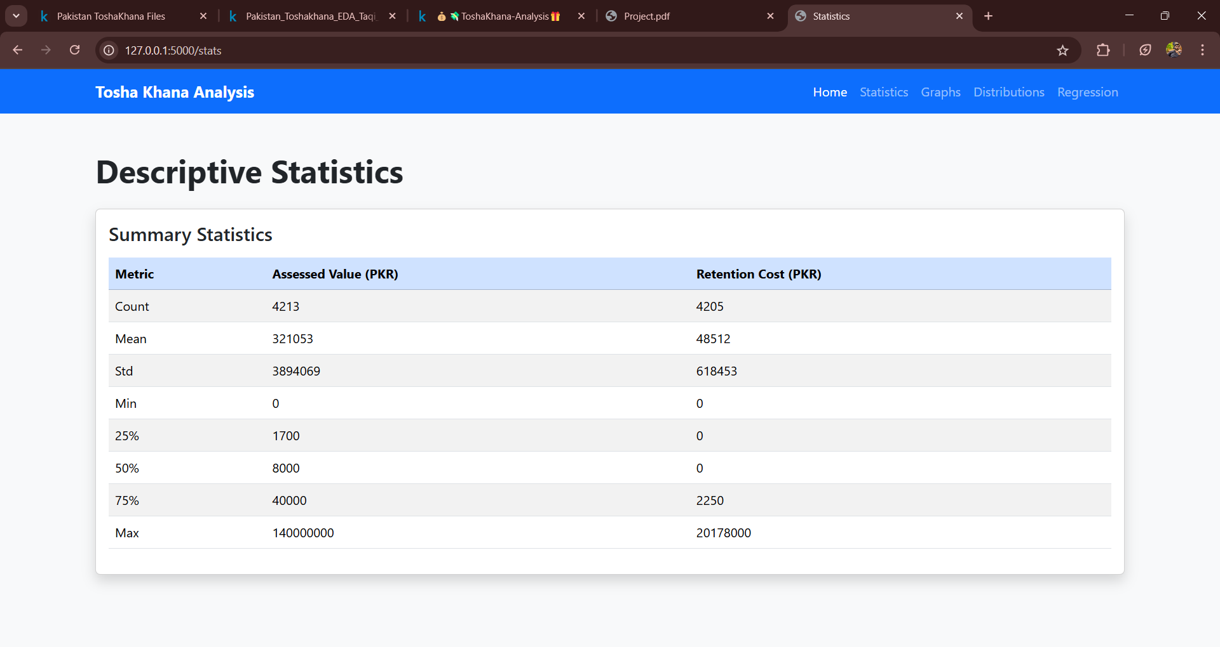

Graphs containing every possible graphical representation of the dataset
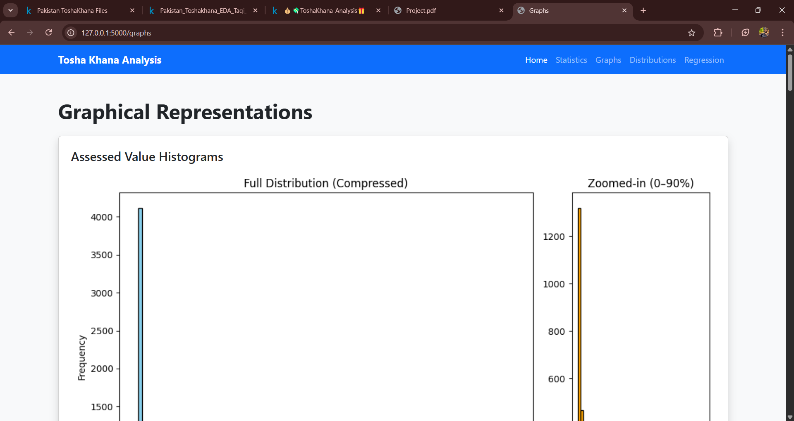

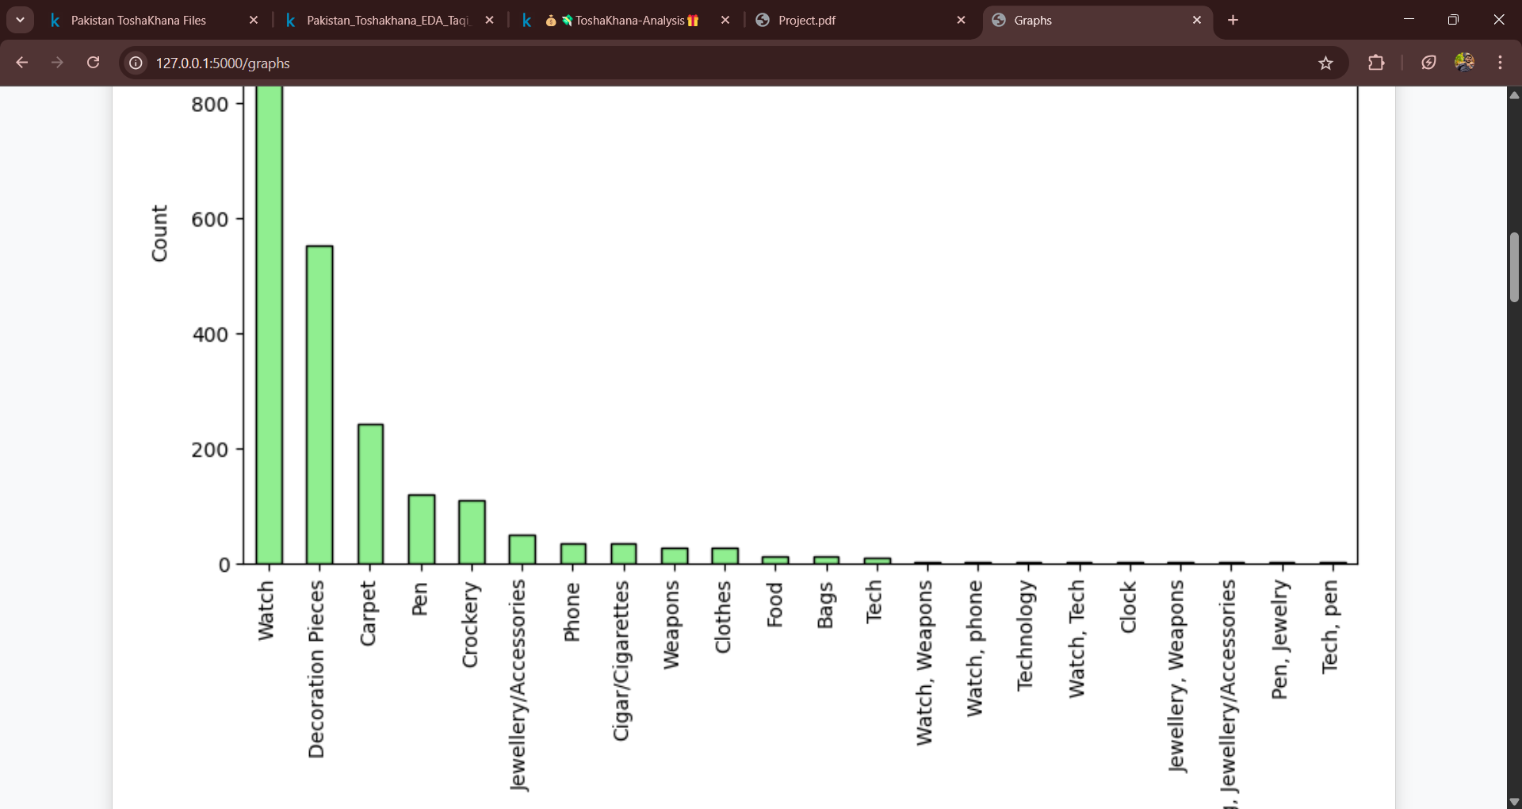

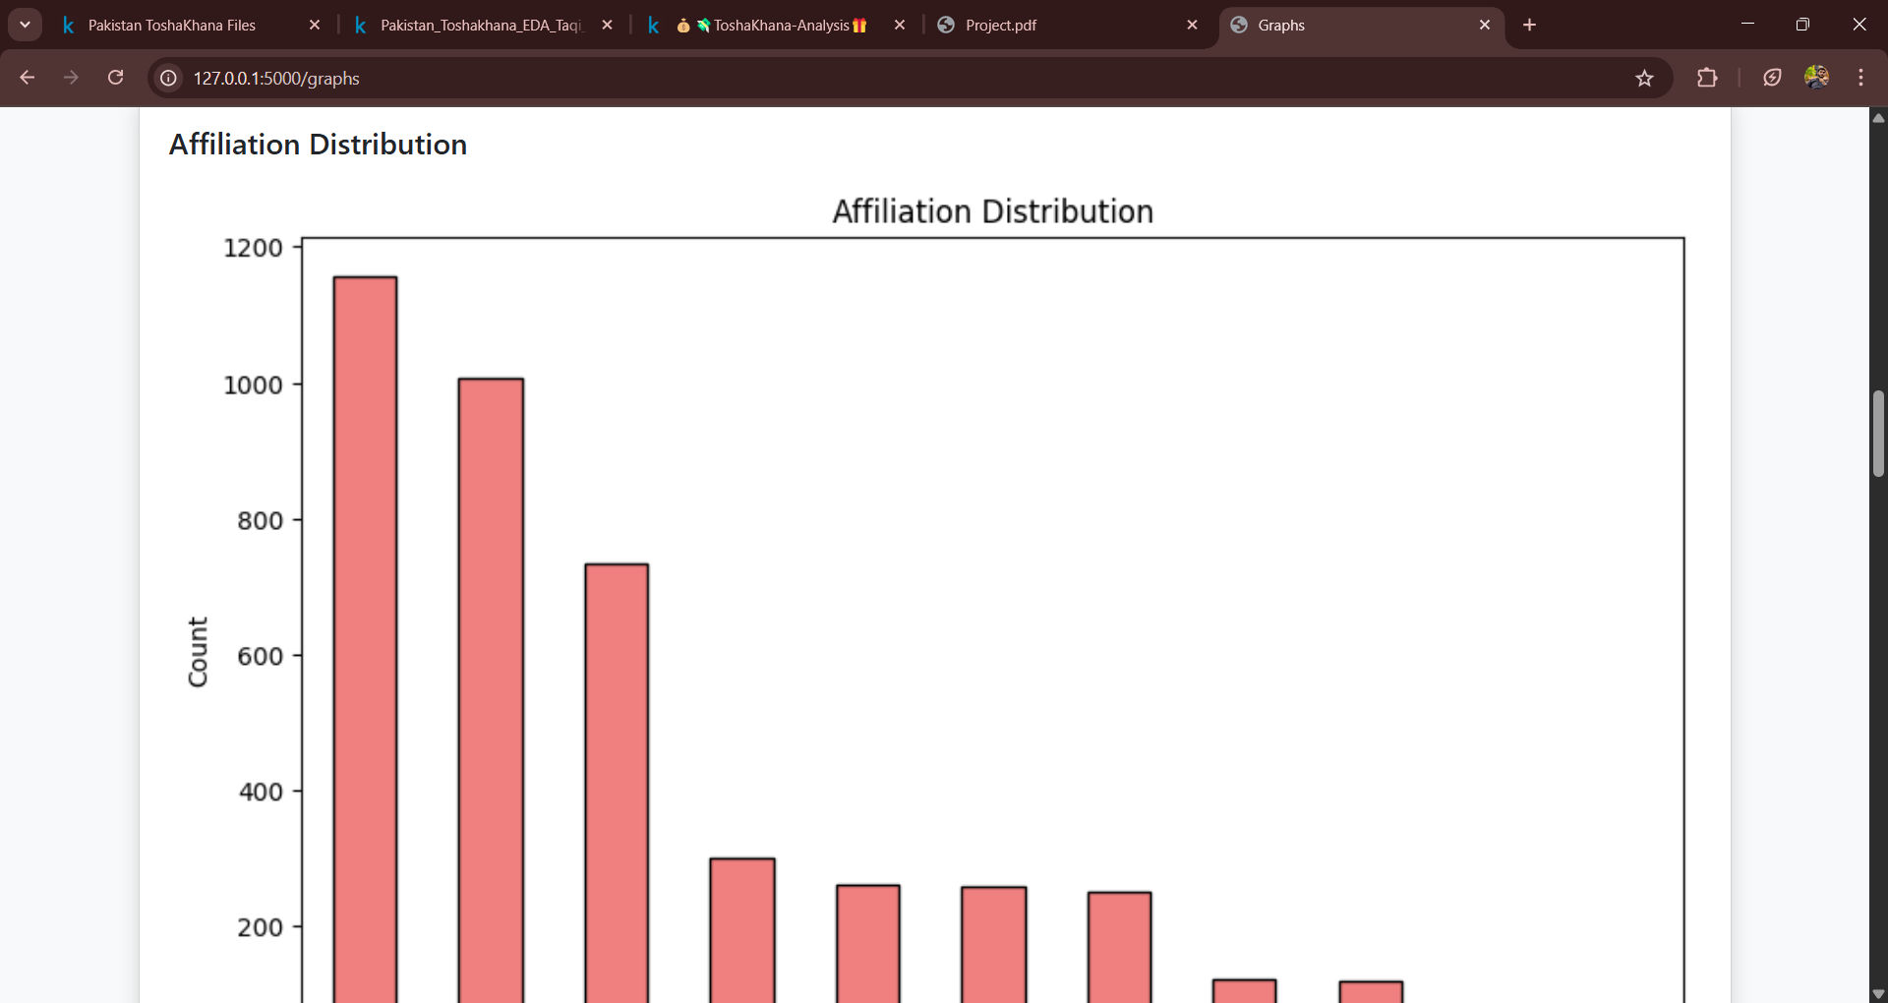

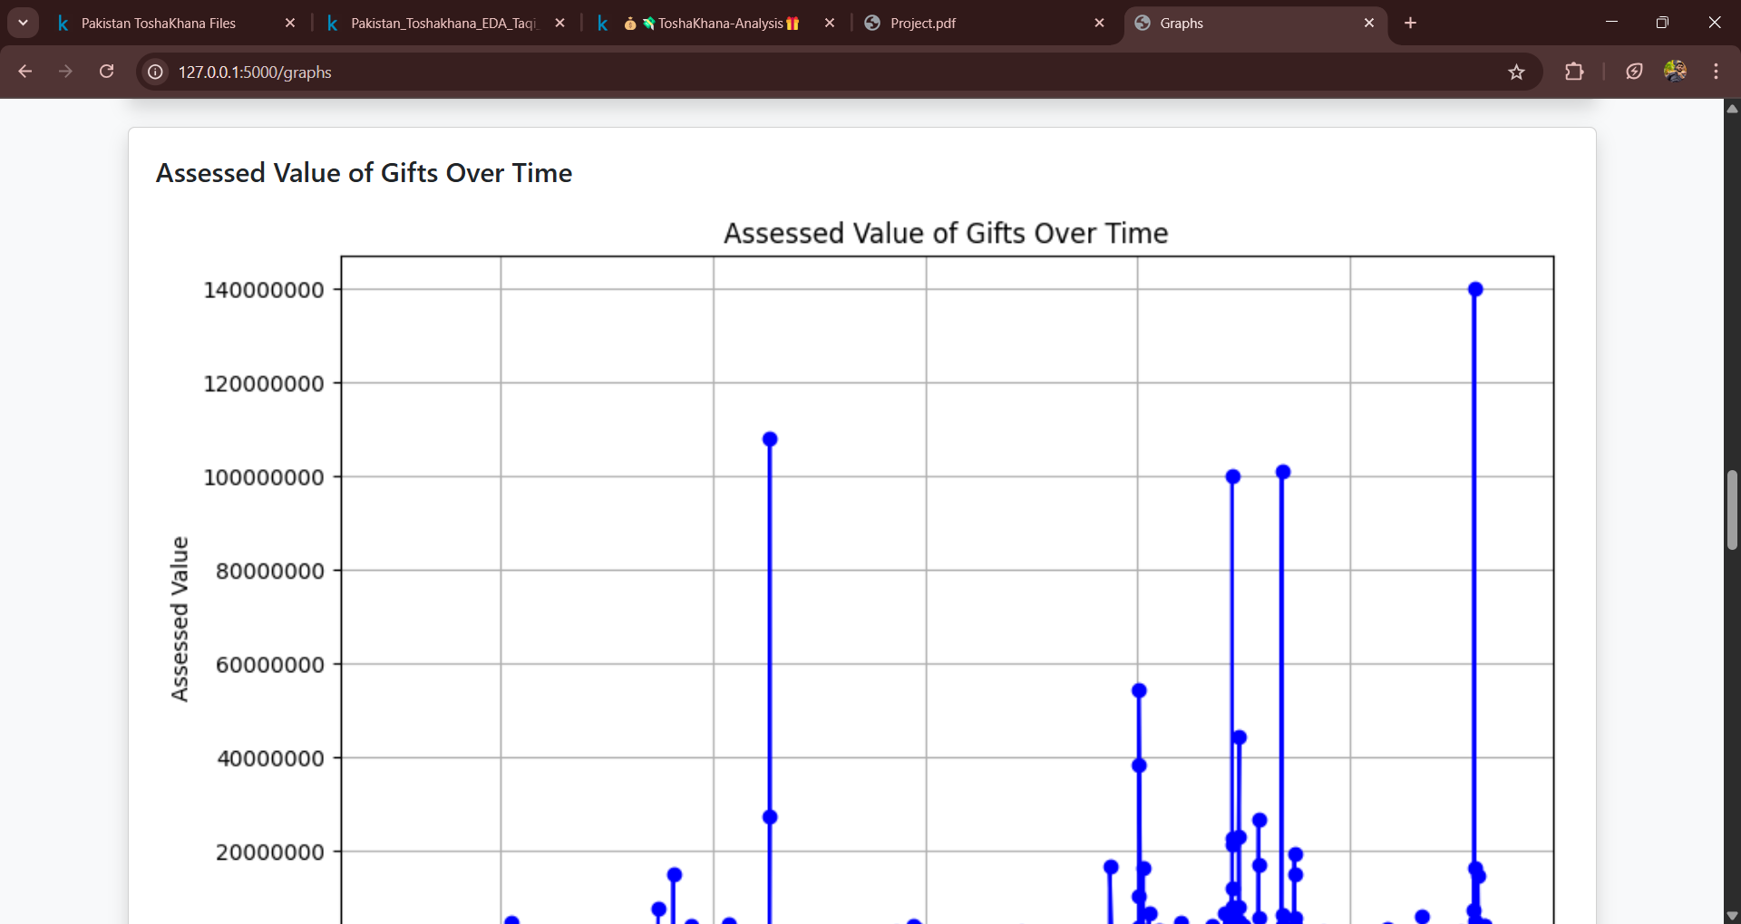
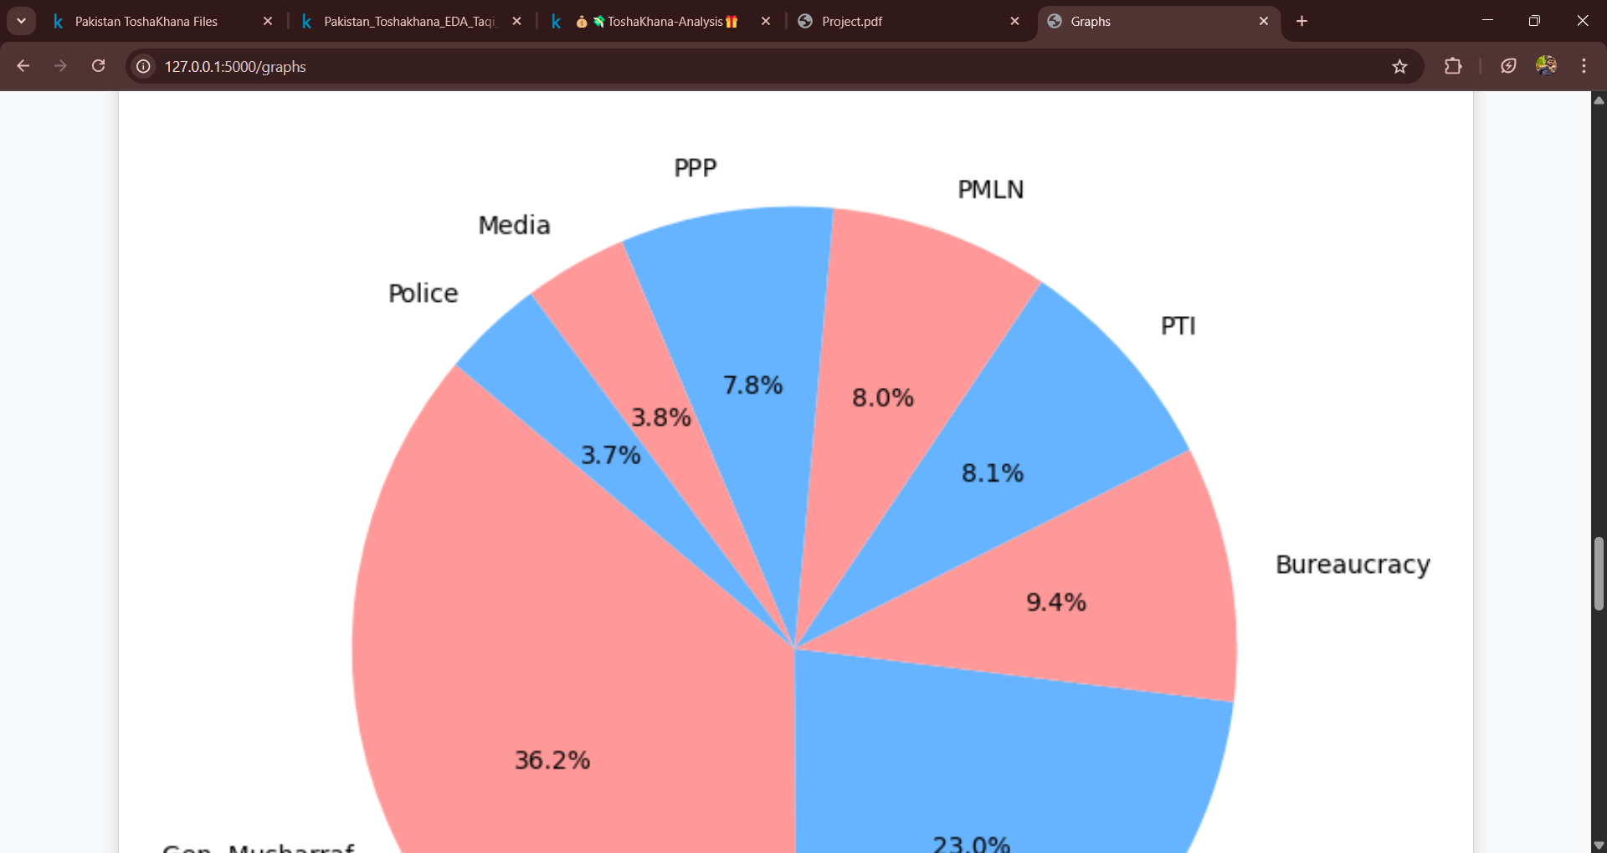

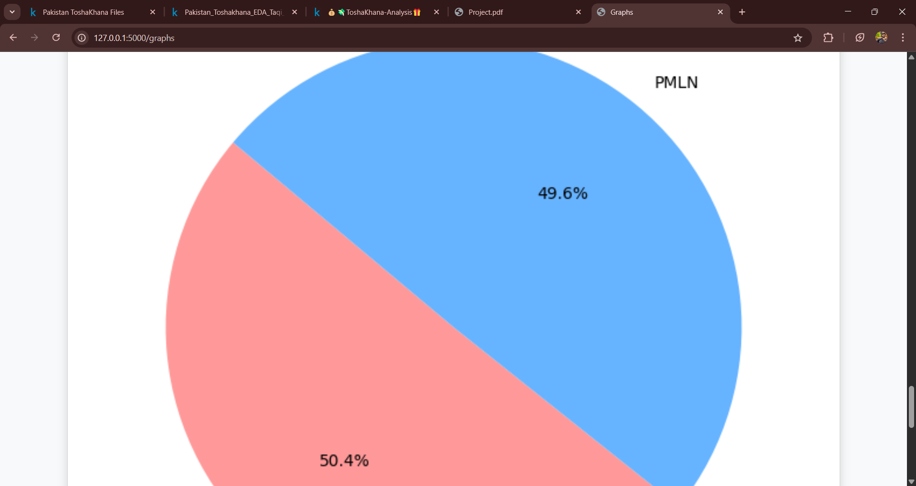

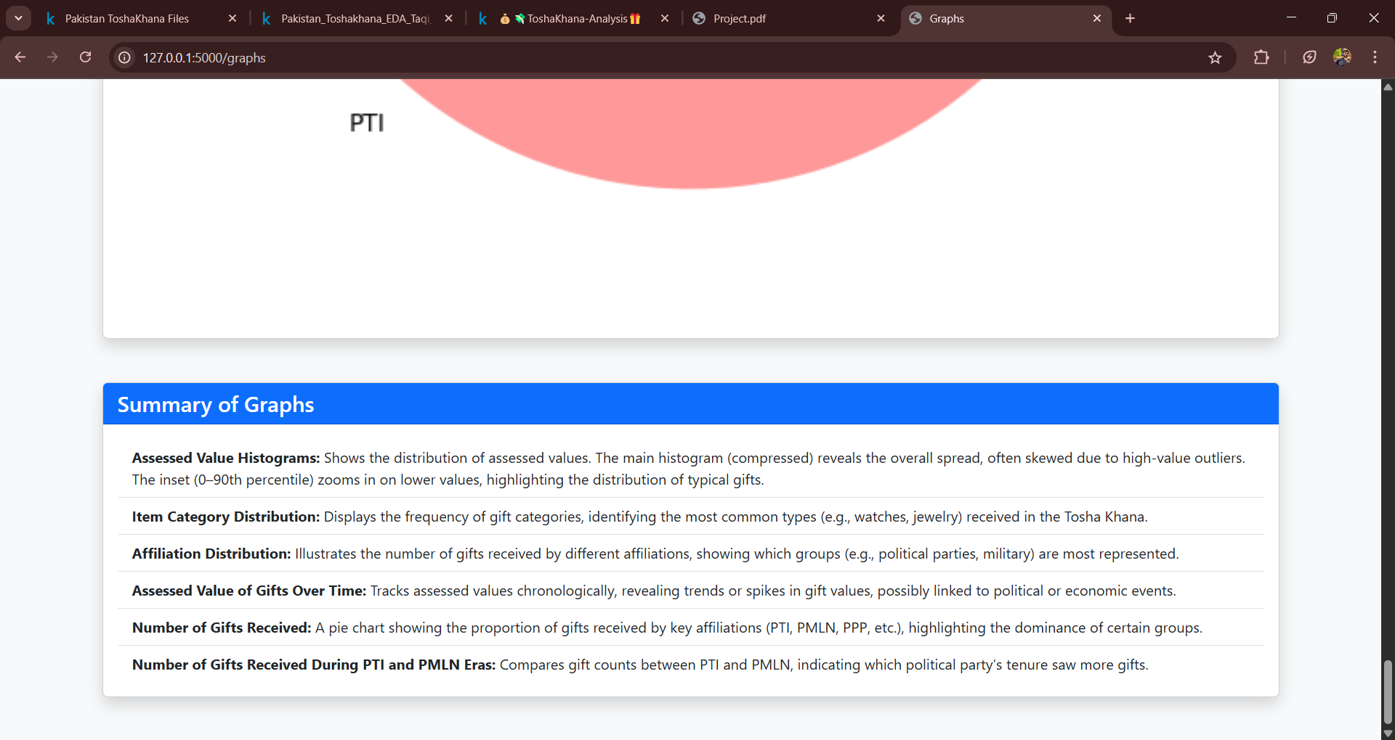

Probabilities containing conditional probabilities of affiliations and items category.
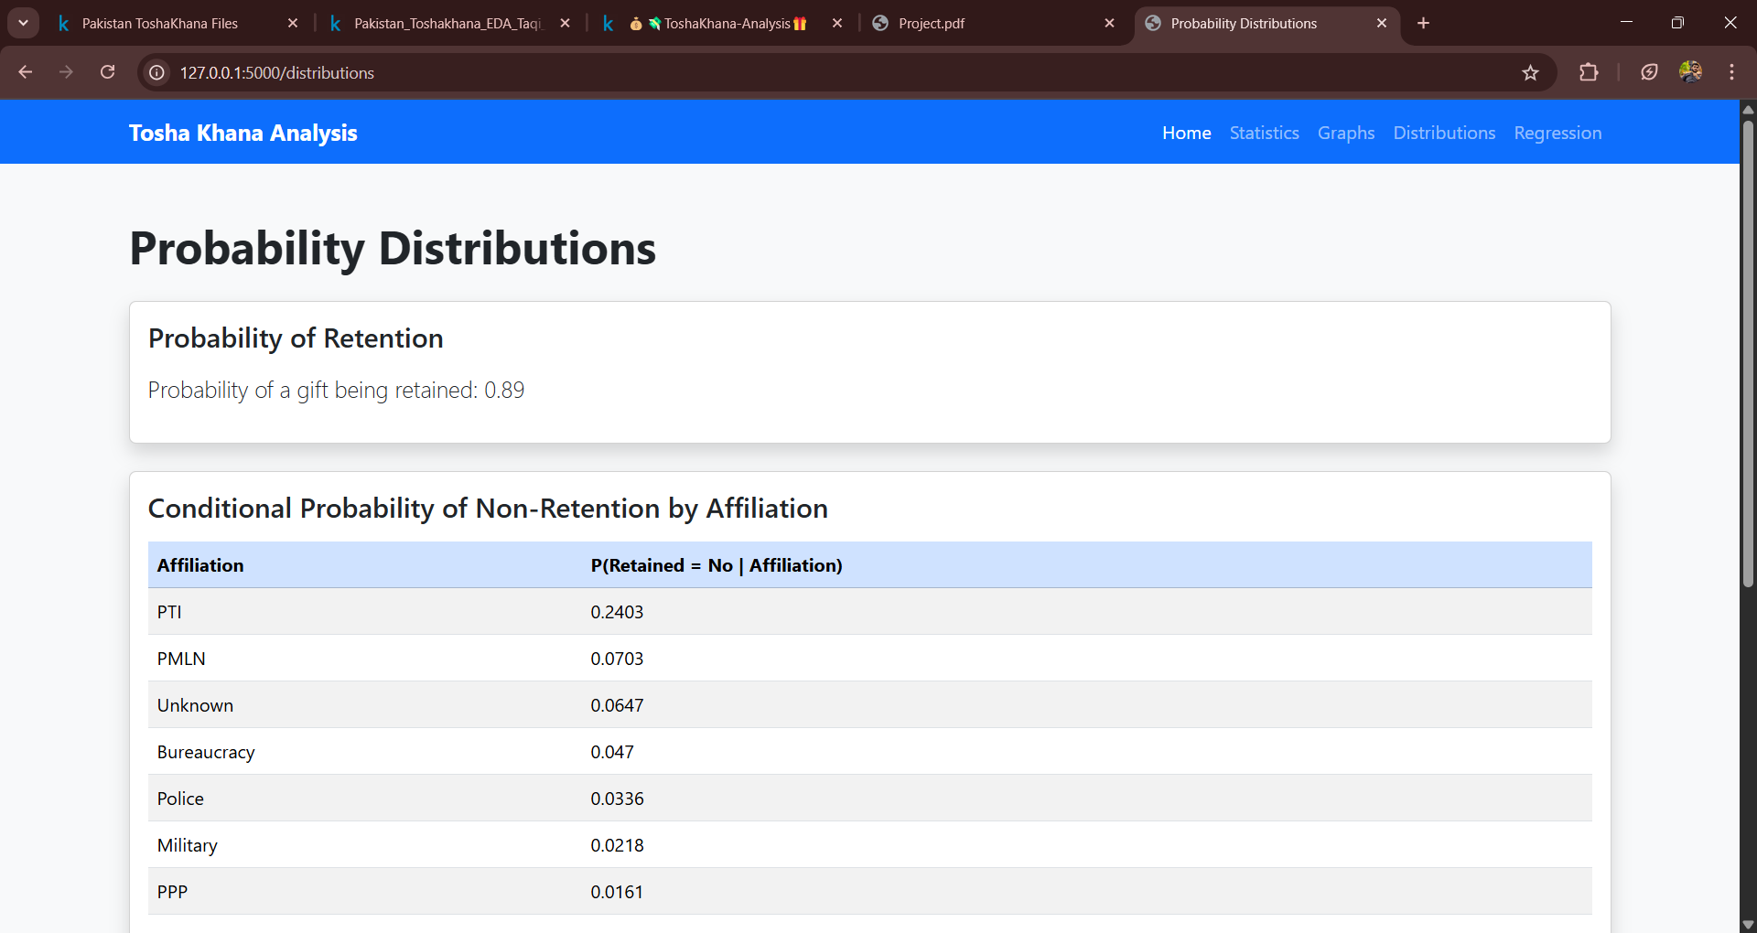

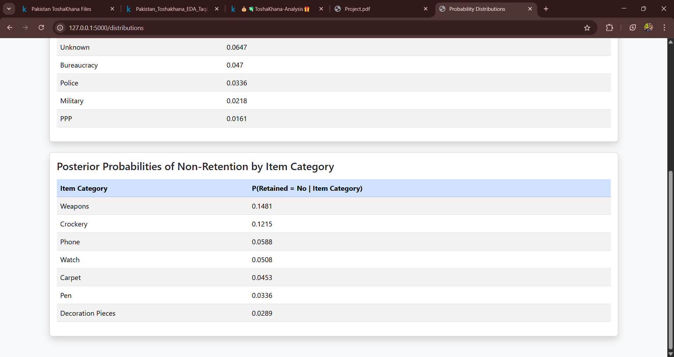

Regression Modelling containing a scatter plot of regression analysis as well as the contants defined.
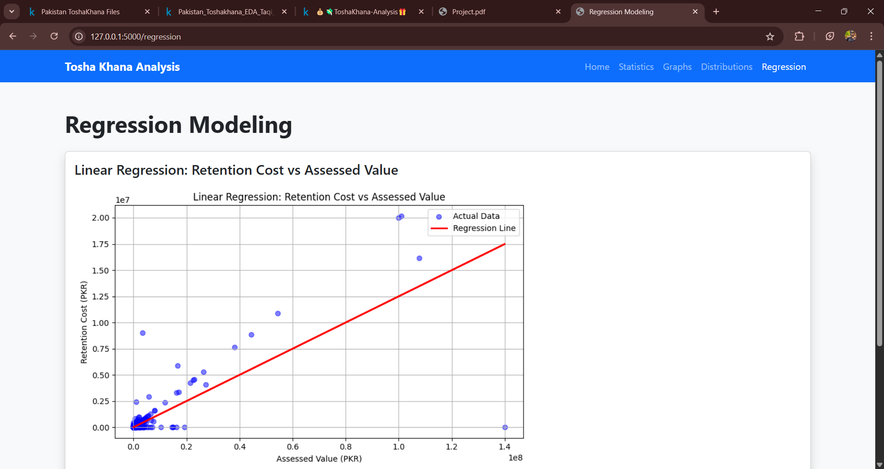
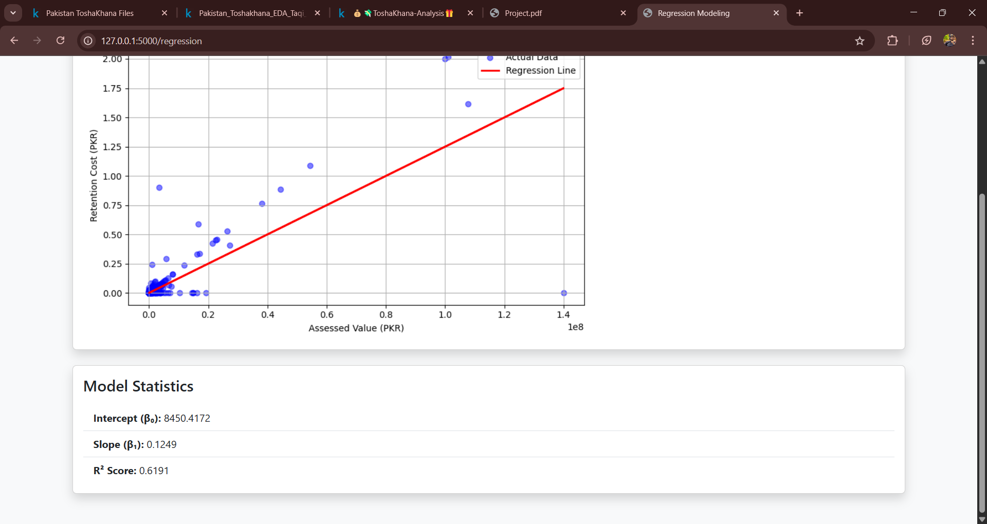

Code:
#fetching data and cleaning
import pandas as pd
df = pd.read_csv('Refined_TK_dataver2.csv') # adjust as needed
df['Affiliation'] = df['Affiliation'].fillna('Unknown')
#df = df.replace(to_replace='\n', value=" ", regex=True) #as we are replacing substring, so regex used
df['Affiliation'] = df['Affiliation'].replace({'Gen Mus':'Gen. Musharraf'}) #data munging in column 'Affiliation'
df['Affiliation'] = df['Affiliation'].replace({'Gen Mush':'Gen. Musharraf'})
df['Affiliation'] = df['Affiliation'].replace({'Gen. Musharrafarraf':'Gen. Musharraf'})
df['Detail of Gifts'] = df['Detail of Gifts'].replace({'One Carpet':'One carpet'})
df.sample(5)
#statistical tools
import matplotlib.pyplot as plt
pd.options.display.float_format = '{:,.0f}'.format
# Convert values to numeric and clean
df['Assessed Value'] = pd.to_numeric(df['Assessed Value'], errors='coerce')
df['Retention Cost'] = pd.to_numeric(df['Retention Cost'], errors='coerce')
# Drop rows where both are missing
df.dropna(subset=['Assessed Value', 'Retention Cost'], how='all', inplace=True)
# Summary stats
print(df[['Assessed Value', 'Retention Cost']].describe())
#histogram for assessed value
import matplotlib.pyplot as plt
from matplotlib import gridspec
# Set up main + inset axes
fig = plt.figure(figsize=(10, 6))
gs = gridspec.GridSpec(1, 2, width_ratios=[3, 1])
ax_main = plt.subplot(gs[0])
ax_inset = plt.subplot(gs[1])
# Main histogram (full data, compressed view)
ax_main.hist(df['Assessed Value'].dropna(), bins=100, color='skyblue', edgecolor='black')
ax_main.set_title("Full Distribution (Compressed)")
ax_main.set_xlabel("Assessed Value (PKR)")
ax_main.set_ylabel("Frequency")
# Inset histogram (only 0–99th percentile)
assessed_99 = df['Assessed Value'].quantile(0.90)
filtered = df[df['Assessed Value'] <= assessed_99]
ax_inset.hist(filtered['Assessed Value'], bins=50, color='orange', edgecolor='black')
ax_inset.set_title("Zoomed-in (0–90%)")
ax_inset.set_xlabel("Assessed Value")
plt.tight_layout()
plt.show()
#histogram for assessed value
import matplotlib.pyplot as plt
from matplotlib import gridspec
# Set up main + inset axes
fig = plt.figure(figsize=(10, 6))
gs = gridspec.GridSpec(1, 2, width_ratios=[3, 1])
ax_main = plt.subplot(gs[0])
ax_inset = plt.subplot(gs[1])
# Main histogram (full data, compressed view)
ax_main.hist(df['Assessed Value'].dropna(), bins=100, color='skyblue', edgecolor='black')
ax_main.set_title("Full Distribution (Compressed)")
ax_main.set_xlabel("Assessed Value (PKR)")
ax_main.set_ylabel("Frequency")
# Inset histogram (only 0–99th percentile)
assessed_99 = df['Assessed Value'].quantile(0.90)
filtered = df[df['Assessed Value'] <= assessed_99]
ax_inset.hist(filtered['Assessed Value'], bins=50, color='orange', edgecolor='black')
ax_inset.set_title("Zoomed-in (0–90%)")
ax_inset.set_xlabel("Assessed Value")
plt.tight_layout()
plt.show()
#Bar chart for item cateegory
df['Item Category'].value_counts().plot(kind = 'bar')
#Bar Chart for Affliation
df['Affiliation'].value_counts().plot(kind = 'bar')
#Chart for assessed value over time
# 1. Convert to datetime (ignore bad formats)
df['Date'] = pd.to_datetime(df['Date'], errors='coerce')
# 2. Remove rows with invalid or missing dates or values
df = df.dropna(subset=['Date', 'Assessed Value'])
# 3. Sort by Date
df = df.sort_values('Date')
plt.figure(figsize=(10, 6))
plt.plot(df['Date'], df['Assessed Value'], marker='o', linestyle='-', color='b')
plt.ticklabel_format(style='plain' , axis = 'y')
plt.title('Assessed Value of Gifts Over Time')
plt.xlabel('Date')
plt.ylabel('Assessed Value')
plt.grid(True)
plt.show()
#Pie Chart for all affliation
filtered_df = df[df['Affiliation'].isin(['PTI', 'PMLN' ,'PPP' ,'Bureaucracy' , 'Media' ,'Police' ,'Military' ,'Gen. Musharraf'])]
# Count the number of gifts received by each affiliation
affiliation_counts = filtered_df['Affiliation'].value_counts()
# Plotting the pie chart
plt.figure(figsize=(8, 8))
plt.pie(affiliation_counts, labels=affiliation_counts.index, autopct='%1.1f%%', startangle=140, colors=['#ff9999','#66b3ff'])
plt.title('Number of Gifts Received ')
plt.show()
#PMLN vs PTI
filtered_df = df[df['Affiliation'].isin(['PTI', 'PMLN'])]
# Count the number of gifts received by each affiliation
affiliation_counts = filtered_df['Affiliation'].value_counts()
# Plotting the pie chart
plt.figure(figsize=(8, 8))
plt.pie(affiliation_counts, labels=affiliation_counts.index, autopct='%1.1f%%', startangle=140, colors=['#ff9999','#66b3ff'])
plt.title('Number of Gifts Received During PTI and PMLN Eras')
plt.show()
retained_prob = df['Retained'].value_counts(normalize=True).get('Yes', 0)
print(f"Probability of a gift being retained: {retained_prob:.2f}")
pd.set_option('display.float_format', '{:.4f}'.format) # show 4 decimal places
affiliation_group = df.groupby('Affiliation')['Retained'].value_counts(normalize=True).unstack()
print("Conditional Probability of Not Retention by Affiliation:")
print(affiliation_group['No'].dropna().sort_values(ascending=False))
category_group = df.groupby('Item Category')['Retained'].value_counts(normalize=True).unstack()
posterior = category_group['No'].dropna()
print("Posterior probabilities (P(Retained=Not | Item Category)):")
print(posterior.sort_values(ascending=False))
from sklearn.linear_model import LinearRegression
from sklearn.metrics import r2_score
# Drop rows with missing values in relevant columns
df = df.dropna(subset=['Assessed Value', 'Retention Cost'])
# Reshape data for sklearn
X = df[['Assessed Value']] # 2D array
y = df['Retention Cost'] # 1D array
# Fit Linear Regression Model
model = LinearRegression()
model.fit(X, y)
# Predict values
y_pred = model.predict(X)
# Plot actual vs predicted
plt.figure(figsize=(8, 5))
plt.scatter(X, y, color='blue', alpha=0.5, label='Actual Data')
plt.plot(X, y_pred, color='red', linewidth=2, label='Regression Line')
plt.title("Linear Regression: Retention Cost vs Assessed Value")
plt.xlabel("Assessed Value (PKR)")
plt.ylabel("Retention Cost (PKR)")
plt.legend()
plt.grid(True)
plt.tight_layout()
plt.show()
# Print model stats
print("Intercept (β₀):", model.intercept_)
print("Slope (β₁):", model.coef_[0])
print("R² Score:", r2_score(y, y_pred))

Conclusion:
From this dataset we can conclude that, Gen. Musharraf has got the highest number of gifts. And most of the gifts are from the category of watches. Also, PTI has got more gifts than PMLN. 24% of the gifts given to PTI are not retained

