ROUTEDGE.NET.QA

1. Every domain registered in Qatar will ADD, DNS management by default,

Domain Forwarding will be FREE with DNS management, at a time only one of them allowed

use, when user choose DNS Management…Domain forwarding must be shown selected

and vice versa.

**Note: We are displaying default DNS Management and Domain Forwarding (free) with any Qatar domain. We will also provide an option where, if the user selects or deselects the DNS Management module, the Domain Forwarding will also be selected or deselected accordingly, and vice versa.**

2. No ID protection provided from QATAR; Domain Privacy can be added instead of ID

protection EXCEPT for Qatar domains.  
  
**Note: In WHMCS, ID Protection is the same as Domain Privacy. Therefore, we are renaming ID Protection, and it will be displayed for all domains except Qatar domains (e.g., .qa, .com.qa, .net.qa, .name.qa).**

3. Make sure Policy acceptance is mandatory to “GO AHEAD” registration process

**Note: I have a query regarding this. Did you discuss making the policy acceptance fields mandatory?**  
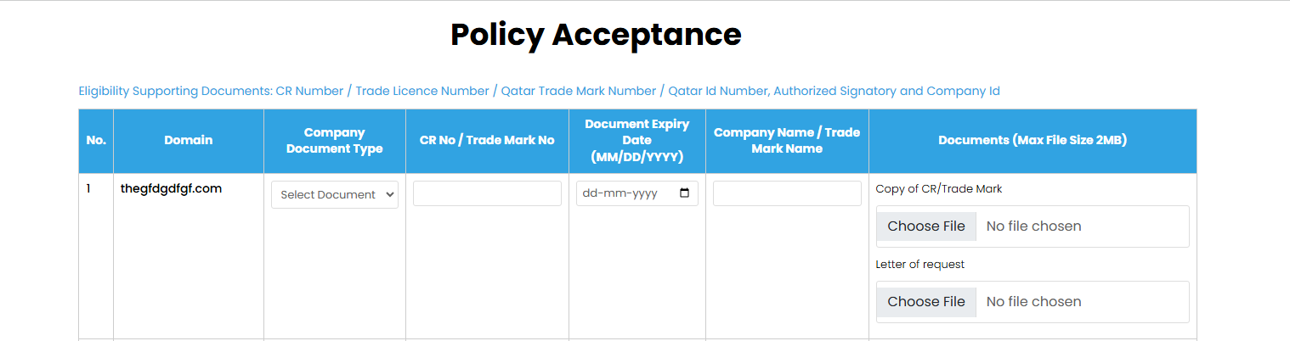

4. If a Domain is deleted DNS zone also should be deleted from CLOUDNS using API  
Note:

Note:

5. There is a REGISTRAR-REGISTRANT agreement format, should be updated and stored

after each domain registration by automatically filling REGISTRANT CONTACT details,

printable any moment in PDF format  
  
**Note: We will implement this. You have shared the agreement document, and we will update the details in it after each domain registration and display the PDF in the client area under the My Domains section**

6. If Registrant searched for .QA domain and ORGANIZATION is FILLED and COUNTRY is

Qatar then .COM.QA of same domain(if available) should be added to CART

automatically, just before payment user MAY give option to remove also  
  
**Note: We will implement this so that when the user searches for a .QA domain and the country is Qatar, .COM.QA will be automatically selected and will also be removable on the cart page**

7. Domain Forwarding and OWN DNS or HOSTED DNS required in the DOMAINS area  
  
**Note: Could you please explain this point in more detail?**

8. Uploaded company documents of customer must be visible somewhere for customer

and Admin, customers should be able to reupload them from domain area of

Customers.  
  
**Note: We are displaying the documents in the client area and also providing the option to add documents for the client. In the admin area, all the documents added by the client are shown in the addon module. Do you also want an option in the admin area to add documents for each specific client domain?**

9.Paytm Payment Gateway of Qatar should be connected.  
  
Note:

10. We should be able to add DNS Management @SERVICES for a specific domain from

SERVICES area from Admin area(with a domain name) ONLY for DNS Management

(domains not registered by us also)  
  
**Note: We will create a provisioning module for this**

11. We should be able to add external DOMAINS also @ DOMAINS area manually from

admin area, clients may just manage DNS from us and Domain may be registered from

somewhere else.

12.except .QA no other search works now including قطر.  
  
**Note: we will check this**

13.While people search domain names

result should be shown first for searched domains

other 3 domains of .QA should be visible @following order

If .QA is searched then

.COM.QA

.NET.QA

.NAME.QA

The following order must be maintained

Followed by

.COM

.AE

.IN

.SA

.NET

.BIZ

.ORG  
  
**Note: we will update the order**

14. Organize MY DOMAINS and MY SERVICES in the same Page Up and Down, also in the

drop down menu positioning as just UP/DOWN  
  
**Note: We will merge the 'My Domains' and 'My Services' sections into the same page**